Project Gutenberg's Ludwig Bechstein's Märchenbuch, by Ludwig Bechstein

This eBook is for the use of anyone anywhere at no cost and with

almost no restrictions whatsoever. You may copy it, give it away or

re-use it under the terms of the Project Gutenberg License included

with this eBook or online at www.gutenberg.org/license

Title: Ludwig Bechstein's Märchenbuch mit

176 Holzschnitte from Original Drawings by Ludwig Richter

Author: Ludwig Bechstein

Illustrator: Ludwig Richter

Release Date: October 15, 2020 [EBook # 63465]

Language: German

Character set encoding: UTF-8

*** START OF THIS PROJECT GUTENBERG EBOOK LUDWIG BECHSTEIN'S FAIRY TALE BOOK ***

Produced by Ray Papworth and the Online Distributed

Proofreading Team at https://www.pgdp.net

1

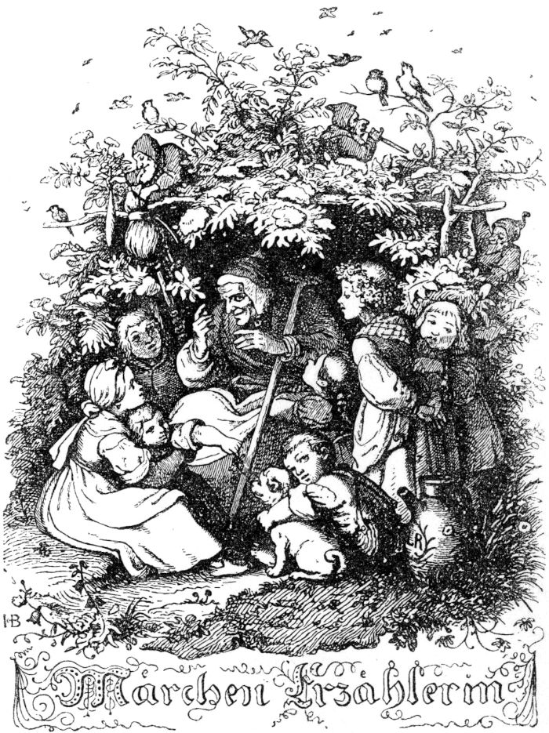

3

**Ludwig Bechstein's  
book of fairy tales**

With 176 woodcuts based  
on original drawings  
by  
Ludwig Richter



Hesse & Becker Verlag, Leipzig

5

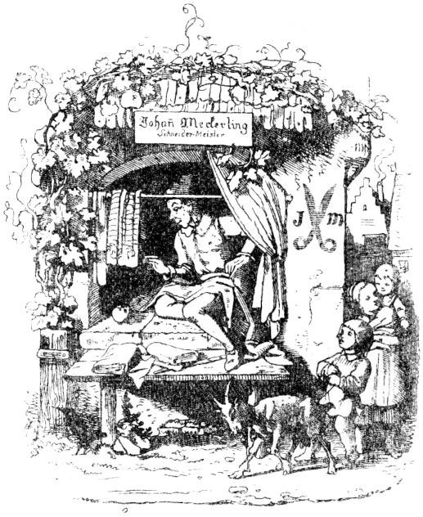

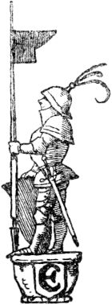

**From the brave little tailor.**

Once there was a little tailor who sat in a town called Romadia; For a time when it was working, it had an apple lying next to it, and many flies perched on it, as is usual in summer, which were attracted by the sweet smell of the apple. The little tailor got angry at this and took a rag that he was about to go to hell 6dropped, hit the apple, and looked at it and found that it had killed seven flies. Oh, thought the little tailor to himself, are you such a hero ?! Had a bare armor made for himself and written on the breastplate in golden letters: Seven in one stroke. Thereupon the little tailor, wearing his armor, wandered around the streets and alleys, and those who saw him thought that the hero had cut seven men in one blow and were afraid.

Now there was a king in the same country, whose praise rang out far and wide, to whom the lazy tailor went, who immediately after his heroic deed hung up a needle, scissors and an iron, stepped into the courtyard of the royal palace, lay down there in it Grass and fell asleep. The court servants, as they went in and out, saw the tailor in his rich armor, and read the gold script, were very astonished at what this warlike man was going to do now, in peacetime, at the king's court? He undoubtedly thought she was a great gentleman.

The king's counselors, who also saw the sleeping tailor, did this, knowing that Sr. Majesty, their most gracious king, with the most humble remark that, should a warlike conflict arise, this hero would become a very useful man and would serve the country well could. The king liked this speech, and immediately sent for the armored tailor, and asked him whether he wanted services. The tailor replied that this was precisely why he had come, and asked the Royal Majesty, wherever she thought of needing him, to give him the most gracious service. The king promised the little tailor services, gave him a handsome lotament and room, and gave him one 7tha good salary on which it could live gloriously and in joy without doing anything.

It wasn't long before the king's knights, who had only a meager wages, grieved the good tailor, and would have liked to want him to be with the devil, especially feared that if they were to disagree with him, they would want him do not offer enough resistance, since he would kill seven of their seven in one go, otherwise they would have liked to have bitten him off, and so they pondered daily and hourly how they would like to get away from the freeman. But since their wit and sagacity were a bit short, like their little skirts, they found no ruse to remove the hero from court, and in the end they advised each other to all appear before the king at the same time, and to ask for leave and dismissal and they did.

When the good king saw that all his loyal servants wanted to leave him for the sake of one man, he was sad as never before, and wished that he had never seen the hero after all; But he was afraid to send him away, because he had to fear that he and all his people would like to be slain by him, and afterwards his kingdom would be possessed by the wicked warrior. Since the king sought advice in this difficult matter, what should be done in order to amicably dismiss everything and to steer it for the best, he finally devised a ruse, with which he thought the warrior (whom no one valued as a tailor) to get single and get away. He immediately sent for the hero and said to him how he (the king) had heard that a mightier and stronger battle hero could never be found on earth, because he (the tailor). Now two giants lived in the nearby forest and they would kill him 8thThere was great damage in the country with robberies, murders, singeing and burning, and they could not be approached either with weapons or in any other way, for they would kill everything, and if he should now try to kill the giants, and would really kill them, so he was to receive the king's daughter as his married wife, and half the kingdom as a trousseau, and the king wanted to give him a hundred horsemen to help against the giants.

The little tailor felt very well at this speech by the king, and he thought it was beautiful that it should become a king's daughter and receive half a kingdom for dowry; therefore said pertly: he would like to be at the service of the king, his most gracious lord, and kill the giants, and know how to kill them without the help of the hundred horsemen. Thereupon he ordered himself into the forest, called the hundred horsemen, who nevertheless had to obey him on the king's orders, to wait in front of the forest, stepped into the thicket, and looked around to see if he would like to see the giants anywhere. And finally, after a long search, he found them both sleeping under a tree, and so snoring that the branches on the trees rustled back and forth as if bent by the storm wind.

The tailor did not think twice about it, quickly read his bosom full of stones, climbed up the tree, beneath which lay the giants, and began to throw one of them with a coarse stone on his chest, from which the giant immediately woke up and was angry with his fellow companions and asked why he hit him? The other giant apologized as best he could that he did not know that it must have happened in his sleep; as they now fell asleep again, the tailor took hold again 9a stone, and threw the other giant, who was now angry at his comrade and asked why he was throwing it? but now he didn't want to know anything about it either. When the eyes of both giants had closed again after some quarreling from sleep, the tailor threw again violently at the other, so that he could no longer bear it, and at his companions, 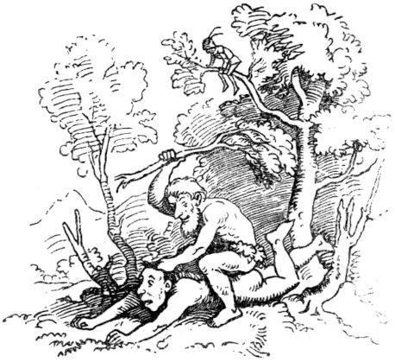from which he thought he was beaten, struck violently; The other giant didn't want to suffer either, so they both jumped up, tore trees out of the ground, but to all the luck they left the tree, on which the tailor sat, and hit each other with the trees so violently that they beat each other to death .

When the tailor saw from his tree that the two giants had killed each other, he felt better than he had ever felt, climbed happily from the tree, struck every giant with a wound or several with his sword, and went out of the forest to them Riders. They asked him if he had spotted the giants or if he hadn't seen them anywhere? "Yes," said the tailor, "discovered and seen and killed both of them - I did, and left them lying under a tree." The riders were surprised to hear that, they could not and would not believe that one man 10so unharmed by the giants should have come, and still have killed them, now rode into the forest themselves to see this miracle, and found it just as the tailor had said. The riders were amazed at this, and felt a terrible shock, they felt even worse than before, because they feared that the victor would kill them all if he became an enemy; rode home and told the king what would happen.

When the tailor came to the king and reported his deed himself, and the king's daughter and half the kingdom coveted, the king regretted the promise he made to the unknown warrior, because the giants had now been strangled and could no longer harm them to do; thought about how he might justly get rid of the hero, and was not in the least inclined to give him the daughter. So he said to the tailor how he unfortunately still had a unicorn in another forest, which was doing him very great damage to fish and people; he should catch the same thing, and if he did this, the king would give him the daughter. The good tailor was satisfied with that too, took a rope, went to that forest where the wild unicorn lived, and ordered his assigned to wait outside the forest. he wanted to go in alone and endure the deed on his own, just as he did the deed against the two giants alone and without any other help. When the tailor had strolled around in the forest for a while, he saw the unicorn, which was running towards him with its horn stretched out, and wanted to kill him. But he was not unresponsive, waited until the unicorn got very close to him, and when it was close to him, he quickly slipped behind the tree next to which he was very close 11stood, and there the unicorn, which was in full running and could no longer turn, ran with all haste against the tree, so that it pushed it almost through and through with its pointed horn, and the horn got stuck in it. Then the tailor, when he saw the unicorn wriggling firmly on the tree, stepped out, wrapped the worn rope around his neck, tied it to the tree completely, went out to his hunting companions, and showed them his victory over the wild unicorn . Thereupon the little tailor went to the king, humbly announcing the happy fulfillment of the royal wish, and modestly recalled the royal double promise. At this the king was saddened beyond measure, did not know what to do, since the tailor wanted the daughter, whom he should not have. And wanted one more thing from the warrior. He was supposed to see the cruel wild boar that ran in a third forest and devastated everything, and if he did this too, then the king would give him his daughter without delay and would also order his whole hunting to help him.

The tailor, not particularly pleased by the king's renewed desire, went out with his companions to the forest, and ordered them to stay outside when the forest was reached. The hunters were very happy and satisfied, for the wild boar had already welcomed them so often that many of them had forgotten to come back forever, and they all no longer wanted to pursue him, so they thanked the tailor very sincerely for making himself Venture into the Fahrnis alone and leave them there in Numero Safe. The tailor had not entered the forest long before the wild boar caught sight of him and 12rushed towards him with foaming jaws and sharp tusks and wanted to run him straight to the ground, so that his heart trembled and he quickly looked around for rescue. It said Fortunately an old ruined chapel in the woods, it was brought from ancient times drain, and then the tailor close stood by, and foresaw the chapel, he jumped with a set in, but also the door against an air jump through a window, 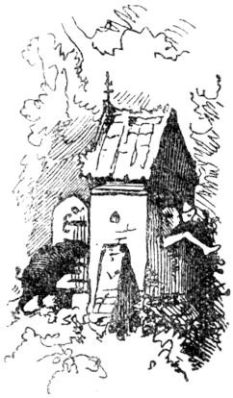There were no more panes in it, out again, and immediately the wild boar followed him, which was now rumbling around in the chapel, but the tailor ran quickly around the little house, wiped at the door, hurriedly tossed it shut and thus locked the cruel game inside the little church, then went to the hunting companions, showed them what he had done, who came there, found the matter true and correct, and rode home with great astonishment, reporting to the king. Whether the news of the once more successful victory of the heroic warrior made the king more happy or more sad, anyone, even with poor understanding, can easily judge, for the king now had to give the tailor the daughter or fear that he would lose his heroism , of which he gave three such astonishing samples, might turn against himself. But there is no doubt that if the king had known completely that the hero was a tailor, he would have preferred him to hang a rope rather than give him his daughter. But whether the king is a man of no origin and no birth, except 13who gave of his mother, his daughter with little or with great distress, gladly or reluctantly, little tailor asked little or not at all, enough, he was proud and happy to have become the king's daughter. So the wedding was not celebrated with great joy from the royal side, and a tailor had become a royal oath, yes, a king.

When a little time had passed, the young queen heard her master and husband talking in their sleep and clearly heard the words: “Servant, make me the doublet - mend my trousers - hurry up - or I'll - measure you the yardstick over the ears! ”The young king's wife found this very surprising, she almost noticed that her husband was a tailor, reported this to her master and father and asked him to help her from this man. Such a speech cut through the king's heart that he had had to entrust his only daughter to a tailor, consoled her as best as he could, and said that she should only open the bedchamber the next night, and that several servants should stand at the door, and when she was back to hear such words, these servants should go in and kill the man outright. The young woman put up with that and so promised to do it. But now the king had an armor-bearer at court, who was kind to the tailor and had heard the king's unfaithful speech, so he hurried to the young king and told him about the difficult judgment that had just now been passed on him and pleaded him that he should defend himself to the best of his ability. The tailor king thanked him for his warning and he knew what to do in this matter. How now The tailor king thanked him for his warning and he knew what to do in this matter. How now The tailor king thanked him for his warning and he knew what to do in this matter. How now 14thWhen night had come, the young king and his wife went to rest at the usual time, and soon pretended to be asleep. Then the woman got up secretly and opened the door, whereupon she lay down again very quietly. After a while the young king began to talk as if he were asleep, but in a clear voice that those outside the chamber could well hear: "Servant, make my pants - blow my doublet - or I want you to measure the cubits over them Beating ears. I - killed seven in one fell swoop - I killed two giants - I caught the unicorn - I also caught the wild boar - should I fear them - those standing outside the chamber? "

When those in front of the chamber heard such words, they fled as if they were chasing a thousand devils, and no one wanted to be the one who dared to go to the tailor. And so the brave little tailor was and remained a king all his life and until his end.

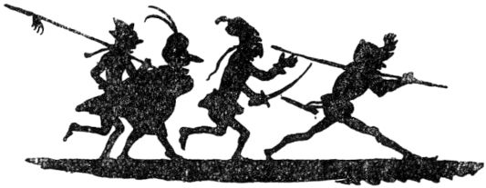

15th

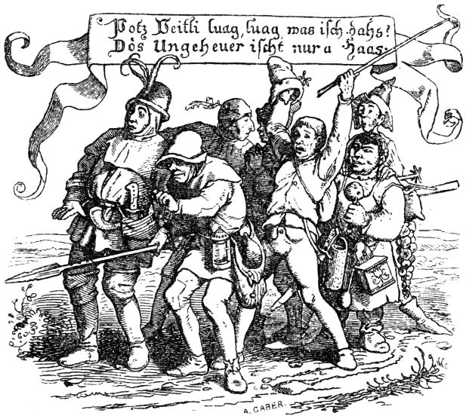

**The fairy tale of the seven Swabians.**

Once upon a time there were seven Swabians who wanted to be great heroes and go on adventures all over the world. But so that they had a good weapon, they first moved to the world-famous city of Augsburg and immediately went to the most skilled master there to stock up on defense and weapons. Because they had nothing less in mind than to kill the gigantic monster, which at the same time lived very badly in the area of ​​Lake Constance. The master was amazed when he saw the seven, but quickly opened his armory, which offered an excellent selection for the brave fellows. “Bygott!” Shouted the Allgäu, “send des au spit? So oaner warmer degrees reach the Zahnstihrer. For mi 16Isn't a spit of seven men’s size not long enough. ”- The master looked at him again with a look that almost annoyed the Allgäu man. Because he peeked back with grim eyes, and with a hair there would have been something if the lightning swab hadn't come into the middle at just the right time. “Hotz Blitz!” He shouted, “you hoscht Reacht and I notice you doin maining: like all sieves for oin, so for all sieves noh oin spit.“This was not entirely clear to the Allgäu, but because the others were right, he said:“ Joh ”. And in less than an hour the master made the spit, which was seven man's lengths. - Before they left the workshop, however, everyone bought something special, the Knöpflesschwab a skewer, the Allgäu a balaclava with a feather on it, the yellow-footed spurs for his boots, noting that they are not only good for riding, but also to hit back. When the sea hare finally chose armor, the Spiegelschwab, with such caution, completely agreed with him, but said it was better to put on armor in the back than in the front. And bought an old barber's basin from the master's lumber room, big enough to cover his backside. "Note: han i Curasche and go ahead,

And after the seven Swabians, like honest people, paid everything right down to the penny and penny, heard a mass at St. Ulrich as good Christians and finally bought good Augsburg sausages from the butcher at Gögginger Tore, they went out the gate on their way continue. All seven of them held the spear and walked in a row, one after the other, that they 17thlooked like skewered larks. Herr Schulz, the Allgäuer, as the manliest among them, went ahead, then came the Jockele, called the Seehas, then the Marle, called the Nestelschwab, followed by the Jerkle, who was called the Blitzschwab, then Michel went to the Spiegelschwab, Then came Hans, Knöpflesschwab, and finally Veitle came, that was Gehlfießler. Herr Schulz was called the Allgäuer because he was born in Allgau; the Seehas had been sitting on Lake Constance; The nestling swab got his name because instead of buttons he had nestles, but he almost always had to help and hold the pants with his hand, since the nestles were often torn off. The Blitzschwab was called because he had got used to the saying: “Hotz Blitz!”. Spiegelschwab had the habit always wiping his nose on the front part of his jacket, which took on a certain mirror shine; that gave that clean name. Knöpflesschwab was a man who knew how to cook good Knöpfle or Spätzle, which is Knötel in Bavarian German and dumplings in Saxon German. The yellow-footed man was finally from the Bopfingen countryside, whose inhabitants scolded the residents of Gehlfießler. About the fact that once they wanted to pound a cart full of eggs, which they had to bring to their duke as a donation, and trampled the eggs with their feet, because the eggs broke a little and the feet of the Bopfinger yellowed. he knew how to cook good Knöpfle or Spätzle, which is Knötel in Bavarian German and dumplings in Saxon German. The yellow-footed man was finally from the Bopfingen countryside, whose inhabitants scolded the residents of Gehlfießler. About the fact that once they wanted to pound a cart full of eggs, which they had to bring to their duke as a donation, and trampled the eggs with their feet, because the eggs broke a little and the feet of the Bopfinger yellowed. he knew how to cook good Knöpfle or Spätzle, which is Knötel in Bavarian German and dumplings in Saxon German. The yellow-footed man was finally from the Bopfingen countryside, whose inhabitants scolded the residents of Gehlfießler. About the fact that once they wanted to pound a cart full of eggs, which they had to bring to their duke as a donation, and trampled the eggs with their feet, because the eggs broke a little and the feet of the Bopfinger yellowed.

When the seven went along with their spears in good spirits, came across a green meadow in the late twilight of a hay moon day, when a horniss rose not far from them with a hostile grumble from behind a thorn hedge and flew by. About it 18thSchulz, from the Allgäu, was terrified and began to sweat with fear, and shouted to his fellow soldiers: “Listen! Listen! the enemy is drumming! "Then the Jackele, who was walking close behind the shoulder, tasted a bad smell and cried:" Well! well! It's ebbs in the near! I can taste it, look at the powder! ”Then Herr Schulz tore it off, let go of the spit and jumped over a fence, but just came to jump on the prongs of a rake, and the handle hit him in the face and gave him an unwashed blow . Schulz thought the enemy was hitting him and shouted: “Give Bardohn! I surrender. "The other six had jumped over the fence, and since they heard their leader screaming, they all shouted:" Surrender de, noh surrender me au! Do you yield de, noh yield i me au! "But there was no one there, who wanted to capture the seven Swabians; and when they saw this, they were ashamed of their little heartiness, and conspired not to tell any further their first heroic deed.

So the seven Swabians came on their procession into a ravine, and as they marched so bravely on it they did not notice that a mighty bear was in the way until the Allgäu almost bumped his nose on him. When he saw him, he was frightened, stumbled and struck the bear with the skewer, which he was unable to do, and cried miserably: “E bear! E bear! ”Said his last bread was baked and already consumed. But the bear did not move because it was dead as a mouse. The man from the Allgäu was delighted, now looked after his brothers, and saw with renewed horror that they were all lying on the floor as quiet as a mouse, and said he had them 19theven stabbed from behind with the skewer, and gave a woe cry. When those lying on the ground noticed that the bear hadn't eaten the Allgäu, because they had just tumbled over in shock, they looked carefully upwards, and when they saw that the bear was dead, they rose fresh and healthy and kicked around and on the bear, and examined how deep the wound the spear had inflicted on him, but found none, and the lightning swab said: “Hotz lightning! The bear is dead and long dodt! "-" Joh, joh, "said the Jockele," merry de Brohde. "They became one to peel off the bear's skin and take it with them as a sign of victory, but leave the carrion lying around . "Now d 'Schoof de Bären know how he d' Schoof gfresse hod!" Said one of them,

Just got into a forest and got deeper and deeper into the bushes until they got stuck in it. At last the trees were so close that there was no thought of advancement until the Allgäu finally stopped in front of a rough trunk, raised the spear and roared like a lion: “Bygott! through must e. ”Spoke and ran the spear with such force to the side of the tree into the ground that the button swab was wedged between tree and spear like a driving wedge and could neither move nor move. And that wasn't child's play, because now the train stopped completely, nobody could go forwards or backwards. The journeymen made some mighty attempts to pull the Knöpflesschwab out of its jam, but it was a vain effort: Hans sat tight and did not waver. Suddenly it was as if the Allgäu was a big oneThought dawned through the brain; he peeked around and called: 20th“Bygott! I must be the devil if mer God et help! ”And he said:“ Hui Ochs! ”and grabbed the tree with a huge fist and tore it out with its roots, stumps and stems. The Knöpflesschwab, more dead than alive, shot out like the ball when it hit a bed, flew six fathoms skyward and tumbled down so that the earth wobbled overhead. The five others, however, looked up at the man from the Allgäu with great respect, because only now did they see what a discovery they had made in Herr Schulz.

A little further, it became clear again that the Allgäu was not wearing his heart in an ankle strap, because when the seven found their way out of the bushes, a brewer from Munich came along who drove a pack of bristle cattle in front of him and one could find it for him a hundred paces to see what country's child he was. He stood tall and wide when he saw the seven with the spit and made a face as if he wanted to laugh at the brave people. The lightning swab was immediately ahead of him and asked ostentatiously: “What is luegscht, Gsell? hoscht you noh koan Schwohbe gseah? "-" O enough, "replied the other," at my home in the malt kiln they run around by the thousands. "Mockingly meant the black beetles, so called, nobody knows why. That was enough to give the lightning swab, which was at times poisonous like a May frog, to let the louse run over the grind. He approached the Bavarian and quickly gave him a waddle so that his eyes flashed brightly and his ears were buzzing just like the great Horniss. The Bavarian, not lazy, reached out with his arms to give the little swabber one; and it would have been one that he would have thought of all his life. But now the Blitzschwab was a cute little guy, turned 21turned around on one leg seven times, and had learned nothing better in his life than to run away. So it happened that the Bavarian hit the air mightily, turned around like a top, stumbled and fell to the ground like a meadow tree. That helped him finish off; the lightning swab rushed over him like a couch potato and grabbed his throat, while the others held hands and feet and drummed merrily on them. But in the end he would still have mastered them because he was a big, strong guy, if the Allgäu hadn't attacked him like a Maltersack. Then he had to apologize, for better or for worse, because the little group didn’t let go and be single.

And it happened that the good fellows came to a wide blue lake on their onward journey, so it seemed to them, because it was always a bit dusk, the waves were blowing in the wind, and up on its slope the seven Swabians stood and peeked down. how they would like to get across this lake as quickly as possible. But there was no water down there, but a field full of flax, which was in its most beautiful blue bloom.

“Hotz Blitz!” Called the Blitzschwab, “what ischt doh z 'tuan? We have to go over the wild water. "

"Allgäu, you wear it like the hoilich Krischdof ed pilgrims," ​​said the Seehas. - "Bygott!" Replied the Allgäu, "I would go into the water if it didn't go deeper than the neck." the other hand would swim; The Knöpflesschwab was not at all indifferent to the thing, he peeped keenly to see whether there were no sharks, whales or crocodiles in the water; 22ndAnd so the others stood there too, very embarrassed, until the lightning swab pushed around behind them and pushed a few down by shouting: “Freshly gwohgt is not half swum” down; He was followed by the Blitzschwab and the Nestelschwab with greater confidence, and at last the Allgäu rode down on the spit and plopped down one on top of the other until they noticed that their noses had fallen into the field, and afterwards their ribs were slightly bruised opened again, fished the spit, and stepped on it again.

Up to the hour the seven had held the spit amicably, and neither injustice nor unrest had occurred between them. Then the evil enemy came and sowed discord between the Blitzschwab and the Spiegelschwab right in the middle. It happened as follows. When the crowd got a good bit further, it was already night and the moon was just rising. Then the Spiegelschwab felt strange, just like at home and said: "Now hent mers gwonne, Mem sum is not far." The Blitzschwab peeps at him in amazement and asks how he could know. Spiegelschwab laughed smartly: “I'll know de Memmenger Mond.” Drob laughed that water ran out of his eyes and shouted: “Hotz Blitz! Gsell, how stupid you are! "Now the Spiegelschwab could take a rough puff, had often called him short and long, but he did not want to be considered stupid. That was just his sensitive side. Hardly said this, so the Blitzschwab already had its roof. Now the two of them drove together, just like a couple of butcher dogs, and almost compete against each other, to the other 23For a while, until the Seehas finally asked the Allgäu to make peace. He did not allow himself to be asked for long, but immediately grabbed the lightning Swabian by the bundle of his trousers and held him in the air like a frog; he fidgeted as he wanted. Meanwhile the Spiegelschwab did not cease to knock the Blitzschwab on the board; therefore the Allgäu grabbed this too and held his body so stiffly and tightly under the throat that he stood rigid and could not muck. "Bygott!" Shouted Herr Schulz, "I want to teach you more, you thundering, wicked straw guys." Shook one and throttled the other angrier and angrier, until they finally gave each other the word that they wanted to be good friends again, what they remained from that time until their death.

It soon turned out that the Spiegelschwab wasn't as stupid as the Blitzschwab was believed, because when they walked two quarters of an hour they came to Memmingen in the right way, as the one from the moon prophesied. But as if this very little town was supposed to bring bad luck to the Spiegelschwaben today, it soon happened again that the poor man got to the skin and hair. “Through a lot of memes went mer net,” he had said and when asked about the cause, he shook his head and said he knew best himself! So the seven went around the city wall, just to regain the military road at the other end. But then it was again evident that man cannot escape his fate. Because before the Spiegelschwab knows it 24finally doh again, you rascal? Where did you mess around for so long, you gallows? ”The Spiegelschwab's eyes turned green and yellow and thought that his end had come, because the old woman was none other than his lovable half of his wife, whom he gave me nothing to do with he had gone out on a journey with the other journeymen. Here it was important not to think twice about it, so I was quickly over to the hop gardens, to the great cheers of the others, who almost wanted to burst with laughter. But the old woman, as fast as a wagtail on spindly feet, followed quickly behind, and there would have been a bad bouquet between the two if the Spiegelschwaben hadn't come up with a bit of a picnic at the good hour. He had nothing to wear because he had nothing but the bearskin; that now served him well. He hurriedly tossed it over his head, slipped nimbly into his paws and now ran on all fours, no different than a real bear, ran grumbling towards the woman, clasped her with his sharp claws and pressed and embraced her so that her hearing and Seeing passed. The old woman was happy when she escaped the rogue, which now happily went away with the others. From that moment on, however, the custom is written that bad men are often called grumpy bears by their halves of the marriage. who now happily went away with the others. From that moment on, however, the custom is written that bad men are often called grumpy bears by their halves of the marriage. who now happily went away with the others. From that moment on, however, the custom is written that bad men are often called grumpy bears by their halves of the marriage.

"Uf sorrow follows Freid!" Shouted the Allgäu and pointed to the Leutkircher Tor, where there was a tavern, over the door of which it was possible to read: "This is where Märzenbier is served!" would have taken, therefore in no time directed their steps towards the inn and reached with the skewer in the hallway, in the same 25thMoment when the fat brewer stepped outside to check out the weather. When he saw the crowd with the terrible spear, 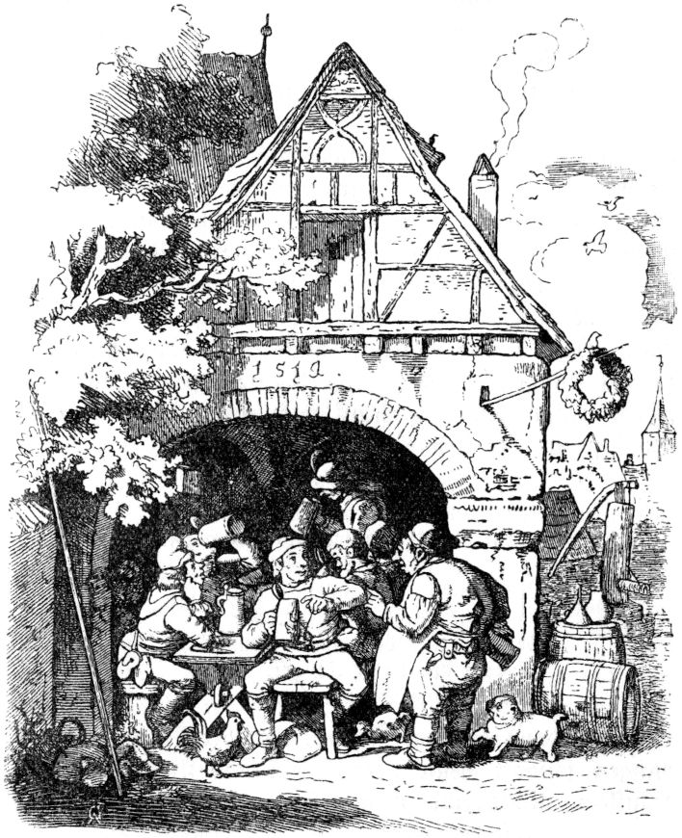He didn't feel warm in his heart, but quickly pulled off his cap and politely asked what she wanted. "Se wellet e bit is beer brobiere," said the Allgäu and walked 26thstraight to the carousel with the journeymen. Then it became clear to the landlord that the embassy with the skewer had been sent by the Swabian district government, as it happens at times, to taste the beer and to check whether it was worth the price. So I ran straight into the cellar and brought up a basket of the best that he brewed only for himself and his people. The basket was empty when we looked around, the second in even less time, and when the seven had drunk close to half a bucket in less than two hours, the landlord said he saw that they liked it. The Blitzschwab, however, who always had his mouth open, said: “It would be better if there wasn't a little malt and hops in it.” “That is not true,” replied the innkeeper, who was a rogue, “hops and there is not too little malt in it, but there is too much water.

In long salt, in long salt

(knows au meme amount hoiße, he said)

Braut mer drui beer from one malt

It seems like the core

Des drinket d 'Burgemoischter gladly,

Others think it is Mittelbier,

Des sets mer de gmoane Leud fir;

Third of all, Covent hopes

Drink di potz sapperment!

Then they all went for bass, and the landlord in Memmingen still swears stone and leg that the little heap was nothing else than the chief beer inspector of the Memmingen district.

“Uf sorrow follows freedom!” Said the Allgäu man, without considering that the wise little saying the other way round comes true far more often. It should now 27Once rain and sunshine almost always alternate on the adventurous journey of the seven journeymen, so it was no wonder that the poor bunch soon got caught in the ink again. It was still twirling and whirling in their heads from the overabundantly enjoyed Märzen beer, then their treacherous fate was waiting for them again. Just passed Kronburg when the stern Herr Junker was listening out the window. Might not seem very safe to him with the merry crowd, which even in appearance did not appear too reputable. So he called his henchman and said, "Look at the tramps over there - seems like a clean clan to me." The henchman took seven bullbiter with him, each big enough to fight a bear if necessary, and climbed up down, To hunt down the unfortunate Swabians. She soon overtook them, and since the Blitzschwab was snappy as always, the Haltmichfest made a short thing and took the little heap with him. The man from the Allgäu did not want to go along so easily, but when the dogs growled grimly, he lowered the spear with his ears at the same time and trotted behind them. They were all brought before the Junker von Kronburg, who began a strict interrogation. The Seehas acted as the spokesman for everyone and told them faithfully: How a terrible animal lives in the area around Lake Constance, and as good compatriots and honest men from all Swabian districts they would have come together to free the country from the monster. made the Haltmichfest short thing and took the heap with it. The man from the Allgäu did not want to go along so easily, but when the dogs growled grimly, he lowered the spear with his ears at the same time and trotted behind them. They were all brought before the Junker von Kronburg, who began a strict interrogation. The Seehas acted as the spokesman for everyone and told them faithfully: How a terrible animal lives in the area around Lake Constance, and as good compatriots and honest men from all Swabian districts they would have come together to free the country from the monster. made the Haltmichfest short thing and took the heap with it. The man from the Allgäu did not want to go along so easily, but when the dogs growled grimly, he lowered the spear with his ears at the same time and trotted behind them. They were all brought before the Junker von Kronburg, who began a strict interrogation. The Seehas acted as the spokesman for everyone and told them faithfully: How a terrible animal lives in the area around Lake Constance, and as good compatriots and honest men from all Swabian districts they would have come together to free the country from the monster. who began a strict interrogation. The Seehas acted as the spokesman for everyone and told them faithfully: How a terrible animal lives in the area around Lake Constance, and as good compatriots and honest men from all Swabian districts they would have come together to free the country from the monster. who began a strict interrogation. The Seehas acted as the spokesman for everyone and told them faithfully: How a terrible animal lives in the area around Lake Constance, and as good compatriots and honest men from all Swabian districts they would have come together to free the country from the monster.

But the Junker did not believe that, but stuck to his opinion that they were thugs and thieves and had them put in the house, that is, in prison.28

This is how it works in Schnitzlebutz Heusle,

Doh sing and dance the Meusle

And bark the snails in the hayloft -

the lightning swab sang in the house, but very quietly, like a mouse.

Only the day before, however, had the Junker made the laudable decision to found a penitentiary to frighten all crooks and day thieves, for the benefit and piety of the bourgeoisie and to enlighten the common people. The seven Swabians were just right for him. Otherwise he was a very pious and gentle gentleman, who even did not shear off more wool from his own peasants than he needed to clothe himself warmly. Therefore ordered that the prisoners should be given food as far as they needed it. But Spiegelschwab, who knew him well and knew that Schmalhans lived in his kitchen and cellar, laid out his plan on what he communicated to the journeymen. So when the henchman brought a large pan full of small dumplings, which they call milk spaetzle, at noon, said the Blitzschwab to the Knöpflessschwaben: “Die ghairet probably for di?” The Scherg said that was probably enough for everyone. But the Knöpflesschwab said he wanted to see if it would take long for him, sat down and ate the pan alone, so that not a crumb or crumb was left. The henchman was frightened and ran to the Junker, saying that one had to cook a whole brewing pan full of spaetzle at once for the tramps, and that, he thought, wasn't enough. Then the Junker went to and fro in Kronburg and said that he did not owe such a great sacrifice to the Swabian district and to humanity that he should be starved to death in his castle for a few so that not a crumb or crumb was left. The henchman was frightened and ran to the Junker, saying that one had to cook a whole brewing pan full of spaetzle at once for the tramps, and that, he thought, wasn't enough. Then the Junker went to and fro in Kronburg and said that he did not owe such a great sacrifice to the Swabian district and to humanity that he should be starved to death in his castle for a few so that not a crumb or crumb was left. The henchman was frightened and ran to the Junker, saying that one had to cook a whole brewing pan full of spaetzle at once for the tramps, and that, he thought, wasn't enough. Then the Junker went to and fro in Kronburg and said that he did not owe such a great sacrifice to the Swabian district and to humanity that he should be starved to death in his castle for a fewless rascals sake. They were straight 29Seven set free, only that the Junker gave them a profile to warn other authorities and dungeon servants dutifully against the Knöpflesswaben's great voraciousness.

After more than one other adventure that would be too much to tell, the Swabians came to a large lake, and then the Seehas, who recognized him right away, said: "This is the Bodesee." Dangerous monsters live, which the seven Swabians, as is well known, had firmly resolved to fight and kill. When they saw the lake and at the same time the forest in which the monster was staying, no one knew whether it was a horrible dragon or a dragon that breathed fire, so their hearts mostly fell in their pants, they stopped and lit a fire so that the Knöpflesschwab finally (because who could know whether the monster would not devour them all skin and hair, with or without a skewer) prepare a meal of Knöpfle or Spätzle, and contemplated death while they ate. “Joh,” said the man from the Allgäu and sighed right up from below, “it’s a real thing when you think about it that you’re having lunch for the last time in your life.” And again he sighed and said: "It's a real thing!" And the Knöpflesschwab began to whimper quietly to himself, although he did not forget to eat. But when the Allgäu sighed for the third time, very deeply, and said: “It's a real thing!” They all began to cry and howl so miserably that it could have pityed a wild heathen. The Nestelschwab alone did not let dying go to his heart; because, he said, my mother often told me that my little hour would never come. Howled "It's a real thing, if you really think about that for the last time in your life you'll have lunch." And again he sighed and said: "It's a real thing!" And the button swab began to be quiet to scream to himself, not forgetting to eat. But when the Allgäu sighed for the third time, very deeply, and said: “It's a real thing!” They all began to cry and howl so miserably that it could have pityed a wild heathen. The Nestelschwab alone did not let dying go to his heart; because, he said, my mother often told me that my little hour would never come. Howled "It's a real thing, if you really think about that for the last time in your life you'll have lunch." And again he sighed and said: "It's a real thing!" And the button swab began to be quiet to scream to himself, not forgetting to eat. But when the Allgäu sighed for the third time, very deeply, and said: “It's a real thing!” They all began to cry and howl so miserably that it could have pityed a wild heathen. The Nestelschwab alone did not let dying go to his heart; because, he said, my mother often told me that my little hour would never come. Howled to whimper quietly to himself, not forgetting to eat. But when the Allgäu sighed for the third time, very deeply, and said: “It's a real thing!” They all began to cry and howl so miserably that it could have pityed a wild heathen. The Nestelschwab alone did not let dying go to his heart; because, he said, my mother often told me that my little hour would never come. Howled to whimper quietly to himself, not forgetting to eat. But when the Allgäu sighed for the third time, very deeply, and said: “It's a real thing!” They all began to cry and howl so miserably that it could have pityed a wild heathen. The Nestelschwab alone did not let dying go to his heart; because, he said, my mother often told me that my little hour would never come. Howled that my hour would never come. Howled that my hour would never come. Howled 30thbut still with a good will to society. But when at last they could no longer do it, it occurred to them that it was time to arrange their battle; but there was all sorts of tension and discord. The man from the Allgäu said that he had always been in the lead up to now, it was time now that he was also the hauler, and the lightning bolt should go ahead. But he said: "Curasche han i gnueg em body, but no body gnueg for d 'Curasche and dehs Bescht von Ongheuer." The Spiegelschwab wiped his nose on his sleeve and made the suggestion that it should be better if one for everyone died and said the Knöpflesschwab could do them this little favor; but he shouted Zetermordio, as if the monster already had him sleeping. And so they talked and argued for a while, until they came to a peaceful agreement and hurriedly stepped forward with their spear, straight towards the forest where the monster was supposed to live. Before they reached it, they came to a rain forest in front of it, there sat a hare and made a man, and stretched its long spoons up into the air; The Swabians were horrible at that, so they stopped their pace, took advice and wondered whether they should move forward and step on the monster with a long spear stretched out, or whether they should turn to flee; but everyone held fast to the spit. Since Veitle was most of all in Numero Safe in the back, his crest swelled and he shouted to Schulzen, who was standing in front: there sat a hare and made a man, and stretched its long spoons up into the air; The Swabians were horrible at that, so they stopped their pace, took advice and wondered whether they should move forward and step on the monster with a long spear stretched out, or whether they should turn to flee; but everyone held fast to the spit. Since Veitle was most of all in Numero Safe in the back, his crest swelled and he shouted to Schulzen, who was standing in front: there sat a hare and made a man, and stretched its long spoons up into the air; The Swabians were horrible at that, so they stopped their pace, took advice and wondered whether they should move forward and step on the monster with a long spear stretched out, or whether they should turn to flee; but everyone held fast to the spit. Since Veitle was most of all in Numero Safe in the back, his crest swelled and he shouted to Schulzen, who was standing in front:

"Bump into äller Schwobe name,

So I wish that you would like to slacken! "

The Hans, the front man of Veitle Gehlfießler, Knöpflesschwab, mocked Veitle's Curasche by saying:31

"At the Element, you have a good chat,

You bite the Letscht when driving the dragon! "

The heartiness of Michel's hair stood on end, he did not look at the monster at all, but spoke with averted face, as he brought the sleeve closer to his face:

"There will be no shortage of a hoar,

So it is probably the devil! "

Jergle peered into Michel's face, and did not even look at the monster's hat, while he hesitantly agreed:

"Lightning! if he doesn't do it, so be it mother,

Or be the devil's step-brother! "

Marle Nestelschwab, who was already quite far in front of the spit, where the Swabians were walking, did not like his place, and he had a good idea; He also turned around, since he did not find it necessary to look at the monster, and called to Vitus:

"Gang, Veitle, gang, walk ahead,

I will dohente for di stahn! "

Veitle, however, opened his ears and pretended not to hear, whereupon the Marle said to Jockele:

"Gang, Jockele, gang, walk ahead,

You suspect spur and boot,

That the dragon does n't bite! "

But Jockele found his consolation in the fact that the Allgäu was at the head of the spit of the seven Swabians and the adventure to be had, and said:

"Schulz, he must be the first,

Because he deserves honor alone. "

Schulz Allgäuer took heart and spoke courageously, since it was now in the inevitable danger:

"So go heartily into the dispute,

Dohran recognizes mer brave people. "

32

And so, in God's name, the monster was attacked at a rapid pace, and when Schulzen's heart pounded, he could not help his fear and shouted: “Hau, huelhau! Hau, hauhau! ”Then the hare was frightened and gave a spur-of-the-moment heel money across the country, and ran what he could run. Now Schulz Allgäuer said happily:

“Potz Veitle, luag, luag, what's that?

There is no hate! "

"Hoschts see? Hoschts gsehe? ”The others asked each other. "Hotz Blitz! A thing like a calf! ”Cried the lightning swab. The nestling swab did his greatest curse: “With all due respect! That you bite Meusle! E animal like a mastoch! ”“ Oho! ”Shouted the Knöpflesschwab:“ An elephant is noh katz against the Ohntier. ”“ Bygott! ”Replied the Allgäu,“ if the koa has ache, noh woiss i the three-man white from Revenge user net z 'difference! "

“Noh, Noh!” Conveyed the Seehas: “Have it! Has hen! A sea hare is just bigger and grumpier than every hare in the holy remic realm. ”“ As the sea white more dear and bitter than all white in the holy remic realm, ”said the crescent at the back, and the sea hare almost had a couple of waddles about this suggestiveness given, for it offended him seriously that Veitle mocked the lake wine which he liked from childhood. But it is the same with the lake wines: there are three kinds of them, first of all the sorrel, tastes only a little better than vinegar and only warps the mouth a little, especially when one has got used to it. The second type is called three men’s wine, tastes ten degrees below vinegar and was baptized that way because it is said that whoever condemns it to drink it is held by two 33must be while a third pours it. The third type is the throat cleaner, has the praiseworthy quality that it removes mucus and everything else, but it is necessary that whoever goes to sleep with the wine in his body should be woken up at night so that he may turn around, otherwise the throat cleaner wants to eat a hole in his stomach.

Now that the adventure with the monster was so successfully passed by the seven Swabians, they became one, 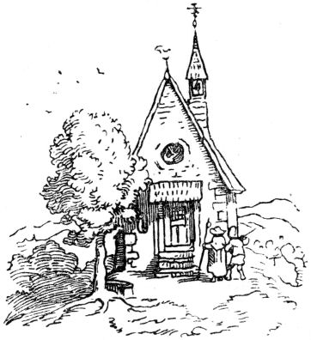now to rest from their deeds and return home peacefully. Before that, however, it was necessary to erect a sign of victory that would announce its triumph to the world around us and posterity for eternity. Since it was now impossible, as brave knights did before times, to hang up the dragon's skin in a church, while no dragon had carried its hide to the market and the hare in its hide safely escaped, the good journeymen became one, their bearskin and their spear to donate a trophy to the nearest chapel, which was then called the Chapel of the Swabian Savior. The spear will probably still hang there, but the moths have eaten the bearskin, and the sparrows have carried their hair into their nests.

34

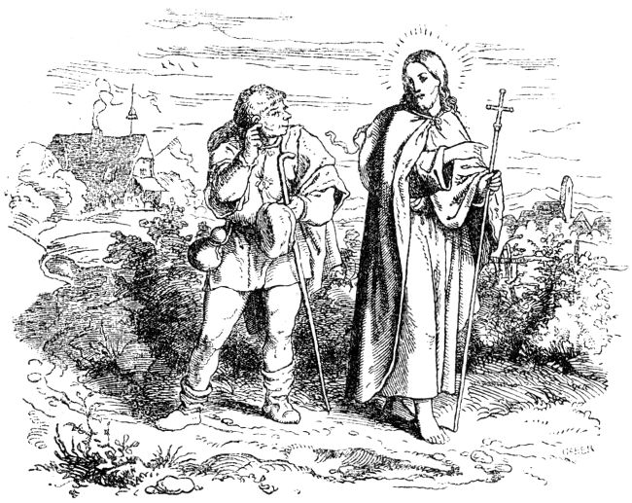

**From the Swabian who ate the liver.**

When our dear Lord and Savior was still walking on earth, from one city to another, preaching the gospel and doing many signs, a good, simple-minded Schwab came to him for a time and asked him: “My fellow sufferer, where are you going? “Our Lord answered him:“ I will move and save the people. ”So the Schwab said:“ Do you want to leave me with you? ”-“ Yes, ”answered our Lord,“ if you want to be pious and gracious pray. ”That said the Schwab. As they were walking together, they came between two villages, in which one rang the bell. The Schwab, who liked to chat, asked our Lord God: “My fellow sufferer, what do you ring?” Our Savior, to everyone 35Knowing things, replied: "In one village you ring the bell for a wedding, in the other to celebrate a dead person." - "Go to the dead!" Said the Schwab, "I will go to the wedding."

Our Lord God then went into the village and brought the dead back to life, and they gave him a hundred guilders. The Schwab changed his clothes at the wedding, helped pour, one guest after the other, and also himself, and when the wedding was over he was given a cruiser. Schwab was probably satisfied with that, set off and came back to our Lord God. As soon as the Schwab saw him from afar, he lifted his little cruiser and shouted: “Lie, my fellow sufferer! I have money; what is the matter with you? "So drove a lot of boasting with his little cruiser. Our Lord laughed at him and said: "Oh, I have more than you!" Opened the sack and let the Swabians see the hundred guilders. But he was not uncomfortable, quickly threw his poor little cruiser under the hundred guilders, and shouted: “Common, common!

Now, as they were walking on together, it happened that they came to a flock of sheep, so our Lord God said to the Swabian: “Go, Swab, to the shepherd, tell him to give us a lamb and cook the hanger or noise for us to a meal. ”-“ Yes! ”said the Schwab, did as the Lord told him to do, went to the shepherd, asked for a lamb, took it off and prepared the hanger for eating. And when it was boiling, the little liver always swam up; the Schwab presses it under with a spoon, but it wouldn't stay down, that annoyed the Swabian beyond measure. Took 36therefore a knife, cut the liver while it was done, and ate it. And when the food came on the table, our Lord asked where the liver had gone? But the Schwab was immediately at hand with the answer that the little lamb had none. “Oh!” Said our Lord, “how would it have lived without a liver?” Then the Schwab conspired high and dear: 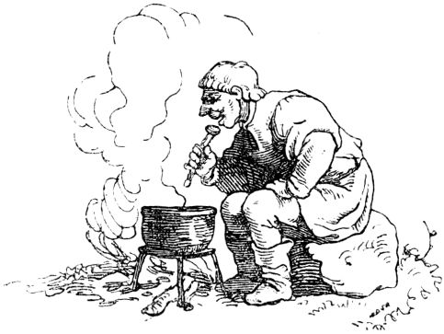“There was none with God and all God's saints!” What did our Lord God want to do? If he wanted the Schwab to remain silent, he must be satisfied.

Now it happened that they were walking together again, and then the bell rang again in two villages. The Schwab asked: "Dear, what do you ring the bell?" - "In one village you ring the bell for a dead person, in the other for a wedding," said our Lord God. “Well!” Said the Schwab. "Now you're going to the wedding, so I want to go to the dead!" (Thought he also wanted to earn a hundred guilders). Further asked the Lord: “Dear, how did you do that you raised the dead?” - “Yes,” answered the Lord, “I said to him, get up 37Names of the Father, Son and Holy Spirit! Then he got up. ”-“ All right, all right! ”Cried the Schwab,“ now I know how to do it! ”And went to the village, where the dead were carried to him. When the Schwab saw this, he called out in a clear voice: “Stop there! Stop there! I want to bring it to life, and if I do not bring it to life, then hang me without judgment or justice. "

The good people were happy, promised the Swabian a hundred guilders, and put down the bier on which the dead man lay. The Schwab opened the coffin and began to speak: "Stand up in the name of the Holy Trinity!" But the dead person did not want to get up. The Swabian was frightened, he spoke his blessing the second and third time, but when the dead man did not rise, he cried out angrily: "Well, stay in a thousand devil names!" When the people heard this ungodly speech, and saw that they had been betrayed by the dude, they left the coffin, grabbed the Swabian and soon hurried with him to the gallows, threw the ladder and led the Swabian up.

Our Lord God slowly pulled up his street, knowing very well how the Swabian would fare, wanted to see how he would fare, came to the court and cried: “O good fellow, what have you done? In what form do I see you? ”The Schwab was wild as a flash and began to scold that the Lord had not taught him the blessing correctly. “I have taught you right,” said the Lord. “But you have not learned and done it correctly, but be as it will. If you want to tell me where the little liver has gone, I will take care of you! ”-“ Oh! ”Said the Schwab,“ the little lamb really had no liver! Wes draw 38you me? ”-“ Oh, you just don't want to say it! ”said the Lord. “Well, confess it, that's how I want to bring the dead to life!” But the Schwab began to scream: “Hang me, hang me! So I come from the torture. He wants to force me with the little liver, and yet hears well that the lamb had no liver! Hang me straight and quickly! "

When our Lord God heard this, that the Schwab would rather be hanged than admit the truth, he ordered him to be lowered and now brought the dead to life himself.

When they left together again, our Lord God said to the Swabian: "Come here, we want to share the money we have won, and then part ways, because if I had to kill you from the gallows everywhere and everywhere, that would be too much for me." So took the two hundred guilders and divided them into three parts. As such the Schwab saw, he asked: “Well, dear, why are you making three parts when ours are only two?” - “Yes,” answered our dear Lord God, “the one part is mine; the other part is yours, and the third part is the one who ate the liver! ”When the Schwab heard this, he exclaimed cheerfully:“ So I ate it with God and all God's dear saints Said it and also crossed out the third part, and thus took leave of our dear Lord God.

39

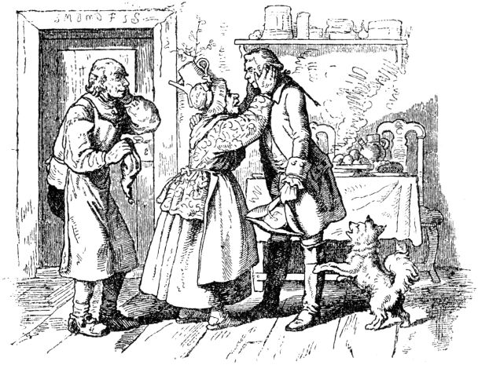

**The master thief's specimens.**

In a village a couple of very poor old people lived all alone in a small house that stood very far outside, and the village ended with this little house. The two old people were good and hardworking, but they had no children. They had had one son, only one, but he had been a stray boy, and he had secretly walked up and away, had never seen or heard from him again during his lifetime, and so the two old men believed that their only one had been dead for a long time in good hands with God.

Now the two old men were once sitting at their doorstep, on a holiday, when a stately wagon drove into the village, pulled by six beautiful horses, and in it sat a single gentleman, with a servant standing in the back, whose hat and coat were only made of gold and silver so stared. 40The carriage drove through the whole village, and the little peasants who had just come out of the church almost thought that a duke or even a king was passing by, because the nobleman who lived upstairs in the old castle could not afford such splendor. Suddenly the carriage stopped in front of the last little house, the servant jumped from the box and opened the door for the gentleman seated in it, who got out and hurried towards the two old men, who had got up from their bench in astonishment. He offered them a friendly hello and a handshake and asked if he could have a dish of potato hats (dumplings) with them? The little mother was most astonished at this, but the young, handsome and very elegantly dressed gentleman immediately satisfied her astonishment by saying that no cook had yet been able to please him with this hat, he wanted to eat them once prepared by country folk, as in his youth. The old people kindly invited the noble Junker, whom they took the stranger to be, into their hut, and he let the carriage with the coachman and servants drive into the tavern for the time being. The mother hurriedly fetched potatoes from the little cellar of the little house, peeled them, rubbed them and pressed them, boiled the water, put in the dumplings, to which she added a little lard, and blessed this meal with the pious saying: "God forbid es, “of which the dumplings in many places in southern Thuringia are called hats. During this time that the old woman was preparing her meal, her husband had gone with the stranger into the little garden, where he was doing a little activity on the young trees that had been planted recently, and checked whether the stakes, 41Old each stem tight again. Then the young stranger began to ask: "Why do you tie this little trunk three times?" - "Yes!" Said the old man, "it has three bends, that's why I tie it so that it just grows." That's right, old man! ”Said the stranger; “But there you have an old, crooked Knorz von Baum! Why don't you tie it to a pole so that it becomes straight? ”-“ Hoho! ”Laughed the old man,“ old trees, if they are crooked, will not straighten again. If you want them straight, you have to pull them well when they are young. ”-“ Do you have children too? ”The stranger asked further. “Oh dear God, Your Grace!” Replied the man, “I had a boy, was an erzer useless person, did wild, nasty pranks, and in the end I ran away and never came back for the rest of his life. Who knows, where the good Lord has led him, or the evil one. ”-“ Why didn't you pull your son straight in time like this one, your little trees! ”said the stranger sadly and reproachfully. “If he has become an unwanted crooked Knorz and wildling, it's your fault. But if he came under your eyes again, would you recognize him? ”-“ Don't know either, dear sir! ”Replied the farmer,“ he will probably have shot up if he was still alive, but he had a birthmark on the body, at best I could know him on it. But he won't come home again until never more than a day. ”Then the stranger took off his coat and showed the old man a birthmark; he clapped his hands over his head and shouted: “Mr. Jes's! You are my son - but no - you are so terribly courteous. Have you become a count 42Son softly, "but a little different, I became a rascal because you didn't pull me straight, but leave it alone, I've studied my art well, I'm not such a miserable bungler as there are many of you."

The old man was quite dumb with shock and joy, led the son by the hand into the house and to his mother, who had just finished the dumplings and served them, and told her everything. Then the little mother fell on her son's heart and neck, kissed him and wept and said: “Thief here, thief here! You are my dear son, whom I carried under my heart, and my heart leaps high in my chest that I saw you again in my old days! Oh, what will your godfather say, the nobleman up at the castle! ”-“ Yes! ”Said the father in between, while all three were now bravely chopping into the dumplings together,“ your godfather won't want to know anything about you, by as skillful circumstances as you are; in the end he will let you wriggle on the light gallows. ”-“ Well, I want to visit him, the godfather!

The nobleman was very pleased to see his godfather, whom he had given as a poor child by grace to be baptized, so stately again as he revealed himself to him. But he was not in the least happy about that, when when asked what he had become in the world, the young godfather replied that he had become a trained rascal. Immediately think about how he would like to get rid of such a dangerous person in times of good quality.

Said the nobleman to his godfather, 43“We want to see whether you have learned your skills properly and have become such a big thief who can be let go with honors, or just such a little one who is hung on the first best gallows. The latter I will do infallibly with you under my spell if you do not pass the three tests that I will impose on you! ”-“ Just bring it on, strict Mr. Godfather! I am not afraid of any work. "

The nobleman thought about it for a little while, then said: “Listen! These are the three samples. First of all: steal my body horse from the stable, which I will probably have soldiers and stable men guarded, who kill anyone who makes an appearance to force their way into the stable. On the other hand, when I'm in bed with my wife, steal the sheet from under my body and my wife's wedding ring from my finger, but know that I have loaded pistols at hand. For the third and last - and notice, this is the hardest part: steal the pastor and schoolmaster from the church and hang them both alive in a sack in my chimney. The gate and doors in the castle should be open to you. "

The master thief thanked his godfather in a friendly manner for giving him such easy little pieces, and went on his way to do the first piece the next night. The nobleman made every effort to have his horse carefully guarded. His first groom had to sit on it, another servant had to hold the bridle, a third the tail, and the master ordered a soldier's watch in front of the door. They watched and watched, froze and cursed, because it was cold and everyone was thirsty; an old, tired mother showed up, she was carrying a keg on a basket, coughing heavily and panting into the courtyard of the palace. The little vessel 44aroused particularly attractive thoughts in the soldiers' souls, namely that there might be brandy in it, and that brandy was a specific against the night frost and against the evil mists. So the old mothers called to the fire to warm up, and looked for the contents of the little vessel. Rightly foreshadowed! There was brandy in it, and more refined, double bitter oranges, bitter Spanish or something like that. 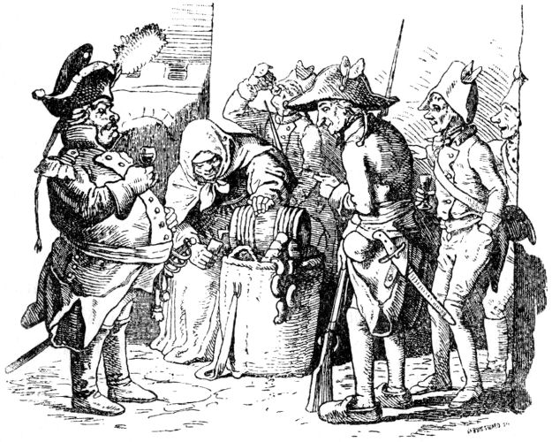Also, the keg was not treacherously pledged and bungled, but there was a little cock on it, and the woman had, that was the best thing, to sell the brandy. The soldiers bought one cup after the other, and called out to the guards in the stable that the wheat was blooming outside in the courtyard, and the old woman had her hands full with pouring cups, so that her keg was almost empty. But the old woman was no other person than the arch thief, who was good 45disguised and mixed a barbaric sleeping potion into the schnapps. It didn't take long before one soldier after another fell asleep and the eyes of the guards in the stable also fell, and it was good that the thief was already standing in the stable with the horse, so he could hold the groom in his arms catch it when it just fell from the horse, and sit it gently astride the barrier and tie a little so that the good person doesn't fall down there and suffer damage. 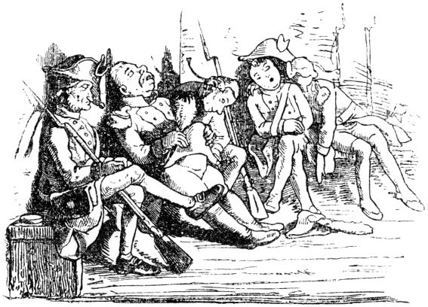The thief lent a rope in the hand of the body coach, who was holding the bridle and snoring in the corner, and the groom a straw rope instead of the horse's tail. Then he took a horse blanket, cut it into pieces, wrapped it around the horse's feet, swung himself into the saddle, and heidi, didn't you see - out of the stable and the open castle gate.

When it was daylight, the nobleman looked out of the window and saw a stately rider come galloping along, on a no less stately one 46Horse that looked so familiar to him. The rider stopped and offered good morning to the castle window. “Good morning, godfather! Your horse is worth gold! ”-“ Oh, all the devils! ”Cried the nobleman when he saw that the horse was his piebald. 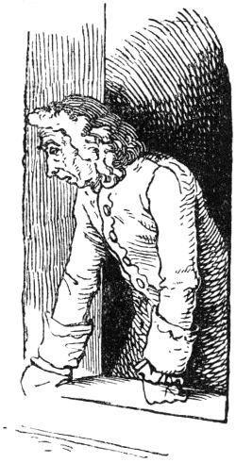“You are a fun thief! Well, well - go ahead! Let your art continue to be seen! ”The nobleman took his riding crop and went to the stable full of anger; but when he saw the strange groups of guards still sleeping, he had to laugh out loud; but soon thought in his heart: if the crook comes tonight to steal my sheet, I'll shoot him in the head, because I don't want to have such a dangerous guy around me.

Now that the night had come, the nobleman lay down in bed with his wife, and next to him he laid a loaded pistol and various other weapons and weapons, did not fall asleep either, but remained vigilant, listening and listening to make sure nothing was moving. For a long time everything remained quiet, now at last, it was already quite dark, it was as if a long ladder was propped against it, and soon afterwards the figure of a person who wanted to climb in became visible outside the window. "Don't be startled, woman!" The nobleman shouted softly, took the pistol, aimed well, released the trigger, and shot the robber right through the head, he staggered, and immediately afterwards a serious fall could be heard downstairs. “He won't get up again,” said the nobleman, “but I would like to avoid a stir, me 47I will therefore quickly go down the ladder so that there is no noise in the house, and move the man who had been shot aside. ”That was fine with the noblewoman, and her husband did as he said. Soon afterwards he came up again and said to the woman: “He is very dead; But I want to wrap the poor devil in a sheet before I throw him into the pit, and since he had to give up his life for your ring, we want to infect him; give me the ring and the sheet too. ”The woman gave both, and the latter hurried down again. But it was not the nobleman, but the master thief who, in order to carry out his little piece, had cut off a freshly hanged man from the first best gallows (at that time there were still many gallows in Germany) and then loaded him on his shoulders when he did Climbed the ladder. As soon as the shot rang inside, he dropped the corpse, hurried down the ladder, and hid. And when the nobleman came downstairs and dealt with the supposedly shot man, he swiftly wiped up into the woman's room, imitated the godfather's voice and asked for a ring and sheet.

The next morning the nobleman looked out of the window again, as was his custom, and there was a man pacing up and down below who, it seemed, had canvas for sale, at least he was carrying a folded bundle over his shoulder, and left a beautiful ring in it the morning sun flashes and sparkles. Suddenly the man called up: “Good morning, Mr. Godfather! I wish you and your godmother to have rested very well! ”- The nobleman was thunderous when he shot his godfather, whom he shot the previous night with his own hand 48Thrown into a pit with the same hand, saw standing in person, and hastily asked his wife for a ring and a shawl. "Well, you asked me to do it this night!" Replied the lady. “Satan! But I don't! ”Raged the nobleman - but he soon gave himself up, considering that the daring thief could have taken still more. He put a fist out of the window for the godfather and called out: “Arch crook! The third! The third will certainly bring you to the gallows! "

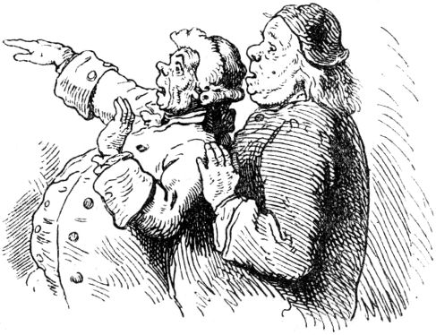

The next night something strange happened in the churchyard. The schoolmaster, who initially lived there, first became aware of it and reported it to the pastor. Small, burning lights wandered around in unsteady motion above the graves. "These are the poor souls, schoolmaster!" Whispered the pastor with horror. Suddenly a large black figure appeared on the steps of the church door, which called out in a hollow tone:

Everyone comes to me, everyone comes to me

Judgment day is just around the corner!

O children of men, pray in silence!

49

The dead are already collecting their bones!

Who wants to go to heaven with me

He'll crawl into this sack!

"Shall we?" The schoolmaster asked the pastor with a clatter of teeth. "It would be time before the gate closes. The holy apostle Peter is calling us, there is no question. But travel money? ”-“ I inherited twenty crowns, ”whispered the schoolmaster. "I have put a hundred dicket tonnes (leaf thaler) aside for an emergency!" Said the pastor. "Let's get it and take it with us!" Both shouted and did so, then they approached the black figure with fear and trembling. This was the master thief; he had bought crabs and stuck burning wax lights on their backs, they were the poor souls, had a monk's beard and a monk's robe, and a hop sack in which he put the two black coats after he had taken away their savings. Now he tied up the sack and dragged it behind him through the village and through a pool, shouting: “Now it's through the Red Sea!”, Then through the stream: “Now it's through the Kidron stream!”, Then through the castle hallway, where it was cool: “Now it's through the Josaphat valley!”, then up to the stairs: “This is the ladder to heaven!” Finally he hung the sack on a hook in the chimney, on which the ham is being smoked , made quite a bit of smoke underneath and called out in a terrible voice: “This is purgatory! This will take a few years! ”And went away. The pastor and schoolmaster Zetermordio shouted that the whole house was running together. The master thief, however, came up to the nobleman cheerfully: “Mr. Godfather, my third sample has also been solved. Pastors and schoolmasters hang in the chimney, 50you can see them fidgeting and screaming yourself! ”-“ O you arch scoundrel and arch villain, you arch villain and master thief of all master thieves! ”cried the nobleman and immediately gave orders to deliver them from purgatory. “You have overcome me, get out of here! Here you have a piece of gold. Get out of here, don't come back to my eyes, and let yourself be hung for your money where it suits you. "

“Thank you to the most beautiful, strict Mr. Godfather, and I want to pretend!” Replied the rascal, “but don't you want to redeem the pledges that I have honestly acquired? Your body horse with two hundred crowns, your wife's wedding ring and the cloth with one hundred crowns, the priest and schoolmaster's money with one hundred and twenty crowns! If not, I'll drive away with it. ”The nobleman was almost touched by the blow; he said: “Dear godfather, it was all just joke, you will not want to keep these goods in yourself; I am giving you my life. ”“ Well, I will go and bring all of these things to you! ”said the master thief; went and had his carriage harnessed, put his old father and mother in it, sat himself on the nobleman's horse,The submissive godfather and master thief. "

Then the nobleman became very afraid, suffered the damage and did not want to know anything more about his godfather, nor did he learn anything more from him, because he had moved with his parents to a distant country and had become an honest and respected man.

51

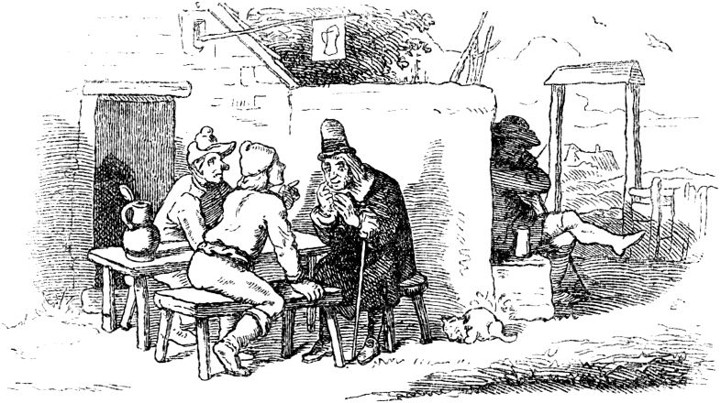

**The enchanted princess.**

Once upon a time there was a poor craftsman who had two sons, a good one called Hans and an evil one called Helmerich. But how that goes in the world, the father loved the bad more than the good.

Now it happened that the year was once a more expensive one than usual, and the master's purse was empty. Egg! he thought, one must know how to live. If the customers have come to you so often, now it is up to you to be polite and make an effort to meet them. Said and done. He moved out early in the morning and knocked on many a stately door; but as it happens that the most stately gentlemen are not the best payers, no one wanted to pay the bill. So the craftsman came to his home in the evening, tired and weary, and sadly sat down in front of the door of the tavern 52all alone, because he neither had the heart to chat with the drinking guests, nor was he looking forward to the long face of his wife. But as he sat lost in thought, he couldn't help but listen to the conversation that was being held inside. A stranger, who had just arrived from the capital, said that the beautiful king's daughter had been imprisoned by an evil magician and had to stay in dungeon for her entire life. 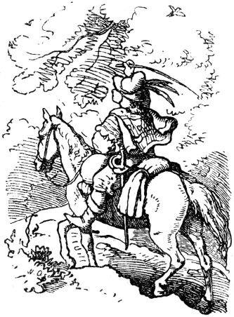unless someone could be found to solve the three tests the wizard had set. But if one were found, the princess would be his and her whole splendid castle with all its treasures. The master listened to that, first with half an ear, then with the whole thing and finally with both of them, because he thought: my son Helmerich is a bright head who would like to bar the billy goat if one of them asked him to; what's the matter, he solves the trials and becomes the husband of the beautiful princess and master of the country and its people. For so the king had proclaimed her father. He returned home quickly and forgot his debts and customers over the new fairy tale which he hastily told his wife. The next morning he said to Helmerich that he would equip him with horse and armor for the journey, and how quickly he set off on his journey! When he said goodbye, he promised his parents that he wanted them and his stupid brother 53Have Hans fetched in a six-horse carriage; because he already thought he was king. As cocky as he went, he let go of his mischief on everything that came in his way. The birds that sat on the branches and praised the Lord God with song, as they understood it, he shooed off the branches with his whip and no animal came in his way that he had not left out his jokes. And first of all he met an anthill; He had his horse trampled on him, and the ants, which crawled angrily on his horse and himself and bit horse and man, he killed and crushed them all. Next he came to a clear pond in which twelve ducks were swimming. Helmerich lured them to the bank and killed eleven of them, only the twelfth escaped. At last he also met a beautiful beehive; then he made it to the bees as he did to the ants. And so was his joy in plaguing and destroying the innocent creature, not for his own benefit, but out of sheer malice.

When Helmerich had reached the splendid castle with the sun setting, in which the princess was enchanted, he knocked violently on the closed gate. Everything was quiet; the rider pounded harder and harder. At last a sliding window opened and an old mother with a cobweb-colored face looked out of it and asked morosely what he wanted. "I want to redeem the princess," cried Helmerich, "quickly open up for me." "Hurry for a while, my son," said the old woman; "Tomorrow is a day too, I'll be waiting for you here at nine o'clock." With that she closed the switch.

The next morning at nine o'clock, when Helmerich reappeared, the little mother was already waiting for him with a vessel full of linseed, which she scattered 54on a beautiful meadow. “Read the grains together,” she said to the rider, “I'll be back in an hour, the work must be done.” - But Helmerich thought that was silly joke and that it wasn't worth bending over; meanwhile he went for a walk and when the old woman came back the keg was as empty as before. "That's not good," she said. Then she took twelve golden keys out of her pocket and threw them one by one into the deep, dark pond of the castle. "Get the keys up," she said, "I'll be back in an hour, the work must be done." Helmerich laughed and did as before. - When the old woman came back and this task was not solved either, she called twice: “Not good! Not good! ”But she took his hand and led him up the stairs into the great hall of the castle; there were three pictures of women all three covered in thick veils. “Choose, my son,” said the old woman, “but be careful that you choose rightly. I'll be back in an hour. ”Helmerich was no wiser when she came back than when she went away; high-spirited, however, he called out at random: "I will choose the one on the right." Then all three threw back their veils; in the middle sat the lovely princess, right and left two hideous dragons, and the one on the right grabbed Helmerich in his claws and threw him through the window into the deep abyss.

A year had passed since Helmerich went out to redeem the princess, and still no six-horse carriage had arrived at the parents' house. "Oh!" Said the father, "if only clumsy Hans had moved out instead of our best boy, the misfortune would be less." - "Father," said Hans, "let me go, I will try it too." But father didn't want to, because what 55if the clever one fails, how did the clumsy bring it to an end? Since his father denied him horse and military, Hans got up secretly and hiked for three days the same way on foot that his brother had ridden on one. But he was not afraid, and slept at night on the soft moss under the green branches as gently as under his parents' roof; the birds of the forest did not shy away from him, but sang him asleep with their best sages. 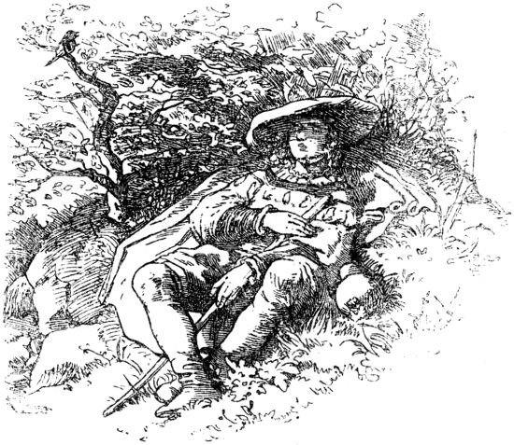When he came to the ants that were busy completing their new burrow, he did not disturb them, but wanted to help them, and he read the little animals that crawled up on him without killing them, even if they bit him . He also lured the ducks to the bank, but to feed them with crumbs; He threw the bees the fresh flowers that he had picked along the way. So he came happily to the royal palace and knocked modestly at the counter. The door opened immediately and the old woman asked what he wanted. "If I don't 56"I should like to try to redeem the beautiful princess," he said. “Try it, my son,” said the old woman, “but if you fail the three rehearsals it will cost your life.” “Well, mothers,” said Hans, “say what I should do.” Now the old woman gave the flaxseed sample. Hans was not lazy to stoop, but it was already three-quarters and the keg was not yet half full. He almost wanted to despair; but all of a sudden black cameAnts more than enough and in a few minutes there wasn't a grain left on the meadow. When the old woman came she said: “That's good!” And threw the twelve keys into the pond, which he was supposed to get out in an hour. But Hans did not bring a key from the depths; As deep as he dived, he never got to the bottom. Desperate he sat down on the bank; then the twelve ducks swam up, each with a golden key in its beak, which they threw into the damp grass. So this test was also solved when the old woman came back to lead him into the hall, where the third and most difficult test awaited him. Hans looked desperately at the three identical veiled figures; who should help him here? A swarm of bees flew through the open window, circled through the hall and hummed around the mouth of the three veiled people. But they flew back quickly from right and left, because the dragons smelled of pitch and sulfur, on which they live; They all circled the figure in the middle and whirred and whirred softly: “The middle, the middle.” Because the smell of her own honey, which the king's daughter loved to eat, smelled against them. So, when the old woman came back after an hour, Hans said very confidently: “I'll choose the middle one.” And then the evil dragons drove out of the window, but the beautiful king's daughter threw 57off her veil and rejoiced at the redemption and her beautiful bridegroom. And Hans sent the prince's father the fastest messenger and to his parents a golden chariot drawn by six horses, and they all lived gloriously and happily, and if they have not died they are still alive today.

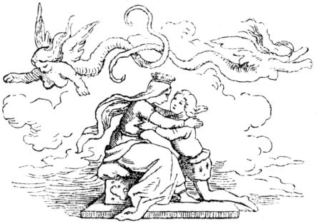

**The devil is loose  
or  
the fairy tale how the devil invented brandy.**

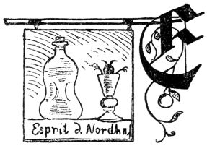

s once two sovereigns had a border dispute; there were witnesses on each side who asserted the right, and among them were two who had learned the black art from the devil and dedicated their souls to him for it.

These two have once each and every night want to set false landmarks, just like each of them 58the border claimed and wanted the stones with black art to make them look as if they had been there for many, many years. The two of them went up to the heights as fiery men. And as one comes up, the other is already there. But neither knew anything about the other that they had the same thought.

Then one asked the other: "What are you doing?"

"" What do you have to ask about it? Tell me beforehand what you want to do there? ""

"I want to set boundary stones, and I want to make the border move as it should actually be."

"" I've already done that myself, and there are the stones, and that's how the border move goes. ""

“That is not right, and so goes the border move. My master said I was right and I shouldn't give in. "

"" Who is your master? That will also be a nice Musjö! ""

“The devil is my lord! Do you have respect now? "

"" That is not true, this is my lord, and my lord told me that I am right and should not give in. Grab the moment or you will feel bad! ""

And so the two came one behind the other, and at last one fiery man gave the other a cuff so that his head flew down and rolled down the whole mountain. And the fiery man without a head ran after his fiery head and wanted to grab him and sit him up again. But he couldn't catch up with him all the way down in the ditch.

When one of them had given the other the cuff, and the other was running behind his head, it came up 59once a third fiery man joined him and asked the one who stayed upstairs: "What have you been doing there?"

"" What is it to do with you and what do you have to order me? The moment grab your way, or I'll do it for you just like that. ""

"Scoundrel! Don't you have more respect for me Don't you know that I am your master, the devil? "

““ And if you are ten times the devil yourself, it doesn't matter to me at all; you can clean me up pretty nicely because of me! ""

"I want to do you this favor, but you should remember it for the rest of your life!"

And then the devil began and made him clean so that the fire-cleaning equipment flew all over the ridge.

But when he made it so clean, my ardent husband saw the opportune moment and reached out and caught the devil in the neck, held him tight and said to him:

“Now you are in my power; now you should see that you are in the hands of people ! You have turned the necks of poor people enough in your life, now you should experience for yourself what it is like when someone's neck is turned! "

And started and wanted to turn the devil's neck. When the devil saw that the fiery man was serious about him, he lay down at the request and gave him the best words to say that he should let him go and not turn his neck; he also wanted to do everything he asked of him. Then he said: “Because you are acting so poorly, I just want to let you go; But first you have to give me back my prescription, in which I have written my soul to you, and you have to promise me, yes, you have to swear that to your grandmother that you have no part 60want to have more in me, even for all your days of life, don't let anyone prescribe your soul to you again. "

If the devil wanted for better or for worse, he was stuck in a tight spot, and if he wanted to get away and didn't want to have turned his neck, he had to bite into a sour apple, and gave him his prescription again and promised him and conspired with his Grandmother, that he no longer wanted to have a part in him, and also did not want to let anyone re-write his soul for all his day of life. As he had done all of this, the latter let go of the devil.

But when the devil was single again, he jumped back so that the latter would not catch him suddenly again, and stood up and said: “Well, now I'm single again; if I have now given you my prescription, you jerk, and have promised and sworn to you that I do not want to have any more part in you, then I have not promised you that I will not turn your neck around too, if I do would be single again. And on that spot you should always die, for gargling me and wanting to turn my neck! "

And with that the devil drove into him and wanted to finish him off, but he ran away and ran into the forest. And the devil is always after him. At last he saw it and came to an old beech tree that was hollow and had a hole at the bottom. Then he crawled in quickly and wanted to hide from the devil. But he hadn't crawled in far enough and his toe was still sticking out. And because he was fiery over and over, the toe shone through the night, and the devil saw where he was hiding, and came and wanted to catch him on the toe.61

But the one in his tree heard how the devil came trapped, how he wanted to reach for him and catch him; then he pulled himself in completely and continued up the tree. Then the devil crept in too, and that one kept going up in the tree and the devil always following him. At last there the tree had a wide knothole up in the air, and that one came up and crawled out. And as he was outside, he took something and wedged the knothole where he had crawled out, and quickly descended and wedged the lower hole too, and made it so tight with black art that it was the devil himself and his grandmother and them Couldn't bring up whole hell again. Then he went his way.

And now the devil was stuck in the old book and couldn't get out, and nothing helped him, he had to get stuck in it. And there he was in it for a long time, and many times at that time, when people were walking the road over that mountain, they heard him bleating and grunting in his book. But finally, when the logging came up there, the beech was cut down. Then he finally came out again and became free again, the devil. When he got going again, he got up and went home to hell and wanted to see what it looked like? But everything was empty in it, as it is in church during the week, and there was no soul to be heard or seen. Since the devil had left and never came back, and no one hadn't known where he had gone, not a single soul had come back to hell. And then his grandmother died of heartache, and when she was dead, everyone grabbed the poor 62Souls who were in hell at that time rose and got up and away and all went to heaven together. And there he stood, mouse-mother-star-alone in hell, and because of his suffering he had no advice on how to begin it, that he would have poor souls again because he was no longer allowed to do it, and he had it with his grandmother at the time have to conspire that he would not let anyone prescribe his soul again, 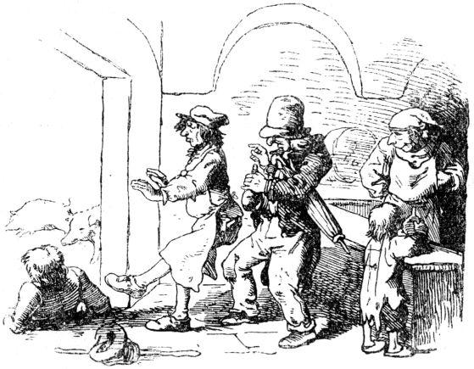and in any other way he did not get people to hell then. And there he stood and knew no end of his heartache, and wanted to pull the horns out of his head for sheer heartache and misery. - Suddenly something occurred to him.

How he had stuck in the old book and couldn't figure it out had finally become long for him, and then he had simulated all sorts of things and thought up and invented the brandy. In the midst of his heartache he always remembered that, and then he thought to himself that it must be a means of getting poor souls back to hell.63

And then he packed up on the spot and let hell be hell, and went to Nordhausen and became a schnapps distiller and made brandy on and on and poured it into the world. And he also showed everyone in the north how the schnapps is made, and promised them a lot of money and good if they learned it and made brandy. And the northern houses did not have to be told twice either, and they all became schnapps distillers and made brandy and poured it into the world. Since that time it has been written that to this day so much brandy is distilled in Nordhausen as in no other place in the whole world.

But as the devil had thought it was okay. When people had a little brandy in their bodies, they began to curse and swear, and cursed and swore their souls to the devil that the devil got them when they died and therefore did not have to serve them, how otherwise he had to do if he wanted a poor soul. And when they had really drunk their heads in the brandy, they started quarreling and fighting and breaking their own necks so that the devil didn't have to bother and turn them around. And if the devil was otherwise able to get a poor soul into hell once every week with all the trouble and trouble, then they came in shock by the dozen every day, and it did not last a year,

And in short, since the devil of the old beech 64that time got loose again, since that time the brandy has appeared, and since the brandy has been in the world, one can really really say: "The devil is loose!"

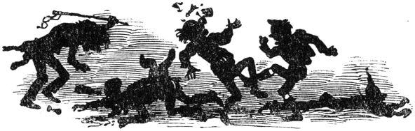

**The blacksmith from Jüterbogk.**

A blacksmith once lived in the little town of Jüterbogk, and children and old people tell a wonderful story about him. This blacksmith was only a young lad who had a very strict father, but who faithfully kept God's commandments. He traveled extensively and had many adventures, and he was extremely skilled and capable in his art. He had a steel tincture, which made every armor and armor impenetrable, which was coated with it, and joined the army of Emperor Frederick II, where he became Imperial quartermaster and took part in the campaign to Milan and Apulia. There he captured the army and banner wagon of the city and finally, after the emperor had died, returned to his homeland with much wealth. He saw good days, then bad again, and lived to be over a hundred years old. 65under an old pear tree, there came a little gray man riding a donkey, which had repeatedly proven itself to be the smith's guardian spirit. This little man lodged with the blacksmith and had the donkey shod, which the latter gladly did without asking for wages. The little man then said to Peter that he should do three wishes, but not forget the best. 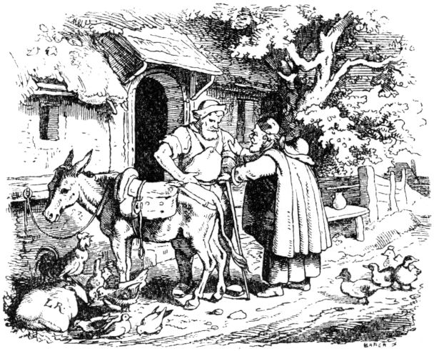Then the blacksmith wished, because the thieves often stole his pears, that no one who climbed the pear tree should be able to come down again without his will - and because he had often been robbed in the room, he wished that no one should to come into the room without his permission, unless it were through the keyhole. With each of these foolish wishes the little man warned: “Don't forget the best!” And then the blacksmith made the third wish, saying: “The best is a good schnapps, so I wish that this bull never should 66become empty! ”-“ Your wishes are granted, ”said the little man, stroked some iron bars that were in the forge with his hand, sat on his donkey and rode away. The iron was turned to silver. 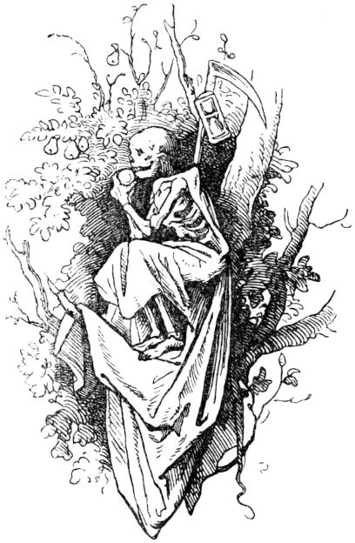The blacksmith, who had previously become poor, was rich again and lived on and on in good health, for the never-drying stomach drops in the bull were, without his knowing it, an elixir of life. At last death knocked, who seemed to have forgotten him for so long; the blacksmith was apparently willing to go with him and only asked to give him a little refreshment and to fetch a couple of pears from the tree which he could no longer climb himself because of great old age. Death climbed the tree and the blacksmith said: “Stay up there!” Because he wanted to live even longer. Death ate all the pears from the tree, then his fasts began, and from hunger he devoured himself skin and hair, which is why he is now such a hideously withered skeleton. But nobody died on earth, neither human nor animal, 67rattling death and agreed with him that he would leave him alone for the future, then he let go of him. Angry, death fled from there and began to clean up the earth. Since he could not take revenge on the blacksmith, he incited the devil on his neck to get him. He set off quickly, but the smart blacksmith smelled the sulfur ahead, closed his door, held a leather sack with the journeymen at the keyhole, and as Mr. Urian drove through, 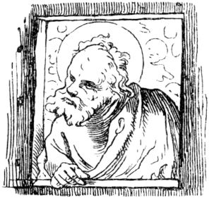Since he could not do otherwise in the smithy, the sack was tied up, carried to the anvil, and now ruthlessly pounded the devil with the heaviest hammers, so that he lost hearing and seeing, he became very weary and the comeback conspired forever. Now the blacksmith lived a long time in peace until, like all his friends and acquaintances, he was fed up and tired of earth life. So he set out and went to heaven, where he modestly knocked on the gate. Then St. Peter looked forward, and Peter the blacksmith recognized in him his patron saint and guardian spirit, who had often visibly saved him out of need and danger and finally granted him the three wishes. But now Peter said: “Get up, heaven is closed to you; you forgot to ask for the best: bliss! ”- Peter turned to this decision, and thought of trying his salvation in hell, and wandered down again, soon finding the right, broad and much traveled path. How 68but when the devil found out that the blacksmith von Jueterbogk was approaching, he slammed the gates of hell in front of his nose and put hell into a state of defense against him. Since the blacksmith von Jüterbogk found refuge neither in heaven nor in hell, and never wanted to please him on earth, he went down to the Kyffhauser to see Kaiser Friedrichen, whom he once served. The old emperor, his master, was pleased when he saw his quartermaster Peter coming and asked him straight away whether the ravens were still flying around the tower of the Kyffhausen castle ruins? And when Peter said yes, the red beard sighed. The blacksmith, however, stayed in the mountain, where he shod the emperor's hand horse and the horses of the princess and those of the riding ladies until the emperor's hour of redemption struck him too. - And that will happen according to the mouth of the legend, when one day the ravens no longer fly around the mountain, and on the council field near the Kyffhauser an old, dry, dead pear tree grows again, grows green and blossoms. Then the emperor emerges with all his armaments, fights the great battle of liberation and hangs his shield on the tree, which is again green. Then he goes with his servants to the eternal rest.

69

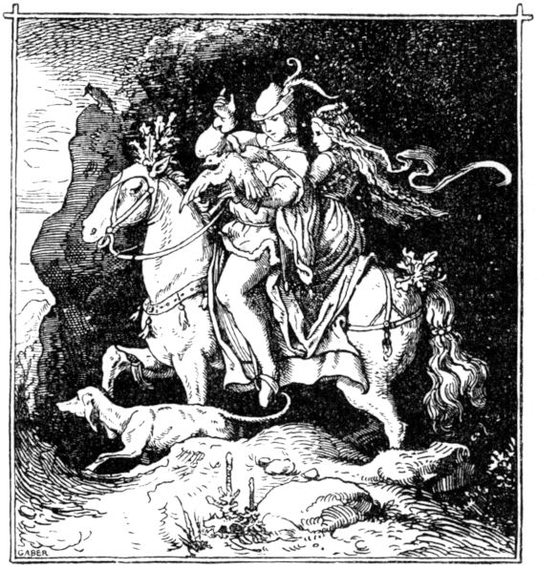

**From roast anger.**

Once upon a time there was a knight who, in addition to a lot of money and goods, had a bad wife, which he never knew how to master, and there was hardly a bad wife to be found on earth. But he was honorable and of gentle courage. Both had one daughter, and the mother raised her in her own bad manners and according to her blow, so that she became bad and barren, malicious and treacherous. All the same, God had made the little maiden into a beautiful virgin, so that whoever looked at her would think she was a picture full of minnial goodness, but whoever became acquainted with her soon noticed her wickedness and avoided her 70entirely. Now the maiden was eighteen years old and would have liked to take a husband, but no one came to desire her.

That bothered the father mightily, and one day he said to her: “Daughter, your mother's manners and her bad advice make you stay without a husband, or else, if someone takes you who does not feel like me, wicked wives to bear patiently, you will be beaten more often than the year counts days, and you will still regret that you followed and followed your mother in every way. "

The daughter of the pious knight was very reluctant to hear this and said angrily: “Well, my father! You can talk a lot before I even like one of your words! You have always given my mother far too many good lessons that she does not thank you. You know what? Do what you think is good and let me have my way. Because even if a suitor would come tomorrow who wanted me, I still wanted to carry the longer knife at all times in my marriage. "

“O my daughter!” Replied the knight, “I don't think it's good that you have such thoughts. You ought to think about being better than your wicked mother, otherwise it might well happen that you got a man who is so bad and pious that he overcomes you, and then you give in with shame, insult and shame must. "

Answered the daughter. “Before the market is over, there are more of the same kofents to buy!” And more such ugly mockery that she gave to her father, so that he angrily exclaimed: “O you wicked Kriemhild! If you don't want to follow your father, your back should be fed up with blows! Whoever desires yours 71whether he be a knight or a servant, he shall have you and draw you according to his will! "

"Or I do it after mine!" Replied the daughter defiantly, and other speeches until this exchange ended.

Now, about three miles from the castle of this good knight, there was another knight who was rich in money and goods and had suitor thoughts, was also handsome in face and polite in manners, who answered questions and said how beautiful and how ugly at the same time that neighbor was daughter, and thought: I dare to do it freely and turn her mind to virtue, and do her well, if not, I will take her for better or worse for her beauty. Then he rode with his friends to the maiden's father and asked for his daughter. This knight revealed to the young wooer how his daughter was behaved, and the latter said: “I have heard it, but you only give her to me as a wife! If God wants us to live together for only one year, you should see how good it will be! ”- To this the future father-in-law answered: “God should protect you from their malevolence! Beware, because if she comes on her mother's trail, you will live with her, no matter how long she lives, never a good day. ”The suitor, however, persisted in his decision, and an agreement was made and an agreement was reached that the boy Ritter, as soon as he came back, was to take the maiden with him and bring her home.

The mother knew neither much nor little about this negotiation, but not at all that the daughter was engaged to a man, and when she found out she was extremely angry, the daughter called and said: "Daughter, know that my curse hits you if you do not resist your husband as I resisted your father with war 72and harsh speech at all times and in every place. Hear what I tell you: I was a little girl when I came to your father, much less than you, because you are fully grown. For three weeks your father beat me every day to make me sick and gave me water to drink, and yet I won my quarrel and up until then I always asserted my rights! "

"Mother!" Replied the fine daughter, "I tell you, and if I should live a thousand years, I will make my husband a monkey."

In the meantime the day of the home tour came; then the knight came up on a beautiful steed of high price, also carried a slender greyhound with him and carried a well-done falcon in his hand, received the maiden without further ado and sat her on his steed behind him, sent all his servants, that none of them rode with the two, and immediately took leave of his bride's father. At the farewell he spoke a flexible word: “God's goodness be with you, oh daughter! He will give you peace of mind in happiness and a more peaceful heart than I invented on my wife! "

As soon as this speech was spoken, the mother made a noise and shouted after the daughter: “Hear my word too! You shall be subject to your husband for all your days, just as I have taught you! "And the daughter called back:" Well, my mother, it should be done according to your teaching. "

So the two of them rode all alone together, but the knight avoided the road, for the bride's sake, and rode an uncomfortable, steep and narrow side path, probably a mile long, but he rode quickly, that in a short time he was half a mile Mile traveled on the rough, unpaved stone path. Then they came across one 73surrounded Werder and the falcon began to flap its wings in its own way and covet its hand because it wanted to meet herons. Said the knight: "Stop beating your feathers or I'll tear your head off." Soon afterwards the hawk saw a crow flying, which he wanted to go after; then said the knight again: “You are betrayed if you strive for trouble and do not like to be in peace, and so I will do your right right away. Die because you do not want to keep my will! ”And he strangled the hawk like a chicken.

The maiden was frightened by this speech and the fatal act and began to fear the knight. Now the path became narrower, stony and thorny, and the greyhound's feet ached, and it was no longer able to hold on to the horse's side as it had before. The knight who wielded it by a strap always had to pull it, that was inconvenient for the knight, and he turned on the greyhound: "You wicked court warden, watch out, it will be a disaster for you that you pull my arm so! “But the poor dog could not follow, and then the knight drew his sword and cut him dead.

The maiden suppressed a scream of indignation, but her heart was frightened, she felt aching and she thought: Lord God, what a madman this man is! then the devil brought me to him! - The knight, however, kept the sword bare in his hand and began to scold his horse: “What are you snorting? Why don't you go pass or trot? You just want to go on the same plan? You must die! ”Since the poor steed could not trot the passport, which gait he had never been taught, the knight said:“ Woman, get off! ”She said:“ Me 74do what you tell me to do. ”Thereupon the knight dismounted and cut the head off the horse's body, saying:“ If you had gone my way, you would not have died. Woman, as you can see, this has happened. I didn't like the horse at all, as did the greyhound and the falcon. But now it is an unfamiliar and arduous thing for me to walk, and I have no practice in it. I will now ride you ! ”And with that he began to put on her belts and ties and he wanted to strap on her saddle as well. She said: "Lord, I already carry enough on you, leave the saddle and the ropes, my dear gentleman, I carry you more gently and better without him."

"Well, woman, how would it be for me to ride you without a saddle or stuff?" Asked the knight vehemently. "You have a bad custom that you venture to speak against my will!" And then she allowed himself to be saddled and bridled her at the hour like a horse, and put her bridle and bit in her mouth, and gave her them Stirrups in her hands to hold them tight, then sat up and rode her for a little while, about three spear lengths, until she fainted from the heavy burden.

Then the knight dismounted from her and said: “Woman, are you gasping for air?” - “Oh no, sir!” She replied. He went on to say: “This is a beautiful field, there you can now walk in the tent (step).” She said, crawling on on her hands and feet: “I would like to do it. There are a lot of horses running on my father's farm that I have learned to walk around in a tent.

“So you want to do everything I want?” Asked the knight, and she countered: “And if I were to live a thousand years, I would do what you like!” There 75he told her to get up and took her beautifully by the hand, and led her modestly home to his castle, where his friends were gathered, they greeted her reverently and led her to her room. This happened with great joy, and the woman was the most dearest woman, honorable and well-behaved, without cunning and deceit, loyal, calm, mild, she lacked no virtue. She received her guests in a friendly and cheerful manner, and without hatred or displeasure, as an honest woman should do, she fulfilled the wishes of her husband.

When six weeks had passed, the young woman's father and mother drove over to her daughter to see how she was doing and how she was doing. Soon enough the mother found out what had happened and how her daughter obeyed her husband when she scolded her angrily and called out to her: “O wretched woman! What I have to see and hear makes me doubt that you are my child. What? You let your husband be your master? ”And the angry mother slapped her daughter in the face and wherever she went, and fell in her hair and tore her, hit and scolded and did some terrible mischief. The young woman wept and shouted: “If you have come here to scold, wait until you find the cause! I have the very best man, and he is good and honest, but who does not do his way he goes straight to life in his anger. Therefore, mother, have a wise mind and be careful not to speak badly against him, for he is so angry that he judges in anger and destroys everything that is contrary to his will. "

"Hoho! Tomorrow is another day too! ”Sneered the mother. “How bad your husband is, that gives me the slightest grief! Not a hair strong I pay attention 76his! You silly trine! The devil must run through your brain that you dare to threaten me, your mother, with your husband! "

"Mother, I am not threatening you!" The daughter defended herself. “I'm only telling you the truth; I may advise you to say hello to my husband, because if you wanted to do him, like my father, he'll puff your back, and although you don't have much hair left, that's enough for him to tear it out! "

"That would be a major work!" Replied the mother angrily. “I do not fear him, even if he were as big as a mountain; I fear him no more and no less than your father! What has he done to me for the last twenty years? Even today I don't give in to him by a hair! "

During this rogue speech by the elderly woman, the father-in-law and the daughter-in-law stood in a secret place where they heard every word, and the old man spoke softly to his son-in-law: "I am heartily glad that you have overcome my daughter's rigid mind, and I am happy to leave behind You and you my belongings when I drive there. "The son-in-law thanked the in-law for the friendly disposition of the in-law, who then spoke to him again:" Please advise me how I do your in-law, who is always opposed to me and my life so bitterly decayed! If it could only be done that about a year before her death she would at least let go of her hardship, I would have the most extraordinary joy and all my sorrows an end!

The son-in-law then promised to make his mother-in-law good in his own way if the father-in-law did not want to prevent him. He said: “I want you 77do not refuse anything, if it boils or roasts, I want to add wood to it. "

The knight soon secretly took four nimble, strong servants, measured himself with great anger, and went to the Kemnate, where the old woman was still sitting and always scolding him and her daughter. When she saw him coming, she greeted him mockingly: “Welcome to God, Mr. Engelhart!” “Thank you very much, Mrs. Schlechthart!” Was his counter-greeting, and he stepped up to her and said: “Woman, leave your bad manners, I ask that of you, against your and my lord. He should measure you countless blows on your back with an oak cubit until you hurt so much that you would become a good wife. "

“Oh!” Said she, “I can hear that you have killed many so, dear Mr. Guguguk! But I've still kept skin and hair so far, I hope to wear it longer! But what have I done to you? "

"You scold my lord, your husband, every day, and spoil his own house for him!" Answered the young knight; but she was immediately at hand with the counter-speech: “In my house my name is Scratcher! I can be his master in this as my own, and God, as long as I live, shall not give him a single good day! "

“And if God gives me happiness,” said the son-in-law, “I take care that you let go of your wicked intrigues before we leave each other.”

“Make sure you don't fail!” She cried, “otherwise, according to the great God of Schaafhausen, you will have only shame and ridicule from it!”

"I know what makes you so crazy and confused and angry," said the knight again. "You have two Zornbraten here on each hip, that's where it comes from 78You have such bad customs; if someone cut you out, that would be excellent, because you would be happier than ever a woman, and it would be no less good for your husband. "

"Oh! I am glad that you are such a good doctor, teach your art to my daughter! ”Was her answer. “Do you also have Bertram and hellebore for sale? You probably mix mugwort with the drink? "-

"Hey! Your mockery is great! ”Cried the knight,“ but it will be too salty for you in a moment; as soon as we have your angry kidneys and angry roast, you will become better and more pious as a child! "

“Enough with your gaping, gaping!” Scolded the woman. But then the servants attacked her at the knight's hint, threw her down, and the daughter man sharpened a large sharp knife, he set it on her hip and cut a long, deep wound through her robe and shirt, so that her laugh was complete passed away; then he spoke, throwing a piece of meat into a vessel: "Look, woman, you have been a bad woman for many years, it was your roast anger that was to blame, I can no longer leave it to you." But she lay sad and screaming: "I didn't know that about myself, but I know what the devil you advised me!"

"Yes, you still have an angry roast," said the knight, "on your other leg, it still has to come out!"

“Oh,” she complained, almost crying, “it's very small, it doesn't do me too much harm! Help me god the one you cut out was to blame for all the damage. I am free of all anger and want to be quiet, just leave the other person uncut. "

The daughter said cheerfully to her husband: “Think carefully about what you are doing; I'm afraid even if he does 79If other Zornbraten does not come here, the great work on one is lost, and in the end the other Zornbraten gets boy, if you don't cut it out too. "

"No, no, dear daughter!" Cried the mother, "tell him that he will leave me unharmed, I want to be good!"

“Mother,” replied the young woman, “you advised me to fight against my husband, not to be subject to him; therefore, and that she played along so badly to my father, just cut her roast! ”And then the knight attacked the other, but the other shouted:“ No, no! It is more than enough! Daughter, think that I have carried you under my heart, and win peace from your husband! I will swear that I will live kindly, and the mild and just God keep me from anger. The knight has already taken my great anger away from me, and the little one is not worth paying attention to! "

“Well,” said the knight, “if she desires peace, I leave her, but I promise her at hand that if she does not avoid anger, she will be cut.” Then she and her wound were lifted connected.

And the woman threw all wars and quarrels under her feet, became a good moral woman, gave up her wicked violence, and when the next day came she took leave with her husband from her son-in-law, and he wished her that God would her may keep from all evil.

If, after the hand, she still sometimes said a word or more to her husband that he felt sorry for and disliked, he was only allowed to say: “I can't help myself, I have to go to our daughter husband 80send, "so she blushed with fear and said:" It is not necessary, his coming would not be good for me. I have the courage and sense to do what is dear to you, and I also advise all women to offer their husbands what I mean now, if they want to survive in peace. "

This is the end of this fairy tale, and every man and woman can make any use of it for themselves. But the old poet, who tells this story, gives the following advice:

If who has a bad wife,

He'll do away with you in time,

Recommend them to the knight,

And put them on a sledge

And buy her a little box

And hang it on a branch.

And hang with it

Two wolves or three.

Then who saw a gallows

With bad guys?

Unless whoever caught the devil

And he also hung in between.

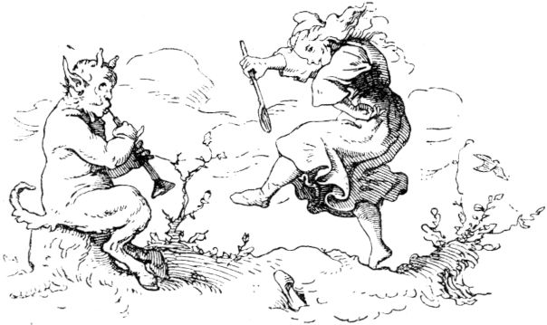

81

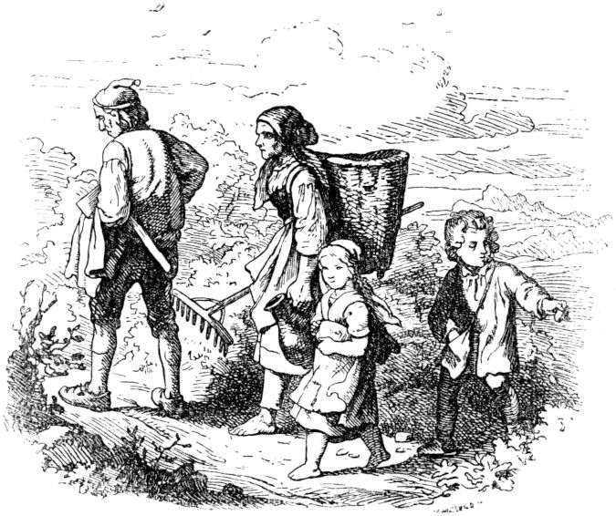

**Hansel and Gretel.**

Once upon a time there was a poor wood cutter who lived with his wife and two children in a poor forest hut. The children's names were Hansel and Gretel, and as they grew up the poor people ran out of bread more and more. The time also became more and more difficult and all food more expensive, which worried both parents very much. One evening, when they were looking for their hard bed, the man sighed: “Oh woman, how are we going to get the children through since winter is approaching and we have nothing for ourselves!” And then the mother replied: “No other advice I know that you would rather the sooner lead them into the forest, give to everyone 82a piece of bread, light a fire for them, command them to God, and go away. "

“Oh dear God! how am I supposed to do that on my own children, woman? ”asked the woodcutter sadly. "Well, let it go!" Said the woman angrily, "that way you can make a drawer for the four of us and watch the children die of hunger!"

The two children, who were still hungry in their little moss bed, listened to what the mother and father were talking to each other, and the little sister began to cry, but Hansel comforted her and said: “Don't cry, Gretel, I'll help us already ”, waited until the old people were asleep, wiped out of the hut, looked for white stones in the moonlight, probably hid them, and crept in again, whereupon he and the little sister soon fell asleep.

What happened in the morning was what the parents had discussed earlier. The mother handed each child a piece of bread and said, “That's all for today; keep it for advice. ”Gretel carried the bread, Hansel secretly carried his little stones, his father had his wooden ax in his arms, his mother locked the house and followed with a water jug. Hansel got behind his mother so that he was the last on the way, often looking back at the house, and when he couldn't see it, he immediately dropped a white stone, and after a few steps another one, and so always away.

Now everyone was in the middle of the deep forest, and then the father lit a fire, for which the children of the brushwood brought a lot, and the mother said to the children: “You are probably tired, now lay down by the fire and sleep, meanwhile we'll cut wood, afterwards we'll come back and pick you up. "83

The children slumbered a little, and when they woke up the sun was high at noon, the fire had burned down, and since Hansel and Gretel were hungry, they ate their piece of bread. Those who did not come were the parents. And afterwards the children fell asleep again until it got dark, then they were still alone, and Gretel began to cry and to be afraid. 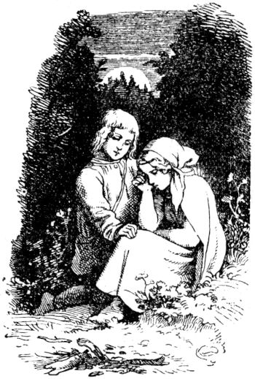Hansel comforted her and said: "Do not be afraid, sister, the good Lord is with us, and soon the moon will rise, we will go home."

And really soon afterwards the moon rose in full splendor and shone the children on their way home and shone the silver-white pebbles. Hansel took Gretel's hand and so the children went away together without fear and without accident, and as early morning dawned they saw their father's roof shimmering through the bushes, came to the little forest house and knocked. When the mother opened the door, she was really frightened when she saw the children, did not know whether to scold or be happy, but the father was happy, and so the two children were let in again with God's welcome into the little house.

But it didn't take long before the worry became loud again, and that conversation and the decision, the children 84leading them into the forest and leaving them there alone and in Heaven's care was repeated. Again the children listened to the sad conversation, with a sad heart, and the wise Hansel left the camp, wanted to look for bare stones again, but the door of the little forest house was firmly locked because the mother had noticed and therefore closed the door . Hansel comforted the crying little sister again and said: "Don't cry, dear Gretel, God knows all ways, will lead us to the right one."

Early the next morning everyone had to get up to walk back into the forest, and then the children received bread again, even smaller pieces as before, and the path went even deeper into the forest; Hanslein, however, secretly crumbled his bread in his pocket, and instead of those stones scattered crumbs on the path, thought that afterwards he would probably find his way back with his sister. And now everything happened as before; a great fire was kindled and the children had to sleep again, and when they woke up they were alone and their parents never came back. And noon came, and Gretel shared her piece of bread with Hansel, because he had scattered his bread in crumbs on the way, and then they fell asleep again and woke up in the evening, lonely and lonely. Gretel wept, but Hansel was blessed,

But when Hansel was looking for the crumbs, none of them was there anymore, because the forest birds had picked all of them and enjoyed them. And there the children wandered through the forest all night, soon came 85astray, got lost and were very sad. At last they fell asleep on soft moss and woke up hungry as dawn broke, for they had no more bite of bread and only had to quench their thirst and hunger with the beautiful wild berries that stood here and there. And as they wandered around in the forest without finding a path or a footbridge, behold, a snow-white bird came flying, 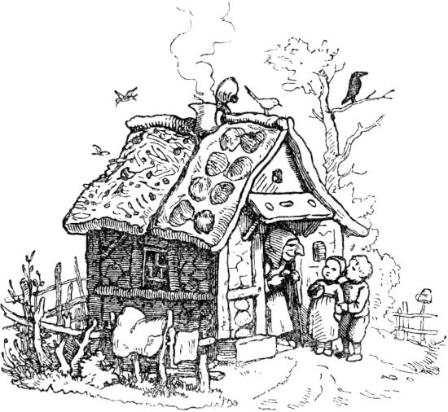it always flew in front of them as if it wanted to show the children the way, and they happily followed the bird. All of a sudden they saw a little house, on the roof of which the bird was flying; it pecked at it, and when the children were so close they could not rejoice and wonder enough, for the little house was made of bread, the walls were made of it, the roof was covered with pancakes, and the windows were made of transparent candy candy bars. That was fine with the children, they ate from the house roof and 86from a broken window pane. Suddenly a voice could be heard inside that called:

“Crisp, crisp, knees!

Who is nibbling on my house? "

The children replied:

"The wind, the wind,

The heavenly child! "

and continued to eat, for they were very hungry and they tasted very well.

Then the door of the little house opened and a very old, hunched-over, dripping-eyed mother stepped out, of no small ugliness, her face and forehead full of wrinkles and a big, big nose in the middle. Had grass green eyes too. The children were not a little frightened, but the old woman acted very kindly and said: "Well, darling little ones, come in into the house, come in! Come in!" There's much better cake there! "

The children liked to follow the old woman, and inside the old woman asked that it was a pleasure. There was, heart, what do you like Sponge cake and marzipan, sugar and milk, apples and nuts, and delicious cakes. And while the children were always eating and being happy, the old woman made two little beds made of fine downy pillows and lily-white linen, and in there she rested the children, who thought they were in heaven, prayed a pious evening blessing and immediately fell asleep.

But it had a very bad end with the old woman. She was an evil and nasty witch who ate the children whom she lured through her bread and cake house after she had fed them all the more fat.

She also had this in mind with Hansel and Gretel. Early in the morning the old woman was already standing in front of the bed of the still sweetly sleeping children, was happy about her catch, 87tore Hansel out of bed and carried him to the narrowly barred goose stable, also blocked his mouth so that he would not scream. Then she woke poor Gretel violently and shouted at her in a hoarse voice: “Get up, lazy whore! Your brother is in the stable, we have to cook him a good meal so that he gets fat and gives me a good roast! "

Then Gretel was frightened to death, cried and screamed, but did not help, she had to obey and get up, help cook food, and was allowed to carry it to the stable herself and cry with her locked brother. She herself was kept to a minimum by the witch. It lasted such a time, during which the old woman often crept into the stable and ordered Hansel to stick a finger through the grate so that she could feel whether he was getting fat. Hansel, however, always stuck out a thin bone, and she was astonished that the boy remained so skinny in spite of the good food. Finally she was tired of that and said to Gretel: “In a nutshell, today it will be roasted”, and made a mighty fire in the oven that was next to the house; then she pushed bread in afterwards so that she had freshly baked food to fry.

But then the snow-white little bird came flying and sang: Take care, take care, take care of yourself! And then Gretel's eyes opened to see through the old woman's wicked ruse and said: "Show me beforehand how I have to do it, then I will do it." The old woman immediately sat up 88the oven shelf, and Gretel pushed the stick, and pushed it into the oven as far as the handle was long, and then it clicked shut, she slammed the iron door in front of the oven, pushed the bolt, and the oven was still amazing was hot, the old witch had to brick and roast inside and perish miserably as a reward for her iniquities. But Gretel ran to Hansel, let him out of the goose stable, and he came out and fell on the neck of the faithful little sister for joy, kissed each other and wept for joy and thanked God.

And there the white bird was there again, and also many, many other forest birds, who flew onto the cake roof of the little house, there was a nest on it, and from it each bird took a colored stone or a pearl and carried it to the children, and Gretel held out his apron so that it could hold all the little stones. The snow-white bird sang:

“Pearls and Gemstones

For the breadcrumbs. "

Then the children noticed that the birds were grateful that Hansel had scattered breadcrumbs on the path, and now the white bird flew in front of them again to show them the way out of the forest. Soon they came to a mighty water, there they stood perplexed, and could not go further or above. Suddenly, however, a big, beautiful swan came swimming, to which the children shouted: “O beautiful swan, be our boat!” And the swan bowed its head and rowed to the bank, and carried the children one by one over to the other bank . But the white bird had already fluttered over and kept flying in front of the children until they finally came out of the forest, back to their parents' little house.89

The old woodcutter and his wife sat sad and quiet in the narrow little room and had great sorrow for the children, regretted many thousands of times that they had left them and sighed: "Oh, if only Hansel and Gretel only once more come back, oh, we never wanted to leave them alone in the forest again " 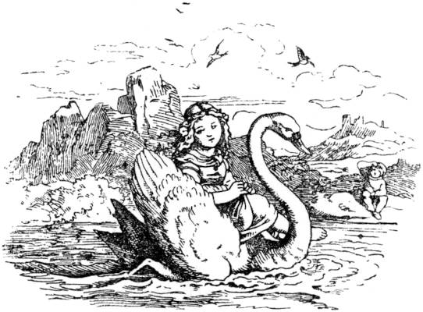- the door just opened without knocking, and Hansel and Gretel entered in person! It was a pleasure! And when the precious pearls and precious stones that the children brought came to light, there was joy in every corner and from then on all misery and worry came to an end.

90

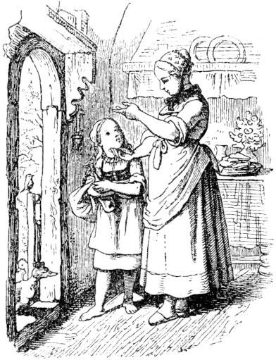

**Little Red Riding Hood.**

Once upon a time there was a very dear, cute thing of a girl who had a mother and a grandmother, they were very good and loved the little thing so much. The peculiar grandmother, who didn't know how well she should mean it with the grandchildren, always gave him this and that and had also given him a fine cap made of red velvet, it looked so pretty on the child, and she knew that too little girls and didn’t want to wear anything else, and that’s why it was called Little Red Riding Hood with old and young. Mother and grandmother but did not live together in one house, but half an hour of each other, and between the two houses was a forest. One morning the mother said to Little Red Riding Hood: 91“Dear Little Red Riding Hood, Grandmother has become weak and sick and cannot come to us. I've baked cakes, go and bring Grandmother some of the cake and a bottle of wine too, and give her my best regards, and be very careful not to fall and break the bottle, otherwise grandmother would have nothing. Don't walk around in the forest, stay nice on the way and don't stay out too long. "

"I will do everything as you command, dear mother," answered Little Red Riding Hood, tied her apron on, took a light basket in which she had her mother put the bottle and the cake, and walked happily into the forest . As it wandered so completely unsuspectingly, a wolf came along. The good child did not yet know wolves and was not afraid. When the wolf came closer, he said: “Hello, Little Red Riding Hood!” - “Thank you very much, Mr. Graubart!” - “Where should it go so early, my dear Little Red Riding Hood?” Asked the wolf. "To the old grandmother, who is not well!" Answered Little Red Riding Hood. "What do you want to do there? You want to bring her something? "-" Yes, of course, we baked cakes, and mother also gave me wine, which she should drink so that she becomes strong again. "

“Tell me, my dear, charming Little Red Riding Hood, where does your grandmother live? I would like to show her my respect one day when I pass her house, ”asked the wolf.

"Well, not far from here, a quarter of an hour, there is the little house right by the forest, you must have passed it. There are oak trees behind them, and hazelnuts grow in the garden fence! ”Chatted Little Red Riding Hood.92

O you dearest, delicious hazelnut you - thought the wrong bad wolf to himself. I have to crack you, that's a sweet core for once. - And acted as if he wanted to accompany Little Red Riding Hood a little longer, and said to him: “Just see how beautiful flowers are over there and over there, and just listen to how lovely the birds are singing! Yes, it is very beautiful in the forest, very beautiful, and such good herbs grow in here, medicinal herbs, my dear Little Red Riding Hood. "

“You are certainly a doctor, dear gray sir?” Asked Little Red Riding Hood, “because you know the medicinal herbs. You could show me a medicinal herb for my sick grandmother! "

“You are just as good a child as you are clever!” Praised the wolf. "Well, of course I am a doctor and know all herbs, you see! there is one here, the wolf bast, there in the shade the wolfberries grow, and here in the sunny rain the milkweed is in bloom, over there you can find the wolfroot. "

“Are all herbs called after the wolf?” Asked Little Red Riding Hood.

"The best, only the best, my dear, pious child!" Said the wolf with real scorn. Because all he named were poisonous herbs . Little Red Riding Hood, however, in her innocence wanted to pick such herbs as medicinal herbs for her grandmother and bring them back, and the wolf said:

“Farewell, my dear Little Red Riding Hood, I was happy to make your acquaintance; I'm in a hurry, have to visit an old, weak patient! "

And with that the wolf hurried away, and spur of the moment to the grandmother's house, while Little Red Riding Hood picked beautiful forest flowers for ostriches and gathered the supposed medicinal herbs.93

When the wolf came to Little Red Riding Hood's grandmother's house, he found it locked and knocked. 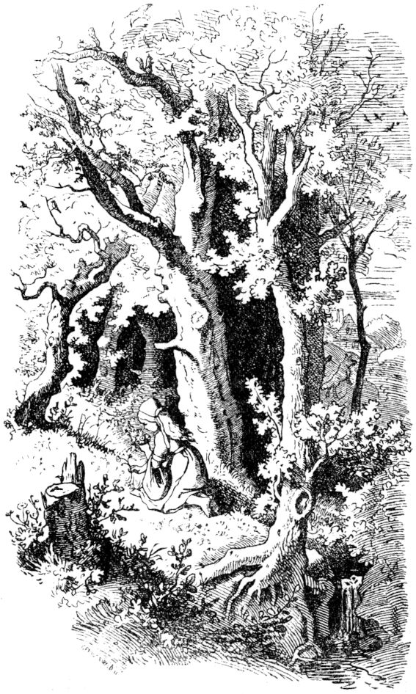The old woman could not get up from bed and see who was there, and called: "Who's outside?"94

“Little Red Riding Hood!” Called the wolf in a fine, disguised voice. “The mother sends the good grandmother wine and cake too! We baked! "

"Reach down through the hole in the door, there is the key!" Cried the old woman, and the wolf did so, opened the door, stepped into the little house and into the little room and devoured the grandmother without further ado - put on her clothes, lay down in her bed and pulled the covers over her and the bed curtains. 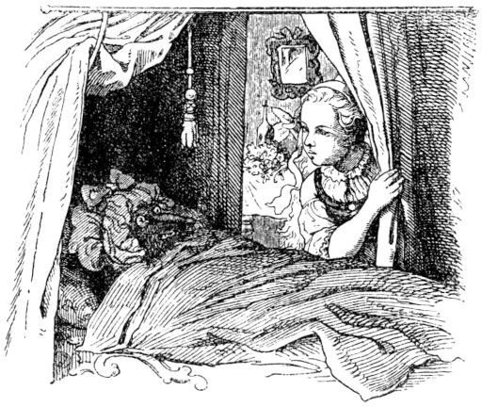After a while Little Red Riding Hood came; it was very astonishing to find everything so open, since otherwise the grandmother liked to keep herself under lock and key, and he was almost worried about the young darling.

When Little Red Riding Hood came up to the bed, there was the old grandmother, wearing a large sleeping cap and there was little to see of her, and what little looked terrible. "Oh, grandmother, what are your ears so big?" Cried Little Red Riding Hood. - "That I can hear you so well!" Was the answer. - "Oh, 95Grandmother, what big eyes you have! ”-“ That I can see you well with them! ”-“ Oh, grandmother, what big hairy hands you have! ”-“ That I can grasp and hold you well with them! ”- "Oh, grandmother, what a big mouth you have and such long teeth!" - "That I can eat you with it!" And with that the whole wolf rushed out of bed grimly and ate poor Little Red Riding Hood. It was gone.

Now the wolf was very full, and he liked it very much in the old woman's room and in the soft bed, and lay down again and fell asleep and snored so that it sounded like a cog in a mill. A hunter happened to pass by, heard the strange noise and thought:

Eh, eh, the poor old woman in there has a nasty snorer on her body, she must be gasping and is dying! You have to go in and see what's wrong with her. - Thought and done; The hunter went into the little house and found Mr. Isegrim lying in the old woman's bed, and the old woman was nowhere to be seen. "Are you there? ”said the hunter and tore the rifle from his shoulder. "Come here, you've run away from me often enough!" - He put on - then it occurred to him: wait - the old woman is not there, in the end the monster devoured her skin and hair, was just a little thin anyway Female. And then the hunter did not shoot, instead he pulled out his sharp hunting catcher and very gently slit open the belly of the fast asleep wolf, a red cap peeped out and under the cap was a little head, and then the cute and dearest Little Red Riding Hood came out and said: "Good Morning! Oh, what a dark little room it was in there! "- And behind Little Red Riding Hood the old grandmother wriggled, 96it was still alive, but it hadn't had much space in the wolf's belly. The wolf was still asleep, and so they took stones, just like the old goat in the fairy tale of the seven little goats, stuffed them in the wolf's stomach and sewed up the satchel, then they hid, and the hunter stepped behind one of them Tree to see what the wolf will finally start. Now the wolf woke up, got out of bed, out of the room, out of the house, and hobbled to the well, for he was very thirsty. On the way he said: “I don't know, I don't know, my stomach is wobbling back and forth, back and forth like Wobelstein - should that be Grandmother and Little Red Riding Hood?” - And how he came to the well and wanted to drink Then the stones pulled him and he got overweight and fell in and drowned. So the hunter saved his bullet; He pulled the wolf out of the well and peeled off his fur, and all three of them, the hunter, the grandmother and the Little Red Riding Hood, drank the wine and ate the cake and were so happy, and the grandmother became fresh and healthy again, and Little Red Riding Hood left home with her empty basket and thought: you will never again want to leave the path and go into the forest if your mother has forbidden you.

**The partridge.**

It was a wealthy Jew who was traveling through a kingdom and carrying a great treasure trove of money and goods. Since his path was to lead him through a large forest, he was afraid that he would be for the sake of his money 97He would have to lose his life in it, and therefore went to the king of the land, offered him a present and asked that the king give him a safe man to accompany him through the forest and through his whole kingdom. The king told his presenter to escort the Jew, and he did what he was commanded to do and escorted the Jews.

When these two had come into the forest, the gift giving lusted after the treasure of the Jew, and he stood still on the way and said to him: “Go ahead!” The Jew was startled, suspected the giving of bad intentions and did not want to go ahead . 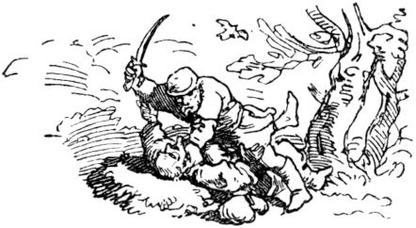The tavern immediately pulled his sword out of its scabbard and shouted: “Jud, you must die here by my hand!” - “Oh, dear tavern, don't do that!” Cried the Jew; “Such a murder against me would not remain hidden! And whether secret murder is carried out unseen by all people, the birds that fly under the sky will reveal it! "

As the Jew said it, a partridge was just flying up in the forest and over them both. Then the tavern laughed scornfully and said mockingly: "Watch out, Jud, the partridge will certainly tell the king that I have murdered you here." And so the tavern murdered the Jew in the forest, took all his money and his treasure, the he carried with him, buried him secretly, and went back to court.

And a whole year passed after the giving 98Unfaithful deed, it happened that partridges were given to the king, which the tavern gave to the cook, had them prepared and brought them to the table. And as he put the partridges on the table in front of the king, he thought of the Jew whom he had murdered and of his last speech about the birds and had to laugh. The king saw it and asked what was he laughing at? But the giver gave the king a false cause for his laughter.

After more than four weeks it happened that the king gave his officials and servants a feast, and the tavern was also there, and the king himself was very cheerful and cheerful, joking and merry, and had so much wine and fine drinks served that some his servants got drunk. And since everyone was so funny, the king said to the gift: “Dear Schenk, now tell me the free truth, what have you laughed about recently, when you brought me the partridges, because you have me not reported in true words at the time! ”The tavern was in drunken courage, for when the wine comes in, wisdom runs out and said:“ Well, my lord King, when the Jew shouted that the birds would reveal his secret murder, those under fly in the sky, a partridge was just flying up, I had to remember it and laugh about it. "

The king was silent on this speech, let nothing be noticed and pretended not to be disturbed in his cheerfulness. But the next day he consulted his secret councilors and said to them: "What is the fault of the one who was to guide you safely through the kingdom on account of the king and who himself murdered and robbed him?" The councilors replied unanimously : "He deserves the gallows!" 99if the king sat in public in court, appointed a plaintiff to accuse the tavern, and since he told his deed before witnesses in a state of intoxication, he had to confess it in court and was sentenced to the gallows. So the secret murder by the partridges was made known and revealed.

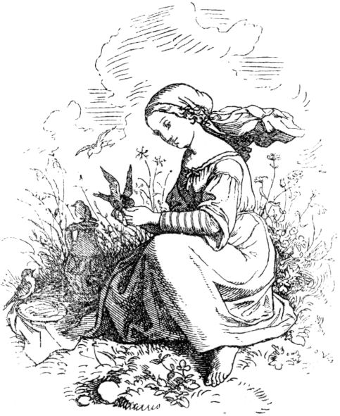

**The Goldmaria and the Pechmaria.**

Once upon a time there was a widow who had two daughters, a real daughter and a stepdaughter; both were called Maria. The real daughter was not good and pious, on the other hand the stepdaughter was a modest, decent girl, 100which, however, had to endure many offenses and disapprovals from mother and sister. But she was always friendly, did the kitchen chores undaunted, and only sometimes cried secretly in her little bedroom when she had to suffer so much injustice from her mother and sister. But soon she was cheerful and fresh again and said to herself: "Be calm, God will help you." Then she did her work diligently and made everything nice and clean. She always didn't work enough for her mother; One day she even said: “Maria, I can no longer keep you at home, you work little and eat a lot, and your mother left you no fortune, nor your father, it's all mine, and I can and like you no longer feed so you have to go out

Maria was very saddened by this severity; but she strode courageously through the fields and meadows and thought: someone will take you in as a maid, and perhaps strangers are more kind than your own mother. When she felt hungry, she sat down on the grass, took out her ash cake and drank from her jug, and many little birds fluttered over to peck at her cake, and she poured water into her hand and let the lively birds drink. And then, unnoticed, her ash cake turned into a cake, her water into delicious wine. Poor Maria moved on, strengthened and happy, and when it got dark she came to a strangely built house, in front of which there were two gates, one looked pitch black, the other glistened with pure gold. 101Maria went modestly through the less beautiful gate into the courtyard and knocked on the front door. A man of terribly wild stature opened the door and brusquely asked what she wanted. She said, trembling: "I just wanted to ask if you would not be so kind as to accommodate me for the night?" And the man growled: "Come in!" She followed him, and shuddered even more than she was in the room saw and heard nothing but dogs and cats and their hideous howls. Apart from the wild Thürschemann (that was his name) there was no one else in the house.

Now the Thürschemann grumbled to Maria: "Who do you want to sleep with, with me or with dogs and cats?" Maria said: "With dogs and cats." But then she had to sleep right next to him, and he gave her a nice, soft one Please pray that Maria slept wonderfully and peacefully. In the morning Thürschemann grumbled: "Who do you want to have breakfast with, with me or with dogs and cats?" She said: "With dogs and cats." Then she had to drink with him, coffee and sweet cream. When Maria wanted to go away, Thürschemann grumbled again: "To which gate do you want to go, to the gold gate or to the Pechtor?" And she said: "To the Pechtor." shook so roughly that the gate trembled and that Maria was completely covered by gold that fell on her from the gold gate.

Now she went home again, and when she went into her parents' house, her chickens, which she usually fed, flew happily towards her and ran, and the rooster shouted: Kikiriki, here comes the Goldmarie! Kikiriki! And her mother came down the stairs and curtseyed to the golden lady as reverently as if she were 102it would be a princess who would give her the honor of visiting. But Maria said: “Dear mother, don't you know me anymore? I am Maria. "

Now the sister came, too, amazed and amazed, like the mother, and both of them envious, and Maria had to tell how wonderful things had happened to her and how she had gotten the gold.

Now she took in her mother and kept her better than before, and Mary was honored and loved by everyone; soon there was also a good young man who brought Marien home as his wife and lived happily with her.

But the envy of the other Maria grew in the heart, and she decided to go away and come back gilded. Her mother gave her sweet cakes and wine with her on the trip, and when Maria ate from them and birds came flying to feast too, she angrily chased them away. But her cake turned into ashes unnoticed, and her wine into dull water. In the evening Maria also came to Thürschemann's gates; she proudly went in to the golden one, and then knocked on the front door. When Thürschemann opened up and asked what she wanted, she said flippantly: "Well, I want to stay here." Cats? ”She said quickly:“ With you, Herr Thürschemann! ”But he led her into the room, where dogs and cats slept and locked them inside. In the morning, Mary's face was ugly scratched and gnawed. Thürschemann grumbled again: "Who do you want to drink coffee with, with me or with dogs and cats?" "Oh, with you," she said, and just had to drink with cats and dogs again. Now 103she wanted to go. Thürschemann grumbled again: "To which gate do you want to go, to the gold gate or to the Pechtor?" And she said: "To the Goldtor, that goes without saying!" But this was immediately locked and she had to go out of the Pechtor, and Thürschemann sat on top, shook and shook it so that the gate wobbled, and so bad luck fell on Mary that she was filled over and over.

When Maria came home angry about her ugly appearance, the cockerel crowed towards her: Kikiriki, here comes the unlucky marie! Kikiriki! And her mother turned away from her in disgust and could not let her ugly daughter see in front of the people, who was severely punished because she was so eager for gold.

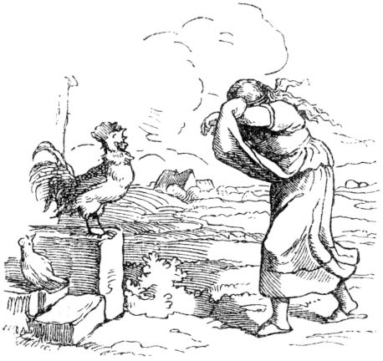

104

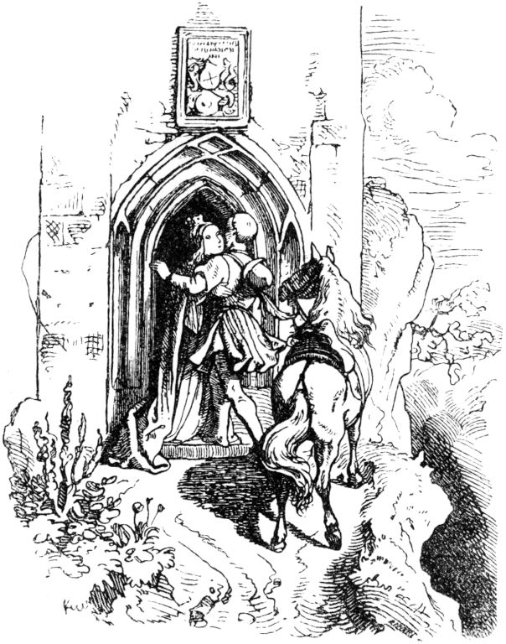

**Millet thief.**

A very rich merchant lived in a town, and he had a large and splendid garden by the house, in which a piece of land was also sown with millet. As this merchant was walking around in his garden once - it was springtime, and the seed was fresh and strong - he saw, to his great annoyance and annoyance, that the night had passed by the impudent hand of the thief 105Some of his millet seeds had been grazed, and this little garden field, on which he sowed millet every year, was particularly dear to him, as sometimes people have an exclusive preference for one thing. He decided to catch the thief and then severely punish him or hand him over to the court. So he called his three sons, Michel, Georg and Johannes, and said: “Last night a thief was in our garden and grazed some of the millet seeds from me, which annoys me greatly. This wrongdoer must be caught and I will pay for it! You, my sons, may now watch through the nights, one after the other, and whoever catches the thief shall receive a handsome reward from me. ”The eldest, Michel, kept watch the first night; he took several loaded pistols and a sharp saber, to eat and drink with me too, wrapped himself in a warm coat and sat down behind a blooming elder bush, behind which he soon fell asleep hard and fast. When he woke up in the bright morning, an even larger piece of millet seed had been grazed than on the previous night. And when the merchant came into the garden and saw it and saw that his son, instead of watching and catching the thief, had slept, he became even more angry, and scolded and mocked him as a good watchman who had him and his own Pistols and sabers themselves could be stolen!

The next night Georg was awake; In addition to the weapons his brother had with him the night before, he also took a tunic and strong ropes with him. But the good guard Georg fell asleep too, and in the morning he found that the millet thief had done a good job again. The father went wild and said: 106"When the third watchman has slept in, the millet seeds will be completely crazy, and then there will be no need for a watchman!"

The third night was now Johannes' turn. Despite all the persuasion, he did not take any weapons with him; but he had secretly provided himself with tried and tested weapons against sleep; he had looked for thistles and thorns and built them up in front of him when he made his way into the garden in the evening. Whenever he wanted to nod off, he always nudged the spines with his nose and immediately perked up again. When midnight came, he heard a patter, it came closer and closer, made itself in the millet seeds and then John heard a very diligent extraction. Stop, he thought, there I have you! and he drew a rope from his pocket, gently pushed back the thorns, and crept cautiously closer to the thief. When he got there - who would have guessed? - was the thief - a very dear little horse. John was inwardly delighted; also had no trouble catching it; the little animal followed him willingly to the stable, which Johannes firmly locked. And now he was able to sleep in comfortably in his bed. In the morning, when his brothers were going up and about to go down into the garden, they saw with astonishment that Johannes was sleeping in his bed. Then they woke him up and mocked him with all kinds of teasing that he was the best watchman, since he could not even endure his watch during the night. But Johannes said: “Just be very quiet, I want to show you the millet thief.” And his father and his brothers had to follow him to the stable, where the strange little horse stood, from which nobody knew where it came from and from whom it belongs. It the little animal followed him willingly to the stable, which Johannes firmly locked. And now he was able to sleep in comfortably in his bed. In the morning, when his brothers were going up and about to go down into the garden, they saw with astonishment that Johannes was sleeping in his bed. Then they woke him up and mocked him with all kinds of teasing that he was the best watchman, since he could not even endure his watch during the night. But Johannes said: “Just be very quiet, I want to show you the millet thief.” And his father and his brothers had to follow him to the stable, where the strange little horse stood, from which nobody knew where it came from and from whom it belongs. It the little animal followed him willingly to the stable, which Johannes firmly locked. And now he was able to sleep in comfortably in his bed. In the morning, when his brothers were going up and about to go down into the garden, they saw with astonishment that Johannes was sleeping in his bed. Then they woke him up and mocked him with all kinds of teasing that he was the best watchman, since he could not even endure his watch during the night. But Johannes said: “Just be very quiet, I want to show you the millet thief.” And his father and his brothers had to follow him to the stable, where the strange little horse stood, from which nobody knew where it came from and from whom it belongs. It When his brothers went up and wanted to go down into the garden, they saw with astonishment that John was sleeping in his bed. Then they woke him up and mocked him with all kinds of teasing that he was the best watchman, since he could not even endure his watch during the night. But Johannes said: “Just be very quiet, I will show you the millet thief.” And his father and his brothers had to follow him to the stable, where the strange little horse stood, from which no one knew where it came from and from whom it belongs. It When his brothers went up and wanted to go down into the garden, they saw with astonishment that John was sleeping in his bed. Then they woke him up and mocked him with all kinds of teasing that he was the best watchman, since he could not even endure his watch during the night. But Johannes said: “Just be very quiet, I want to show you the millet thief.” And his father and his brothers had to follow him to the stable, where the strange little horse stood, from which nobody knew where it came from and from whom it belongs. It "If you are just very quiet, I want to show you the millet thief." And his father and his brothers had to follow him to the stable where the wondrous little horse stood, of which no one knew where it came from and to whom it belonged. It "If you are just very quiet, I want to show you the millet thief." And his father and his brothers had to follow him to the stable where the wondrous little horse stood, of which no one knew where it came from and to whom it belonged. It 107was lovely to look at, of delicate and slender construction, and also very silver-white. The merchant was very happy and gave his brave Johannes the horse as a reward, who gladly accepted it and called it millet thief.

Soon the brothers heard that a beautiful princess was enchanted in the castle, which stood on the glass mountain, to which no one could climb because of the great smoothness. But whoever rides happily up and around the castle three times will deliver the beautiful princess and have her as a wife. An infinite number of people would have tried the mountain climb, but would all have fallen down again and lay dead. This miracle marvel rang all over the country and the three brothers also felt the urge to try their luck, to ride to the glass mountain and - possibly to win the beautiful princess. Michel and Georg bought young, strong horses whose horseshoes they sharpened properly, and Johannes saddled his little millet thief, and so it was a lucky ride. Soon they reached the glass mountain, the oldest rode first, but alas - his horse slipped, fell down with him and both horse and man forgot to get up again. The second rode, but alas - his horse slipped, fell with him and both man and horse forgot to get up. Now Johannes rode, and it was trapp trapp trapp trapp - they were up there, and trapp trapp trapp trapp trapp again and they were three times around the castle, as if millet thief had walked this dangerous way a hundred times. Now they were standing in front of the castle door; this opened and the lovely princess stepped out; she was dressed entirely in silk and gold and joyfully spread her arms towards John also forgot to get up. Now Johannes rode, and it was trapp trapp trapp trapp - they were up there, and again trapp trapp trapp trapp trapp and they were three times around the castle, as if millet thief had walked this dangerous way a hundred times. Now they were standing in front of the castle door; this opened and the lovely princess stepped out; she was dressed entirely in silk and gold and joyfully spread her arms towards John also forgot to get up. Now Johannes rode, and it was trapp trapp trapp trapp - they were up there, and again trapp trapp trapp trapp trapp and they were three times around the castle, as if millet thief had walked this dangerous way a hundred times. Now they were standing in front of the castle door; this opened and the lovely princess stepped out; she was dressed entirely in silk and gold and joyfully spread her arms towards John 108out. And he quickly got off the horse and hurried to embrace the lovely princess and thus all of his great happiness.

And the princess turned to the little horse, caressed it and said: "Oh, you little rascal, why had you escaped from me that I could no longer enjoy the only hour of the night that I was allowed to dwell on the green earth below since you no longer carried me down and up the glass mountain? Now you must never leave us. ”- And then John became aware that his millet thief was the magic horse of his heavenly princess. His brothers came up again from their fall, but John did not see them again, because he lived happily ever after and removed from all earthly worries with his angel in the magic castle on the glass mountain, but no human child could find the way to this mountain either, because the magic was broken and the princess was freed from her spell by her clever little horse,

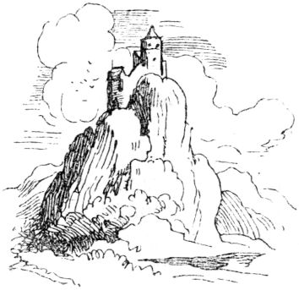

109

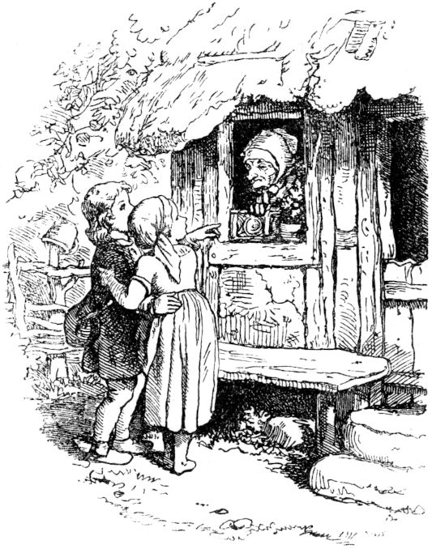

**The golden roebuck.**

Once upon a time there were two poor siblings, a boy and a girl, the girl's name was Margarete, the boy was called Hans. Their parents had died and left them no property, so they had to go out begging to get away. Both were too weak and small to work; because Hänschen was only twelve years old and Gretchen was even younger. In the evening they went to the first house, knocked and asked for a night's lodging, and many times they were 110has already been received, fed and drunk by good benevolent people; also some and some merciful had thrown them a piece of clothing.

So once in the evening they came in front of a little house, which stood alone; then they knocked on the window, and when an old woman looked out immediately afterwards, they asked her if she could stay here the night? The answer was: “Come on in!” But as they entered, the woman said: “I will keep you overnight, but if my husband becomes aware of it, you will be lost; because he likes to eat a young man's roast, so he slaughters all the children that come before his hand! ”The children were very frightened; but they couldn't go any further now, it was already very dark night. So they let the woman hide them in a barrel and kept quiet. But they couldn't sleep for a long time, especially since after an hour they heard the heavy footsteps of a man, who was probably the ogre. They soon became certain of that, for now he began to quarrel with his wife in a roaring voice that she would not cook a human roast for him. In the morning he left the house again and groped so loudly that the children, who had finally fallen asleep, woke up over it.

When they had got something to eat from the woman, she said: "You children now have to do something too, you have two brooms, go upstairs and sweep my rooms, there are twelve, but you only sweep eleven from them. For God's sake you can't open the twelfth. I currently want to do an exit. Be diligent that you will be ready when I come back. " 111The children returned very busily and they were soon finished. Now Gretchen wanted to know what was in the twelfth room that they shouldn't see because they were forbidden to open the room. She peeked a little through the keyhole and saw a wonderful little golden chariot, harnessed to a golden roebuck. She quickly summoned Hanschen to have him look inside too. And when she first looked around carefully to see whether the woman was not returning home, and since nothing was to be seen of her, they quickly opened the door, pulled out the wagon and the roebuck, sat down in the wagon and drove up and away. But not for long, they saw the old woman and the ogre coming towards each other from afar, just the way they had taken with the stolen car. Hanslein said: "Oh, Sister what are we doing If the two old people discover us, we will be lost. ”“ Quiet! ”Said Gretchen,“ I know a powerful little magic spell that I learned from our grandmother:

Rose-red rose stands out;

If you see me, don't see me! "

and immediately they were transformed into a rose bush. Gretchen became a rose, Hänslein became a thorn, the roebuck a stalk, the carriage a leaf.

Now both the ogre and his wife came walking along, and the latter wanted to break off the beautiful rose, but it stung herself so badly that her fingers bled and she went away angrily. When the old people were gone, the children got up quickly and drove on and soon came to an oven that was full of bread. Then they heard a hollow voice calling out: "Move my bread for me, move my bread for me." Quickly moved 112Gretchen the bread and put it in her car, whereupon they drove on. Then they came to a large pear tree, which hung full of ripe, beautiful fruits, from which it sounded again: "Shake my pears for me, shake my pears for me!" Gretchen shook immediately, and Hansen helped diligently pick up the pears and put the pears in the golden wagon pour. And again they came to a vine, which called out in a pleasant voice: “Pick me my grapes, pick me my grapes!” Gretchen picked these too and packed them in her car.

In the meantime, however, the ogre and his wife had arrived home and had perceived with anger that the children had stolen their golden wagon including the roebuck, just as these two had stolen the wagon and the roebuck long years ago and had also committed a murder in the theft, namely, slay the rightful owner. The carriage drawn by the roebuck was not only of great value in and of itself, but it also had the excellent quality that wherever it went, gifts were given from all sides, from trees and berries, from ovens and vines. So the people, the ogre and his wife, had owned the car for many years, albeit illegally, had good food donated and lived wonderfully and happily. Now that they saw Having been robbed of their car, they set out quickly to hurry after the children and steal their precious booty from them again. At the same time the ogre's mouth watered after roasting people; for he wanted to catch and slaughter the children at once. The two old men hurried after the children with long strides and soon caught sight of them from afar because they were driving ahead. 113The children now came to a large pond and could not go any further, and there was neither a ferry nor a bridge that they could have escaped over. There were only a lot of ducks to be seen swimming around merrily. Gretchen lured them to the bank, threw them food and said:

"You ducklings, you ducklings, swim together,

Make me a bridge so that I can come over! "

The ducks swam together amicably, formed a bridge and the children with the roebuck and wagon came happily to the other bank. But the ogre came quickly afterwards and growled in an ugly voice:

"You ducklings, you ducklings, swim together,

Make me a bridge so that I can come over! "

The ducks swam quickly together and carried the two old people over - do you think? No! in the middle of the pond, since the water was deepest, the ducks swam apart, and the evil ogre and his old men plopped down into the depths and perished. And Hänschen and Gretchen became very wealthy people, but they also donated a lot of their blessings to the poor and did a lot of good because they always thought of how bitter it was when they were still poor and had to go begging.

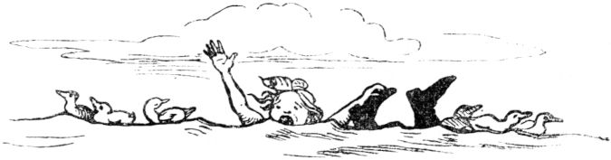

114

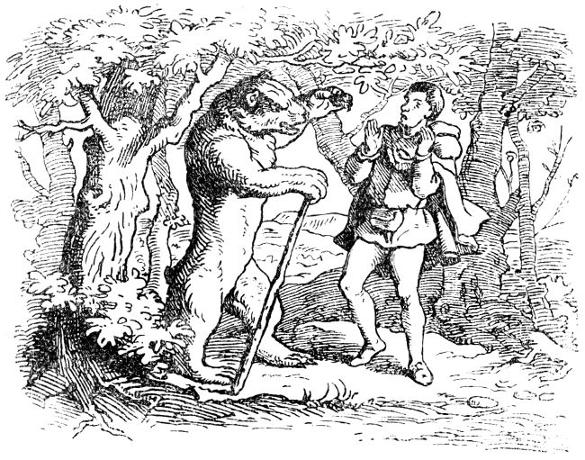

**The nut branch.**

Once upon a time there was a rich merchant who had to travel to foreign countries in his business. As he was saying goodbye, he said to his three daughters: “Dear daughters, I would like to make you happy on my return, so tell me what to bring with me?” The oldest said: “Dear father, a beautiful one for me Pearl necklace! ”The other said:“ I wanted a finger ring with a Demantstone. ”The youngest hugged her father's heart and whispered:“ A beautiful, green twig of nuts, father. ”-“ Good, my dear daughters! ”Spoke the merchant, "I'll take a look and then goodbye."

The merchant traveled far away and made great purchases, but also faithfully thought of the wishes of his daughters. He already had a precious pearl necklace in 115packed his suitcase to please his eldest, and he had bought an equally valuable Demantring for the middle daughter. But he couldn't see a green nut branch anywhere, just as he tried to. On the way home he therefore walked long stretches and hoped, since his route often led him through forests, that he would finally come across a walnut tree; but this was long in vain, and the good father began to be saddened that he was unable to fulfill the harmless request of his youngest and dearest child.

Finally, as he was walking so sadly on his way, which was just leading him through a dark forest and thick bushes, he bumped his hat on a branch and it rustled as if locks were falling on it; When he looked up, it was a beautiful, green branch of nuts with a cluster of golden nuts hanging from it. The man was delighted, reached up with his hand and broke off the splendid branch. But at the same moment a wild bear shot out of the thicket and stood on its hind paws, grumbling, as if it were about to tear the merchant apart. And in a terrible voice he roared: “Why did you break off my nut branch, you? Why? I'll eat you up. "Trembling with shock and trembling, the merchant said:" Oh, dear bear, don't eat me and let me go my way with the nut branch, I also want to give you a big ham and lots of sausages for it! ”But the bear roared again:“ Keep your ham and your sausages! Only if you promise me that you will give me what you meet first at home, I will not eat you. "The merchant was happy to accept this, because he thought of how his poodle usually ran towards him, and he wanted this, to save your life, gladly 116sacrifice. After a rough handshake, the bear padded calmly back into the thicket; and the merchant walked away quickly and happily, breathing a sigh of relief.

The golden nut twig was gloriously emblazoned on the merchant's hat as he hurried home. The youngest girl hopped joyfully towards her dear father; the poodle followed with great leaps; and the eldest daughters and mother stepped a little less quickly out of the front door to greet the newcomer. How terrified the merchant was when his youngest daughter was the first to fly towards him! Sorrowful and sad, he withdrew from the embrace of the happy child and, after the first greetings, told his family what had happened to him with the nut branch. Everyone wept and was saddened, but the youngest daughter showed the most courage and resolved to keep her father's promises. The mother soon devised some good advice and said: "If we don't be afraid, my friends, should the bear come and you, My dear husband, remember your promise, so instead of our youngest, we will give him the shepherd's daughter, he will be satisfied with her too. ”This proposal was valid and the daughters were happy again and were really happy about these beautiful gifts. The youngest always carried her nut branch with her; she soon stopped thinking of the bear and her father's promise.

But one day a dark car rattled through the street in front of the merchant's house and the ugly bear got out and grumbled into the house and in front of the frightened man, wanting to keep his promise. The shepherd's daughter, who was very ugly, was quickly and secretly fetched, nicely cleaned, and placed in the bear's carriage. And the 117Journey went away. Outside the bear laid his wild, shaggy head on the shepherdess' lap and growled:

"Gray me, crawl me,

Tender and delicate behind the ears,

Or I'll eat you skin and leg! "

And the girl began to crawl; but she did not please the bear and he saw that he was being cheated; 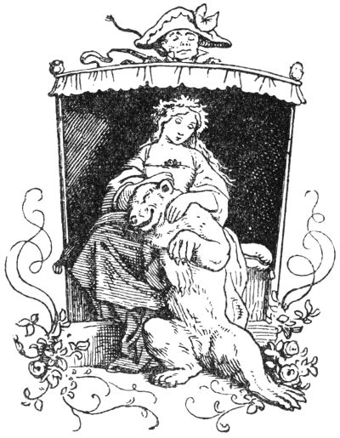then he wanted to eat the cleaned shepherdess, but she quickly jumped out of the car in her fear of death.

Thereupon the bear drove again to the merchant's house and called for the right bride with a terrible threat. So the lovely little girl had to come over to continue with the ugly bridegroom after a difficult bitter farewell. Outside he growled again, laying his rough head on the girl's lap:

"Gray me, crawl me,

Tender and delicate behind the ears,

Or I'll eat you skin and leg! "

And the girl crawled, and so gently that he liked it and that his terrible bear-face became friendly, so that gradually the poor bear-bride gained some confidence in him. The journey didn’t take long because the car drove incredibly fast, as if a storm wind was blowing through the air. Soon they came into one 118very dark forest, and there the car suddenly stopped in front of a dark yawning cave. This was the bear's apartment. Oh how the girl trembled! And especially since the bear clasped her with his terrible claw arms and said to her with a friendly grumbling: "You should live here, bride, and be happy if you behave well inside so that my wild animal does not tear you apart." And he closed When both of them had taken a few steps in the dark cave, an iron door opened and went with the bride into a room which was filled with poisonous worms, which licked greedily at them. And the bear growled in his bride's ear:

“Don't look around!

Not right, not left;

Alright, so you have peace. "

Then the girl went through the room without looking around and no worm stirred or moved for that long. And so it went through ten rooms, and the last one was filled with the most hideous creatures, dragons and snakes, poisonous toads, basilisks and lindworms. And the bear growled in every room:

“Don't look around!

Not right, not left;

Alright, so you have peace! "

The girl trembled and trembled with fear and anxiety like an aspen leaf, but she remained steadfast, did not look around, not to the right, nothing to the left. But when the twelfth room opened, a shimmering light shone towards both of them, there was a lovely music inside and there was exultation everywhere like shouts of joy, like cheers. Before the bride could even reflect a little, still trembling from looking at the terrible and now 119this surprising loveliness again - it made a terrible clap of thunder, so that she thought that earth and sky were collapsing. But soon it was quiet again. The forest, the cave, the poisonous animals, the bear - were gone; A splendid castle, with rooms adorned with gold and beautifully dressed servants stood there for it, and the bear had become a handsome young man, was the prince of the magnificent castle, who now pressed his dear bride to the heart and thanked her a thousand times that she and him his servants, the animals, so lovingly redeemed from his enchantment.

But the now so tall, rich princess still carried her beautiful nut branch on her bosom, which had the property of never withering, and now carried it all the more because it had become the key to her lovely happiness. Soon her parents and her siblings were informed of this friendly fate and were taken to the castle by the bear prince for a wonderful good life.

**The old wizard and his children.**

Once upon a time there lived a wicked magician who had recently stolen two tender children, a boy and a girl, with whom he lived in a lonely and solitary cave. He had sworn these children, thank God, to evil, and he practiced his evil art from a magic book that he kept as his best treasure.

But if it happened that the old magician withdrew from his cave and the children were alone in it 120If you stayed behind, the boy, who had spotted the place where the old man hid the magic book, read in the book and learned from it many a proverb and some black art formula, and learned to do magic himself very well. Because the old man only rarely let the children out of the cave and wanted to keep them prisoner until the day when they were to fall victim to evil, they longed all the more to get away, discussed with each other how they wanted to escape secretly, and one day, when the magician had left the cave very early, the boy said to the sister: “Now it is time, little sister! The wicked man who holds us so hard is gone, so let's get up now and walk away as far as our feet can carry us! ”The children did so, went away and wandered the whole day.

When it came towards afternoon, the magician had returned home and immediately missed the children. As soon as he opened his magic book and read in it which area the children had gone to, he had really almost caught up with them; the children could already hear his angry roaring voice, and the sister was full of fear and horror and cried: “Brother, brother! Now we are lost; the bad man is already very close! ”Then the boy used his magic, which he had learned from the book; he spoke a saying, and immediately his sister became a fish and he himself became a large pond in which the little fish swam cheerfully around.

When the old man came to the pond, he noticed that he had been cheated, grumbled angrily: “Just wait, just wait, I'll catch you!” And ran straight back to his cave to fetch nets and the fish in them 121catch. But when he was gone, the pond and fish became brother and sister again, they hid themselves well and slept, and the next morning they hiked on and hiked again for a whole day.

When the evil wizard came with his nets to the place he had remembered, there was no more pond to be seen, 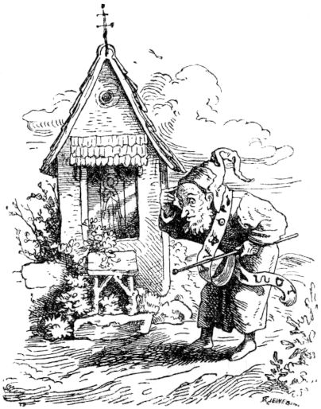instead there was a green meadow in which there were frogs but no fish to catch; then he became even more angry than before, threw down his nets and continued to follow the children's trail, which he did not miss, for he was carrying a wizard in his hand which showed him the right way.

And when it was evening he had almost caught up with the wandering children; they already heard him snort and roar and the sister called again: “Brother, dear brother! Now we are lost, the evil enemy is close behind us! "

Then the boy uttered another magic spell that he had learned from the book, and he became a chapel on the road, and the girl a beautiful altarpiece in the chapel.

He noticed how the magician came to the chapel 122probably that he was again ape and ran around it, roaring terribly; but he was not allowed to enter it, because it was always in the wizard's pact with evil that they were never allowed to enter a church or a chapel.

"If I am not allowed to enter you either, I want to toast you with fire and burn to ashes too!" Shouted the magician and ran away to get fire from his cave.

While he ran through most of the night, the chapel and the beautiful altarpiece became brother and sister again; they hid and slept, and on the third morning they wandered on and wandered all day while the wizard, who had a long way to go, pursued them again. When he got with his fire to where the chapel had stood, his nose struck a large stone rock that could not be struck with fire and burned to ashes, and then he ran furiously on in the children's trail.

Towards evening he was now very close to them, and for the third time the sister hesitated and was lost; but the boy uttered another magic spell that he had learned from the book, and it became a hard threshing floor on which the people thresh, and his little sister was transformed into a grain that lay as if lost on the threshing floor.

When the wicked wizard approached, he saw that he had been aping for the third time, but this time did not think twice, did not first run home, but also spoke a saying that he had learned from the magic book; then he was transformed into a black rooster, which ran quickly towards the stye in order to get it 123to pick up; but the boy uttered a magic spell that he had learned from the book, and he quickly became a fox, grabbed the black rooster before he had picked up the stye and bit his head off, and the magician had like this Fairy tale, an end soon.

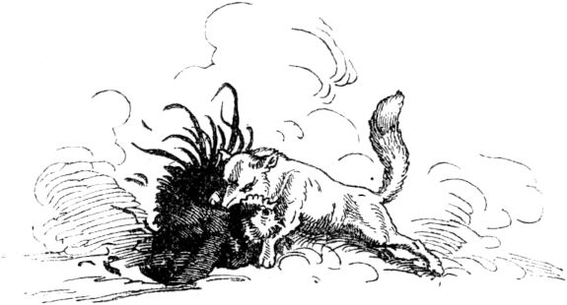

**The Grim Reaper.**

Once upon a time there lived a very poor man, his name was Klaus, to whom God had brought abundance of wealth, which worried him very much, namely twelve children, and over one little one came another little one, that was the thirteenth child. Then the poor man of his worries had no advice where he should get a godfather, because all his clans and magicians had already given him children, and he could not hope to find a compassionate soul among his friends. who love his youngest child. So I thought to turn to the first complete stranger, especially since some of his acquaintances had already rejected him with a lot of hard-heartedness in similar cases.124

So the poor child's father went out onto the country road, willing to offer the child's godparenthood to the first person he met. And behold, he soon met a very friendly man, stately appearance, well-formed, not old, not young, mild and kind in face, and then it seemed to the poor as if the trees and flowers and all the grass bowed down before that man. and cereal stalks. Then it seemed to Klaus that it must be the good Lord, took off his bad hat, folded his hands and prayed an Our Father. And it was also the good Lord who knew what Klaus wanted before he asked and said: “You are looking for a godparent for your child! Well, I want to give it to you, I, the good Lord! "

"You are too kind, dear God!" Replied Klaus despondently. “But I thank you; you give children to those who have goods and children to the other, so often both lack the best, and the rich indulge, the poor hunger! ”The Lord turned to this speech and was no longer seen. Klaus went on, and as he had walked a distance, a guy came up to him who not only looked like the devil, but was it and asked Klaus who he was looking for? - He's looking for a godparent for his child. - "Hey, take me there, I'll make it rich!" - "Who are you?" Asked Klaus. “I am the devil!” - “That would be the devil!” Shouted Klaus, measuring the man from horn to horse's foot. Then he said: “With all due respect, go home to yourself and to your grandmother; I don't like you for my godfather, you are the very worst! God be with us! "

Then the devil turned around, showed Klaus a hideous grimace, filled the air with a sulphurous stench and drove away. Then met the child's father 125Again a man who was as thin as a hops stick, so thin that he rattled; he also asked: "Who are you looking for?" and offered to sponsor the child. "Who are you?" Asked Klaus. "I am death!" Said the other in a very hoarse voice. - Then Klaus was scared to death, but he took courage, thought: With him my thirteenth son would be best looked after, and said: “You are the right one! Poor or rich, you will do it right away. 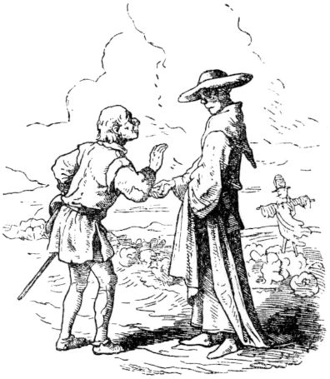Great! You should be my godfather! Just imagine at the right time, the baptism should be on Sunday. "

And on Sunday the real death came, and there was a decent dot, that is the little one's godmother, and the boy grew and prospered very happily. When he had come to the years when man had to learn something so that he could earn his bread in the future, the godfather came at that time and told him to go with him into a dark forest. There were all kinds of herbs, and Death said: “Now, my godmother, you should receive your godparent gift from me. You should become a doctor above all doctors through the right, true medicinal herb that I am now giving you in your hand. But notice what I am telling you. If you are called to a sick person, you will see my figure every time.

If I stand at the head of the sick person, you can assure me 126that you want to heal him and give him some of the herb; but when he has to chew earth, I stand at the sick man's feet; then just say: No doctor in the world can help here, and neither can I. And if you don't need the medicinal herb against my mighty will, it would go badly for you! "

With that death went away and the young man went on a wandering journey, and it did not take long 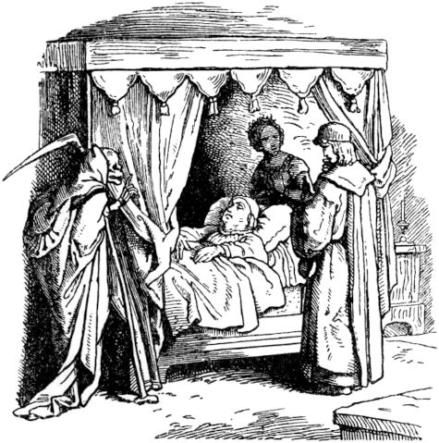so the call went before him and the fame that he was the greatest doctor on earth, because he saw it like the sick whether they would live or die. And so it was. When this doctor saw death at the sick man's feet, he sighed and said a prayer for the soul of the departing; But when he saw the figure of death at the head, he gave him a few drops, which he pressed out of the medicinal herb, and the sick healed. Then his fame increased day by day.

Now it happened that the miracle doctor came to a country whose king was seriously ill, and the court doctors gave no more hope of his coming. But because the kings least like to die, the old king hoped to see another miracle, namely that the miracle doctor would heal him, let him be called and 127promised him the highest wages. But the king had a daughter who was as beautiful and as good as an angel.

When the doctor came into the king's chamber, he saw two figures standing by his bed, at the head the beautiful weeping king's daughter and at his feet the cold death. And the king's daughter pleaded so touchingly to him to save her beloved father, but the figure of the dark godfather gave way and did not waver. Then the doctor thought of a ruse. He had swift servants turn the king's bed quickly, and quickly gave him a drop of the medicinal herb, so that death was deceived and the king saved. Death retreated angrily, but raised his long bony index finger threateningly at his godfather.

He was in love with the lovely king's daughter, and she gave him her heart out of deep gratitude. But soon afterwards she became seriously and severely ill, and the king, who loved her above all else, made it known which doctor would heal her, who should become her husband and then king. Then a high hope flared through the young man's heart, and he hurried to the sick woman - but death stood at her feet. In vain did the doctor throw his godfather pleading looks that he should change his position and step a little further up, possibly right up to the patient's head. Death did not leave its place, and the patient seemed to be passing away, but she looked at the youth pleadingly for her life. Death's godfather practiced his cunning once more, quickly turning the bed of the king's daughter around, and quickly gave her a few drops of the medicinal herb, so that she revived and smiled gratefully at her lover. But death threw its deadly hatred on the youth, seized him with an iron, ice-cold hand 128and led him from there into a vast underground cave. Many thousands of candles were burning in that cave, large and half-large and small and very small; many went out and others were ignited, and death said to his godfather: “See, here every person's light of life burns; the big ones are for the children, the half-big ones are for the people who are in their prime, the small ones for the old and old, but also children and young people often only have a small light of life that soon goes out. "

“Show me mine!” The doctor asked Death, who then pointed to a very small stump that was soon in danger of going out. “Oh dearest godfather!” Asked the young man, “I want to renew it for me so that I can become my beautiful bride, the king's daughter, free, her husband and king!” - “That doesn't work -” replied death coldly. "One has to burn out completely before a new one is put on and plugged in."

"So just put the old one on a new one!" Said the doctor - and death said: "I want to pretend!" Took a long light, pretended to put it on, but did it on purpose and knocked over the little one, that it went out. At the same moment the doctor sank down and was dead. No remedy for death can be found.

**The man without a heart.**

Once upon a time there were seven brothers, were poor orphans, had no sisters, had to do everything in the house themselves, they didn't like that, they shared advice, they wanted to get married. But now there was where they lived 129no brides for them, the older ones said they wanted to move abroad, look for brides and their youngest should look after the house, and they wanted to bring him a very beautiful bride. The youngest was probably satisfied and the six set off happily and cheerfully. On the way they came to a little house, which stood quite lonely in a forest, 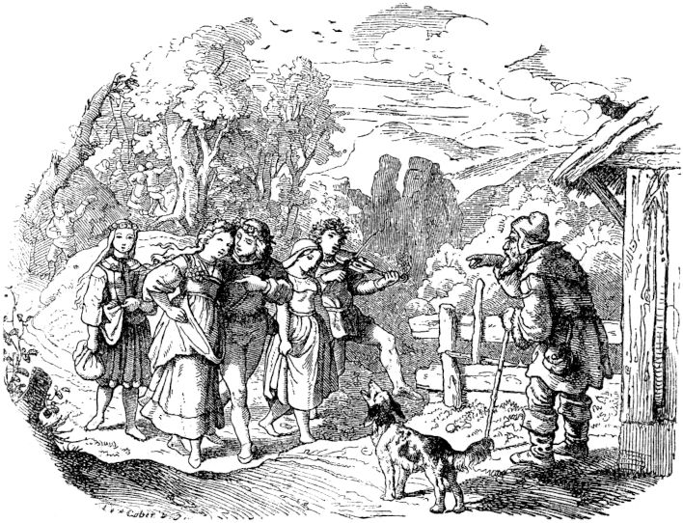and in front of the house was an old man who called the brothers and asked: “Heda! Your young Gieke-in-die-Welt! Where are you going so funny and so fast? ”“ Well, we each want to get a pretty bride for ourselves, and one for our youngest brother at home too! ”Replied the brothers.

"O dear boys!" Said the old man, "I live here so alone, bring me a bride too, but it must be a pretty young one!"130

The brothers went away and thought: Hmm, what does an old, ice-gray wooden man want to do with a pretty young bride? -

Now that the brothers had come to a town, they found seven sisters there, as young and as pretty as they could possibly wish, and they took them, and they took the youngest with them for their brother. The path led them through the forest again, and the old man was standing in front of his house again, as if he were waiting for them, and said: "Oh, you good boys! I praise that you have brought me such a beautiful young bride! ”-“ No! ”Said the brothers,“ she is not for you, she is at home for our brother, we promised him it! ”-

“So?” Said the old man, “promised? Oh that you! I will promise you too! ”and took a white stick and mumbled a few magic words, and touched the brothers and the brides with the stick - except for the youngest - they were all turned into gray stones. The youngest of the sisters, however, was taken into the house by the man, and she now had to load it up and keep it in order, and she was happy to do it, but she was always afraid that the old man would soon die and then she would be in the lonely house in the wild desolate forest to be so all alone as the old man had been before. She said that to him and he replied: “Have no fear, do not be afraid and do not hope that I will die. See, I have no heart in my chest! but if I die anyway, you will find my white magic wand above the door,

"But where in the world do you have your heart if you don't have it in your chest?" Asked the young bride. 131"Do you have to know everything?" Asked the old man. "Well, if you have to know, my heart is in the duvet."

Then the young bride sewed and embroidered beautiful flowers on his bedspread in her loneliness when the old man went about his business, so that his heart should be happy. But the old man smiled at it and said: 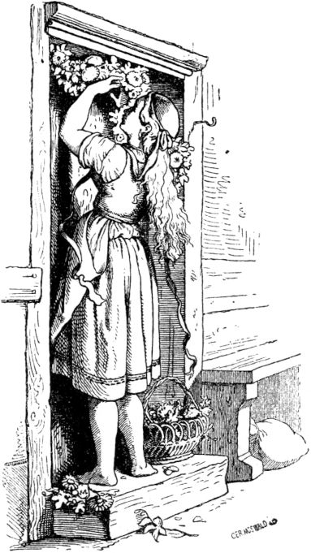“You good child, it was just my joke; my heart, that's stuck - that's stuck "-" Well, where is it, dear father? "-" It's in the - room door! "-

The next day the old woman was gone, the young woman adorned the door of the room with brightly colored feathers and fresh flowers and hung wreaths on it. When he got home, the old man asked what that meant? She said: “I did that to please your heart.” Then the old man smiled again and said: “My heart is completely different from the door of the room.” The young bride was very saddened and said: "Oh, father, you have a heart and you can die and then I'll be so alone." Then the old man repeated everything that he had already said to her twice, and she urged him anew, to her 132say where his heart actually is? Then said the old man: “Far from here, in deep solitude, lies a large, ancient church, which is firmly secured with iron doors, around it is a deep moat, over which there is no bridge, and in the church there is probably a bird now and then, he doesn't eat, drink or die, and nobody can catch him and as long as the bird lives, I live that long too, because my heart is in the bird. "

Then the bride was sad that she could not do anything to please the heart of her old man, and the time became long for her when she sat so alone, for the old man was out most of the day.

Once a young traveling companion passed by the house, he greeted her and she greeted him and he liked her, and he came closer and she asked him where he was going, where he was from? - “Oh!” Sighed the young fellow, “I'm really sad. I still had six brothers who moved from there to get brides, and they wanted to bring one for me, the youngest, too, but they never came back, and so now I'm away from the house and want to look for my brothers. "

“Oh, dear fellow!” Cried the bride, “you don't need to go any further! First sit down and eat and drink something, and then let me tell you! ”And gave him something to eat and drink, and told him how his brothers had come to town, and how they brought their sisters and they themselves as brides with them Would have wanted to run the house, and that she was destined for him, her guest, and how the old man had kept her with him and turned the others into gray stones. She told him all this sincerely and wept along with it, and also that the old man had no heart in his chest and that it was far, far away in one 133fixed church and in an immortal bird. Then the bridegroom said: “I want to go, I want to look for the bird, maybe God will help me catch it.” - “Yes, do that, you will do well with it, then your brothers and my sisters will become people again ! "And hid the bridegroom, because it was already evening, and when the next morning the old man was gone again, 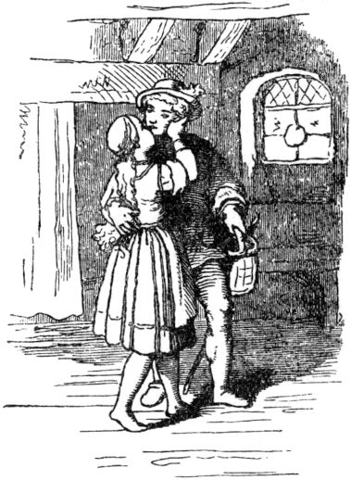then she packed a lot to eat and drink for the journeyman, and gave it to him, and wished him all the luck and God's blessings on his journey.

When the companion had come a long way, he thought it was time to have breakfast, unpacked his travel bag, was delighted with the many gifts and shouted: “Holla! now we want to feast! Whoever wants to be my guest! "

Then it shouted from behind the journeyman: “Moo!” And as he looked around, a big red ox stood there and said: “You have invited, I would like to be your guest!” - “Be welcome and stay as long as I can The ox lay down leisurely on the ground and let himself be tasted, and then licked its mouth quite nicely with his tongue, and when he was full he said: "Thank you very much and if you ever meet someone need to help you in need and danger, just call out to me, your guest, in your mind. ”And got up and disappeared 134In the shrubs. The companion packed up the remains of his table and made the pilgrimage, again a long way, when, after the short shadow he cast, it seemed to him that it must be noon, and his stomach thought the same. So he sat down on the ground, spread out his tablecloth, put his food and drinks on it, and cried: “Well! Lunch! Now let me know who wants to be served! ”There was a lot of rustling in the bushes, and a wild pig broke out, which grunted: oui oui oui, and said:“ Somebody called here to eat! I don't know if it was you, and if I was meant? "

"Anyway, just watch what's there for a long time!" Said the wanderer, and then they both ate happily together and both tasted good. Then the wild pig got up and said: "Thank you, if you need me, call the pig!" And with that it trudged into the bushes. Now the companion hiked a long distance, and had already hiked a long way, then it was towards evening, and he felt hungry again and also had supplies, and then he thought: How about having a snack? It would be time, I think; and again spread out his cloth and put his food on it, also had something to drink, and shouted: “Whoever wants to eat should be invited. It's not as if nothing was there! ”A heavy flap of wings rushed above him and became dark on the ground, as if from the shadow of a cloud. and a great griffin appeared, which called out: “I heard someone invite down here to the table! Nothing will fall off for me? "

"Why not? Settle down and take it easy, it won't be much! "Cried the young man, and then the Griffin sat down and ate enough, and then he said:" If you need me, call me! " 135rose into the air and disappeared. Well, thought the journeyman, he's in a great hurry; he could have shown me the way to church, because I will probably never find her that way, and gathered up his things, and wanted to hike a bit before going to bed. And when he hadn't gone long, he suddenly saw the church lying in front of him and was soon with it, that is, at the broad and deep ditch that surrounded it without a bridge. So he looked for a nice place to rest, because he was tired from the long walk and slept, and the next morning he wished he was over the ditch and thought: Look, if the red ox were there and was really thirsty, he could Fill up the ditch and I would come across dry. No sooner had this wish been done than the ox stood there and began to drown out the ditch. Now the companion was standing at the church wall, which was really thick and the towers were made of iron, and he thought so in his mind: Oh, who would have a wall breaker! The strong wild pig might be more able to do something here than I can. And behold, the wild pig came running up and bumped violently against the wall and rooted loose a stone with its tusks, and as soon as one was loose, it dug more and more stones out of the wall until a large, deep hole was dug was through which one could enter the church. So the young man climbed in and saw the bird flying about in it, but was unable to take hold of it. Then he said: "If the griffin were there now, it would grab you, that's why it's the griffin!" And the griffin was there and immediately he grabbed the bird,136

Now the young man hurried as much as he could to the young bride, arrived before evening and told her everything, and she gave him food and drink again and told him to crawl under the bed with his bird so that the old man would not see him . He did this immediately after he had eaten and drunk; The old man came home and complained that he felt ill, that he would no longer want to leave - that was because his heartbird was caught. The bridegroom heard this under the bed and thought, the old man may not have done you any harm, but he put a spell on your brothers and their brides, and he kept your bride to himself, that is not too little of the evil, and so he pecked the bird, and then the old man whimpered: “Oh, it pinches me! Oh, death pinches me, child - I'm dying! "And fell from the chair and passed out, and before the young man knew it, he had pinned the bird to death, and then it was over with the old man. Now he crawled out, and the bride took the white staff, as the old man had taught her, and struck the twelve gray stones with it; behold, they became the six brothers and the six sisters again, it was a joy and an embrace and hearts and kisses, and the old man was dead and stayed dead, couldn't a masterwort bring him back to life if they would have wanted him alive again. So they all moved away together, and had weddings together, and lived well and happily together for many years. behold, there they became the six brothers and the six sisters again, that was a joy and an embrace and hearts and kisses, and the old man was dead and stayed dead, couldn't a masterwort bring him back to life if they also had him want to be alive again. So they all moved away together, and had weddings together, and lived well and happily together for many years. behold, there they became the six brothers and the six sisters again, that was a joy and an embrace and hearts and kisses, and the old man was dead and stayed dead, couldn't a masterwort bring him back to life if they also had him want to be alive again. So they all moved away together, and had weddings together, and lived well and happily together for many years.

137

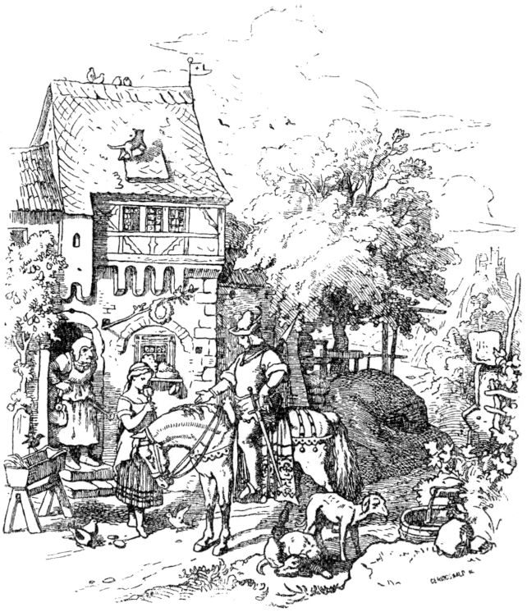

**Star and bathtub.**

A handsome young rider stopped in front of an inn in the forest, and a fine maiden came out of the door, greeted him chaste, and asked what he wanted. So he asked for a mug of cool wine, which the maiden brought him. The rider did not drink until the maiden had sipped the wine with her red lips and served him the drink. While he was drinking now 138the landlady stepped out the door, an ugly woman with a brown complexion and a disgusting appearance. The rider asked: “Holla, landlady! You really have a fine daughter! Not so? ”-“ No, sir! ”Answered the landlady,“ this whore there is not my daughter, she is only my adopted maid, no longer has parents or home. I accepted them out of mercy. "

The rider felt love for the beautiful maiden, dismounted from his horse, wanted quarters for the night, and that the maid should prepare a footbath for him because he wanted to talk to her. The landlady told the maid to go into the garden and pick rosemary, thyme and marjoram for the bath. She did this gladly and happily, went and broke the herbs, when a star flew onto a bush next to her and sang and said: Oh, dear bride! Thou shalt bruise the Junker's feet in the little bath tub in which you were carried here! Your father died of heartache and your mother grieved to death for you!

Alas, you bride, you foundling!

Do not know who your father and mother are!

Then the pious maiden was frightened and grieved, prepared the bathroom with tears in the little tub, and carried it up to the room where the young knight was waiting for her. When he saw her crying, he asked: “Why are you crying, beautiful one? Wouldn't you rather be happy with me? "

"How can I be happy with you?" She asked back, crying. “I cry over what the star was singing to me, as I was down in the garden picking the herbs in your bathroom. The star who sang: Alas, you bride! Thou shalt bruise the Junker's feet in the little bathtub, 139in which you are carried. Your father died of heartache and your mother grieved to death for you!

Alas, you bride, you foundling!

Don't know who your father and mother are! "

Then the gentleman looked at the little bathtub and saw the coat of arms of the king on the Rhine, was amazed beyond measure and cried: “This is my father's coat of arms! How does this little girl get into this bad tavern? "

Then a bird banged against the window outside, that was the star again, who sang: In the little bathtub she was carried!

Alas, you bride, you foundling!

Do not know who your father and mother are!

Now the young gentleman saw a birthmark on the maiden's neck and exclaimed joyfully: “Howdy God, you most beautiful! You are my dear sister! Your father was the king on the Rhine! Christine is your mother's name! My name is Konrad, I am your twin brother. That is why my heart felt such a strong desire for you as soon as I saw you for the first time! "

Then they fell on each other's necks and both wept, knelt down and thanked God, and talked lovingly to one another all night. As the dawn broke, the landlady called out in front of the door with a loud voice and full of scorn: "Get up, get up, you young bride, and sweep the room of your wives!" But Mr. Konrad's voice answered: "Neither is she a young bride, she is still sweeping her room for the landlady! Just bring us the morning wine yourself! ”When the landlady came in with the morning wine, she asked Mr. Konrad:“ From whom and from whom did you get this noble one 140Virgin? She is a king's daughter and my sister! "

The landlady went white as a wall and fell trembling on her knees, but couldn't utter a word that was not needed, because the star was already at the window again and betrayed the landlady's evil deed by singing: In a pleasure garden in the green Grass, sat a tender child in a little bathtub, and when the nurse had only stepped aside for a moment, the angry gypsy came and carried the child and the little bathtub away!

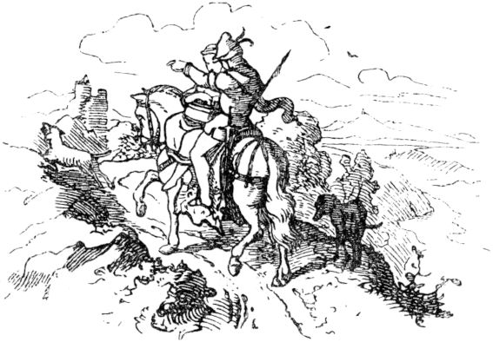

Herr Konrad became so indignant about this that he drew his sword and speared it through the ears of the landlady, one in and one out. Then he kissed his most beautiful sister, took the bathtub, led her out of the house by her snow-white hand, lifted her onto the saddle and she had to carry the bathtub in front of her on her lap. The star sat on her shoulder. So they rode in front of the royal palace on the Rhine, in which the mother, the queen, ruled, and 141as they rode into the gate, their mother was just walking towards them. She asked in astonishment: “Oh, my dearest son! What kind of whore are you bringing in there? She carries a little bathtub with her, as if she were walking with a child! "

“Oh, my dearest mother!” Replied the young prince, “she is therefore not a prostitute, but is your daughter Gertraud, who was stolen from you in this little bed!” And then the princess got out of the saddle, but the queen fell with joy into a swoon from which she awoke again in the arms of her children. The star sang: Today it's just eighteen years since the king's daughter was stolen and carried across the Rhine in the Wännelein! This is what the star sang, and this too:

The gypsy's ears hurt so much

She won't steal any more children!

The princess, however, had a goldsmith appointed, who had to forge a little golden lattice over the little bathtub, there she put the star in it and looked after him to the end.

142

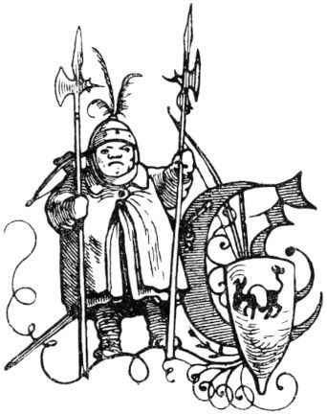

**The two round millers.**

There was once a miller who was already very strong and fat in himself, but also wanted to be firm against blows and stabs, bolts and arrows, so he put himself in strange clothes. First of all he had a doublet made for himself, fed it with lime and sand, and let melted pitch flow into it in order to combine it, in the back he made a lining of several baskets and in the front he sheeted it with old graters and iron lid lids the doublet heavier than the heaviest chest and back armor a warring knight ever wore.

This miller put on three shirts over them, and under the doublet he put a real armor, over the shirts also an armor, and over them he put on nine bright skirts, as they are still made today by woolen weavers in Swabia. When the miller dressed himself in this stately bulwark of clothes, while he kept his legs with more than four old lederhosen pulled over one another, he was such a stately, spherical fellow that he was as wide as high as a right ball must be, and could hardly go in and out through a city gate without being forced, could hardly move and stir, and then his friendship with him had to go, lead and accompany him. Because he 143now went to St. Oswald's church day every year and also wanted to be seen in front of the people, so he drove along on a cart in his armor and armed in a way that anyone had never seen before. Four strong oxen pulled the cart, and behind it all the peasants in his town went with their wives and children, who, when an enemy showed up, stuck themselves behind their miller's cart, as if behind a fortress and an umbrella hat. He was armed with two spears and a crossbow, at his side hung a sword a man's length, a two-handed sword; and next to him lay a bow and a quiver of arrows.

When the round miller came with his cart and his four oxen to a certain mountain, over which the road led, a pair of nephews with wife and children were waiting for him there, who helped push the cart up, while six oxen were in front as the opening credits, and so they finally brought him up with a bang and a bang and the shedding of many drops of sweat. If it was going down again on the other side of the mountain, you had to restrain as much as possible so that the round ball did not go head first head down. When his kin had finally reached his goal, he would be crushed from the wagon with ladders and lifting trees like a large full wine barrel, and then they would crowd around him, and mostly behind him like the Philistines behind their Goliath.

The round flour sack was of great strength and fearlessness, and it was said that once in a game of abuse, one fighter carried an apple and the other a pear at the tip of his blade, and a great racket arose smacked in the middle of the pile like a shower of hail in the grain, 144so that he brought much suffering to many peasants. But then he was met by an opponent, strong and vigorous, who struck a major blow at the miller that his tin hood fell to the ground, and everyone who saw it said that his head had flown off with him; But as his opponent drew back, the spherical champion had quickly pulled his head out of the hood and under the high neck, and now he was doing a prank at the enemy that cut his throat as deep as the mower's scythe did the grass. Everyone was afraid of the huge man to whom the deeds that one read of warriors seemed to be just joking.

But now there was another miller in the neighborhood, he was just as strong and tall, just as round as a ball and also wore such a well-lined and sheeted doublet, and neither liked the other because neither was inferior to the other. And hated and warred one another for ten years. On every church festival day wherever they went, they clashed and fought each other with words and weapons; but none of them could harm the other, and they were two very feared battle heroes. One miller had a son, the other a daughter, who both loved each other as much as their fathers hated each other, and the conflict grew even greater, until at last good and insightful friends came up against each other and advised both millers to make good friends and marry their children together.

When the rumor of the alliance between the two millers spread across the country, and that they even wanted to marry their children together, there arose great unrest and concern, for everyone could now count on their fingers that the two would be spherical 145like two millstones, between which everything that came too close to them would be wiped out. And whoever stepped too close to the one miller had to deal with both of them, and no prince could overcome both jackets, because the millers were like round castles and could not be starved to death by a siege, because they also had some in their jackets Metze caught, from which they could draw for a long time. But since the two insurmountable heroes were so manly that even the emperor would have had great difficulty in overcoming them, one only had to be glad that they turned their great power against the enemies of the empire, and wanted no wages at all Wages, but only the honor to be able to fight and argue. And was that only their only complaint that so many a day went by when they saw no opponent,

The two ball-shaped millers have performed many brave deeds since they were connected, and if one had written down these deeds and the adventures they had through them, it would have been a book, twice as strong as the Bible and the chronicle of the world. They also did more miracles than any of the warriors the ancient songs and stories tell of. At last they set up their homes in a desert at the far end of the world, and if they haven't died they are still alive today.

146

**The judge and the devil.**

In a city sat a man who had all boxes full of money and goods, but he himself was full of all vices, he was so bad that the people thought it was a miracle that the earth did not devour him. This man was also a judge, that is, a judge who was full of all injustice. On a market day he rode out in the morning to see his beautiful vineyard, when the devil came up to him on the way home, in rich clothes and shaped like a very distinguished gentleman. Since the judge did not know who this stranger was and still wanted to know this, he did not ask him politely who and from whom he was? The devil replied: “You are better off if you don't know who and where I am from!” - “Hoho!” Exclaimed the judge, “if you are who you want, I must know, or you are lost because I am the man, who has power here, and if I do you this and that, there is no one who will and can defend me. I'll take your body and belongings if you don't let me know in response to my question! ”-“ If things are so bad, ”replied the evil,“ then I must reveal my name and my origin to you; I am the devil."

“Hm!” Growled the judge, “and what is your business here, I want to know too!” - “Look, Mr. Judge,” answered the evil one, “I have been given power to go to this city today, and that to take what is given to me in all seriousness. "

"Well!" Replied the judge, "do so, but let me be his witness that I see what they will give you!"

“Don't ask me to be there when I take something 147I am granted, ”the devil advised the judge against; But he began to conjure up the prince of hell with mighty spells, and said: "I command and command you by God and all God's commandments, by God's power and God's wrath, and by everything that binds you and your comrades. and by the eternal judgment of God, so that before my face, and not otherwise, you take what is seriously given to you. "

The devil was frightened that he trembled at these terrible words, and made a very annoyed face, also said: "Well, I would like that I didn't have life! You bind me with such a strong bond that I've hardly ever been in a bigger fix. But I give you my word as prince of hell, which I never break as such, so that it does not serve you piously if you insist on your mind. Get out of it! "

"No, I am not getting away from it!" Shouted the judge. “Whatever happens to me about it, I have to put up with it; I just want to see that! And should it affect my life! "

Now both the judge and the devil went to the market together, where it was market day, so a large crowd gathered, and everywhere the judge and his companion, of whom nobody knew who he was, were offered full cups and they were informed to do. The judge did this according to his custom, and also handed the devil a pot, but the devil did not accept the drink because he knew that the judge was not serious.

Now it happened by chance that a woman drove a pig along, which did not go according to her will, but crossed the cross, when the angry woman shouted to the pig in the highest annoyance: "Well, go to the devil so that he can go with you." Get skin and hair! "148

“Do you hear, journeyman?” Shouted the judge to the devil. “Now reach out and take the pig.” But the devil replied: “Unfortunately, the woman is not serious about her word. She would mourn and grieve for a whole year if I took her pig. I can only take what is seriously given to me. "

Something similar happened soon afterwards to a woman and a child. The latter did not go the way the woman wanted to direct it, so that she began to scream: "The devil take you and turn your neck!" "Do you hear, journeyman?" Asked the judge again. "The child is yours, don't you hear that it is seriously being given to you?"

"Oh no, you are not serious either!" Answered the devil. "She would lament bitterly, if I took her at her word, and not let the child go."

Now they both saw a woman who had a lot to do with a child, who screamed violently and behaved very naughty, so that the woman was full of indignation and exclaimed: “If you don't want to follow me, the evil enemy will take you, you brat ! "

"Now? won't you take this child either? "asked the judge, very surprised, and the devil replied:" I have no power to take the child. This woman would not take ten, not a hundred, or a thousand pounds, and would seriously treat me to the child; however much I would like to take it, I am not allowed to, because the woman is not really serious. "

Now the two of them came right in the middle of the market, where there was the greatest crowd, so they had to stand a little still and could not walk through the bustle and turmoil. Then a wife of the judge saw who was poor and old and sick and was carrying 149a great hardship; she began to weep and scream loudly, and let the people hear the following violent speech: “Woe to you, judge! 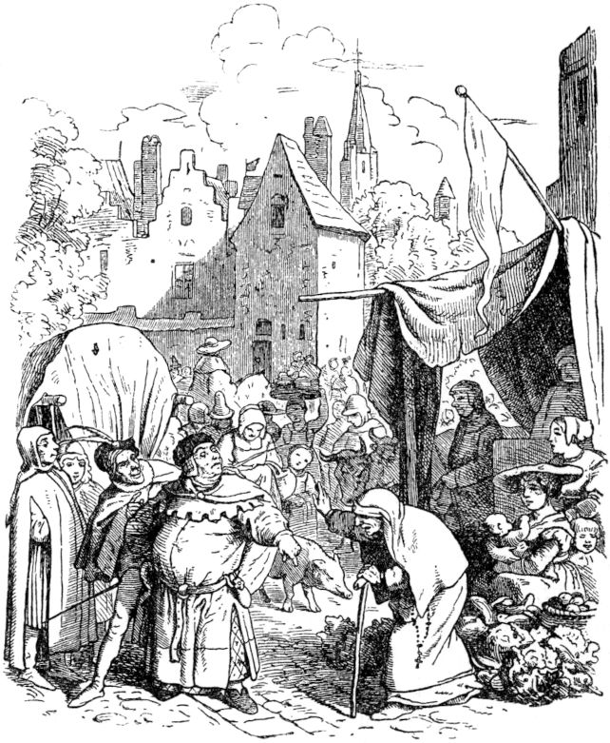Woe to you that you are so rich and I am so poor; you have taken from me without guilt, denying divine and human mercy, my only cool girl, who nourished me, from whom I had all my livelihood. Woe to you who took it from me! I plead and scream 150to God that through his death and bitter suffering, which he endured for humanity and for us poor sinners, he grant my request, and it is that the devil may lead your body and soul to hell! ”He responded to this speech Judge neither saying nor asking, but the devil scornfully scorned him and said: "You see, judge, this is serious, and you should be aware of it right away!" With that the devil stretched out his claws, took the judge by the forelock, and drove away with him through the air like a vulture with a chicken. All the people were shocked and amazed, and wise men uttered the doctrine:

It is unwise advice

Who gaht at the devil.

Who likes to drive around with him,

He gets a bad reward.

**Happy Hans.**

Once upon a time there was a peasant boy, called Hans, an honest blooded man, who did not seem to have fallen on his head, he served faithfully and honestly a great, rich gentleman for a number of years. In the end, however, Hans got homesick, wanted to be with his mother and asked his master about the wages he had earned. He gave Hansen a piece of gold that was as big as Hansen's head, and Hansen's head wasn't one of the thinnest and smallest. He was satisfied, put the heavy gold nugget in a handkerchief and got down on the walking sticks. But walking became blood angry for him, he was sweating and dripping, because the gold nugget was terribly heavy, he liked it 151Carry it however you want, on your head or on your shoulders.

Then a rider trotted past Hans easily and cheerfully, sat on a horse as smooth as glass. "Oh!" Shouted Hans, "riding is a fine art, if you can do it and have a horse!" 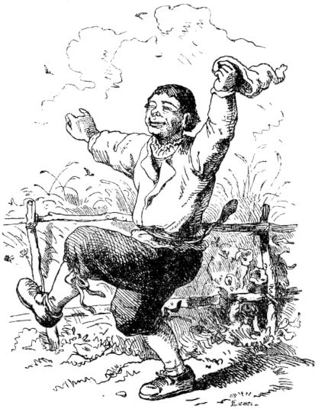The rider stopped his horse because he heard Hansen's speech in his ears and asked him what he was dragging himself with so laboriously?

"Oh! it is gold, pure heavy gold! Man is a troubled animal! ”Said Hans, groaning to throw the lump to the ground.

“Oh!” Said the rider, “if you want to ride, let's make an exchange. Give me your lump of load and take my horse for it! ”Hans didn't accept that twice, he called out cheerfully:“ Great, strike! ”And the deal was closed. The rider took the gold and used it to get Hansen out of his face, thinking that the deal might repent them. But Hans climbed up on the horse and rode away, so that it was dusty, but not for long when the horse jumped so that Hans, who could not ride, fell down like a bag of nuts. Could hardly move a limb. A farmer who was pulling a cow caught the unmarried horse 152and it leads to where Hans was. He cried and rubbed his bones. “Never ride again is not good for you! Who would have such a gentle little kitchen like you there, good friend! You could eat milk there every day, and butter and cheese and it won't be thrown off. "

"Well," said the smart farmer, "if you like the cow so well, I like your brave horse too, give you the cow for the horse!"

"This is a good exchange, I praise it," 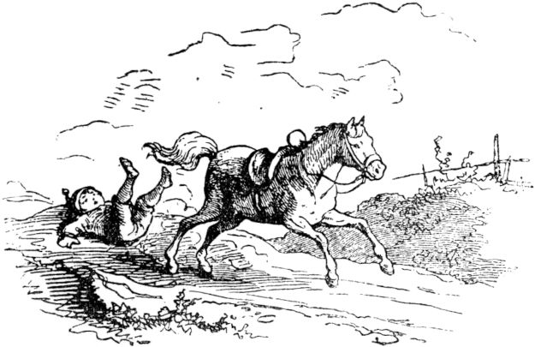said Hans, took the cow and drove her ahead of him while the farmer sat on the horse and heidi, didn't you see, rode away.

When Hans came to an inn, he ate his last few pennies, because he now thought that he had the cow, he didn't need any money, and marched on. But it was very hot that day and still a long way to the village where Hans was from and where his mother lived, and Hansen was thirsty. So he got ready to milk the cow, but so clumsily that no milk came, and that at last the cow gave him a kick, away 153he lost hearing and seeing and he did not know whether he was a boy or a girl. A butcher was just drifting along with a young pig, who asked the beaten Hans what was wrong with him and offered him a drink from his bottle. Hans related his adventure and the butcher made it clear to him that milk was not to be expected from such an old cow, that one had to slaughter it. “Hm!” Said Hans, “there won't be a special roast either, old cow meat! Yes, if you had such a nice fat pig, it tastes good and gives shredded sausages! "

“Good friend!” Said the butcher, “if you like the piglet so much, let's make a trade, straight up, you the pig, I the cow! Is it all right? ”-“ It's all right! ”Said Hans, heartily happy about his happiness. Moved up his street cheerfully and thought: “You're a real lucky child, Hans! The damage is always replaced. Oh, how should this roast pork taste! "

Soon a boy came along the same road and caught up with Hans, who was carrying a fat, heavy, white goose in his arms, greeted Hans, and when they got into conversation, he told him that the goose was destined for a christening roast. That would have to be a roast that is looking for its own kind. He let the goose cradle Hans in his hand and feel the lumps of fat under the wings.

"The goose is good, but my piggy is not a dog either!" Said Hans. "Where did you get the pig?" Asked the boy, and Hans said that he had only recently got it. Then the latter looked around worryingly and said: “Hear a word in confidence! Back there in the last village, Schulzen is always on 154young pig has been stolen. The thief missed it on you, and if the hall contactor comes after us (I think I can see his spear flashing over the ears of corn there), he'll grab you for the thief and instead of the pig you come to your mother's kitchen , in the devil's kitchen! "

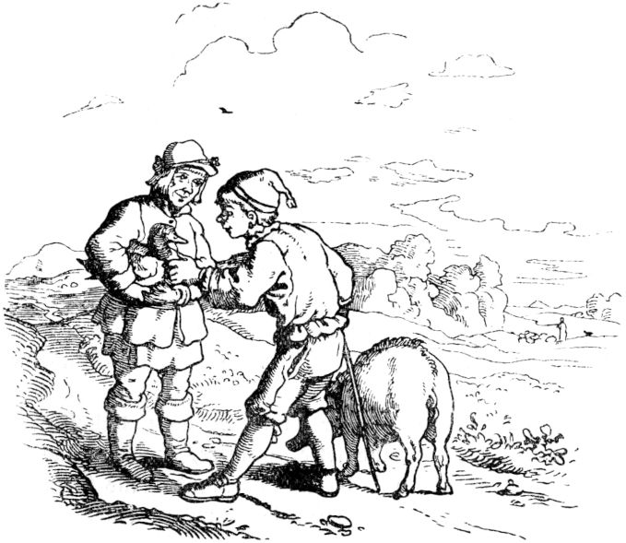

“Oh my dear Lord! What a bad luck I am! ”Shouted Hans. "Help me for God's sake, good, dearest friend!"

“You know what,” said the boy, “quickly give me the pig and take my goose! I know the secret routes around here and I want to make myself invisible! "

No sooner said than done, dealings closed and in two moments the boy and the pig were out of the Hans 155Eyes. "I'm a lucky bird!" Laughed Hans inwardly and carried the goose a good distance. There was nothing to be seen of the corridor contactor or anyone else pursuing. Hans calculated the good roast, the fat, the feathers, the joy of his mother; and so he came to the last village before his. There was a scissors grinder at his cart, it looked very happy, grind and whistle and whistle and grind until it purred, then he sang a jolly street hooter:

"A young grinder came here,

Sharpen your knives and scissors!

Gladly did it

Do it again

What is it to you

What's in it for you? "

Hans stopped in astonishment with his goose and was amazed at the grinder's amusement, then offered him good day and asked: “You are certainly doing very well that you are so funny and happy? Who would have it! "

“Oh yes, my good comrade,” said the scissors grinder, “I'm always funny, always money in my pocket, you can have it that way with your goose too. Where did you get the goose from? "

"Got it for a pig!" Reported Hans. "And the pig?" - "Got for a cow!" - "And the cow?" - "Bartered for a horse." - "And the horse?" - "Given a lump of gold as big as my head." - “Oh, you clever head! And where did the gold come from? ”-“ Served seven years, got a wage! ”-“ Smart, nothing is wrong with you except that you become a grinder like me, then the money will sound in every pocket. All it takes is a good brain whetstone; I have another one here, it's already 156a bit worn, but goes with you (if you wear it)! I'll give it to you for your goose. Do you want?"

"Do I want to? Of course! ”Exclaimed Hans, very pleased. "Having money in every pocket is a beautiful profession."

The loose grinder gave good Hans an old whetstone and a pebble that was lying on the road, and Hans pulled away, very happy that everything had come together so nicely, said that he must have been born in a lucky skin.

But the sun was shining and burning hot, Hans was hungry and thirsty, was weary and tired and the stones were heavy, almost as heavy as the lump of gold had been, and he thought: Oh, if I didn't have to drag myself with these whetstones after all . There was a little fountain by the way, from which Hans wanted to quench his thirst, so he stooped and when he stooped the stones fell into the fountain. Who was happier than Hans that he suddenly got rid of the heavy stones without his doing anything! He jumped up happily, loose and free of all worries, all burdens, praised himself as the happiest person, and reached his mother in good spirits - Hans in happiness.

157

**The three feathers.**

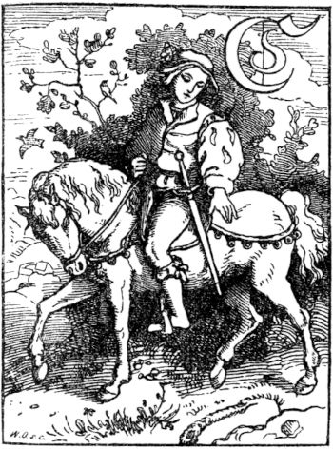

A little boy was born to a man, and since the father went out to look for a godparent who would give birth to the child, he found a beautiful young boy, for whom his heart immediately became completely full of love. And when he made his request to him, the beautiful boy was ready to go with him and lift the child, and left a young white horse as a godparent gift. But this boy was none other than Jesus Christ, our Lord.

The young boy, who had received the name Heinrich when he was baptized, grew to the joy of his father and mother, and when he had reached his youth, he was no longer kept at home, but drawn into the distance, after deeds and Adventures. So he took leave from his parents, sat on his saddled horse, which the unknown boy had given him as a godparent gift, although he did not know how much this horse was worth, and rode it fresh and happy into the world. One day he was riding through a forest, and, behold, there lay a feather made from a peacock's wheel close to the road, and the sun shone on the feather so that its bright colors shone magnificently in their splendor. The young boy stopped his horse and wanted to get down to pick up the feather and 158to put it on his hat. Then the horse opened its mouth and said: "Oh, let the feather lie on the ground!" The young rider was astonished that the horse could speak, and he shivered; stayed in the saddle, did not dismount, did not pick up the feather, rode on. After a while it happened that the boy rode on the bank of a little brook, and there lay a brightly colored, much more beautiful feather on the green grass than the one that had lain in the forest, and the boy's heart longed for it, his hat to decorate with it; for he had never seen such splendor of a feather in all his life. But when he was about to dismount, the horse said again: "Oh, leave the pen on the ground!" And again the boy was amazed beyond measure that the horse spoke when it did not speak otherwise.

Now it was only a short time before the boy came to a high mountain, wanted to ride up there, there was another feather at his foot in the meadow, but he thought that was the most beautiful thing in the whole wide world, and he had to to have. It shone and sparkled like sheer blue and green precious stones or like the bright drops of dew in the morning sun. But again the horse said: "Oh, leave the pen on the ground!" This time the young man was unable to obey the horse and did not want to hear his advice, because he longed too much for the lovely and stately ornament. He dismounted, lifted the pen from the bottom and put it on his hat. The little horse said: “Oh, what harm are you doing to yourself? You will probably regret it! ”Next 159it said nothing. As the young man rode on, he came to a stately and well-built city, there he saw many decorated citizens, and a fine procession came towards him with whistles, kettledrums and trumpeters and many waving flags, and it was splendid to look at. And in the procession went virgins, scattering flowers, and the four most beautiful wore a royal crown on a pillow. And the elders of the city handed the crown to the young man and said: “Hail, you noble young man sent to us by God! You shall be our king! Praise be to the Lord God for ever and ever! ”And all the people shouted:“ Hail our King! ”The young man did not know what happened to him when he felt the royal crown on his head, knelt down and praised God and the Savior. Had he picked up the first pen, he would have become a count; the second: a duke, and if he had not picked up the third pen, he would have found a fourth on the mountain top, and the little horse would have said: "Take this pen from the bottom." Then he would have become a mighty emperor over many empires of the world and the sun would not have set in his lands. Yet he was also so satisfied and became a kind, wise, just and pious king.

**The seven Ravens.**

Just as many strange things happen in the world, it also happened once that a poor woman gave birth to seven boys at once; and they all lived and prospered. After several years she also had a daughter. Her husband was hardworking and efficient 160in his work, which is why the people who needed manual labor gladly took him into service, which not only allowed him to support his numerous family in an honest manner, but also earned so much that his good housewife could set aside an emergency penny even with more precise arrangements. But this faithful father died in his prime, and the poor widow soon found herself in need, for she could not create so much to feed and clothe her eight children. 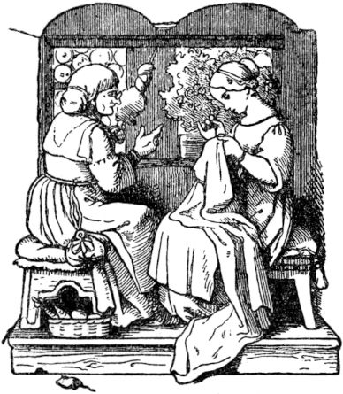In addition, the seven boys got bigger and bigger and needed more and more, but also became more and more naughty, to the greatest sadness of their mother, they even got wild and angry. The poor woman could hardly bear all the troubled and depressed her. She wanted to bring up her children well and piously, and her severity and mildness were of no avail, the hearts of boys were and remained obdurate. That is why she said one day, when her patience was all over: "Oh, you wicked ravens, I wish you were seven black ravens and flew away that I would never see you again." And immediately the seven boys became ravens and drove out the window and disappeared.

Now the mother and her only daughter lived quite quietly and contentedly, they earned more than they needed. And the daughter turned out to be a pretty good one 161and good girl. But after a number of years, both mother and daughter felt a heartfelt yearning for the seven brothers and often spoke of them and said: if the brothers would come back and be good fellows, how could we stand so well on each other through our work have so much joy. And because the longing for her brothers in the maid's heart became more and more intense, she once said to the mother: “Dear mother, let me wander off and seek out the brothers, so that I can divert them from their evil nature and bring them to you for honor and joy Your age. ”The mother replied:“ You dear daughter, I cannot and will not prevent you from performing the pious deed, wander away, and God guide you! ”Thereupon gave her a little gold ring that she had as a small child worn on the finger,

The girl immediately got up and wandered away, far, far away, and for a long time found no trace of her brothers; but once she came to a very high mountain, on the top of which there was a little house, where she sat down to rest, and kept looking thoughtfully up at the little house. It soon appeared to her like a bird's nest, for it looked gray, as if it had been put together by pebbles and excrement, and soon it appeared to her like a human dwelling. She thought: don't your brothers live up there? And when she finally saw seven black ravens fly out of the house, her suspicion was even more confirmed. She happily set out to climb the mountain; but the path that led up was paved with so strange, mirror-smooth stones that 162was, slipped and fell again. Then she was saddened and did not know how to get up. Then she saw a beautiful white goose and thought: if only I had your wings, I would soon be up there. Then she thought again: Can't I cut off her wings? Well, then it would help me! And she quickly caught the beautiful goose, cut off its wings and legs too, and sewed them on. And see how she tried to fly, it went so beautifully, so easily and well, and when she was tired from flying she ran a little with her goose feet and did not even slip again. So she got quickly and safely to her long-awaited destination. Upstairs she went into the little house, but it was very small; inside there were seven tiny tables, seven chairs, seven beds, and in the room there were also seven little windows, and in the stove there were seven bowls with roasted birds and boiled birds' eggs on them. The good sister had grown tired from the long journey and was now happy to be able to take a good rest; she also felt hungry. So she took the seven bowls out of the oven, and ate a little of each one, and sat down a little on each chair, and lay down a little in each bed, and in the last bed she fell asleep and lay there. until the seven brothers came back. They flew into the room through the seven windows, took their bowls out of the oven and wanted to eat, but noticed that they had already eaten. Now they wanted to go to sleep and thought their beds were crazy, and one of the brothers gave a loud scream, and said: “Oh, what a girl is lying in my bed!” The other brothers ran quickly and saw the sleeping girl lying in astonishment. Then someone spoke 163to the other: “If only it were our little sister!” and again one called to the other with joy: “Yes, that's our little sister, yes, that's it! It had such hair, and such a little mouth it had, and it wore such a ring on its largest finger then, as it wears the smallest one now! ”And they all shouted, and all kissed the sister; but this slept so soundly that it did not wake up for a long time.

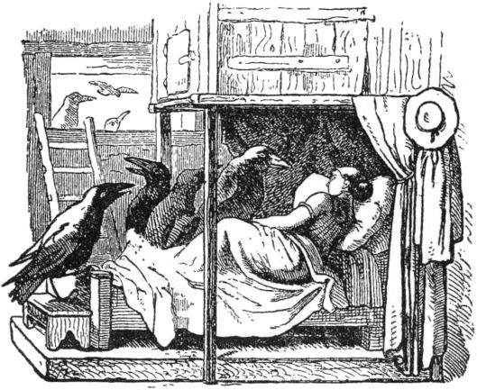

At last the girl opened her eyes and saw the seven black brothers sitting around her bed. Then she said: “Greetings, my dear brothers, thank God that I have finally found you; Because of you, I made a long, arduous journey to bring you back from your exile, when you have grasped a better sense in your hearts that you never want to annoy your good mother again, that you work diligently with us, and honor and you want to become the joy of your old mother. ”During this speech the brothers had wept bitterly, and now said: 164“Yes, dear sister, we want to be good and never offend our mother again, oh, as ravens we have a miserable life, and before we built this little house we often perished of hunger and misery. Added to this was the repentance that tortured us day and night: for we had to eat the corpses of the poor judged sinners, and were thus always reminded of the sinner's horrible end. "

The sister wept tears of joy that her brothers had been converted and that they spoke so piously. “O!” She exclaimed, “now everything is fine; when you come home and the mother hears that you have got better, she will forgive you heartily and make you human again. "

When the brothers wanted to travel home with their little sister, they first spoke by opening a wooden box: “Dear sister, take these beautiful golden rings and sparkling stones that we found outside so little by little in your apron and wear them home, because that way we can get rich as human beings. As ravens we only brought them together for the sake of their beautiful shine. "

The little sister did as the brothers wanted and enjoyed the beautiful jewelry herself. On the journey home the raven brothers carried their little sister on their wings one after the other until they came to their mother's apartment; then they flew in through the window and asked their mother for forgiveness and vowed to always be good children from now on. The sister also helped to pray and plead, and the mother was full of joy and love and forgave her seven sons. Then they became people again and even beautiful, blooming youths, one as tall and as graceful as the other. 165Thankfully, they embraced and kissed the good mother and the loving sister. And soon afterwards all seven brothers took young, decent women and built themselves a big, beautiful house, because they had received a lot of money for their treasures. And the first consecration of the new house was the sevenfold marriage of the brothers.

Then the sister also took a good husband, but had to stay with them on the brothers Flehn and Bitten.

So the good mother still enjoyed her children a lot, and was lovingly cared for and childlike by them until she was very old.

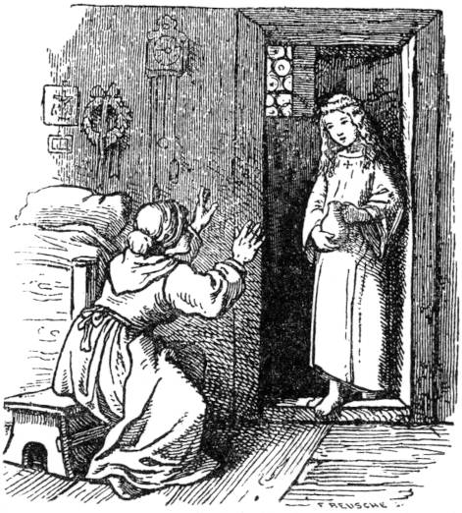

**The teardrop jug.**

Once upon a time there was a mother and a child, and the mother had the child, her only one, dear with all her heart, and could neither and not live without the child 166be. But then the Lord sent a great disease, which raged among the children and also seized that child, that it sank on its bed and fell ill to the point of death. For three days and three nights the mother woke up, wept and prayed with her beloved child, but he died. Then the mother, who was now alone on the whole of God's earth, seized a tremendous and nameless pain, and she neither ate nor drank and wept, wept again for three days and three nights without ceasing, and called for her child. As she sat on the third night, so full of deep sorrow, in the place where her child had died, tired of tears and pained to the point of fainting, the door opened softly and the mother gave a start, because her dead child was standing in front of her . She had become a blessed angel and smiled sweetly as innocence and beautiful as in transfiguration. But it was carrying a jug in its little hands that was almost overfull. And the child said: “O dear mother, do not weep for me any more! Behold, in this jar are your tears that you have shed for me; the angel of mourning has collected them in this vessel. If only you stillif a tear cry for me, the jug will overflow, and then I will have no rest in the grave and no bliss in heaven. Therefore, oh dear little mother, don't weep for your child anymore, because your child is well looked after, is happy, and angels are his playmates. ”With that the dead child disappeared and the mother no longer wept tears, for the peace of the child and heavenly peace not to bother.

167

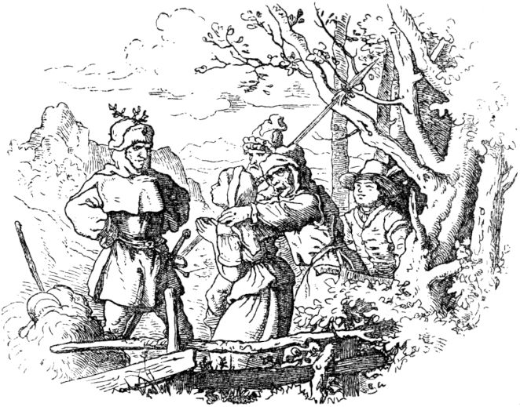

**The beautiful young bride.**

Once a pretty country girl went into the forest to fetch fodder for her cow; As she was now grazing in God's name and thinking of nothing bad, suddenly many robbers came, surrounded her and led her away with her, without mercy or mercy, she could scream and fidget, ask and beg as much as she wanted. Far from the girl's home in a dark forest, the robbers had a house in which they stayed, at least some of them stayed at home when the others went out to rob. But the robbers did nothing more to harm the girl than that they were just taking her away from her home and, as it were, keeping her prisoner in the house; she had to take care of the household, cook, bake and wash, otherwise she had it good, but was 168always closely guarded. The robbers had given her the name: Beautiful young bride.

So the girl had already been in the robber's hostel for a few years when it once happened that a major robbery was to be carried out, in which, if it were to succeed, the whole gang had to take part.

Since the girl seemed to have gotten used to the life in the robber's den, had not yet made any attempt to escape, and would also have difficulty finding her way through the wild forest - so thought the captain - so this time she remained alone and unguarded in the forest house back. But the robbers had scarcely left before the beautiful bride pondered how she could escape unrecognized. She quickly made a shape of straw, put on her clothes, put her hood on her, but smeared herself with honey from head to toe, rolled over it over and over in feathers, so that she became quite unrecognizable. and looked like a strange bird. She leaned the figure in her clothes against a window over the front door and let her look out, but with her face covered, and then she hurried away.

But whether it was now that the captain had an inkling of the girl's intended escape, or that something had been forgotten, enough, he sent some of his robbers back to the house, and it must just be that on their way they did belched feathery owls. But they thought it was one of their buddies who had made himself unrecognizable, and called the figure laughing and questioning:

"Where, where, Mr. Federsack?

What is the beautiful young bride doing? "

She, who was it herself, was very frightened, 169but she took heart and answered in a disguised voice:

“She sweeps and cleans our house

And look out of the window too! "

With that she made that she came out of sight of the robbers, came out of the forest happily, reached a village, bought clothes, bathed and, although after a long hike, got back to her home happy and safe, and there she was not exactly had left the best in the robber's hostel, but had to go with her for her annual wages, so she had to live well and married a brave lad.

Those robbers, as they now saw the house, saw the figure of the beautiful young bride at the window and greeted them from afar by shouting:

"Hello, beautiful young bride,

The friendly looks at us. "

But since the greeting remained unanswered, the robbers were astonished, and when they got closer they thought that the beautiful young bride had fallen asleep. In vain they cried, she did not encourage herself; In vain did they tell her to open it, all her throbbing and screaming, shouting and scolding were unsuccessful, and angrily they finally kicked the door into ruins, stormed up the stairs and took hold of the figure of the beautiful young bride hard, when the straw doll fell on them Into the arms. Then the robbers shouted:

“Go well, you beautiful young bride!

A goal is whoever builds on women! "

170

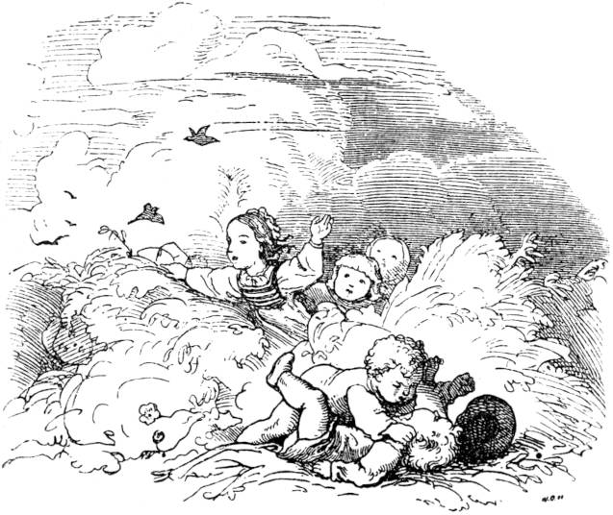

**The ears of corn.**

Once upon a time, but it was an unbelievably long time ago, all the stalks of corn and also those full of other grain bore golden-yellow ears down to the ground; there was no poverty and no famine, never, and that was the golden age. Everyone could feed themselves with joy and also the birds that like to eat grains, chickens and pigeons and other birds found plenty of food.

But there were some among the people who were ungrateful and God-forgotten and did not regard the beautiful, precious gift of God, the dear grain, for anything. There were women who, when their little children were polluted, took the full clusters of ears and cleaned their children with them and threw the ears on the dung; and the maids scrub with their full ears, and they 171Boys and little girls chased their way through the sweet corn, played hide and seek in it, rolled over and trampled on it. That lamented the dear God, who had given the grain to the people for food and to the cattle for fodder and not for searing [ [1](http://www.gutenberg.org/files/63465/63465-h/63465-h.htm#fn_1) ] and thought to himself, we want to do it differently and the golden age should come to an end.

And then the good Lord created that from now on each stalk bore only a single ear, once for the people so that they could learn to better protect the dear grain, and once for the innocent animals so that they should still have their food, even if they too People not even worth an ear.

From then on hunger and dearth and poverty came into the world. Only occasionally and seldom does the good Lord let a miracle stalk with many, many ears shoot up here or there and thus show people what grain was once like and what he can do. And there is an old prophecy among the people that once after long years, when the angelic word will have been fulfilled: Glory to God on high, peace on earth and benevolence, blessing and love among all people, that then the ground will also be back to be awakened by God to bear such stalks that are full of ears to the root. But none of us will experience that.

[1] Willfully spoil.

**From the chickens and chickens.**

Once upon a time there was a chicken and chickens who went up the nut mountain together and looked for nuts. The chicken said to the chicken: “If you have a

172

The chicken now quickly returned to the Nussberg; but how the chicken came about 173the same thing meanwhile was strangled. As the chicken kikirikite brightly with pain, all the animals in the neighborhood heard it, they ran up and cried for the chicken. And there six little mice built a mourning wagon, on it they laid the dead chicken and stretched themselves in front of it and pulled the wagon away. When they were on the way, the chicken, the dead chicken, the little mice and the mourning wagon, the fox came after them and asked: "Where are you going, chicken?" - "I want to bury my chicken!" "I want to do that, you fool!" Cried the fox, ate the chicken because it was not long dead and buried it in his stomach. Then the chicken mourned and cried: “I wish for death to be with my chicken.” - “That is how it should be!” Said the fox and ate the chicken so that it came to its chicken. Then the little mice cried for the chicken, and then the fox thought they wanted to be dead too, and swallowed them behind. But because the little mice were hitched to the wagon, he also swung the wagon down with it, and then the tiller pushed his heart off, so that he fell down for a long time and stretched out all four of them. Then a bird flew onto a linden branch and sang: “Fox is dead as a mouse! Fox is mouse dead! "

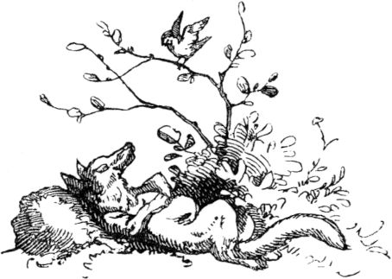

174

**The three wedding guests .**

Once upon a time there were three farm dogs in a village, they kept good neighbors with one another, and there was supposed to be a big peasant wedding; young and old were invited to the same place and were boiled and baked, boiled and roasted so that the smell wafted through the whole village. The three dogs were also together and smelled the fine haze and advised how they wanted to go to the wedding and see if nothing would fall off for them? But in order to avoid useless fuss, they decided not to run there at the same time, all three at once, but individually, one after the other.

The first went, went to the slaughterhouse, suddenly snatched a large piece of meat and wanted to go on his way with it, but he was caught and received a terrible beating, the next time the piece of meat was torn from his teeth.

So he came back to the farm, hungry and badly beaten, to his neighbor's companions, who were already hungry for good news and asked: "Well, how did you fare and please?" But now the dog was ashamed to admit the truth that his wedding feast Passed in a spicy whipping soup, therefore said: “Very well! But there is a lot going on and you have to be able to take it hard and soft! "

When the comrades heard this, they thought that there would be excessive eating and drinking at the wedding, and that many good crumbs fell off, hard and soft, flesh and bone, and immediately the second dog was running in full leaps towards the wedding house , straight into the kitchen and took what he found, - but before he found the way back, he was already noticed, and was 175poured a pot full of boiling hot water over his back so that it only steamed when he shot away, like a poodle coming out of the water; but even if it burned him terribly, he stifled his pain. When he came to the yard, where his two comrades were waiting for him, they immediately asked: "Well, how did you like it?" Can tolerate cold and warm! "

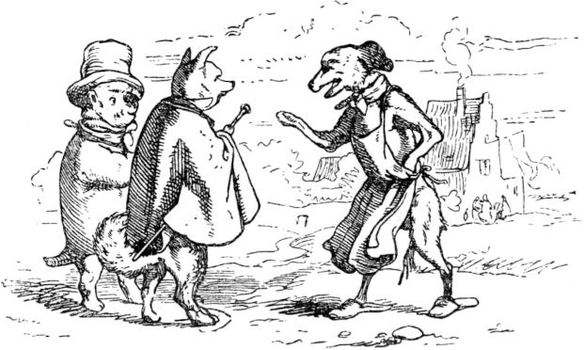

Then the third dog thought: the wedding guests are busy at the feast, and hot and cold dishes alternate, so didn't want to miss anything and at least be there for dessert when the crumbly cake is served. Hurrying what he could. But no sooner was he in the house than someone caught him, wedged his tail between the door of the room, tanned his fur as soft as a diaper, and clamped until the skin peeled off the tail and the dog emerged disgusted.

"Well, how did you like the wedding?" Asked the friends, each with a little mockery in their hearts. 176The injured man pulled his battered tail between his legs as best he could, so that one could not see it, and said: "Very well, it went really well and gave a lot of crumbs, but someone has to be able to leave hair."

And then the three dogs thought for a long time how much they had tasted the wedding soup, the wedding broth and the wedding cake, and everyone smelled enough of the roast.

**The hare and the fox.**

A hare and a fox both traveled together. It was winter time, no herbs were growing, and neither mouse nor louse crawled in the fields. “This is a hungry weather,” said the fox to the hare, “all my intestines purr together.” - “Yes,” answered the hare. "It's Dürrhof everywhere, and I would like to eat my own spoon if I could reach into my mouth with it."

So hungry they trotted off together. Then they saw a farmer girl coming from afar, she was carrying a hand basket, and a pleasant smell came out of the basket for the fox and the hare, the smell of fresh rolls. “You know what!” Said the fox: “Lie down for a long time and pretend to be dead. The girl will put down her basket and want to pick you up to win your poor brat, because hare hides give gloves; meanwhile I catch the bread basket, for our consolation. "

The hare took the advice of the fox, fell and pretended to be dead, and the fox ducked behind a winddrift 177of snow. The girl came, saw the fresh hare, who was stretching out all fours, put the basket down properly, and bent down to pick up the hare. Now the fox wiped out, snatched the basket, and ran it across the country, the hare was soon alive and hurriedly followed its companion. But the latter did not stand still at all and made no attempt to share the rolls, but let it be known that he wanted to eat them alone. 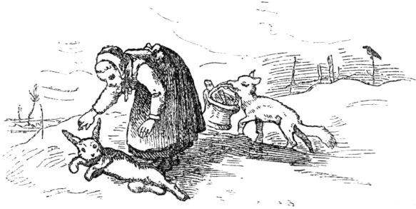The hare noticed that very badly. When they came near a small pond, the hare said to the fox: “How about if we got a meal of fish? Then we have fish and white bread, like the great men! Hang your tail a little in the water and the fish, which don't have much to bite now, will cling to it. But hurry before the pond freezes over. "

That made sense to the fox, he went to the pond, which was about to freeze over, and hung his tail in it, and for a little while the tail of the fox was frozen solid. Then the hare took the bread basket, slowly ate the bread in front of the fox's eyes, one after the other, and said to the fox: 178"Just wait until it thaws, just wait until spring, just wait until it thaws!" And ran away, and the fox barked after him like an angry dog ​​on a chain.

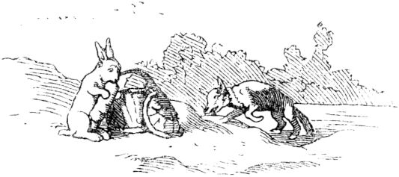

**God everywhere.**

There were a pair of siblings, called Görgel and Lieschen, soulful children who once stayed at home all alone; her parents had walked across the fields and carried baskets woven from willows into town for sale. It is true that the good parents had given their children, Görgeln and Lieschen, quite a bit of bread to each of them, from which they were to nourish themselves that day; but soon Görgel had consumed his and still felt the desire to eat, but had nothing more to chunk and nothing more to bite. Lieschen gave him a little more of her bread, but this didn't quite satisfy the boy either, and he began to talk to his younger sister with mischievous flattery words: "Come on, dear Lieschen, we want to nibble a little of the sweet beet juice, that mother keeps outside in the closet, 179nobody. ”But Lieschen said:“ Oh, you are very angry, Görgel, if you do that; don't you see the rays of the sun over there by the closet? God lets them shine through, and he sees it when we snack. "Then Görgel said:" So we want to go to the attic, where mother has nice pears, we want to eat from them, there is no window, she can The sun doesn't shine in and God doesn't see us there either. "

At first Lieschen refused, but finally the children went to the attic; But here the broken rays of the sun fell abundantly through the gaps in the roof tiles and flickered over the pears in a very peculiar way, as if they were dancing on them, and Lieschen said again: "O Görgel, God sees us here too, we mustn't snack here." They went down again, and something happened to the kid on the stairs, which he said right away: “Well, my mother has a potty full of cream in the cellar, and downstairs it's very dark, God can't possibly look into it ; come, let's go downstairs, Lieschen, come quickly, quickly! "- Görgel took his hesitant little sister firmly by the hand and quickly pulled her away with him, down to the cellar, where he carefully closed the door from the inside, that not a day shines in and God does not see it when they nibbled on the cream. But after a few minutes it got a little light in the cellar, Lieschen saw that the lovely sun was shining through a crack in the wall, and just on the creamer, the good Lieschen was frightened and hurried back up into the room. But Görgel stayed, angrily blocked the crack with moss and began to eat some of the cream. But as he was at the best of licking and licking, a mighty one rolled angrily clogged the crevice with moss and began to eat the cream. But as he was at the best of licking and licking, a mighty one rolled angrily clogged the crevice with moss and began to eat the cream. But as he was at the best of licking and licking, a mighty one rolled 180Thunder came over him, and lightning flashed through the crack in the wall so that it was very bright and fiery in the cellar, and a black man climbed out of a corner of the cellar, walked up to Görgeln and sat down across from him; he had two fiery eyes, with which he kept glinting at the creamer, so that the kid couldn't move a finger out of fear and had to sit very still.

In the meantime, a lovely angel had come to Lieschen upstairs in the room and, along with many beautiful toys and clothes, had given him 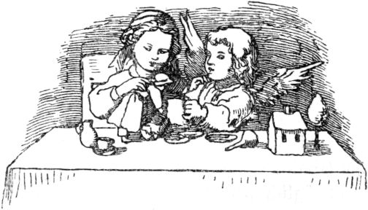also brought sugar cakes and sweet milk, and had played with Lieschen until his parents came back, who looked at the beautiful things with great joy. When they asked about the Görgel, Lieschen was frightened, because she had completely forgotten that her brother had stayed in the cellar because of the beautiful presents from the angel child, and now called: "Oh, dear God, he's still in the cellar, we want to get him quickly, maybe he can't open the door again. ”Everyone went down quickly, opened the cellar door and, lo and behold, Görgel sat still very rigid and held the creamer in his hand. And when he heard the noise and saw his mother, he was startled 181violently and started and cried. And his mother took the half-empty creamer from his hands, led him out of the cellar and gave him his well-deserved place.

But the Görgel never nibbled again in his whole life, and when later sometimes others tried to tempt him to do something evil and to do things that shy away from the light, he always said: “I won't do it, I won't go with you, God everywhere see it, God protect me! ”- And has become a thoroughly legal and good man.

**The courageous flute player.**

Once upon a time there was a jolly musician who played the flute masterfully; therefore he traveled around the world, played his flute in villages and towns, and made a living from it. So one evening he came to a tenant's farm and stayed overnight because he could not reach the next village before nightfall. He was welcomed in a friendly manner by the tenant, had to dine with him and, after the meal was over, play a few pieces on his flute. When the musician had done this, he looked out the window and saw an old castle a short distance away with the glow of the moon, some of which seemed to be in ruins. "What kind of old castle is that?" He asked the tenant, "and who did it belong to?" The tenant said that many, many years ago a count lived there who was very rich, but would also have been very stingy. He had plagued his subjects very much, did not give alms to any poor person and was finite 182died without an heir (because he had not even married out of stinginess). Then his closest relatives would have wanted to take possession of the inheritance, but would not have found the slightest money. It is therefore said that he must have buried the treasure and that it is still hidden in the old castle today. Many people would have gone to the old castle for the treasure, but none would have appeared again. 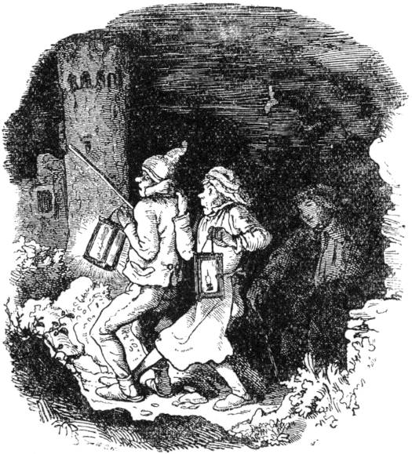Therefore the authorities have forbidden entry into this old castle and seriously warned all people in the whole country against it. The musician had listened attentively, and when the tenant had finished his report, he said that he had a great desire to go in, for he was courageous and knew no fear. The tenant asked him to 183most urgent and at last almost falling to the ground, but yes to spare his young life and not go to the castle. But pleading and pleading did not help, the musician was imperturbable.

Two of the tenant's servants had to light a couple of lanterns and accompany the courageous musician to the old, gruesome castle. Then he sent her with one Lantern back again, but he took the second in hand and bravely climbed a high staircase. When he had climbed it, he came into a large hall with doors around it. He opened the first and went in, sat down at an old-fashioned table in it, put his light on it, and played the flute. But the tenant could not sleep all night because of sheer worries and often looked out of the window. He was inexpressibly happy every time he heard the guest over there still making music. But when his wall clock struck eleven and the flute stopped playing, he was violently frightened and believed no different than the ghost or the devil, or whoever else lived in this castle, had definitely turned the handsome lad's neck. But the musician had waited and tended to play the flute without fear; but when at last he was hungry, because he hadn't eaten much at the tenant's, he paced up and down the room and looked around. Then he saw a pot full of uncooked lentils, on another table there was a vessel full of water, one full of salt and a bottle of wine. He quickly poured water over the lentils, put salt on them, lit a fire in the stove because there was already wood in it, and made himself a lentil soup. While the lentils were boiling, he drained the bottle of wine and then played the flute again. When the lentils cooked Then he saw a pot full of uncooked lentils, on another table there was a vessel full of water, one full of salt and a bottle of wine. He quickly poured water over the lentils, put salt on them, lit a fire in the stove because there was already wood in it, and made himself a lentil soup. While the lentils were boiling, he drained the bottle of wine and then played the flute again. When the lentils cooked Then he saw a pot full of uncooked lentils, on another table there was a vessel full of water, one full of salt and a bottle of wine. He quickly poured water over the lentils, put salt on them, lit a fire in the stove because there was already wood in it, and made himself a lentil soup. While the lentils were boiling, he drained the bottle of wine and then played the flute again. When the lentils cooked 184he moved them from the fire, poured them into the bowl that was already waiting on the table, and ate them fresh. Now he checked his watch and it was around the eleventh hour. Suddenly the door opened, two tall black men came in and carried a bier with a coffin on it. They set this without oneTo say a word in front of the musicians, who by no means let himself be disturbed in his meal, and went back out the door just as silently as they had come. When they had now gone, the musician got up hastily and opened the coffin. Inside lay an old man, small and wizened, with gray hair and a gray beard; but the lad was not afraid, took it out, put it by the stove, and scarcely seemed to be warmed up when life was already stirring in it. Thereupon he gave him lentils to eat and was very busy with the male, yes, like a mother, feeding her child. Then the male became very lively and said to him: “Follow me!” The male went ahead, but the boy took his lantern and followed him with astonishment.

There was a lot of money here. Then the little man commanded the boy: "Divide this pile into two equal parts, but that nothing remains, otherwise I will kill you!" The boy just smiled, immediately began to count on two large tables over and over and brought so the money in a short time in two equal parts, but in the end - there was still one cruiser left. But the musician thought about it for a moment, took out his pocket knife, set it on the cruiser with the edge, and hit it in two with the hammer that came with it. 185When he threw one half on this, the other on that pile, the little man became very cheerful and said: “You heavenly man, you have redeemed me! For a hundred years I have had to guard my treasure, which I scraped together out of avarice, until one would succeed in dividing the money into two equal parts. Nobody has ever succeeded and I had to strangle them all. One heap of money is yours now, but the other is shared among the poor. Divine man, you have redeemed me! ”Then the male disappeared. But the boy climbed the stairs and in his previous room played funny pieces on his flute.

Then the tenant was happy to hear him play again, and at the earliest morning he went to the castle (because everyone was allowed in during the day) and received the boy with joy. He told him the story, then he went down to his treasure, did as the little man had told him and distributed half of it among the poor. But he had the old castle torn down and soon a new one stood in the previous place, where the musician now lived as a rich man.

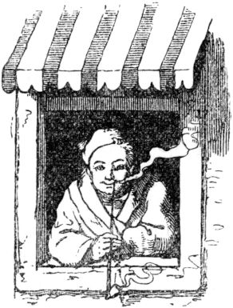

186

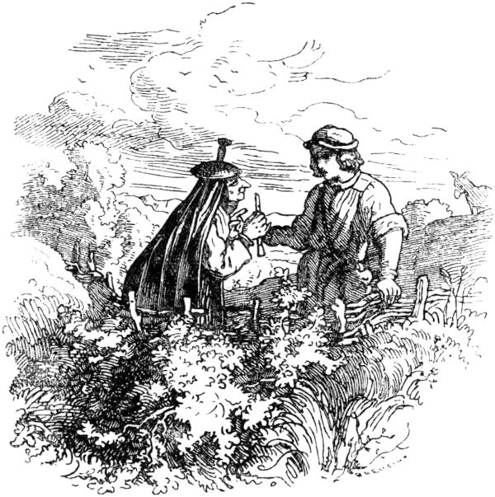

**The hare keeper.**

A rich king had a very beautiful daughter; When she wanted to get married, all the suitors who had appeared had to gather on a large green meadow, there she threw a golden apple several times in the air and whoever caught it and stood under, three bunch or three tasks she did gave up himself to solve, he should then have her as his wife. Now many had caught the apple, in the end a beautiful, cheerful shepherd boy, but none of them was able to solve the three tasks. Then it was the turn of the shepherd's boy, as the last and least of the suitors. The first task was to: 187The king had a hundred rabbits in a stable, whoever drove them to the pasture, looked after them and brought them all back in the evening, had done the first task. When the shepherd's boy heard this, he said that he wanted to think about it for one more day, but on the next day he would determine with certainty whether he dared undertake the matter or not. But now the shepherd's boy was walking around in the mountains and was sad because he shied away from the daring venture. Then an old mother met him and asked him the cause of his sadness; but he said: “Oh, nobody can help me.” Then said the gray mother: “Don't judge so loudly; say your request, maybe I can help you. ”And then he related the task. Then the little mother gave him a pipe and said: “Well, keep it, it will be of use to you! “And before the boy had thanked him, the little mother had disappeared. Now he went happily to the king and said: “I want to tend the rabbits!” And then they were let out of the stable. But when the last one was out, you couldn't see the first one, it was already over the mountains. But the boy went out into the field and sat down on a green hill and thought: What am I going to do? Then he remembered his pipe; he drew it out quickly and whistled, then the hundred rabbits came all jumping again and grazed merrily around him on the green hill. it was already over the mountains. But the boy went out into the field and sat down on a green hill and thought: What am I going to do? Then he remembered his pipe; he drew it out quickly and whistled, then the hundred rabbits came all jumping again and grazed merrily around him on the green hill. it was already over the mountains. But the boy went out into the field and sat down on a green hill and thought: What shall I do? Then he remembered his pipe; he drew it out quickly and whistled, then the hundred rabbits came all jumping again and grazed around him on the green hill.

But the king and the beautiful princess were not at all interested in the shepherd solving the task and the princess winning because he was so poor a swallow and not born high, and they pondered lists of how they would make the hare keeper do not bring home his flock in full.188

Then the king's daughter came along and had disguised herself and changed her face so that he shouldn't know her, but he did know her. When she saw all of the rabbits, she asked: “Can't you buy one of the rabbits here?” Then the boy said: “There's no one to sell, but there is no one to earn!” Then she asked: “How is that to be understood ? "Then said the boy: 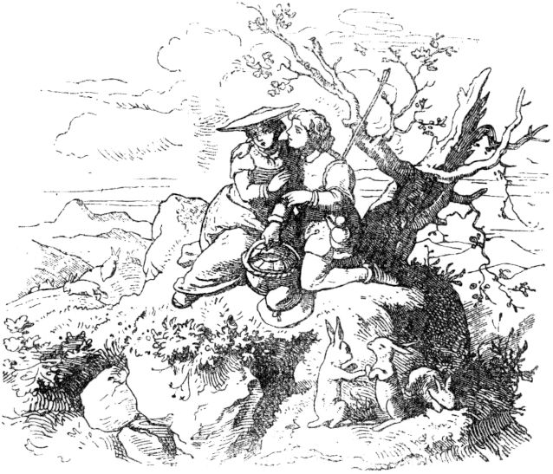"If you ask yourselves to love me and have a sweet pastoral hour with me!" But she didn't want to. But since she wanted a hare and he didn't give any other, she finally made it up to it. When he had kissed and fondled her enough, he caught a hare for her and put it in her handcup, and she went away. When she was now a quarter of an hour away from him, he whistled on his pipe, and quickly 189When the rabbit pushed the lid of the basket open, jumped out and jumped again.

It wasn't long before the old king came and had disguised himself too, but the boy knew him anyway. The king came riding a donkey and had a basket hanging on both sides. The king asked: “Isn't a rabbit sold?” - “No, not sold, but one can be earned!” The boy replied boldly. "How is that to be understood?" Asked the king. "If you kiss the donkey under the tail here," began the lad, "you shall have one!" But the king did not want to do that; and he offered him heavy money if he wanted to sell one; but the boy didn't. When the king saw that he couldn't buy a hare, he finally made himself comfortable and gave the donkey a good smack under the tail; then a hare was caught, put in the one basket on the donkey, and the king left. But it wasn't far when the boy whistled and the rabbit hopped out of the basket and came back. Then the king came home and said, "It's a loose fellow, I couldn't get a rabbit!" He didn't say what he had done. “Yes!” Replied the princess, “it was the same for me!” But what she had been up to, she did not admit. When it was evening the boy came with his rabbits and counted them to the king, every hundred in the stable.

Now the king began: “The first task has been solved and now it is time for the second! Notice! A hundred measure of peas and a hundred measure of lentils are on my floor, I have to pour these under each other and mix them through, if you separate them out in a night without light, then you have completed the second task. " 190The boy said: “I can do it!” And then he was locked on the floor and the door was locked tightly. Now that everything in the castle was quiet, he whistled on his pipe; Thousands of ants came crawling and swarmed and tingled until the peas were again in a special heap and the lentils too. When the king looked early, the task was solved, but he did not see the ants, they were gone again. The king was amazed and didn't know how the fellow did it. Thereupon he said: “I will now also tell you the third task. If the next night you crack your way through a large chamber full of bread, so that nothing remains, then you have completed the third task and then you shall have my daughter! "

When it was now dark, the boy was put in a bread chamber, which was so full that there was only one empty place near the door where he went. But when everything was quiet in the castle, he whistled again on his pipe; so there were so many mice that it almost creeped him; and when the day came the bread was all eaten up so that not a crumb was left! But he rumbled at the door and shouted: “Open up! I'm hungry! ”Now the third task was also solved.

But the king said: "Just tell us another sack full of lies for fun, and then you shall have my daughter!" Then the boy began and said terrible lies for half a day, but the sack always refused to fill up. Then he finally said: "I have already had a pastoral hour with the very dearest princess, my bride!" At these words she turned fiery red, the king looked at her and whether it should be lies, he believed it and educated yourself already 191a how and where it happened. “The sack isn't full yet!” He shouted. Then the boy began: “The Lord King has the donkey too.” - “It is full, it is full! The king shouted, for he was ashamed and did not want to let it know what honor the donkey had been bestowed through his royal mouth, since his whole court was standing around in a circle. And the wedding of the shepherd boy with the king's daughter was celebrated for a fortnight, and it was so lively and so funny that the one who told it wished he had been a guest too.

**The fairy tale of the man in the moon.**

Once upon a time a man went into the forest on a lovely Sunday morning, cut down wood, a mighty wave, tied it, stuck a baton into it, picked up the wave and carried it home.

On the way he met a handsome man in Sunday clothes, who probably wanted to go to church, stopped, spoke to the wave carrier and said: “Don't you know that it is Sunday on earth, on which day God was resting when he was World and all animals and people created? Don't you know that it is written in the third commandment that you should keep the holiday holy? ”But the questioner was God himself; That woodcutter, however, was very obstinate and replied: "Sunday on earth or lunar day in heaven, what does that concern me and what does it concern you?"

“This is how you should carry your twigs for ever!” Said the good Lord, “and because Sunday on earth is so unworthy of you, you should have an eternal lunar day for ever, 192and stand in the moon, a warning picture for those who violate Sunday with work! "

From that time on, the man with the bundle of wood is still standing in the moon, and will probably remain there for all eternity.

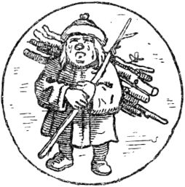

**The king in the bath.**

Once upon a time there was a king to whom many lands of the German and French tongues were subject, because of this his heart became cocky, and he believed that there was no mighty lord in the world except himself. Now it happened that one evening he went to Vespers and heard the priest reading the words: *Deposuit potentes de sede, et exaltavit humiles.*Then, because he did not understand Latin, he asked the learned men around him what these words meant? And then the interpretation came to him: the Lord God casts the mighty from their throne, and exalts the lowly. The king was shocked at this saying and became angry, and gave a command that this saying of the evangelist Luke should no longer be read, nor should anyone hear it and it should be completely erased from the holy books. 193The king's messengers carried the commandment into every country and to all clergymen and to all monasteries. But the books in which this passage was left should be burned. So those words were destroyed and erased many times and were no longer read or sung in public in churches.

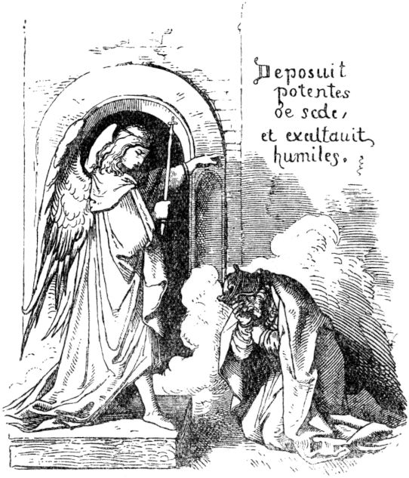

Now it happened at a time that the king went into a bath; Then God sent an angel to atone for the sacrilege of the holy word of the gospel, who took the form of the king, and struck everyone's eyes with blindness, that they thought he was the king, but the king himself was not as such who he was recognized. When the king stepped out of the bath, he sat down on one 194Bench on which the angel was already sitting. The bather told him to get up and sit down somewhere else. “Are you drunk, Bader?” Asked the King, “that you are speaking to me in a disgraceful manner? It's me, the king, your master! ”-“ You may be a fool! ”Replied the barber. “Sir, the king is sitting here; whose king are you? And where is your majesty's realm? Narragonia? "

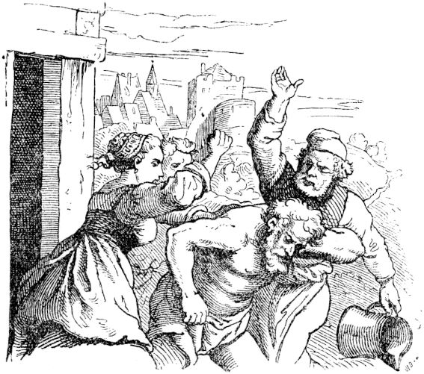

“Villain!” Cried the king in anger, took a bucket and threw it on the bather's head, then the bathing party heard the noise, hurried over and anointed the king with fist oil until the angel stepped in as king and took him out of the hands of the Servants freed. But then he left him, stepped out of the bath-room, and there the king's servants, who had to mistake the angel for their master, put on him that precious garment and led him on 195proud horses in all splendor to the Hofburg. But the barber and his companions threw the king out of the house naked and bare, and there he stood at the door, not knowing what had happened to him. And the people gathered around him and mocked him, as well as his own servants, for no one knew him any more. And he hurried, naked as he was, and with great shame from the people, who ran after him like a fool, to the house of his tavern and much faithful advice.

It was past midday, and the tavern was having his lunch break when the king rang the bell at the gate and asked to be admitted. The porter asked who he was and what he wanted? and that said: "I, the King!"

Shouted the porter. “I have never seen a king so shameful. You are by no means coming in! ”Then the king shouted and made a loud noise so that the innkeeper could hear it, and asked what was going on. The gatekeeper said: "Lord, there is a man standing outside, he is naked and bare, and says he is your lord and king, and the people are behind him, and have their fools on the monkey."

“Let him in!” Said the barman with pity, “and handed him a makeshift robe to cover his nakedness.” This happened, and then the king stepped in to the tavern, who was also unable to recognize him as his master , and said: "O my friend, you will and must recognize me that I am your king, although today a strange fate haunts me and drives me away from honor and good. Think of the speeches we made in confidence yesterday morning when I gave you, my councilors, an order that I gave 196Wanted to see fulfilled, and you talked me out of it, as not worthy of a prince. ”And the king said more secrecies of this kind about the gifts, but he began to laugh and said:“ You tell the truth, yes, but the devil must tell you the truth have blown in the ear! "And the king said:" With which I also deserve the misfortune that beats me, my heart tells me that I am a just and true king. "

The tavern didn't want to contradict, because that tends to upset fools and is not considered a sign of a good way of life in the wise people either, but he ordered the stranger to be served food and thought to himself: I want to bring this rare case to the king as news . He, the tavern, was so valued at court for his wise advice that he had free access at all times, and so he immediately went to the royal castle, stepped before the angel and told him the tale of his strange guest. He ordered him to take the king to court, and the whole court gathered in a large hall, and the servants filled all the stairs and galleries. When the presenter brought the humiliated king, everyone screamed mockingly: "Hello, Lord King without a country!"

The angel sat in rich splendor on the throne next to the beautiful queen and greeted his doppelganger, whose heart surged with hatred when he saw the supposed enemy sitting with his own wife. The angel said: “Say, is that true, are you king here?” And the king replied: “I saw the day when I was mighty here, when my wife still received me as her king and lord, her amicable one Greetings I now completely dispense with, which I have never been denied until today, on this day of my shame and my suffering. 197Oh how kindly I left her ministerial arms this morning! "

The queen was quite ashamed at this speech that she should have embraced the strange man and said to the angel: “My royal lord and consort, this man is probably nonsensical !?” and an old knight of the court shouted: “Be silent, villain! You have to be dragged to the gallows on a cow skin! ”And the young Lecker at court wanted to gain favor and show their heroism and grabbed the king, would have played him bad enough, but the angel repelled them and led the king away with you into a beautiful, lonely room. There he said to him: “Say, do you believe or do you not believe that God has power over all creatures? See how his almighty power treads you in the dust! What is your mighty army of war helping you? Who obeys your call and commandments? The truth is still alive:*Deposuit potentes de sede* , and you and those like you will never suppress it! "

So said the angel to the king, and he trembled and asked: “Man, who are you? If you are God Almighty, of whom you speak, have mercy on me poor, beguiled man! "

“I am not God!” Said the angel, “but I am one of his messengers and the servant of the true Christ. He sent me and you he sent the punishment of your arrogance. God exalts and humiliates whom he wills! Why do you pursue this truth? "

Then the king fell at the angel's feet and asked for God's grace and forgiveness. The angel called him up and said: “You must have faith in the word of Scripture from the mouth of the priest! You need to 198be merciful to those who complain to you of their grief. You must be fair to both the small and the great! If you want that, then you should again take the chair of your power and your honor. "

Then the king humbled himself again before the messenger of the Lord, bowed, kneeled and said: "I will follow you gladly, grant me grace through God!" Then the angel offered him his hand and gave him the king's robes and gave him them King again, and the king took off the scanty skirt that the presenter had given him. But the angel disappeared before the king's eyes and flew up again into heaven, into the home of souls, into the kingdom of the Eternal Father.

The king said: “Praise be to the sweet Christian, the mighty one. What the angel said to me is the real truth. ”And came out of the room like one who never suffered harm. Then the servants reverently asked him: "Lord, where has the fool gone?" But he called the queen and all his people around him and told them everything how things happened and what he suffered; his quarrel with the bath and everything else, and showed them the scanty skirt. The Schranzen were frightened and ashamed that they had so offended and misunderstood the Lord, and many of them thought that their body and their property would now be affected. Even the queen begged her husband for grace and mercy and gave a holy and dear assurance that she had not recognized him. He gently closed her hands in his hand and said: “Woman, be silent! God wanted it that way! In the end I didn't know myself anymore. "-

Then he had the saying “ *Deposuit” rewritten* in all the books where it had been erased, and had it read again in the churches, and even became a humble one 199Ruler. And whoever reads this fairy tale humble his heart before God and ask that he will graciously protect him from arrogance and arrogance.

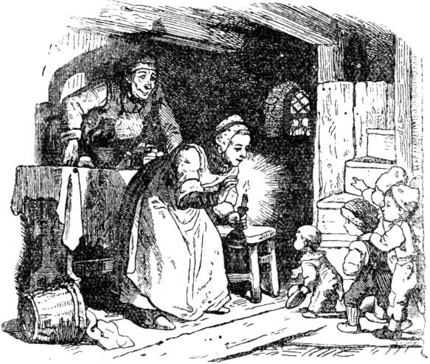

**Little Thumbnail.**

Once upon a time there was a poor basket maker who and his wife had seven boys, one of whom was always shorter than the other, and the youngest was not much more than a finger's length when he was born, which is why he was called Tom Thumb . Although he grew a little afterwards, but not too much, and he kept the name Thumbnail. But it was a very clever and smart little boy who put all his brothers in the sack for dexterity and cunning.

The parents felt bad at first, because basketry and straw weaving are not such a nourishing profession as 200Baking breads and slaughtering calves, and when an expensive time came, the poor basket maker and his wife were terrified of how they should feed their seven worms, all of which were blessed with extremely good appetites. Then one evening, when the children were in bed, the two parents discussed what to do with each other and were advised to take the children into the forest, where the willows grow from which baskets are made, and to close them secretly leave. Thumble, who did not sleep like his brothers, listened to all of this and wrote his parents' bad advice behind his ears. Also simulated the whole night, because he couldn't sleep for worry about how to do it to help himself and his brothers.

Tom Thumb ran to the brook early in the morning, looked for the little pockets full of white pebbles, and went home again. He never said a single word to his brothers about what he had overheard. Now the parents went into the forest, asked the children to follow, and Thumbnail dropped one pebble after the other on the path, nobody saw that because, as the youngest, smallest and weakest, he was always paddling backwards. The ancients did not know otherwise.

In the forest the old people went unnoticed away from the children, and suddenly they were gone. When the children noticed this, all of them, with the exception of Thumbnail, uttered a shout of excitement. Thumble laughed and said to his brothers: “Don't howl and shout so miserably! Want to find the way alone. ”And now Thumble went ahead and not behind, and aligned himself exactly with the white pebbles, and found the way without any effort.

When their parents got home, God gave them money 201into the house; an old debt they had no longer hoped for was repaid to them by a neighbor, and now they bought food that bent the table. But now came the regret that the children had been cast out, and the woman began to lament miserably: “Oh dear, dear God! If only we hadn't left the children in the forest! Oh, now they could eat their fill, and so the wolves may already have them in their stomachs! Oh, if only our dearest children were there! ”-“ Mother, here we are! ”Said little Thumble, who had already reached the door with his brothers and had heard the lamentation; opened the door and the little basket makers tripped in - one, two, three, four, five, six, seven. They had brought their good appetite back with them, and that the table was set so generously was a meal they found. It was great that the children were there again, and as long as there was enough money, people lived happily, this is the habit of poor manual workers.

It didn’t last very long when Schmalhans, the basket maker’s hut, was again the kitchen master and there was no cellar master anyway, and the resolution arose again to leave the children in the forest to their fate. Since the plan was again negotiated as a loud evening conversation between father and mother, little Thumble heard everything, the whole conversation, word for word, and took it to heart.

The next morning Tom Thumb wanted to slip out of the house again to pick up pebbles, but alas, it was locked there, and Tom Thumb was far too small to be able to reach the bolt, so he thought of helping himself otherwise. As it went on to the forest, 202Thumbling took bread and strewed crumbs of it on the path, thinking that this would help him find him again.

Everything happened like the first time, with the difference that Tom Thumb couldn't find the way home because the birds had eaten all the crumbs. Now good advice was dear, and the brothers howled in the forest that it was to the mercy of the stone. They padded through the forest until it got really dark and were fearful beyond measure, except for Thumble, who neither screamed nor was afraid. The seven brothers slept under the canopy of a tree on soft moss, and when it was day Tom Thumb climbed a tree to explore the area. At first he saw nothing but vain forest trees, but then he discovered the roof of a small oneLittle house, remembered the direction, slipped down from the tree and bravely led his brothers. After many a struggle with thickets, thorns and thistles, everyone saw the little house looking through the bushes and walked in good cheer, knocking at the door very modestly. Then a woman stepped out and Tom Thumb asked nicely to let them in after all, they had lost their way and didn't know where to go? The woman said: "Oh, you poor children!" And let Thumbnail enter with his brothers, but also immediately told them that they were in the house of the ogre, who especially likes to eat the little children. That was a nice confidence! The children trembled like a leaf when they heard this, would have preferred to have something to eat themselves and should now be eaten instead. But the woman was good and compassionate hid the children and gave them something to eat. Soon afterwards one heard footsteps and there was a strong knock on the door; that was none other than the one returning home 203Man eater. He sat down at the table to eat, had wine served and sniffed as if he smelled something, then he called to his wife: "I smell human flesh!" The woman tried to talk him out of it, but he followed his smell and found her Children. They were completely terrified. 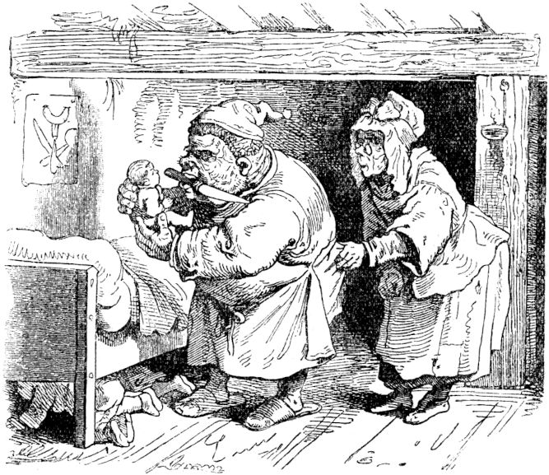He was already sharpening his long knife to slaughter the children, and only gradually did he give in to his wife's requests to let them live a little longer and feed them because they were too skinny, especially little Thumbnail. So the bad man and child eater finally let himself be appeased. The children were put to bed in the same room where seven daughters slept in a large ogre bed 204were as old as the seven brothers. They were very ugly in face, but each had a golden crown on its head. Thumbling had noticed all this, got out of bed very quietly, took off his and his brothers' nightcaps, put these ogre daughters on and their little crowns on himself and his brothers.

The ogre drank a lot of wine, and then his evil desire to murder the children came back to him , took his knife and crept into the bedroom, where they slept, willing to cut their necks off. But it was pitch dark in the room, and the ogre groped blindly until he came across a bed and felt for the heads of those sleeping in it. Then he felt the crown and said: “Stop there! These are your daughters. Soon you would have made a donkey prank on the drunk sheep! "

Now he padded to the other bed, felt the nightcaps there, and cut off the necks of his seven daughters, one after the other. Then he lay down and slept off his intoxication. As soon as Tom Thumb heard him snore, he woke his brothers, snuck out of the house with them, and ran away. But no matter how much they hurried, they still knew neither the way nor the footbridge and continued to wander around full of fear and worry.

When morning came, the ogre woke up and said to his wife: “Go and prepare the crabs that were yesterday!” She said she should wake the children now and went up to the room in fear for them. What a horror for the woman when she saw what had happened; she immediately passed out at the horrible sight she had there. When she now the 205Ogre stayed too long, he went upstairs himself, and there he saw what he had done. The anger he got into cannot be described. Now he put on the seven-mile boots he had, they were boots, if you took seven steps with them you had walked a mile, it was nothing small. It wasn't long before the seven brothers saw him striding over mountains and valleys from afar and were very worried, but Tom Thumb hid with them in the hollow of a large rock. When the ogre came to this rock, he sat on it to rest a little, because he was tired, and soon he fell asleep and snored so that it was as if a storm wind was blowing. As the ogre slept and snored, Thumble crept out of his hole like a mouse and took off his mile boots and put them on himself. Fortunately, these boots had the ability to fit any foot as appropriate and a glove. Now he took one of his brothers by each hand, they again took each other's hands, and that is how it went, you have not seen, with seven-mile boot strides home. They were all welcome. Thumbling advised his parents to keep a careful eye on his brothers, he would now, with the help of his boots, see to his progress himself, and when he hardly said that he took a step and he was already far away, another and he stood on a mountain for over half an hour, another, and he was out of sight of his parents and brothers. to fit every foot as appropriate and glove. Now he took one of his brothers by each hand, they again took each other's hands, and that is how it went, you have not seen, with seven-mile boot strides home. They were all welcome. Thumbling advised his parents to keep a careful eye on his brothers, he would now, with the help of his boots, see to his progress himself, and when he hardly said that he took a step and he was already far away, another and he stood on a mountain for over half an hour, another, and he was out of sight of his parents and brothers. to fit every foot as appropriate and glove. Now he took one of his brothers by each hand, they again took each other's hands, and that is how it went, you have not seen, with seven-mile boot strides home. They were all welcome. Thumbling advised his parents to keep a careful eye on his brothers, he would now, with the help of his boots, see to his progress himself, and when he hardly said that he took a step and he was already far away, another and he stood on a mountain for over half an hour, another, and he was out of sight of his parents and brothers.

After the hand, Tom Thumb made his fortune with his boots and made many long and long journeys, served many gentlemen, and if he didn't like it somewhere, he went on spur of the moment. No 206Pursuers on foot or on horseback could overtake him, and the adventures he wore with the help of his boots are beyond description.

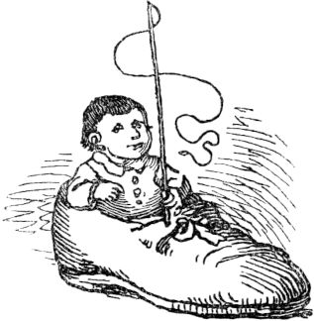

**The magic contest.**

Once a young journeyman bookbinder went abroad and wandered until no more cruisers jingled in his pocket. Then at last his tense relationship with his slack purse compelled him to ask seriously about the work, and soon he was also accepted by a master and got it very well, very well. His master said to him: “Friend, you will have it well with me; the work you have to do every day is very little. You just sweep the books here very neatly every day and then put them back in order. But you mustn't touch this one little book, which stands apart here, look much less into it, otherwise you'll end up badly, fellow, take note of it. On the other hand, you can read as much as you like in the other books. "207

The journeyman heeded the words of his master very well and had the best days for two years, only cleaning the books daily, then reading some of them and having the most excellent food - he left that forbidden little book completely untouched. In this way he gained the full confidence of his master, so that he often stayed away from the house for days and occasionally went on a trip. But just as people always long for the forbidden, so once, when the master was away for several days, a powerful desire arose in the journeyman to finally know what was in the little book, which was always holy in its particular place . - Because he had already read through all the other books. True, his conscience was reluctant to do the forbidden, but curiosity was more powerful; he took the booklet, opened it, and began to read it. In the little book stood the greatest, most precious secrets, the greatest magic formulas were contained in it, and everything gradually became so clear to the astonished, most astonished fellow that he began to try magic. Everything worked out. If the boy spoke a powerful little magic spell from this little book, then in no time what he wanted was there in front of him. The booklet also taught how to transform every human form into another. Now he tried more and more and in the end he made himself a swallow, took the little book and flew to his home in the fastest flight. His father was quite astonished when a swallow flew in to his window and suddenly it became his son, whom he had not seen for two years. 208I'll bring a little magic book with me, through which we can become the richest people. ”The old man liked that because he lived very poorly. Soon afterwards the young wizard made himself a very big, fat ox and said to his father: "Well, take me to the market and sell me, but ask a lot, a lot, I will be paid dearly, 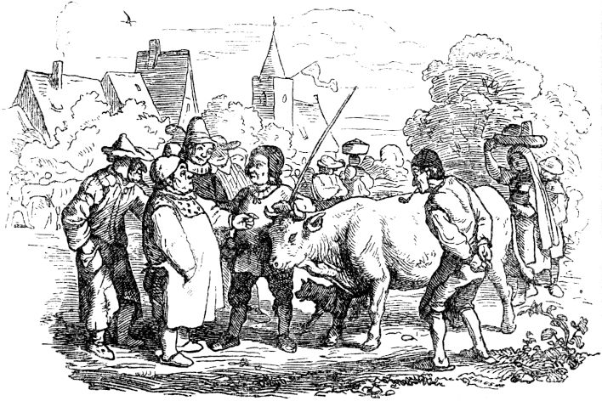And don't forget to take off the little rope that is tied around my left rear foot and take it home with you, otherwise I'll be lost. "

Father did everything like that; He sold the ox for heavy money, because when he appeared with him at the market, a crowd of people immediately gathered around him, everyone admired the rare ox, and Christians and Jews fought to buy him. Of the 209But the buyer, who did the highest bid and paid, and led the ox away in triumph, had a bundle of straw lying in his stable the next morning instead of the splendid ox. And the journeyman bookbinder - he was happily back home with his father and lived with him wonderfully and with friends on the money. Some people make themselves big, fat oxen, but nobody buys them dearly.

Soon afterwards the boy enchanted himself again into a magnificent black horse, and let his father take him to the horse market and sell him. Then the people gathered again to see the beautiful, shiny black horse. - But that master bookbinder, when he returned home, had immediately seen what was going on, and since he was actually not a bookbinder, but a powerful magician who only pretended to be doing this, he knew at once how much it had hit had, and pursued the escaped. At that horse market the master was among the buyers, and since he knew all the bits and pieces of the magic book, he immediately noticed what the situation was with the horse and thought: Stop, now I want to catch you. And so he tried to buy the horse for any price, which he succeeded without much effort because he accepted the first purchase price straight away. The father did not know the buyer, but the horse began to tremble violently and sweat, and acted extremely shy and fearful, but the father could not have suspected the now so dangerous situation of his son. When the new owner's horse was brought in and placed in the place intended for it, the father wanted to take off the rope again; but the buyer did not allow this at all, since he knew very well that it would be his catch When the new owner's horse was brought in and placed in the place intended for it, the father wanted to take off the rope again; but the buyer did not allow this at all, since he knew very well that it would be his catch When the new owner's horse was brought in and placed in the place intended for it, the father wanted to take off the rope again; but the buyer did not allow this at all, since he knew very well that it would be his catch 210would have happened. So the father had to go off without a rope, and thought in his mind: he will help himself, he can do so much that he turns himself into a horse, he can certainly get loose again there in the stable with his magic and come home.

In that stable, however, there was a great crowd of people; big and small, old and young - the excellently beautiful horse wanted to see everything. A cheeky boy even dared to stroke the horse and pound it caressingly, and it seemed to be quite happy to please it, and as this boy approached more and more confidentially and stroked the horse's head and neck, it whispered to him Boys shut up very softly: “Dearest boy, don't you have a knife in your pocket?” And the happily surprised boy replied: “Oh yes, I have a very sharp one.” Then the black horse spoke very softly again: “Cut the little rope on my left one Hind foot off, ”and the boy quickly cut it in two. And at that moment the beautiful horse collapsed in front of all eyes and became a bundle of straw, and from it a swallow flew out. and up out of the stable into the high blue skies. The master had only neglected the horse for a moment, now there was no time to be lost. He needed his art, quickly transformed into a vulture, and shot after the fleeting swallow. It only took a little while before the vulture had the swallow in its claws, but the little swallow noticed the enemy, looked down at the earth, and saw a beautiful castle just below it, and a princess sat in front of the castle, and swiftly the little swallow turned into a golden ring of fingers, fell down, and fell on the lovely princess's lap. She didn't know quickly transformed into a vulture, and shot after the fleeing swallow. It only took a little while before the vulture had the swallow in its claws, but the little swallow noticed the enemy, looked down at the earth, and saw a beautiful castle just below it, and a princess sat in front of the castle, and swiftly the little swallow turned into a golden ring of fingers, fell down, and fell on the lovely princess's lap. She didn't know quickly transformed into a vulture, and shot after the fleeing swallow. It only took a little while before the vulture had the swallow in its claws, but the little swallow noticed the enemy, looked down at the earth, and saw a beautiful castle just below it, and a princess sat in front of the castle, and swiftly the little swallow turned into a golden ring of fingers, fell down, and fell on the lovely princess's lap. She didn't know and just on the lovely princess' lap. She didn't know and just on the lovely princess' lap. She didn't know 211as it happened to her, and put the ring on her finger. But the vulture's keen eyes had seen everything, and the magician quickly transformed from a vulture into a handsome junker and stepped up to the princess and politely and humbly asked her to return this ring, with which he had just done a trick . The beautiful princess smiled blushing, pulled the ring from her finger, and wanted to hand it over to the artist, but behold, her delicate fingers dropped it and rolled like a tiny grain of millet into a stone crack. In an instant the junker changed and became a proud cockerel, who busily pecked at the grain of millet with its beak in the stone crack, but immediately after that the millet grain became a fox, and the fox bit off the head of the cockerel. And so the magician was defeated. But now the young journeyman took on his form again, sank at the princess's feet, and thanked her for having carried him on her finger and thus becoming engaged to him. The princess was terrified of everything that had happened, for she was still very young and inexperienced and gave him her heart and her hand, but on the condition that from then on he renounced all metamorphosis and remained unchangeably loyal to her. The young man vowed this and sacrificed his magic book to the flames, which he did very badly because he could have given it to you, dear reader, or to me and bequeath it; in that she had carried it on her finger and thus became engaged to him. The princess was terrified of everything that had happened, for she was still very young and inexperienced and gave him her heart and her hand, but on the condition that from then on he renounced all metamorphosis and remained unchangeably loyal to her. The young man vowed this and sacrificed his magic book to the flames, which he did very badly because he could have given it to you, dear reader, or to me and bequeath it; in that she had carried it on her finger and thus became engaged to him. The princess was terrified of everything that had happened, for she was still very young and inexperienced and gave him her heart and her hand, but on the condition that from then on he renounced all metamorphosis and remained unchangeably loyal to her. The young man vowed this and sacrificed his magic book to the flames, which he did very badly because he could have given it to you, dear reader, or to me and bequeath it; in which, however, he did very badly, because he could have given it to you, dear reader, or to me and bequeath it; in which, however, he did very badly, because he could have given it to you, dear reader, or to me and bequeath it; inWe two oxen would certainly not have changed.212

**Man and woman in a vinegar jug.**

Once upon a time there was a man and a woman who lived together in a vinegar jug ​​for a long time. In the end they got tired of it, and the man said to the woman: "It's your fault that we have to live in the sour vinegar jug ​​if we weren't there!" 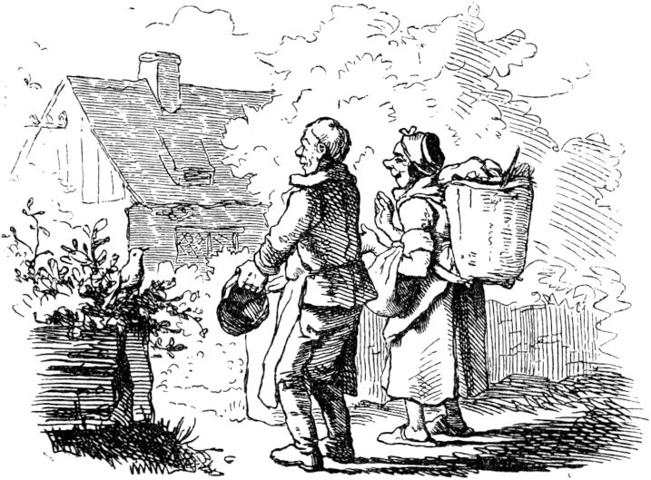But the woman said: “No, it's your fault.” And that's when they started to fidget and quarrel with each other, and one after the other ran after the other in the vinegar jug. A golden bird just got to the vinegar jug, it said: “What do you guys have with each other?” - “Oh,” said the woman, “we're tired of vinegar jugs and would like to live like other people one day, too, afterwards we want to be satisfied. ”There she has the golden one 213Let Vogelein out of the vinegar jug, led them to a new little house, where there was a dainty garden in the back, and said to them: “This is yours now! Now live in harmony and satisfaction with one another, and if you need me, you are only allowed to clap your hands three times and shout:

'Golden bird in the sunbeam!

Golden birds in the demant room!

Golden birds everywhere! '

that's how I am. "

With that the golden bird flew away and the man and the woman were glad that they no longer lived in the sour vinegar jug, and were happy about their nice little house and green garden. But that only lasted a while, because when they had lived in the little house for a few weeks and got around the neighborhood, they had seen the large stately farms with large stables, gardens, fields, many servants and cattle. And then they didn't like it anymore in their tiny house, and got tired of it, and one fine morning they both clapped their hands almost at the same time and shouted:

“Golden bird in the sunbeam!

Golden birds in the demant room!

Golden birds everywhere! "

Witsch, the golden bird flew in through the window and asked you what you wanted again?

"Oh," they said, "the little house is really too small, if only we had such a big, splendid farm, afterwards we wanted to be satisfied." 214but said nothing, and led the man and the woman to a large, splendid farm, where there were many fields, and stables with cattle, and male and female servants, and gave them everything.

The man and the woman jumped up to the ceiling and could not stop for joy. And now they have been content and happy for a whole year and couldn't think of anything better. But it didn't take longer either, not a day, because because they now sometimes drove into the city, they saw the beautiful, big houses and the well-dressed gentlemen and madams going for a walk, so they thought: Well, it must be in the city be wonderful and there is not much to do or work; and the woman couldn't get enough of the state and the wellbeing and said to her husband: “We want to go to the city too, call the cute little bird! We've been on the farm long enough now. ”But the man said:“ Woman, call him!

“Golden bird in the sunbeam!

Golden birds in the demant room!

Golden birds everywhere! "

Then the golden bird flew in through the window again and said: “What do you want from me?” - “Oh,” said the woman, “we are tired of peasant life, we would also like to be townspeople, and nice clothes and live in such a big, splendid house, afterwards we want to be satisfied. ”The golden bird blinked its peep-eyes again, but didn't say anything, and took them to the most beautiful house in town, everything was stripped up in a rarity , 215and there were cupboards and chests of drawers in them, and there hung and lay clothes in the latest fashion. Now the man and the woman have said that there is nothing better or more beautiful in the world and were beside themselves with joy. Unfortunately, that didn't take long, so they got tired of it again, and said to each other: “If only we had it like the nobles; they live in splendid palaces and castles, and have carriages and horses, and servants with gold-braided skirts stand on the carriages. Yes, that would be a right thing to do; so it's just a poor bourgeois rubbish. ”And the woman said:“ Now it's your turn to call the golden bird. ”The man has not wanted for a long time, finally, as the woman has not let up with urgency and Urge

“Golden bird in the sunbeam!

Golden birds in the demant room!

Golden birds everywhere! "

Then the golden bird flew in through the window again and asked: “What do you want from me?” Then the man said: “We would like to be nobles, afterwards we want to be satisfied.” But the golden bird is very bad at it blinked his eyes and said: “You dissatisfied people! Won't you even have enough? I also want to make you noble people, but it is of no use to you! ”And immediately gave them a beautiful castle, carriages and horses and numerous waitresses. - Now they have been noblemen, and went for walks every day, thinking of nothing more than how they wanted to pass the days around in joy and in idleness, except that they had read the newspapers.216

Once they went to the capital to see a big festival. There the king and queen sat in their gilded carriage, in gold-embroidered clothes, and marshals, courtiers, noblemen and soldiers rode in front and behind and on both sides, and all the people waved their hats and handkerchiefs, wherever the king and the queen drove by. Oh, how impatient the heart of the man and the woman was! As soon as they were back home, they said: “Now we want to be king and queen, but afterwards we want to comply.” And then they both clapped their hands again and shouted whatever they could shout :

“Golden bird in the sunbeam!

Golden birds in the demant room!

Golden birds everywhere! "

Then the golden bird flew in through the window again and asked: “What do you want from me?” They both answered: “We would like to be king and queen.” But the bird blinked its eyes terribly , raised all her feathers, flapped her wings and said: “You people, when will you have enough? I also want to make you king and queen, but it won't stay that way, because you never have enough! "

Now they have been king and queen, and have ruled over the whole country, held a large court for themselves, and their ministers and courtiers had to kneel down when they saw one of them. Little by little, too, they let all officials in the whole country come before them, and gave them their strictest orders from the throne 217granted. And whatever was expensive and splendid all over the world had to be brought about so that it was surrounded by a splendor and richness that is indescribable. And yet they were not yet satisfied and kept saying: “We have to become a little more!” Then the woman said: “We will be emperor and empress.” - “No!” Said the man, “we want to become pope ! "-" Hoho! That's not enough! ”The woman screamed in her eagerness. "We want to be Lord God!"

But no sooner had she finished this word than a mighty storm wind came, and a big black bird with sparkling eyes that rolled like wheels of fire flew in through the window and called out that everything shuddered: " That you must perish in the vinegar jar! "

Pautz, and there was all the glory, and there they both, the man and the woman, sat in their narrow vinegar jug ​​again; they are still sitting there and can stay there until judgment day.

This is a lesson for those who can never get enough.

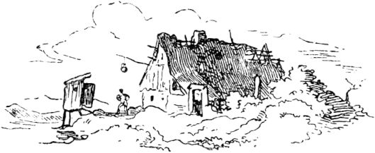

218

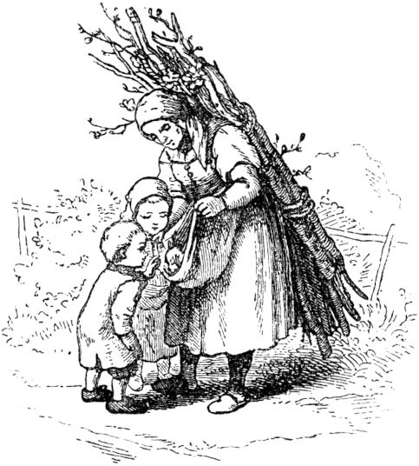

**The kitten and the knitting needles.**

Once upon a time there was a poor woman who went into the woods to read wood. As she was on her way back with her burden, she saw a sick kitten lying behind a fence that was crying miserably. The poor woman pityingly put it in her apron and carried it home. On the way her two children met her and when they saw that the mother was carrying something, they asked: “Mother, what are you wearing?” And wanted the kitten straight away; but the compassionate woman did not give the kitten to the children out of fear that they might torture it, but instead put it on old soft clothes at home and gave him milk to drink. When the kitten had fed itself and was well again, it was suddenly gone and gone. After a while the poor woman left 219Wife back into the woods, and when she came back with her load of wood on the way back to the place where the sick kitten had been lying, there was a very distinguished lady, waved the poor woman over and threw five knitting needles into her Apron. The woman did not quite know what to think, and found this strange gift to be inadequate for her; but she took the five knitting needles of the evening on the table. But when the woman left her bed the next morning, there was a pair of new, ready-knitted stockings on the table. That amazed the poor woman beyond measure, and the next evening she put the needles back on the table, and the next morning there were new stockings. Now she noticed that as a reward for her pity for the sick kitten she had been given these hard-working needles, and now let them knit every night, until she and the children had enough. Then she also sold stockings and had enough until her blissful end.

**The race between the hare and the hedgehog.**

This story is completely lying to tell, boys, but it is true, because my grandfather, from whom I got it, always used to say when he told it: “It must be true, my sons, because otherwise you couldn't tell. ”But the story happened like this:

Once upon a time on a Sunday morning in autumn, just as the buckwheat was in bloom. The sun had risen golden in the sky, the morning wind was fresh over the stubble, the larks sang in the air, the bees hummed in the buckwheat and the people 220went to church in their Sunday clothes, in short, all creatures were happy and so was the hedgehog.

The hedgehog, however, was standing in front of his door, had crossed his arms, peeked out into the morning wind and trilled a little song to himself, as good and as bad as a hedgehog can sing on Sunday morning. While he was now singing so half-quietly to himself, it suddenly occurred to him that while his wife was washing and dressing the children he could walk a little in the field and look around at how his turnips were standing. The turnips were the closest to his house, and he used to eat them with his family, and so he considered them his own. The hedgehog closed the front door behind him and took the path to the field. He was not very far from the house and just wanted to stroll up to the sloe bush that lies in front of the field, when he met the hare who had gone out in similar shops, namely to look at his cabbage. When the hedgehog saw the hare, he offered him a friendly good morning. The hare, however, who in his way was a very distinguished gentleman and cruelly arrogant at that, did not answer the Swinegel's greeting, but said to him, with a tremendously scornful expression: "How is it that you are so early Tomorrow you're walking around in the field? '' I'm going for a walk, 'said the hedgehog. "Go for a walk?" Laughed the hare, "I think you could use your legs for better things." This answer annoyed the hedgehog beyond measure, because he can take everything, but he doesn't let anything get on his legs, precisely because they are naturally crooked. "You are probably imagining," said the hedgehog, 221can do more? ”“ I think so, ”said the hare. "Well, it would depend on a try," said the hedgehog, "I'll parry if we race, I'll run past you." "That's laughable, you with your crooked legs!" Said the hare, "but I like be it when you have such excessive desire. What is the bet? ”“ A golden Lujedor and a Buttelje schnapps, ”said the hedgehog. “Suppose,” said the hare, “strike in and then we can start right away.” “No, it's not in such a big hurry,” said the hedgehog, “I'm still quite sober; first I want to go home and have a little breakfast. I'll be there in half an hour. ”Then the hedgehog walked, for the hare was satisfied.

On the way the hedgehog thought to himself: “The hare relies on its long legs, but I want to get it. He thinks himself to be a distinguished gentleman, but he's a stupid fellow and he still has to pay. "When the hedgehog arrived at home, he said to his wife:" Woman, get dressed in a hurry, you have to go into the field out. ”“ What is it? ”said the woman. “I made a bet with the hare for a golden Lujedor and a Buttelje schnapps, I want to run a race with him and you should be there.” “Oh my God, man!” Shouted the hedgehog his wife, “you are not wise have you lost your mind? How can you want to race the hare? ”“ Shut up, woman, ”said the hedgehog,“ that's my business. Do not argue in men's business. March, get dressed and then come with me. “What should the hedgehog do with his wife? She must have followed, whether she wanted to or not.

When they were on their way together, he spoke 222Swinegel to his wife: "Now watch out what I'm going to tell you. Look, in the long field, there we want to do our race. The rabbit runs in one furrow and I in the other, and we start to run from above. Now you have nothing more to do than stand down here in the furrow and when the rabbit arrives on the other side, you call out to him: "I'm already here."

With that they had reached the field, the hedgehog showed his wife her place and now went up the field. 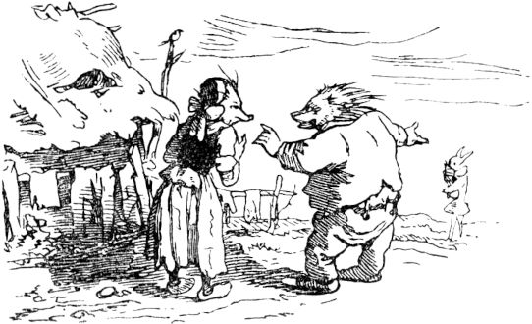When he got to the top, the rabbit was already there. "Can we go?" Said the hare. "Yes," replied the hedgehog. "Then you close!" And with that everyone stood in their furrow. The hare counted: “One, two, three!” And off he went down the field like a storm wind. But the hedgehog only ran about three paces, then crouched down in the furrow and sat quietly.

When the hare arrived at the bottom, the hedgehog his wife called out to him: “I'm already there!” The hare was startled and was not a little surprised. He didn't mean otherwise, it was the hedgehog himself, the 223shout this to him, because it is well known that the hedgehog his wife looks just like her husband.

The hare, however, said: “This is not going well.” He shouted: “Walked again, around again!” And away it went again like the storm wind, so that his ears flew on his head. But the hedgehog his wife remained calmly in her place. When the rabbit reached the top, the hedgehog called out to him: 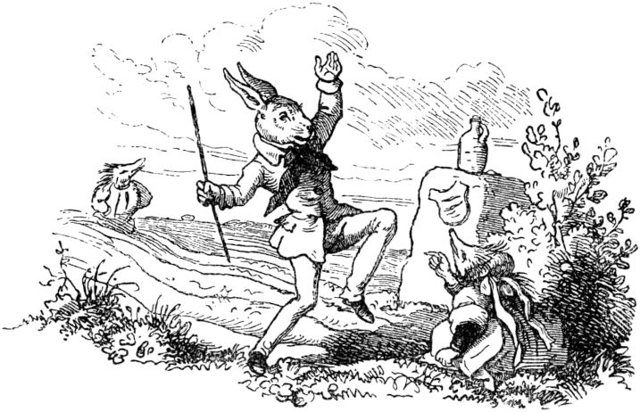“I'm already there!” The hare screamed, however, completely beside himself with zeal: “Run again, around again!” “Fine with me,” replied the hedgehog, “as often as you like.” So the hare ran seventy-three times, and the hedgehog always endured him. Every time the rabbit reached the top or bottom, the hedgehog or his wife said: "I'm already there."

For the seventy-fourth time, however, the hare never came to an end. In the middle of the field he fell to the ground, the blood flowed from his neck and he stayed dead on the ground 224Squares. The hedgehog, however, took the louisdor he had won and the bottle of brandy, called his wife from the furrow, and both went home happily, and if they have not died they are still alive.

So it happened that the hedgehog ran the hare to death on the Buxtehuder Heide, and since that time no hare has come up with a race with the Buxtehude hedgehog.

But the lesson from this story is, first, that no one, no matter how distinguished they may be, should allow themselves to be made fun of the lowly man, even if it were only a hedgehog. And secondly, that it is advisable, if someone is free, that he takes a woman from his class who looks exactly like himself. Anyone who is a hedgehog must see to it that his wife is also a hedgehog.

**Oda and the snake.**

Once upon a time there was a man who had three daughters, the youngest of whom was named Oda. Now the father of these three wanted to go to the market and asked his daughters what he should bring them with him. Then the eldest asked for a golden spinning wheel, the second for a golden white ribbon, but Oda said: "Bring me what runs under your car when you are on your way back." Then father went shopping at the market What the older girls wanted, and drove home, and, behold, a snake ran under the wagon, which the man caught and brought Oda with him. He threw them downstairs in the car, and then outside the front door, where he left them. As soon as Oda came out, the snake caught 225to speak: “Oda! dear Oda! Shall I not go into the hall? ”(In the hallway.) -“ What? ”Said Oda,“ my father took you to our door, and you want to enter the hall too? ”But she let them in anyway . As Oda went to her room, the snake called again: “Oda, dear Oda! Shouldn't I lie in front of your chamber door? ”-“ Hey, look! ”Said Oda. “My father brought you to the front door, I let you in on the hall, and now you want to lie in front of my chamber door too? 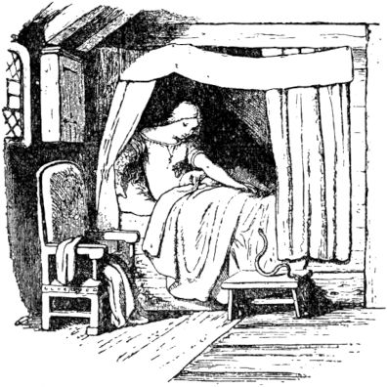But it may be so! ”- When Oda wanted to enter her bedroom and opened the chamber door, the snake called again:“ Oh, Oda, dear Oda! Shall I not go to your room? ”-“ How? ”Cried Oda,“ didn't my father take you to the front door with him? Didn't I let you in the hall and in front of my chamber door? And now you want to go into the chamber too? - But, if you want to be satisfied now, just come in, but lie still, I'll tell you! ”With that, Oda let the snake in and began to undress. As she was about to climb into her bed, the snake called out again: “Oh Oda, dearest Oda! Shouldn't I come to your bed with you? ”-“ Now it's going to be too great! ”Oda exclaimed angrily. “My father took you to the front door; I let you in the hall, afterwards in front of the chamber door, 226enter the chamber - and now you even want to go to bed with me? But are you frozen to death? Now come in with me and warm yourself, you poor worm! ”And there the good Oda herself stretched out her soft warm hand and lifted the cold snake up to her in her bed. Suddenly the serpent, which had been enchanted for a long time and which could only be redeemed when all that had happened to it, was transformed into a young and handsome prince who immediately had good Oda as his Wife took.

**The three gifts.**

Once upon a time there was a poor linen weaver, to whom three rich students came, and when they saw that the man was very poor, they gave him a hundred thalers as a gift to his inn. The linen weaver was very happy about this gift, thought to use it well, but wanted to feast his eyes on the bare thalers for a while, so he told his wife, who had not been at home, anything about his happiness and hid the money wherever nobody is looking for money, namely in the rags.

Once, when he was away, a rag-collector came and the woman sold him the whole stock for a few cruisers. There was great heartache when the linen weaver came home and his wife happily showed him the little money that had been paid for the rags.

The three students came back like this for over a year, hoping to meet the linen weaver in good circumstances, but found him even poorer than before because he complained to them of his misfortune. With the admonition to be more careful, the students gave him another hundred thalers; 227now he wanted to do it wisely, again said nothing to his wife and put the money in the ash-pot. And then it was just like the previous time; the woman exchanged the ashes for an ash collector for a few pieces of soap when her husband was away again to deliver some canvas to some customer. When he came back and found out about the ash trade, he became so angry that he leached his wife with unburned ashes.

Over a year the students came for the third time, found the linen weaver almost a rag and told him by throwing a piece of lead at his feet: “What use is the cow muscat? Giving you drip money would be more stupid than you are. We won't come back to you either. ”With that they went away, very annoyed, and the linen weaver picked up the piece of lead from the floor and laid it on the windowsill. Soon afterwards his neighbor came in, he was a fisherman, said hello and said: “Dear neighbor, don't you have a piece of lead or something heavy that I could use on my net? I don't have any more of that. ”Then the linen weaver gave him the piece of lead, and the neighbor thanked him very nicely and said:“ You should have the first big fish that I catch as a reward! ”-“ It's okay, it's not about

Soon afterwards the neighbor really brought in a pretty fish from a pound four to five and the linen weaver had to accept it. He immediately slaughtered the fish, and it had a large stone in its stomach. The linen weaver also laid the stone on the windowsill. In the evening, when it got dark, the stone began to shine, and the darker it got, the brighter the stone shone like a light. "It's a cheap lamp," 228said the linen weaver to his wife. "Don't you want to decorate them like you did the two hundred thalers?" And placed the stone so that it lit the whole room.

The following evening a gentleman rode past the house, saw the gloss stone, dismounted and went into the room, looked at the stone and offered ten thalers for it. The weaver said: “This stone is not for me!” - “Not even for twenty thalers?” Asked the gentleman. "Neither," replied the linen weaver. But the latter continued to bid and bid until he bid a thousand thalers, for the stone was a precious diamond and worth much more. Now the weaver struck and was the richest man in the village. Now the woman had the last word and said: “You see, man! If I hadn't given the money away with me twice! You only have to thank me for that! "-

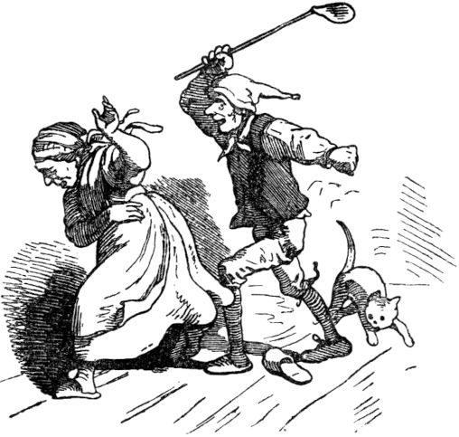

229

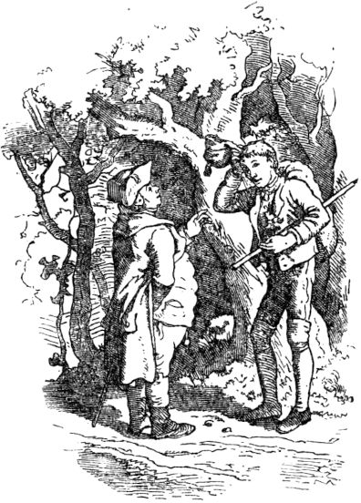

**Set the table, donkey stretch out, stick out of the sack.**

An honest tailor lived in a small town with his family, which consisted of five heads: father, mother and three sons. The latter were not named by their baptismal names, neither by their parents nor by all the inhabitants of the town, but simply the tall, the fat, the stupid. So they followed one another after the elder. The tall man became a carpenter, the fat man a miller, the stupid one a turner. When Tall Hendrik came out of his apprenticeship, his bundle was tied up and he was sent abroad, and he walked cheerfully with long strides to the gate of his native town. The fellow wandered for a long time 230from place to place and couldn't get a job; Now that his travel money, which was already scarce, was running out and he had no happy prospect of work and income, he became sad and hung his head and went on slowly on his way. This led just through a quiet, beautiful forest, and as the fellow was so far into it, he met a small, somewhat stout man who greeted him in a friendly way, stopped and asked: “Well, boy, where are you? You look really sad, what is wrong with you? ”-“ I don't have work, ”said the boy, honestly. "That's all my sorrow - I've been hiking for a long time - have run out of money." - "What kind of craft are you able to do?" - “I'm a carpenter.” - “Oh, come with me,” the little one exclaimed happily, “I want to give you work! See I live here in this forest - yes, yes, just come with me, you will see it in a moment. ”And barely a hundred paces further was a beautiful house, and all around was a thick, fresh green pine fence, looking like a protective wall, and standing in front of the entrance two tall fir trees, like huge sentinels. There the little man led the journeyman carpenter, who immediately let go of his sadness and walked into the lonely master's cozy room with a happy expression. "Welcome!" Called an elderly mother from the corner behind the stove and tripped over to the boy to help him get rid of his skin iron. The master chatted with the boy for a long time that evening, and the mother served food and also put a jug on the table, in which there was something far better than water or a cofent. you'll see it in a moment. ”And barely a hundred paces further there was a beautiful house, and all around was a thick, fresh green pine fence, to look like a protective wall, and at the front of the entrance there were two tall fir trees, like giant sentinels. There the little man led the journeyman carpenter, who immediately let go of his sadness and walked into the lonely master's cozy room with a happy expression. "Welcome!" Called an elderly mother from the corner behind the stove and tripped over to the boy to help him get rid of his skin iron. The master chatted with the boy for a long time that evening, and the mother served food and also put a jug on the table, in which there was something far better than water or a cofent. you'll see it in a moment. ”And barely a hundred paces further there was a beautiful house, and all around was a thick, fresh green pine fence, to look like a protective wall, and at the front of the entrance there were two tall fir trees, like giant sentinels. There the little man led the journeyman carpenter, who immediately let go of his sadness and walked into the lonely master's cozy room with a happy expression. "Welcome!" Called an elderly mother from the corner behind the stove and tripped over to the boy to help him get rid of his skin iron. The master chatted with the boy for a long time that evening, and the mother served food and also put a jug on the table, in which there was something far better than water or a cofent. and all around was a thick, fresh green pine fence, to look like a protective wall, and at the front at the entrance there were two tall fir trees, like huge sentinels. There the little man led the journeyman carpenter, who immediately let go of his sadness and walked into the lonely master's cozy room with a happy expression. "Welcome!" Called an elderly mother from the corner behind the stove and tripped over to the boy to help him get rid of his skin iron. The master chatted with the boy for a long time that evening, and the little mother served food and also put a jug on the table, in which there was something far better than water or a cofent. and all around was a thick, fresh green pine fence, to look like a protective wall, and at the front at the entrance there were two tall fir trees, like huge sentinels. There the little man led the journeyman carpenter, who immediately let go of his sadness and walked into the lonely master's cozy room with a happy expression. "Welcome!" Called an elderly mother from the corner behind the stove and tripped over to the boy to help him get rid of his skin iron. The master chatted with the boy for a long time that evening, and the little mother served food and also put a jug on the table, in which there was something far better than water or a cofent. same as giant sentinels. There the little man led the journeyman carpenter, who immediately let go of his sadness and walked into the lonely master's cozy room with a happy expression. "Welcome!" Called an elderly mother from the corner behind the stove and tripped over to the boy to help him get rid of his skin iron. The master chatted with the boy for a long time that evening, and the little mother served food and also put a jug on the table, in which there was something far better than water or a cofent. same as giant sentinels. There the little man led the journeyman carpenter, who immediately let go of his sadness and walked into the lonely master's cozy room with a happy expression. "Welcome!" Called an elderly mother from the corner behind the stove and tripped over to the boy to help him get rid of his skin iron. The master chatted with the boy for a long time that evening, and the little mother served food and also put a jug on the table, in which there was something far better than water or a cofent. “Called an elderly mother from the corner behind the stove and tripped over to the boy to help him get rid of his skin iron. The master chatted with the boy for a long time that evening, and the mother served food and also put a jug on the table, in which there was something far better than water or a cofent. “Called an elderly mother from the corner behind the stove and tripped over to the boy to help him get rid of his skin iron. The master chatted with the boy for a long time that evening, and the mother served food and also put a jug on the table, in which there was something far better than water or a cofent.

The young carpenter was quite happy with his 231Master; he didn't have too much to do, worked hard and otherwise behaved well and orderly, so that no complaint was brought about him. But after several months the little old man said: “Dear fellow, I can no longer need you, I have to give you the end of the day. And I cannot reward you with money for the work you have done for me; but I want to give you a nice souvenir that will help you more than gold and silver. ”He handed him a lovely little table and continued:“ Whenever you put this' table set yourself up 'and say three times:' Little table "Cover yourself" whenever it will offer you the food and drink for your meal that you only wish. And now farewell and remember your old master. "The journeyman reluctantly left his previous workshop, sadly and gladly at the same time he took the miraculous table from the giver's hands and, thanking him many times, withdrew and directed his steps back to his dear home. On the way the little table offered him his rich delights as often as the boy spoke the magic formula, and in no time the finest dishes and the finest wines were on it and all the vessels were made of silver, and underneath the finest, snow-white table settings shone. Of course, the journeyman held his "little table, set yourself up" very dearly; at his last inn, before he came home, he gave it to his host to keep. But since he hadn't eaten anything in the inn beforehand, but had locked himself in with the little table, the landlord had overheard him through a lens in the board door and had discovered the little table's secret. So he was happy beyond measure that he had the little table in his safekeeping was very pleased with its wonderful quality. He did it very well 232feel comfortable in front of the small table and wonder how he would like to appropriate the table in the best way. Then it occurred to him that he had a very similar table, although not a “table, cover yourself”. The clever landlord therefore hid the real little table and delivered the other, fake, to the journeyman the next morning, who loaded himself with it without hesitation and now happily hurried to his home. The tall carpenter at home greeted his family with joy and immediately discovered his father the delicious thing about the little table. The father had strong doubts, but the son put it in front of himself, said three times: “Little table, cover yourself” - but it did not cover itself and the honest master tailor said to his son: “You stupid Hans, that's why you were abroad to uzen your old dad? Go don't let yourself be laughed at! ”The tall carpenter had no idea what to do with the little table in the world? He tried again; but it did not coincide again, and Tall Hendrik had to pick up the plane again and work that the rind cracked.

In the meantime, the fat miller had come from an apprenticeship and was wandering off into a foreign country. And it happened that he also took the same route, found the same little man, and was taken to work by him. But the forest house was now a mill. When the young miller had been working well, loyally and diligently for a while, his master gave him a beautiful miller's lion as a souvenir and said: “As a farewell, take a little gift that you will receive, although I cannot reward you with money for your work , but will do more good than gold and silver. Whenever you will speak to this donkey: 233'Donkey, stretch!' as often as you will ducats - sneeze. "

Almost more often than Tall Hendrik had said on the way: "Little table, cover yourself" now said the fat one: "Little donkey, stretch yourself", and then it stretched and dropped ducats so that it rattled and pattered. 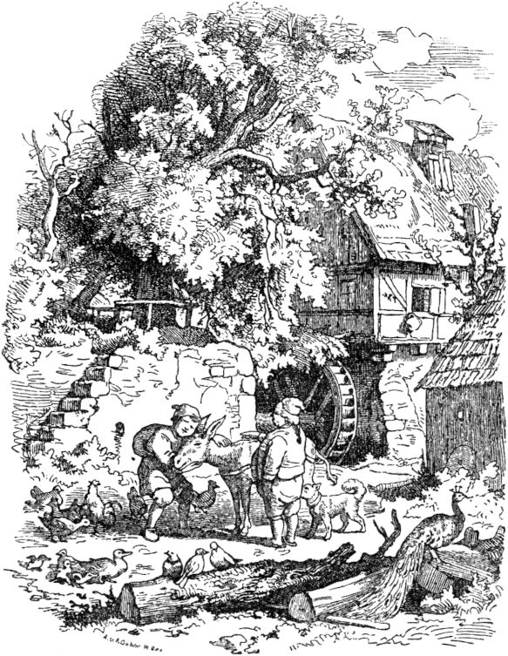It was a very dearest thing - the shiny gold pieces. But the journeyman miller also came with his donkey to the inn of the deceitful and cunning innkeeper, had dinner served, entertained whoever wanted to be entertained, and as the innkeeper, the colliery 234demanded, he said: "Wait a little, I just want to get some money first." Took the tablecloth with me, went into the stable, spread it over the straw on which the donkey was standing, and said: "Donkey, stretch yourself!" then the donkey stretched and sneezed, and ducats rang on the cloth, but outside the landlord stood, looked through a knothole in the door and made a note of the matter. 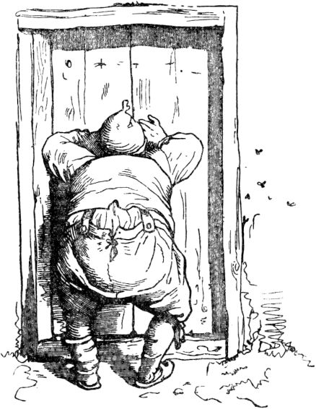The next morning there was a donkey, but not the right one, and the fat man, not suspecting any deception, sat up cheerfully and rode away. When he came to his father, he announced his happiness to him and said, when all of his family stood around the donkey in joyful amazement: "Now be careful!" And turning to the donkey: "Donkey, stretch yourself!" The strange donkey stretched itself also, but what dropped it was nothing less than gold pieces. The fat man was horribly laughed at by everyone he wanted to show the art to; he made the donkey as soft as a nappy, yet he never knocked any ducats out of its skin and from then on had to work again and eat bread in the sweat of his brow.

Another year had now passed, and the stupid man, too, had survived his apprenticeship and moved in as 235brave woodturner in a foreign country. He took the same course with diligence as his brothers and wished very much to get into work with that little man, since, as the brothers had told, he was well versed in all subjects, in handicrafts as well as in learning and wisdom and such beautiful things had to give away. The journeyman wood turner also got right into the certain forest, found the little man's lonely apartment, and as a hardworking fellow he was also happy to take it to work. After several months, however, it was said again: “Dear fellow, I can no longer keep you, you have finished work.” In parting, the little man said: “I was happy to give you, like your brothers, a nice souvenir, but what would you do that help since they call you the stupid Your long brother and your fat brother have lost their gifts because of their stupidity, what would it become with you? But take this simple sack; it can be very useful to you. Whenever you say to him: Stick out of the sack! - so often a well-twisted stick stuck in it will come out for your protection, your defense and help, and this will continue to beat you until you command: Stick in the sack! "

The turner thanked him nicely and went home with his little sack; However, for a long time he did not need the protection guard on his journey, for anyone who walked easily and happily along his road let him wander unhindered for a long time. Only sometimes did he give a stern mendicant bailiff a little to taste or the village dogs that drive out of all the farms and bark at and after hikers. So he finally got to that inn where the wicked landlord had cheated his brothers out of theirs and now 236lived gloriously and joyfully, but still always had a desire to appropriate something of the travelers' goods. When he went to sleep the turner gave the landlord the sack for safekeeping and warned him not to say to this sack: “Stick out of the sack!” Because there was a special reason for this and someone could, if he said so, carry something away . However, the landlord liked his little table and donkey too much for him not to have so secretly caught a third miraculous object; 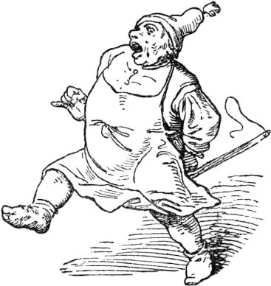he could hardly wait for the guest to go to sleep and say: "Cudgel out of the sack!" And in an instant the cudgel came out and whirled like a drumstick on the landlord's back, beating on and on, and beat the landlord so brown and blue that he raised a pitiful cry and howled cheerfully to the wood turner. He said: “Host, that serves you right! I warned you yes. You laid the table for my brothers and stole the little donkey stretching you. "The landlord screamed:" Oh, just help me for God's sake! I'm going to be killed! ”(Because the club was still working restlessly on the landlord's back.)“ I want to surrender everything again, the little table and the donkey! Oh, I'll fall over and I'm dead! "

Now the journeyman ordered: “Stick in the sack!” And the beating crawled back into the sack in no time. And 237the landlord was just glad that he had lost his life and willingly gave the little table and donkey back. 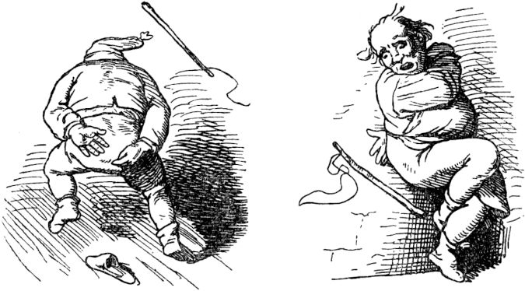Then the turner packed up his stuff, loaded his bundle and himself onto the donkey, and trotted off to the little hometown. 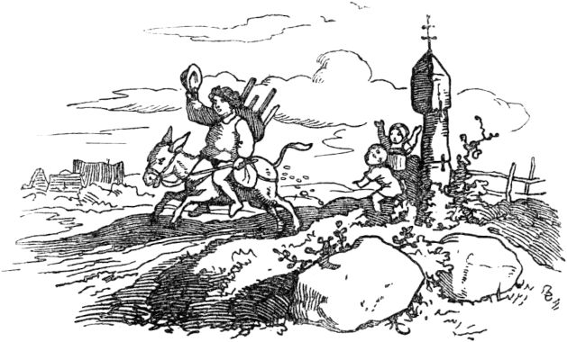There was no small joy among the brothers when they saw the extremely valuable gifts and souvenirs regained, which just now performed their miracles as gloriously as before - regained by the one whom they always scolded stupidly 238and who was smarter than her. And the brothers stayed together with their parents and no longer needed to work in order to create their daily bread from their earnings, because from now on they had the abundance and abundance of everything that human life needs.

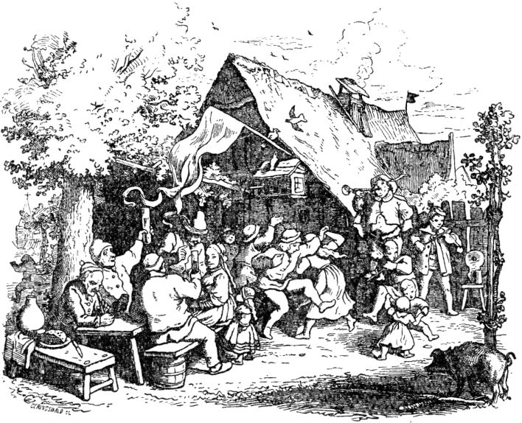

**The three musicians.**

Once three young musicians moved from their home to a foreign country; all three of them had learned music from a master and now wanted to stay together and try their luck in foreign lands. They happily wandered from place to place, played at fairgrounds and 239Festive dances, and won through their funny little pieces of music even some heavy chunks in addition to the quiet and loud applause. So once they came to a town and in the evening amused the company with beautiful music. Finally they stopped playing, but had a drink, let some of them know and also gave their part to the conversation with the guests. Many astonishing things were chatted together and told. At first there was talk of a magic castle, which was located near the town, and about which as much wonderful as wonderful was told. Soon it was said: yes, there are tremendous treasures there, there is always an abundance of the most delicious food, although not a soul lives in it - soon it was said again: but there is a terrible ghost haunt. Whoever carries his hump in white brings him out again, colored brown and blue, without having lifted the treasures or having broken the spell. This and much more was talked back and forth about the enchanted castle. The three musicians were not alone in their little bedroom as soon as they talked for a long time and at the same time got the idea of ​​taking a closer look at the enigmatic castle, even venturing into it, possibly to uncover the bewitched treasures hidden there. Now they agreed that everyone should venture into it individually, one after the other, depending on the elder, and that everyone should have a whole day to endure their adventure. The first attempt at luck fell to him without having raised the treasure or having broken the spell. This and much more was talked back and forth about the enchanted castle. The three musicians were not alone in their little bedroom as soon as they talked for a long time and at the same time got the idea of ​​taking a closer look at the enigmatic castle, even venturing into it, possibly to uncover the bewitched treasures hidden there. Now they agreed that everyone should venture into it individually, one after the other, depending on the elder, and that everyone should have a whole day to endure their adventure. The first attempt at luck fell to him without having raised the treasure or having broken the spell. This and much more was talked back and forth about the enchanted castle. The three musicians were not alone in their little bedroom as soon as they talked for a long time and at the same time got the idea of ​​taking a closer look at the enigmatic castle, even venturing into it, possibly to uncover the bewitched treasures hidden there. Now they agreed that everyone should venture into it individually, one after the other, depending on the elder, and that everyone should have a whole day to endure their adventure. The first attempt at luck fell to him when they talked for a long time and at the same time grasped the idea of ​​taking a closer look at the enigmatic castle, even daring to venture inside, possibly to uncover the bewitched treasures hidden there. Now they agreed that everyone should venture into it individually, one after the other, depending on the elder, and that everyone should have a whole day to endure their adventure. The first attempt at luck fell to him when they talked for a long time and at the same time grasped the idea of ​​taking a closer look at the enigmatic castle, even daring to venture inside, possibly to uncover the bewitched treasures hidden there. Now they agreed that everyone should venture into it individually, one after the other, depending on the elder, and that everyone should have a whole day to endure their adventure. The first attempt at luck fell to him to survive his adventure. The first attempt at luck fell to him to survive his adventure. The first attempt at luck fell to himViolinist too. He made his way courageously and without hemming into the castle and when he got there found the entrance gates already open, as if one had waited for him; but when he had crossed the threshold, hit behind 240The heavy door closed for him and a huge iron bolt jumped forward, although no living creature could be seen, but as if a strict porter was doing his job and keeping watch - and the violinist was terrified, so that his hair fell on it Eddy bucked. But he could neither turn back nor linger, and he was strengthened again by the thought of the luck to be hoped for, of gold and treasures. Upstairs, downstairs, the young man wandered through wonderful rooms, precious halls, cozy little cabinets - everything splendidly furnished and preserved in the most beautiful cleanliness. But everywhere there was a dead silence, not even the smallest mosquito lived or lived here. But the young man's courage grew again, especially as he turned to the lower rooms, kitchen and vaults, where the rarest and most delicious supplies of food were abundantly available, the wine bottles were stored high in the vaults and all sorts of sweet, preserved fruit were placed one after the other in large glasses. In the beautiful bright kitchen a bright little fire crackled confidentially, and an invisible hand placed a grid above it, and selected venison danced out of the vault into the kitchen and onto the grate; and many other dishes, fine vegetables and pies and delicious pastries and selected venison danced out of the vault into the kitchen and onto the grill; and many other dishes, fine vegetables and pies and delicious pastries and selected venison danced out of the vault into the kitchen and onto the grill; and many other dishes, fine vegetables and pies and delicious pastrieswere prepared just as quickly as precious by invisible hands and then carried to one of the most beautiful rooms, where the young man had gone, and placed on a table in front of him. The youth first took up his instrument and let his beautiful melodies resound through the quiet rooms, whereupon he sat down at the inviting table without hesitation and began to feast. But not long before the door opened and a little man stepped in, for example 241three elbows high, dressed in a scarlet skirt, with a withered face and a gray beard that reached down to the large silver shoe buckles. And the little man sat in silence next to the violinist and feasted with him. When it came to the turn of the beautiful roast venison, the violinist took the bowl and nodded to the little man, but first to reach for it, and the latter, smiling, speared a piece of meat on the fork and nodded again, dropping the roast piece under the table. The good violinist bent down to pick it up again; but in an instant the little beard man was sitting on his back and bleeding so ruthlessly at him, as if it wanted to blow out the light of life. And the violinist's mouth was also closed, until it was finally pushed out of the great entrance gate under incessant beating. Outside, the half-dead violinist scooped up fresh breath and then, groaning, crept to the inn where the comrades had stayed. It was already night when he reached him and those two were already asleep. The next morning they were quite astonished to see the violinist lying in bed too, and soon stormed him with many questions; but he scratched his head and back, gave very short answers and said: “Go and see for yourself! It's a ticklish thing. " The next morning they were quite astonished to see the violinist lying in bed too, and soon stormed him with many questions; but he scratched his head and back, gave very short answers and said: “Go and see for yourself! It's a ticklish thing. " The next morning they were quite astonished to see the violinist lying in bed too, and soon stormed him with many questions; but he scratched his head and back, gave very short answers and said: “Go and see for yourself! It's a ticklish thing. "

The second musician, a trumpeter , now took the passage to the magic castle, found everything just like the blued violinist, and was also entertained with pies and beatings, so that the following morning he too lay on his bed like a bruised fox and complained that it had been played to him in a strange way, in a rough key. Nevertheless, the third, a flute player , still had courage enough to see his salvation 242Try magic castle. He was the smartest. He wandered fearlessly through the whole castle; it seemed to him quite pleasant to own these beautiful rooms forever; There was an abundance of food in the kitchen and cellar. Soon a precious table was set for him too, and when he had wandered about long enough singing happily and blowing the flute, he sat down and let himself be comfortable. Then the little beard man came in again and sat down next to the guest. And the intrepid musician entered into a conversation with him and pretended to have met him here a hundred times, but the little man was not very talkative. At last it came back to the roast and the little man deliberately dropped his piece again; the flute player was just about to take it up when he saw that the dwarf wanted to jump quickly on his back. Then he turned around quickly, tore it away, and grabbed and shook the little man by his beard so roughly until at last he tore it out completely and the little old man fell down with a groan. But as soon as the young man had the beard in his hands, an extraordinary power came over him and he saw much more wonderful things in the castle as before; on the other hand the little man had lost almost all life; it whined and pleaded: "Give, oh, give me my beard back, so I will announce to you all the magic that surrounds this castle and help you to release the magic, so that you will become rich and happy forever." But the clever flute player said: “You shall have your beard again, but you must have me Then he turned around quickly, tore it away, and grabbed and shook the little man by his beard so roughly until at last he tore it out completely and the little old man fell down with a groan. But as soon as the young man had the beard in his hands, an extraordinary power came over him and he saw much more wonderful things in the castle as before; on the other hand the little man had lost almost all life; it whined and pleaded: "Give, oh, give me my beard back, so I will announce to you all the magic that surrounds this castle and help you to release the magic, so that you will become rich and happy forever." But the clever flute player said: “You shall have your beard again, but you must have me Then he turned around quickly, tore it away, and grabbed and shook the little man by his beard so roughly until at last he tore it out completely and the little old man fell down with a groan. But as soon as the young man had the beard in his hands, an extraordinary power came over him and he saw much more wonderful things in the castle as before; on the other hand the little man had lost almost all life; it whined and pleaded: "Give, oh, give me my beard back, so I will announce to you all the magic that surrounds this castle and help you to release the magic, so that you will become rich and happy forever." But the clever flute player said: “You shall have your beard again, but you must have me until at last he tore it out completely and the little old man fell down with a groan. But as soon as the young man had the beard in his hands, an extraordinary power came over him and he saw much more wonderful things in the castle as before; on the other hand the little man had lost almost all life; it whined and pleaded: "Give, oh, give me my beard back, so I will announce to you all the magic that surrounds this castle and help you to release the magic, so that you will become rich and happy forever." But the clever flute player said: “You shall have your beard again, but you must have me until at last he tore it out completely and the little old man fell down with a groan. But as soon as the young man had the beard in his hands, an extraordinary power came over him and he saw much more wonderful things in the castle as before; on the other hand the little man had lost almost all life; it whined and pleaded: "Give, oh, give me my beard back, so I will announce to you all the magic that surrounds this castle and help you to release the magic, so that you will become rich and happy forever." But the clever flute player said: “You shall have your beard again, but you must have me on the other hand the little man had lost almost all life; it whined and pleaded: "Give, oh, give me my beard back, so I will announce to you all the magic that surrounds this castle and help you to release the magic, so that you will become rich and happy forever." But the clever flute player said: “You shall have your beard again, but you must have me on the other hand the little man had lost almost all life; it whined and pleaded: "Give, oh, give me my beard back, so I will announce to you all the magic that surrounds this castle and help you to release the magic, so that you will become rich and happy forever." But the clever flute player said: “You shall have your beard again, but you must have me before all this manifest, otherwise you're a rogue. And I would rather not give the beard out of my hands. ”The old man had to be comfortable with fulfilling his promise first. 243whether he hadn't been willing right away, but just wanted to regain his beard with cunning. The youth now had to follow him through dark, secret passages, underground vaults and grayish crevices until they finally came to a free field that looked entirely like a much more beautiful world than ours. And they came to a river that roared wildly; but the little man pulled out a small stick and struck the water, whereupon the tide broke apart and stood still until both feet were dry. It was splendid over there! - there it went on through beautiful green leafy walks, flowers everywhere, birds with silver and gold feathers that sang wonderfully, and shiny beetles and butterflies fluttered and danced around, and other cute animals flirted in bushes and hedges;

The youth was amazed; and was even more astonished when he was led by the gray dwarf into an even more magnificent building than the wonderful castle. Here, too, in addition to all the splendor, the deepest silence reigned in the rooms, and as she wandered through them a lot, they came to one that was covered entirely with veils, where there was a tightly veiled bed in the middle of the room, with a beautiful birdcage hanging over it a little bird, which uttered bright songs through the lonely silence. The little gray man lifted his veil and coverings from the bed and led the young man closer; he saw here on soft silk pillows, which were richly hung with gold tassels, a very lovely girl lying asleep, she was as beautiful as it was 244an angel was wearing a little white dress, and over her chest and shoulders flowed the golden curls, and a demantic crown flashed on her head; but a deep, death-like sleep held the gentle features captive, and no sound was able to wake the lovely sleeper. The little man said to the astonished young man: “Look here at this sleeping child! It is a high princess. This beautiful castle and this blessed land is her inheritance when she is redeemed; 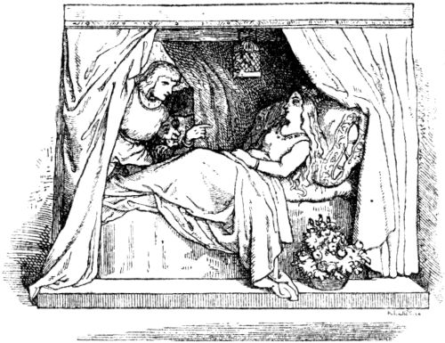but for centuries she has been sleeping in a deep magical sleep and for centuries no human soul has yet found the way that leads here, which only I covered daily to dine there in the castle, which is my apartment, and the gold-hungry people who are found himself to be beaten with a court. I am the guardian of this sleeper and had to carefully prevent no stranger from entering here, and in addition I was given my beard, in which reside such excessive powers that I too have been able to practice this magic for centuries. But now where the 245Torn from my beard, I am powerless and have to let this exuberant happiness, which awakens with the lovely princess, discover and leave to you. And so send yourself quickly to perform the miracle of redemption. Take this bird that hangs over the princess and that once sang her into the magic slumber, and since then had to sing those melodies constantly - take him, slaughter him and cut out his little heart, then burn it to powder and give this the princess in the mouth, immediately she will wake up and make you happy with hand and heart, with land and castle and all her treasures. ”The little man was silent, exhausted, and the young man did not fail to go to the work of redemption. Everything was done quickly and well according to the little old man's instructions and the powder was prepared. After a few minutes, When it was given to the princess, she opened her eyes, fresh and smiling, and rose from the bed and sank to the happy youth's breast, caressed and thanked him, and accepted him as her husband. And at the same moment there was a thundering and crashing through the lock, it was loud on all the stairs, and it was noisy in all the rooms. And finally a crowd of servants with friendly faces came into the room in which the happy couple was staying, and everyone was happy, and then flew briskly and happily into the kitchen and cellar, into the rooms and halls and corridors to their work , and were all reborn. caressed and thanked him and took him to be her husband. And at the same moment there was a thundering and crashing through the lock, it was loud on all the stairs, and it was noisy in all the rooms. And finally a crowd of servants with friendly faces came into the room in which the happy couple was staying, and everyone was happy, and then flew briskly and happily into the kitchen and cellar, into the rooms and halls and corridors to their work , and were all reborn. caressed and thanked him and took him to be her husband. And at the same moment there was a thundering and crashing through the lock, it was loud on all the stairs, and it was noisy in all the rooms. And finally a crowd of servants with friendly faces came into the room in which the happy couple was staying, and everyone was happy, and then flew briskly and happily into the kitchen and cellar, into the rooms and halls and corridors to their work , and were all reborn.

The gray dwarf, however, now sternly demanded his beard from the youth, and still thought in his malicious heart to play a prank to the lucky one. Because when his beard is back on his chin 246sat he had power, all mortalsto overwhelm. But the clever flute player still used caution with the treacherous little man, he said: "Oh, you shall have your beard back, do not be afraid, I will hand it over to you as a farewell, but allow the two of us, my lovely bride and I to accompany you a short distance. ”The little man couldn't refuse that. They now walked a long way through beautiful foliage and flowerbeds with the dwarf, and finally came to the immensely deep, rushing water which flowed many, many miles around the princess's land and formed the dividing line, as it were. There was no bridge and no boat around by which people could reach the other bank; not even a bold swimmer would have won it, because the tide of the waves was too roaring and wild. The young man said to the little man: "Give me your staff, so that this time I will separate the water for your honor." And the little man had to obey because he had not yet regained his beard and thought in silence with malicious joy: if he would give me over there Handing over the beard to water, I will get it under my control, then take the staff from him again, and neither of them can set foot on their beautiful land. But that was not how the dwarf's malicious thoughts ran out. The clever, happy young man struck the water with his staff, it parted nimbly and stood still, and the dwarf went ahead and crossed over, and quickly behind him the tide rushed together; but the youth had stayed behind with his dear bride on the other bank, he kept his magic wand and only threw his beard over the water, so that the dwarf over there caught him and put him back on; and so was the old man 247but cheated out of his wand and was never allowed to enter the wonderful area again. And the happy young man returned to the castle with his fair girl, to constant joy and happiness; and no longing came to his heart to ever return to his comrades. They sat in the pub for a long time, and when that one did not come back they said: "He left," - and that has become a saying afterwards when something or something is lost and does not come back.

**The miller and the mermaid.**

Once upon a time there was a miller who was rich in money and goods and led a happy life with his wife. But misfortune comes overnight; the miller became poor and in the end could hardly call the mill in which he sat his own. During the day he went about sorrowful, and when he lay down in the evening he found no rest, but spent the whole night waking up in sad thoughts. One morning he got up early one day and went outside; he thought it should be easier on his heart. As he paced up and down the embankment at his mill pond, he suddenly heard it rustling in the pond, and when he looked a white woman climbed up from it. Then he realized that it must be the mermaid of the pond, and because of great fear he did not know whether to walk away or stop. While he hesitated the mermaid raised her voice, called him by name and asked him why he was so sad? As the miller the kind words 248heard, he took heart and told her how otherwise he would have been so rich and blissful and now he was so poor that he did not know what to do with his misery and worries. The mermaid spoke to him with comforting words and promised him that she would make him even richer than he had ever been if, on the other hand, he would give her what had just become young in his house. The miller thought she wanted a young one from his dog or his cat, so he agreed to what she asked and hurried off good onesCourage after his mill. His maid stepped out of the front door with a joyful gesture and called out to him that his wife had just given birth to a boy. The miller stood there and couldn't look forward to the birth of his child, which he had not expected soon. Sadly, he went into the house and told his wife and relatives, who came over, what he had praised the mermaid. “All the luck that she promised me may fly away,” he said, “if only I can save my child.” But no one had any other advice than that one must carefully watch out for the child so that it never goes into the pond would come too close.

The boy grew up happily and in the meantime the miller gradually got money and property, and it wasn't long before he was richer than he had ever been. But he could not really enjoy his luck, because he always remembered his vow and feared that sooner or later the mermaid would insist on its fulfillment. But year after year passed, the boy grew up and learned to hunt, and because he was a handsome hunter, the master of the village took him into his service, and the hunter married a young woman and lived peacefully and happily.

Once he chased a hare on the hunt, the 249finally turned into the open field. The hunter eagerly pursued him and knocked him down with one shot. Immediately he began to eviscerate, not paying attention to the fact that he was near the pond, which he had had to watch out for from childhood. He was soon finished with the evisceration and went to the water to wash his bloody hands. No sooner had he plunged her into the pond than the mermaid rose 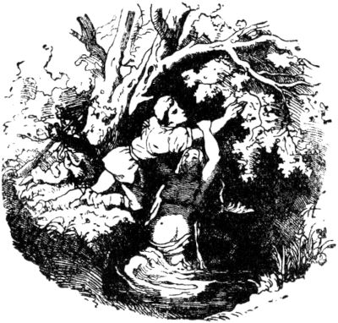embraced him with wet arms and dragged him down with him so that the waves crashed over him.

When the hunter did not return home, his wife became very frightened, and when they looked for him and found his hunting bag lying by the mill pond, she no longer doubted how he had fared. Without rest or rest she wandered about the pond and wailedly called her husband day and night. At last she fell asleep from weariness, dreaming of how she wandered through a flowering hallway to a hut where a sorceress lived, who promised to restore her husband to her. When she woke up that morning, she decided to follow the inspiration and see the sorceress. So she emigrated and soon came to the flowering hallway and then to the hut in which the sorceress lived. She told of her grief and that a dream had promised her advice and help from her. The sorceress 250informed her that she should go to the pond when the moon was full and straighten her black hair with a golden comb and then lay the comb on the bank. The young hunter's wife gave the sorceress plenty of presents and went home.

The time until the full moon passed slowly; But when it was finally full moon, she went to the pond and straightened her black hair with a golden comb, and when she was finished she put the golden comb down on the bank and then looked impatiently into the water. Then it rushed and roared from the depths and a wave washed the golden ridge from the bank and it wasn't long before her husband lifted his head out of the water and looked at her sadly. But soon another rushing wave came and the head sank without having spoken a word. The pond was again calm as before and shone in the moonlight and the hunter's wife was no better off than before.

She woke up desolate days and nights until she sank tiredly into sleep again and the same dream that had referred her to the sorceress came over her again. Once again in the morning she went to the flowering corridor and to the hut and complained to the sorceress of her grief. The old woman informed her that she should go to the pond when the moon was full, blow on a golden flute, and then lay the flute on the bank.

When the moon was full, the hunter's wife went to the pond, blew a golden flute, and then laid it on the bank. Then it rushed and roared from the depths and a wave washed the flute from the bank and soon the hunter raised his head above the water and dived higher and higher, up to over his chest, and spread his arms to his wife. Then came another rushing one 251Wave and pulled him back into the depths. The hunter's wife had stood on the bank full of joy and hope and sank in deep grief when she saw her husband disappear into the water.

But as a consolation, the dream appeared again, which referred her to the flowering hallway and the hut of the sorceress. This time the old woman gave the order: As soon as the moon would be full, she should go to the pond, spin on a golden wheel and then put the wheel on the bank. When the full moon came, the hunter's wife obeyed orders, went to the pond, sat down and spun on a golden wheel, and then set the wheel on the bank. There it rushed and roared from the depths and a wave washed the golden wheel from the bank, and soon the hunter lifted his head above the water and dived higher and higher, until at last he climbed to the bank and fell on his wife's neck. Then the water began to rustle and roar and flood the bank far and wide, pulling both of them down with them as they held each other. In her anguish of the heart, the hunter called on the assistance of the ancients, and suddenly the hunter was transformed into a toad and the hunter into a frog. But they could not stay together, the water tore them in different directions, and when the flood had passed they both had become human again, but the hunter and the huntress were each in a strange region and they knew nothing of one another.

The hunter decided to live as a shepherd, and the huntress also became a shepherdess. So for many years they looked after their flocks, one from the other.

But once it happened that the shepherd went there 252came where the shepherdess lived. He liked the area and saw that it was very fertile for his flock to graze on. So he brought his sheep there and tended them as before. The shepherd and the shepherdess became good friends, but they did not recognize each other.

But one evening they sat together in the full moon, let their flocks graze and the shepherd blew on his flute. 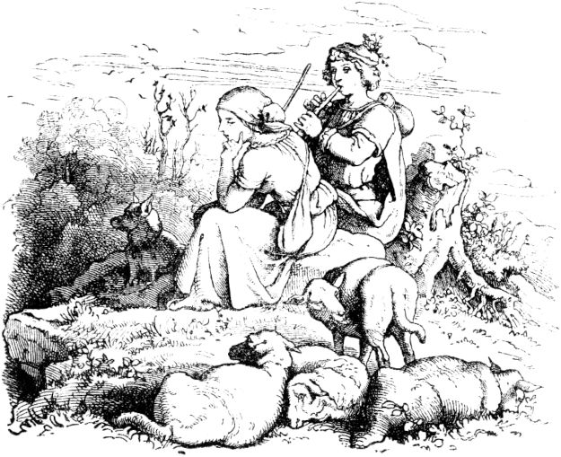The shepherdess remembered that evening when she played the golden flute by the pond under the full moon; she could not hold out any longer and burst into crying. The shepherd asked her what she was crying and complaining about? - until she told him what had happened to her. Then it fell like scales from the shepherd's eyes, he recognized his huntress and revealed himself to her. Now they happily returned to their homeland and lived together undisturbed and in peace.

253

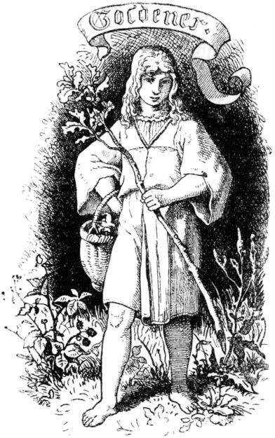

**Golden.**

Long years ago a poor shepherd lived in a dense forest, he had built a wooden house in the middle of the forest, where he lived with his wife and six children, all of whom were boys. At the house there was a draw well and a little garden, and when the father fed the cattle, the children went out and brought him a cool drink from the well or a dish from the little garden for lunch or dinner.

The parents only shouted to the youngest boy: "Golden one," because his hair was like gold, and although the youngest boy, he was still the strongest of all and also 254the biggest. Whenever the children went out into the hallway, Goldener led the way with a branch of a tree, no one else wanted to go, for each was afraid of encountering an adventure first; 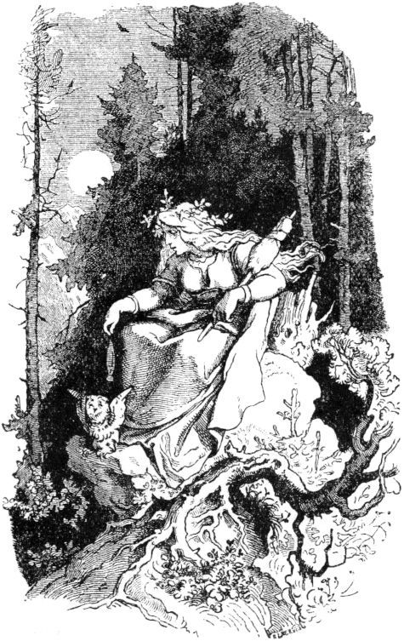but if Goldener went ahead, they happily followed one after the other, through the darkest thicket, even when the moon was already over the mountains.

One evening the boys on their way back from their father amused themselves with games in the forest, and Goldener had got so excited in front of everyone that he looked as bright as the sunset. “Let's go back!” Said the oldest - “it seems to be getting dark.” - “Look there, the moon!” Said the second. Suddenly there was light from between the dark fir trees and a woman, shining like the moon, sat down on one of the mossy stones, spun a light thread with a crystal spindle into the night, nodded her head towards Goldener and sang:255

"The white finch, the golden rose,

The queen in the bosom of the sea! "

She would probably have continued to sing when the thread broke and it went out like a light. Now it was all night, the children were seized with horror, they jumped with pitiful cries, one there, the other there, over rocks and crevices, and lost one after the other.

Goldener also wandered around in the thick forest for many days and nights, but found neither one of his brothers, nor his father's hut, nor any other trace of a person, because the forest was densely overgrown, one mountain placed above the other and one chasm under the other.

The blackberries that hung all over the place satisfied his hunger and thirst, otherwise he would have died miserably. Finally on the third day - others say only on the sixth or seventh day - the forest became bright and always lighter, and then Goldener finally came out onto a beautiful green meadow.

It was so easy for his heart and he breathed in the open air with full gulps.

Yarns were laid out in the same meadow because there lived a bird dealer who caught birds that flew out of the forest and carried them into town to buy.

“I need a fellow like that,” thought the bird operator when he saw Goldener, who was standing on the green meadow close to the yarn and looking into the wide blue sky and couldn't see enough of himself.

The bird operator wanted to have some fun, he pulled his yarn and shoo! Goldener was caught and lay quite astonished under the thread, for he did not know how it had happened. “This is how you catch the birds that are out 256come to the forest "- said the bird operator with a loud laugh -" your red feathers are just fine with me. Are you a devious fox? Stay with me, I'll teach you to catch the birds too! "

Goldener was right there, he thought it was a very funny life among the birds, especially since he had completely given up hope of finding his father's hut again.

"Let us try out what you have learned," said the bird operator to him after a few days. Goldener pulled the yarn and on the first move he caught a snow-white finch.

“Pack yourself with this white finch!” Shouted the bird operator, - “you have to deal with the evil one!” And so he pushed him very roughly from the meadow by taking the white finch that Goldener had handed him from among many Trampled curses with his feet.

Goldener could not understand the words of the bird handler, he went back sadly but confidently into the forest and resolved once more to look for his father's hut. Day and night he ran over rocks and old fallen tree trunks, and often fell over the black roots that protruded from the ground everywhere.

On the third day, however, the forest finally became lighter again, and there he came out into a beautiful, light garden, which was full of the loveliest flowers, and since Goldener had not yet seen any of them, he stopped in admiration. The gardener in the garden did not see him as soon as he said: “Ha! I just need a fellow like that! ”and the gate of the garden closed. It was more golden than that 257He thought there was a very colorful life among the flowers, especially since he had completely given up hope of finding his father's hut again.

“Off into the forest!” Said the gardener to Goldener one morning, “get me a wild rose bush so that I can plant tame roses on it!” Goldener went and came back with a stick of the most beautiful gold-colored roses, they were no different either, as if the most skilled goldsmith had forged it for a king's table.

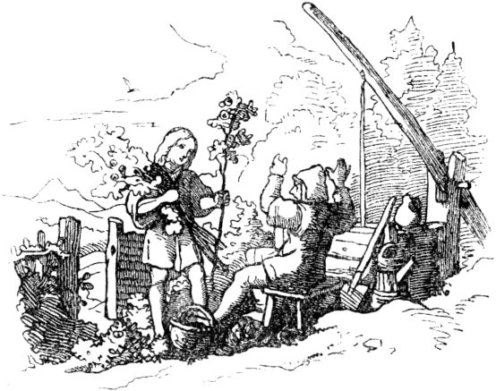

“Pack yourself with these golden roses!” Shouted the gardener, - “you have to deal with evil,” and so he pushed him out of the garden very roughly by kicking the golden roses into the earth under many curses.

Goldener couldn't understand the gardener's words, but he confidently went back into the forest and resolved once more to look for his father's hut.

He ran from tree to tree day and night 258Rock to rock. On the third day, at last, the forest grew bright and lighter, and then Goldener came out to the blue sea; it lay in front of him in an immeasurable distance, the sun was just being reflected in the crystal-clear surface, there it was like flowing gold, on which were beautifully decorated ships with long flying pennants. A few fishermen stopped in a delicate boat on the bank, into which Goldener stepped and looked out into the light with astonishment.

“We need a fellow like that,” said the fishermen, and shoved them from the country. Goldener put up with it, because by the waves it seemed to him a golden life, especially since he had completely given up hope of finding his father's hut again. The fishermen cast their nets and caught nothing. “Let’s see if you’re happier!” Said an old fisherman with silver hair to Goldener. With clumsy hands, Goldener lowered the net, drew and fished - a crown of light gold.

“Triumph!” - cried the old fisherman and fell at Goldener feet, - “I greet you as our King! A hundred years ago the old king, who had no heirs, dying, sank his crown into the sea, and until somebody fortunate had the fate determined to pull the crown out of the deep again, the throne should remain shrouded in mourning without a successor . "

"Hail our King!" Shouted the fishermen and put the crown on goldeners. The news of Goldener and the recovered royal crown soon spread from ship to ship and across the sea far into the country. The golden surface was soon occupied with brightly colored boats and with ships adorned with flowers and foliage; they all greeted this with loud cheers 259Ship on which King Goldener stood. He stood with the pale crown on his head at the front of the ship and calmly watched the sun go out into the sea. His golden curls blew in the evening breeze.

**Seven beautiful.**

Once upon a time there were a couple of poor people in a village who had a little house and only one daughter, who was beautiful and good beyond measure. She worked, swept, washed, spun and sewed for seven, and was as beautiful as seven together, that's why she was called the Siebenschön. But because people always marveled at her beauty, she was ashamed, and on Sundays when she went to church - because Siebenschön was also more religious than seven others, and that was her greatest beauty - a veil over her face . This is how the prince saw her one day, and was delighted with her noble figure, her magnificent stature, as slender as a young fir, but he was sorry that he did not see her face before the veil, and asked one of his servants: "How is it that we do not see Siebenschön's face? ”-“ That is because of that ”- answered the servant,“ because Siebenschön is so modest. ”Thereupon the king's son said:“ If Siebenschön is so modest to her beauty, I will love her all my life and wants to marry her. You go and bring her this golden ring from me and tell her I have to talk to her, she should come to the big oak in the evening. ”The servant did as he was ordered, and Siebenschön believed that the king's son wanted a piece 260Order work from her, so went to the big oak tree, and there the prince told her that he loved her for the sake of her great modesty and virtue and that he wanted to take her as his wife; Siebenschön, however, said: "I am a poor girl and you are a rich prince, your father would be very angry if you wanted to take me as your wife." But the prince penetrated her even more, and then she finally said that she wanted to think about it, give her a few days to think it over. 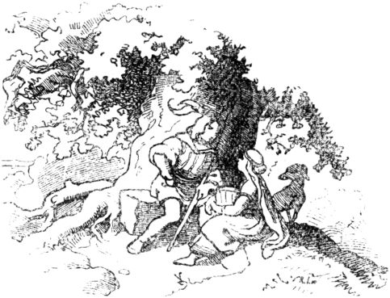But the prince's son could not possibly wait a few days, on the following day he sent a pair of silver shoes to Siebenschön and asked her to come under the big oak again. Now that she was coming, he asked whether she had considered herself? But she said she hadn't had time to think about it, there was a lot to do in the household, and after all she was a poor girl and he a rich prince, and his father would get very angry when he, the prince to take her as a wife. But the prince asked again and again, until Siebenschön promised to think twice and tell her parents what the prince had in his will. As the following 261Day came when the king's son sent her a dress made entirely of gold, and asked her again to go to the oak. But when Siebenschön came there, and the prince asked again, she had to say and complain again that she had too much to do all day, and no time to worry, and that she and her parents were about this matter too I had not yet been able to speak, and also repeated once more what she had already said twice to the prince, that she was poor, but he was rich, and that he would only anger his father. But the prince told her that all of this had nothing to do with her, she should just become his wife, so she would later become queen too, and when she saw how sincerely the prince meant it to her, she finally said yes, and now came every evening to the oak tree and to the king's son - the king was not yet to find out about it either. But there was an ugly old lady at court who lay in wait for the king's son, discovered his secret, and told the king about it. The king was enraged, sent servants and set fire to the little house in which Siebenschön's parents lived, so that they might burn in it. But she did not do this, when she noticed the fire, she jumped out and immediately into an empty well, but her parents, the poor old people, burned in the little house. so that it burns in it. But she did not do this, when she noticed the fire, she jumped out and immediately into an empty well, but her parents, the poor old people, burned in the little house. so that it burns in it. But she did not do this, when she noticed the fire, she jumped out and immediately into an empty well, but her parents, the poor old people, burned in the little house.

Then Siebenschön was sitting down in the well, grieving and crying a lot, but in the end couldn't endure the length of the well down, crawled up, found something useful in the rubble of the house, turned it into money and bought men's clothes for it, went as a fresh boy at the king's court and offered himself to be a servant. The king asked the young servant's name, and received the answer: "Bad luck!" 262and the king liked the young servant so well that he accepted him at once, and soon got on well with all the other servants.

When the king's son found out that Siebenschön's little house had been burned, he was very sad, believed no other than Siebenschön was burned with it, and the king believed that too, and wanted his son to finally marry a princess, and now he had to daughter of a neighboring king free. Then the whole court and all the servants had to go to the wedding, and that was the saddest thing for misfortune, it was like a stone on his heart. He also rode after the last in the train, and sang plaintively in a clear voice:

" I was called seven beautiful ,

I am now aware of misfortune . "

The prince heard this from afar, and he noticed and stopped and asked: “Well, who is singing so beautifully?” - “It will be my servant, the misfortune,” answered the king, “whom I have accepted as a servant have. "Then they heard the singing again:

" I was called seven beautiful ,

I am now aware of misfortune . "

Then the prince asked again whether it really was none other than the king's servant? and the king said he didn't know otherwise.

When the procession came very close to the new bride's castle, the beautiful clear voice rang out again:

" I was called seven beautiful ,

I am now aware of misfortune . "

Now the prince did not wait a moment longer, he spurred his horse and rode like an officer along the entire procession at a straight gallop until he was unlucky 263came, and Siebenschön recognized. Then he gave her a friendly nod and dashed back to the front of the train and moved into the castle. Now that all guests and all entourage were gathered in the great hall and the engagement was about to take place, 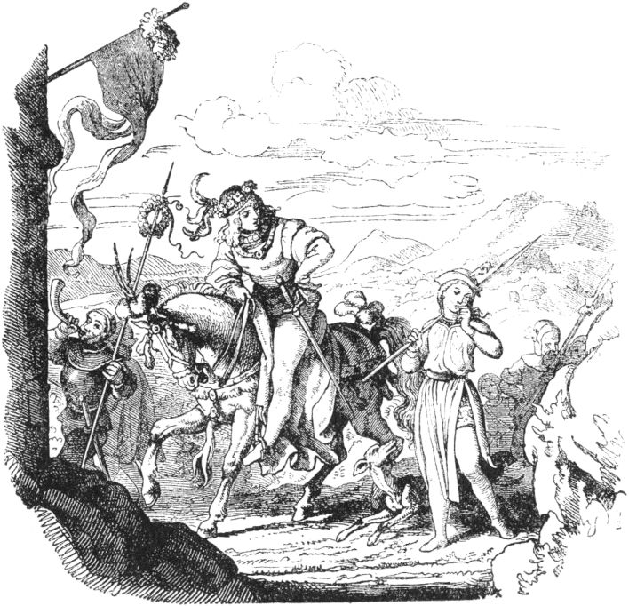So the prince said to his future father-in-law: “Mr. King, before I solemnly get engaged to your princess daughter, I first wanted to solve a little riddle for me. I have a nice cupboard, I lost the key to it some time ago, so I bought a new one; soon afterwards I found the old one again, now Herr König tell me whose key I am using 264should? "-" Well, of course the old one again! "replied the King," the old should be honored and not neglected when it comes to the new. "-" Very well, Herr König, "answered the Prince," so Do not be angry with me if I cannot free your princess daughter, she is the new key, and there is the old one. "And he took Siebenschön by the hand and led her to his father, saying:" See, father, this is mine Bride. ”But the old king exclaimed in astonishment and shock:“ Oh dear son, that is a misfortune, my servant! ”- And many courtiers shouted:“ Lord God, that is a misfortune! ”-“ No! ” said the prince. "Here is no misfortune, but here is Siebenschön, my dear bride." And took leave of the meeting and led Siebenschön as mistress and wife to his most beautiful castle.

**The king's cathedral.**

Once upon a time there was a king who built a magnificent cathedral for the honor and praise of God and was not allowed to contribute a penny to this building, according to the king's express command, but wanted to build it entirely from his own treasure. And so it happened and the minster was perfect, beautiful and worthy, with all splendor and ornament. And there the king had a large marble table prepared, in which he had a script carved in golden letters that he, the king, had built the cathedral alone, and that no one had contributed to it. But when the tablet was set up for a day and a night, the writing was in that night 265changed, and instead of the king's name there was another name on it, namely the name of a poor woman, so that it now sounded as if she had built the whole magnificent cathedral. That annoyed the king mightily; he had the name erased and his own inscribed again. But overnight the name of that poor woman was on the blackboard again, and everyone read that she was the founder of the cathedral. 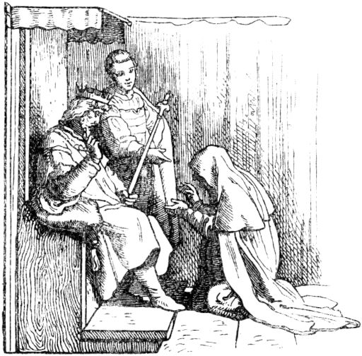And the third time the king's name was written on the tablet, and the third time he disappeared, and that came out. Then the king noticed that God's finger was writing here, humbled himself, and asked for the woman to ask her before his throne. Fearful and frightened, she stepped before the king, who said to her: “Woman, there are strange things, tell me the truth about God and your life! Have you not heard my command that 266nobody should give to the minster? Or did you give it? "

Then the woman fell at the king's feet and said: “Grace, my lord the king! I want to confess everything to your grace! I am a very poor woman; I have to feed myself poorly on spiders so that hunger does not kill me, and I had a penny left over, which I would gladly offer to your temple and to honor God, but I was afraid, oh Lord, your spell and Your harsh alarm, and then I bought a bundle of hay for the Hellerlein, which I scattered on the road to the oxen, who pulled the stones to your cathedral, and they ate it. So I did as I wanted and without violating your commandment. "

Then the king was mightily moved by the talk of women, and saw how the Lord God honored her pure mind and accepted it as a higher sacrifice, like the king's rich treasure. And the king abundantly endowed the poor woman and took the punishment of his vanity to heart.

267

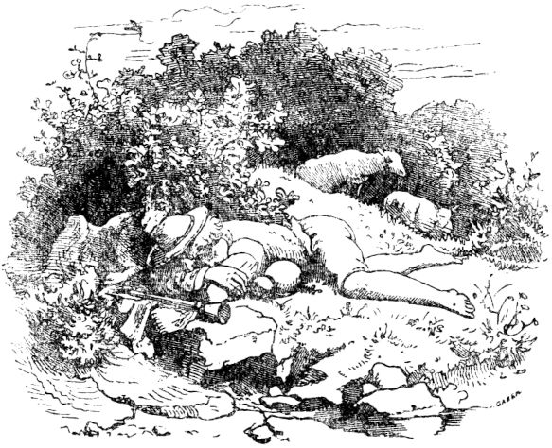

**The little shepherd's dream of happiness.**

Once upon a time there was a very poor farmer who was a shepherd in a village, and had been for many years. His family was small, he had a wife and only one child, a boy. But he had taken him out to the pasture with him very early on and impressed on him the duties of a faithful shepherd, and so, when the boy had only grown up to some extent, he could rely entirely on him, could entrust the flock to him alone and could meanwhile be at home still earn a few threesomes with basket weaving. The little shepherd cheerfully drove his flock out onto the Drifts and Raine; he whistled or sang many a bright song, and in between cracked his shepherd's whip loudly; it didn’t take him long. At midday he lay down leisurely next to his flock, ate his bread and drank from the spring, 268A little while before it was time to move on. One day the little shepherd lay down under a shady tree to rest for noon, fell asleep and dreamed a very strange dream: He was traveling away, even infinitely far away - a loud ringing, as if a mass of coins were incessantly falling to the ground - a thunder as if incessant shots rang out - an endless crowd of soldiers, with weapons and in flashing armor - everything circled, buzzed, tossed him. He kept walking towards and climbing uphill until he was finally at the top where a throne had been built, on which he sat, and next to him was another place on which a beautiful woman, who suddenly appeared, sat down . Now in the dream the little shepherd straightened up and spoke very seriously and solemnly: “I am King of Spain. “But at the same moment he woke up. Thoughtful about his strange dream, the little one drove his flock on, and in the evening he told his parents at home, who were sitting in front of the door and carving willows, and wherever he helped them - his strange dream, and finally said: "Truly, if I dream like that again, I'll go to Spain and still want to see if I won't become king! ”-“ Stupid boy, ”muttered the old father,“ they make you a king, don't let them laugh at you! ” And his mother giggled profusely, and clapped her hands and repeated in astonishment: “King of Spain, King of Spain!” - The next day at noon the little shepherd lay early under that tree, and oh wonder! the same dream engulfed his senses again. Hardly did it keep him on guard until evening, he would have liked to run home and set off on a trip to Spain. As he 269finally drove home, he announced his repeated dream and said: "But if I have another dream like this, I will leave on the spot, right on the spot." - On the third day he camped again under that tree, and quite the same Dream came back for the third time. The boy straightened up in the dream and said: "I am King of Spain," and he woke up again, but immediately picked up hat and whip and bread bag from the camp, drove the flock together and headed straight for the village. Then people began to quarrel with him that he was collecting so soon and so long before vesper time, but the boy was so enthusiastic that he did not listen to the scolding of the neighbors and his own parents, but rather his few clothes, the on Sunday he wore it, tied it in a bundle, hung it on a walnut stick, took it over the armpit and so nothing wandered away from you. The boy was on his feet for a moment; it ran as quickly as if it were supposed to arrive in Spain before night. But only on that day did he reach a forest, nowhere was a village or a single house; and he decided to look for his night camp in this forest in a thick bush. But no sooner had he lay down to rest and was asleep when a noise awakened him again: a crowd of men passed loudly talking past the bush in which he was lying down. The boy stepped out quietly and followed the men at a short distance, thinking, perhaps you will find a place to stay after all; where these men sleep today, you can certainly sleep too. - They hadn't wandered on for long, when a pretty handsome house stood before them, but right in the middle of the dark forest. The men knocked on it 270was opened and next to the men the shepherd boy slipped into the house with them. Inside a door opened again and everyone stepped into a large, very poorly lit room, where on the floor there were many bundles of straw, beds and duvets that seemed to be kept ready for the men's night camp. The little shepherd boy quickly crawled under a heap of straw that had been piled up near the door, and was now listening to everything that he could only hear and perceive from his hiding place. He soon found out, because he was wise and alert anyway that this band of men was a band of robbers whose captain was the lord of this house. When the newly arrived members of the gang lay down, he climbed into a slightly raised seat and spoke in a deep bass voice: "My good comrades,broken intoare and what you have looted! ”First a long man with a coal-black beard stood up and replied:“ My dear captain, I robbed a rich nobleman of his leather trousers this morning, these have two pockets, and as often as you put them on top turns and shakes vigorously, every time a heap of ducats falls out on the floor. ”-“ That sounds very good! ”said the captain. Another of the men came forward and reported, “I stole a general's triangular hat today; This hat has the property, when you turn it upside down, that shots go off incessantly from the three corners. ”-“ That can be heard! ”said the captain again. And a third stood up and said: “I have robbed a knight of his sword; if you push the same into the ground with the tip, 271brave deed! ”praised the captain. A fourth robber got up and began: “I have taken off the boots of a sleeping traveler, and if you put them on you will cover seven miles with every step.” - “I praise a quick act!” Said the captain with satisfaction, “hangs put your prey on the wall, and then eat and drink and sleep well. ”So he left the robbers' bedroom; they were still drinking hard and then fell soundly asleep. 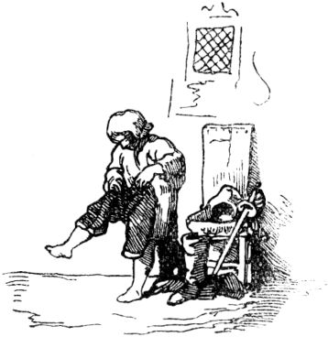When everything was quiet and calm, and the men were all asleep, the little shepherd got out, put on his leather trousers, put on his hat, put on his sword, dug into his boots and then crept quietly out of the house. Outside, however, to the delight of the little one, the boots were already showing their miraculous power, and it wasn't long before the little boy strode into the great capital of Spain; it's called Madrid.

Here he asked the first best to find the largest inn for him, but the answer he received was: "Little wretch, you go where your kind come and not where rich gentlemen dine." But a shiny gold piece made that one immediately more polite, so that he would now gladly become the guide of the little shepherd and show him the best inn. Once there, the youth immediately rented the most beautiful rooms and asked his host in a friendly manner: “Well, how is it in your city? What's new here? ”The landlord made a long face and 272replied: “Sir, you are a stranger in this country? It seems you have not yet heard that our King, Your Majesty, is arming himself with an army of twenty thousand men? See, we have enemies; Oh, it's a bad time! Sir, do you want to go into the army? ”-“ Of course, of course, ”said the tender young man, and his face shone with joy. When the landlord had left, he quickly took off his leather trousers, shook a pile of gold pieces, and bought valuable clothes and weapons and jewelry, did everything, and then asked for an audience with the king. And when he came into the castle and was led through a large, splendid hall by two chamberlains, they met a wonderfully lovely young lady, who gracefully presented herself in front of the beautiful youth, who went in the midst of the gentlemen and greeted them gracefully, bowed, and the gentlemen whispered: "This is the princess, daughter of the king." The young man was not a little delighted by the beauty of the king's daughter, and his delight and enthusiasm made him bold and speak courageously before the king. He said: “Your Majesty! I hereby humbly offer my services as a warrior. My army, which I am leading you, is to fight for your victory, my army is to conquer everything that my king orders to conquer. But I ask for a reward, so that if I win, I may bring your lovely daughter home as a wife. Is that what you want, my most gracious king? ”And the king was astonished at the young man's bold speech and said:“ Well, I am accepting your demand; if you come home victorious,

Now the former shepherd went out all alone 273into the open field and began to thrust his sword into the ground, and in a few minutes many thousands of battle-armed fighters were standing in the square, and the young man was sitting as a general armed and adorned on a splendid horse, which was hung with gold-woven blankets was; the bridle flashed with precious stones, and the young general went out and met the enemy, and there was a great, bloody battle; Deadly shots thundered incessantly from the general's hat, and his sword called one regiment after another out of the earth, so that in a few hours the enemy was defeated and dispersed and the flags of victory were waving. But the victor followed and took away the best part of his country from the enemy. Victorious and glorious he then returned to Spain, where the loveliest happiness awaited him. The beautiful king's daughter had been no less delighted with the handsome young man as she had met him in the hall than he was with her; and the most gracious king also duly appreciated the great merits of the brave youth, kept his word, gave him his daughter to be his wife and made him his successor and heir to the throne.

The wedding was splendid and splendid, and the former shepherd was very happy. Soon after the wedding, the old king placed the crown and scepter in the hands of his son-in-law, who sat proudly on the throne and next to him his lovely wife, and as the new king he received homage from his people. Then he remembered his dream so beautifully fulfilled, and remembered his poor parents and said, when he was alone with his wife again: “My dear, you see, I still have parents, but they are 274very poor, my father is a village shepherd, far from here, and as a boy I looked after the cattle until a wonderful dream revealed to me that I would still be king of Spain. And luck was with me, see, I am now king, but I would also like to see my parents happy, so with your kind consent I want to go home and get my parents. ”The queen was happy and left her husband pulling, who was pulling very quickly because he was wearing the seven-league boots. On the way the young king returned the marvelous things that he had stolen from the robbers to their rightful owners, except for the boots, fetched his poor parents, who were overjoyed, and gave the owner of the boots a duchy for them.

**The dog's distress.**

It was a dog that was lying hungry and sorrowful in the field, when a lark sang her delightful little song above him in a sweet tone. When the dog heard this, he said: “O happy bird, how happy you are, how sweet you sing, how high you swing yourself! But I - how should I be happy? My master has cast me out, his door locked behind me, I'm lame, I'm sick, can't hunt food and must die of hunger here! "

As soon as the lark heard the hungry dog ​​complain, it flew close to him and said: “O you poor dog! I am moved by your suffering, will you also thank me if I help you to get full? "275

“With what, Mrs. Lerche?” Asked the dog in a weak voice, and the lark replied: “Look, there comes a child who is carrying food to that farmer; I want to make it put down the food and run after me, meanwhile you go and eat the cheese and the bread and satisfy your hunger! "

The dog thanked this kind offer, 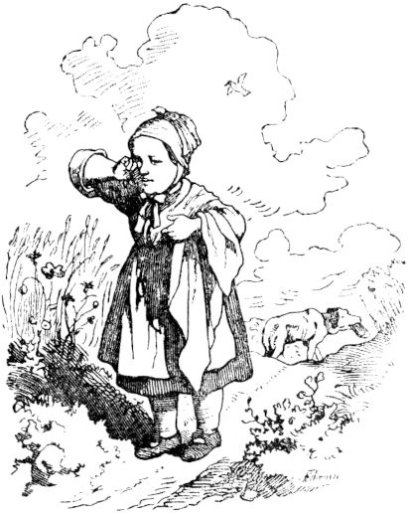and the lark flew towards the child and began to ape it. Sometimes she ran in front of him, sometimes she fluttered on this side, sometimes on that side, until the child thought: I must catch the lark, and the lark paralyzed itself and let one of its little wings hang as if broken. The child often reached out for her, but in vain grabbed with one hand, and there it put down its little handkerchief in which it carried the food and ran after the lark, which always flew ahead into a ground; In the meantime the dog got up, limped at the cloth and sniffed into it, there was a piece of bread, a quark cheese and four good eggs, which he ate unsouled and unpeeled, and the cheese untranched, and he took the bread with him when he did crawled away and hid in the grain.

The lark when she realized that the dog was doing his part 276had, flew into the air and sang merrily; but the ape cursed her, and even more so when it found its handkerchief empty. She went back to her mother, crying, and I don't know whether she had been beaten; but something like this will probably have fallen away.

The lark flew to the dog and asked him how he was now? He said thank you very much and he had never been more comfortable. “There is only one request left on my heart, dear Frau Lerche,” he said, “if you are full, you like to be happy. 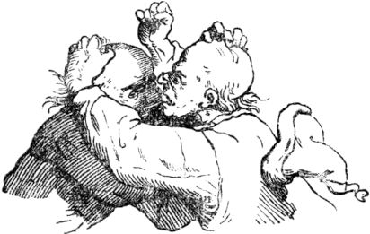Oh please, tell me something else that I like to laugh a little and be funny about. "

“Well!” Said the lark, “follow me.” And then the lark flew ahead and the dog followed her to a barn, the attic of which could easily be reached from the ground; up there the lark told the dog to go up and look down, for the ground was broken and broken. Two bald heads were standing on the threshing floor; then the lark quickly sat down on the bald head of one, and quickly the other clapped his hand on it, thinking he was catching the lark; but the clever little bird was faster than him and flew to the side.

“Well, journeyman, what's that supposed to mean? What are you hitting me? ”The first bald head asked the other. He apologized for putting a little bird on that head that he wanted to catch; the clap hurt, he was sorry. In the meantime the lark sat down on the bald head of the one who was speaking, and immediately struck 277the other with a Schmitz so hard that his head would certainly have cracked if it had been made of glass, at least it grunted well to the defeated man, and then the scolding began immediately, and both thresher threw down their flails and wanted each other in them Hair. Because they now had no hair, no one could pull it out from the other, and so instead of scratching each other's bald heads, instead of tugging so that the blood ran after them, and pounded each other hard; Then it was bald against bald and scratch against scratch, they tore at their ears too, and the dog had to laugh so unrestrainedly at that that it hurt quite a bit, and he could neither lie nor stand, and then he tumbled from him with laughter Down the floor, the thresher straight on the bald heads so that they trimmed, for the dog was heavy, and this way of getting hair on the head, seemed spanish to them. They immediately turned their anger against the dog, and since they were thresher, they beat him until he drove through a hole in the scouring wall and through the fence, making him not only laugh, but almost Hearing and seeing passed. Very crumbling and ailing he lay down in the grass behind the fence, and then the lark came flying and asked: "Noble sir, how are you?"

“Well, Frau Lerche,” groaned the dog, “I've had enough. I am a very beaten man! I believe in my loyalty, I have no back at all, the threshers have tanned and tanned my hide while I was alive. Oh, if I want to live longer, I have to have a surgeon! ”-“ Well done! I'll get that for you too, if it's at all possible, ”said the lark and flew away. She soon found a wolf, whom she addressed: “Mr. Wolf? You have no appetite at all? "278

"Oh, Mrs. Lerche," was her answer, "as far as that is concerned, I can serve with hunger for wolves."

"Well, if you want to thank me," continued the lark, "I would like to show you where a fat dog lies that will hardly escape you!"

“Oh, my noble queen, how gracious you are!” Flattered the wolf and smiled, licking his teeth. The lark flew in front of him, and he followed her, and when she got to the dog she said to him: “Well, fellow? Are you sleeping? Don't you wanna see the doctor Stand up, there comes the doctor! "

"Where? Mrs. Lerche, where? ”Asked the dog, very tired; but when he saw the wolf he shouted: “No, Frau Lerche, no! Not this doctor! Hold him back! I'm healthy! ”And with one leap the dog was on its feet, and away as if we were flying away, so that no fence was too high and no ditch too wide.

279

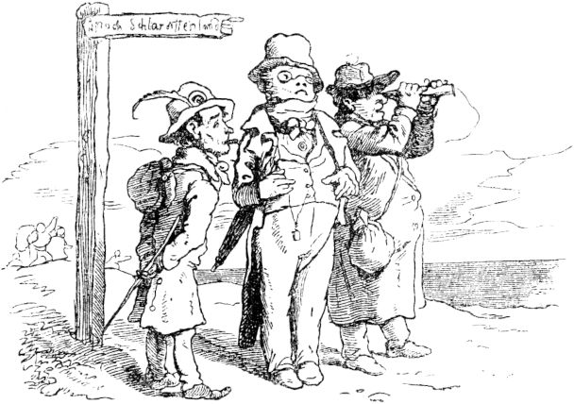

**The fairy tale of the land of milk and honey.**

Listen, I want to tell you about a good country, many would emigrate there, if they knew where it would be and a good opportunity for a ship. But there is a long way to go for the young and for the old, for whom it is too hot in winter and too cold in summer. This beautiful area is called the land of milk and honey, in Welsch Cucagna, the houses are covered with egg cakes, and the doors and walls are made of gingerbread, and the bars of roast pork. What you buy from us for a ducat costs only one penny there. There is a fence around every house, it is made of sausages and Bavarian sausages, some of which are roasted on the grill, some of which are freshly boiled, depending on whether one likes to eat them one way or the other. All the fountains are full of malvasia and other sweet wines, including champagne, which only trickle into your mouth when you hold it to the pipes. So whoever likes to drink such wines should hurry to get into the land of milk and honey. There on the birches and willows 280the rolls grow freshly baked, and streams of milk flow under the trees; the rolls fall into these and soak themselves for those who like to break them in; that is something for women and for children, for servants and maidservants! Holla Gretel, holla Steffel! Don't you want to emigrate? Make your way over to the Semmelbach and don't forget to bring a large milk spoon with you.

The fish swim in the land of milk and honey on top of the water, 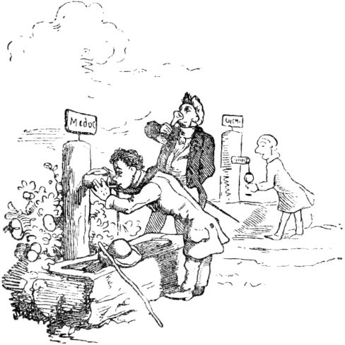are already baked and boiled, and swim very close to the shore; But if someone is too lazy and a real Schlaraff, he can only call! bst! - so the fish come for a walk out into the country and hop into the hand of the good Schlaraffen so that he doesn't have to bend down.

You can believe that the birds are flying around roasted there, geese and turkeys, pigeons and capons, larks and crab birds, and if you find it too hard to reach out for them, they fly straight into your mouth. The suckling pigs do well there every year; they walk around fried and each has a carving knife inside 281Back, so that whoever wants can cut off a fresh, juicy piece.

In the land of milk and honey, the cheeses grow like stones, big and small; the stones themselves are nothing but pigeon heads with stuffed meat, or small meat patties. In winter, when it rains, it rains a lot of honey in sweet drops, one can lick and lick that it is a pleasure, and when it snows, 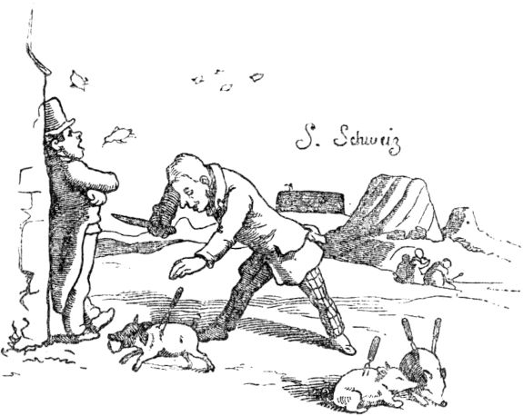so it snows clear sugar, and when it hails, it hails sugar cubes, mixed with figs, raisins and almonds.

In the land of milk and honey, the horses do not lay horse apples, but eggs, large, whole baskets full, and whole heaps, so that one buys a thousand for a penny. And the money can be shaken from the trees like boxes (good chestnuts). Everyone likes to shake off the best and leave the inferior values ​​behind.

There are also large forests in the country, where the most beautiful clothes grow in the bushes and on the trees: 282Skirts, coats, hoods, trousers and vests of all colors, black, green, yellow (for the postillions), blue or red, and whoever needs a new garment goes into the forest and throws it down with a stone, or shoots up with the bolt. Beautiful women's dresses of velvet, atlas, gros de naples, barège, madras, taffeta, nanking etc. grow in the heather. The grass consists of ribbons of all colors, including ombred. The juniper sticks wear brooches and gold chemisette and mantle needles and their berries are not black, but real pearls. Women's watches and chatelaines hang very artificially on the fir trees. Boots and shoes grow on the perennials, as well as men's and women's hats, rice straw hats and marabouts and all kinds of headdresses decorated with birds of paradise, hummingbirds, diamond beetles, pearls, enamel and gold braids.

This noble country also has two major fairs and markets with beautiful freedoms. Anyone who has an old wife and no longer likes her because she is no longer young enough and pretty for him can swap her for a young and beautiful one and get a bonus. The old and nasty (because a proverb says: when you get old, you get nasty) come to a young bath so that the country is pardoned; that is of great strength; The old women bathe in it for about three days, or at most four, and they turn into pretty whores of seventeen or eighteen years of age.

There is also a lot and all kinds of entertainment in the land of milk and honey. If you have no luck in this country, you have it there in games and pleasure shooting, as in journeyman jousting. Many a person shoots here all his life alongside and far from the target, but there he hits, and if he were the furthest of them, the best. Also for 283the sleeping bags and sleeping furs, which here become poor from their laziness, that they go bankrupt and have to go begging, that country is excellent. Every hour of sleep there brings in a guilder, and every time you yawn a double thaler. If you lose in the game, your money will fall back into your pocket. The drinkers have the best wine for free, and for every drink and gulp three chunks of wages, both women and men. Whoever can tease and tease people best gets a guilder. Nobody should do anything for free 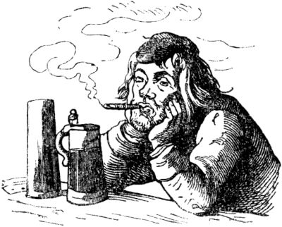and whoever makes the biggest lie always has a crown for it.

In this country many people lie insanely and have nothing for their trouble; there, however, lies are considered to be the best art, therefore all sorts of procuration, doctoral and other giants, horse buffs and the *** r craftsmen, who always talk their customers into it and never keep their word, lie in the country.

Whoever wants to be a learned man there must have studied to be a rascal. We also have such students in our country, but they have no thanks and no honors. He also has to be lazy and voracious, these are three fine arts. I know someone who can become a professor every day.

Anyone who likes to work, does good and leaves bad things is averse to everyone there, and he is expelled from the land of milk and honey. But whoever is stupid, can do nothing, and yet full of stupid arrogance, is there as a nobleman 284viewed. Anyone who can do nothing but sleep, eat, drink, dance and play is appointed count. The however, which recognized the universal suffrage as the laziest and to all good Untauglichsten that will reign over the whole country, and has a large income.

Now you know the nature and quality of the land of milk and honey. So if you want to go there and go on a trip, but don't know the way, ask a blind man; but a mute is also good for this, because he certainly does not tell him the wrong way.

All around the country, however, there is a mountain-high wall of rice porridge. Anyone who wants to get in or out has to eat their way through there first.

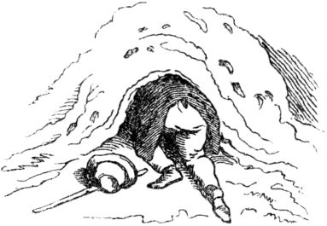

285

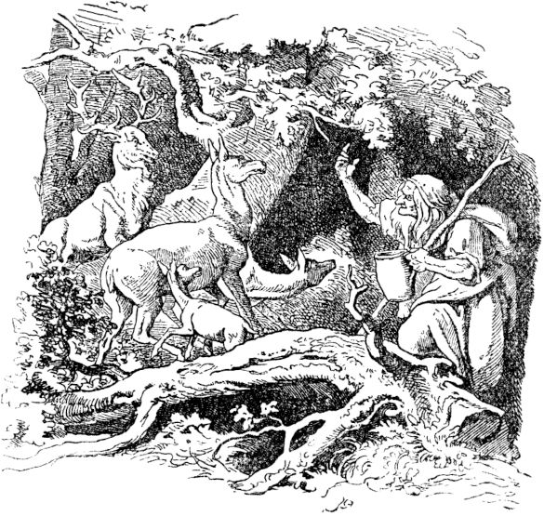

**The witch and the royal children.**

In the middle of a forest a bad old witch lived all alone with her daughter, who was a good, gentle child, and with whom the saying: the apple does not fall far from the tree, did not apply. The trunk was gnarled, prickly and ugly beyond measure; whoever saw the old woman avoided her and thought: Far from it is good before the shot. The old woman always wore green glasses, and over her shaggy hair, which hung uncombed far down from her head, a red cloth, and liked to walk in short sleeves, so that her thin, weather-tanned arms protruded far from the garment that was shivering around her. She usually carried a sack of magic herbs on her back 286in the forest, and in her hand a large pot, in which she boiled them, and with it brought thunderstorms, hail and castles, frost and frost as often as she pleased.

On her finger she wore a gold witch's ring with a glowing red carbuncle stone, with which she could bewitch people and animals. This ring made the old woman immensely strong and vital, and made her, if she wanted, completely invisible; there she could go where she wanted and take whatever she wanted - and she did that too, and in the forest she looked for the hinds, and when the animals saw the ring and saw the stone sparkle, they had to be spellbound stop, and then the old woman went to the doe and milked their milk in the pot, and drank it with her daughter. This daughter's name was Käthchen, and she did not have it well with her wicked mother, but she patiently bore all the suffering. What was most painful for her was that her mother sometimes brought children with her, with whom Käthchen would have liked to play, but the old woman always took the children's clothes, locked the children up and fed them with deer milk so that they became fat, and what she then did to them is creepy to tell; she turned them into deer calves and sold them to hunters. The hunters, however, shot the poor, transformed and sold deer calves dead, and delivered them to the city, where the people like to eat the young venison. The ugly old woman was so bad and angry, and since she did nothing all day except conjuring up and devising wicked schemes, and often muttering loudly to herself, her daughter Käthchen unnoticed learned a few magic pieces from her, which she completely kept secretly to himself. and what she then did to them is creepy to tell; she turned them into deer calves and sold them to hunters. The hunters, however, shot the poor, transformed and sold deer calves dead, and delivered them to the city, where the people like to eat the young venison. The ugly old woman was so bad and angry, and since she did nothing all day except conjuring up and devising wicked schemes, and often muttering loudly to herself, her daughter Käthchen unnoticed learned a few magic pieces from her, which she completely kept secretly to himself. and what she then did to them is creepy to tell; she turned them into deer calves and sold them to hunters. The hunters, however, shot the poor, transformed and sold deer calves dead, and delivered them to the city, where the people like to eat the young venison. The ugly old woman was so bad and angry, and since she did nothing all day except conjuring up and devising wicked schemes, and often muttering loudly to herself, her daughter Käthchen unnoticed learned a few magic pieces from her, which she completely kept secretly to himself.

One evening the old woman brought two beautiful ones again 287Led children, a boy and a girl, you could tell that they were siblings, and children of rich people; Both had got lost in the forest, had been found by the old woman and taken to her house, and she had told them that she wanted to take them back to their parents. The children were terribly disappointed when the old woman stripped them of their beautiful clothes, put them on rags, and locked them in a dark little room. But they got a whole pot of deer milk to eat, which tasted good, and a piece of black bread, which tasted less good, but was finally eaten.

The next morning the old woman hobbled early into the forest and waved to the doe. There was a deer family that knew and valued the old woman particularly well, consisting of Herr Hirsch, Frau Hirschin and two young calves, who always kept faithfully together in the forest, but were in constant fear of the angry old woman who did the job they all had to stand still, and had to let the wicked witch take their mother's milk so that the calves could not drink their fill or get fat. If only I could run my antlers through your arid body once! the stag often thought, and the stag didn’t have any good wishes for the old woman either - but neither did her wishes. While the old woman was in the forest, Käthchen crept to the little room, and saw through a crack in the door the poor imprisoned children, who sighed and wept with great heartache. Then Käthchen asked: “Who are you, you poor children?” - “We are the children of a king! O set us free, my father will reward you! ”- said the prince. "And my mother too" - said the little princess, 288while she added: "You should also be our good sister, and you should sleep with me in the silk bed, and I want to give you beautiful golden clothes, help us, just help us!" - Then Käthchen said: "Just be patient, dear royal children; I want to watch and think about my freeing you. "-

The next morning early in the morning, good Käthchen made a magic piece. She quickly left her camp, breathed into it, and said softly:

"Dear bed, speak for me,

I'm gone, be me! "

So she breathed on her drawer, on the stairs, and on the stove in the kitchen, and said the same little saying. Then she went to the well-kept little chamber of the royal children, held a spring root, which the old woman had lying on the Kannrück, up to the castle and said:

"Riegel, Riegelein, Riegelein,

Open up, let out and in! "

Then the lock and bolt jumped open, and Käthchen immediately led the royal children away and into the forest.

When the old woman woke up, she called: "Käthchen, get up and stoke the fire!"

“I'm already up and awake!

I'll be right down in the kitchen! "

The old woman remained lying there, but after a while she didn't hear anything, she called out again: “Käthchen! Where's the lazy thing? "

“I'm sitting on the drawer

And tie the garter around the calf! "

As a while passed again and nothing stirred or stirred in the house, the old woman became angry and cried: 289“Kathe! Bellows! Where are you staying? "Then a voice rang out from the stairs:

“I'm coming, I'm flying!

I'm already on the stairs in person! "

The old woman calmed down again - but not for long, because when everything remained quiet again, she started and scolded and cursed. Then it called from the herd:

“Why the evil curses?

I'm already at the stove and in the kitchen! "

all the same, it was dead quiet in the kitchen and in the whole house. Now the old woman's patience broke completely, she jumped out of her bed, pulled into her clothes and took a broomstick, willing to beat Katy ruthlessly. But when she came out, there was no Kathchen, not to be seen, not to be heard, and what was the best thing, but for the old woman the worst, was the royal children also gone. Now you should have seen the witch's leaps that the angry, angry old woman made. Her ring immediately indicated the direction in which Käthchen had fled with the children, and she now raced wildly after them. But when the children came into the forest, they met the Lord von Edelhirsch with his wife, son and daughter there. and told this family in a hurry of their misfortune and their flight, and their noble hearts were mightily touched, so that they showed themselves ready to give them all possible help. The good lady Hirsch offered her back to the children to carry them all three to the royal palace on the other side of the forest, and the husband ordered his children to retreat into the thicket, he himself stood behind thick foliage near the path, willing to knock the old woman over when she rushes by and he doesn't see her ring.290

It wasn't long before the old woman came leaping forward; In her anger and zeal she completely forgot that she wanted to be invisible, did not hold up the finger with the ring either, and so it happened that suddenly a large and stately deer antler came into very intricate contact with her, 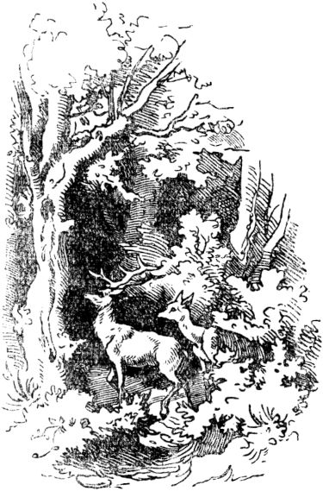at which one of the ends of the antlers forcibly brushed the old woman's finger so that the magic ring came down from the finger and got stuck on the end, and before anyone knew it, the stag had picked up the old witch, who was now powered by the ring herself became rigid and stiff, and carried her in a stretched course after the trail which the good hind, his wife, had left behind in the dewy grass. In the meantime, she and the three children had already arrived at the royal palace, and the king and queen welcomed the lost children and the good Käthchen whom they had rescued with great joy - when suddenly they all saw the old woman on the antlers with great astonishment the stately red deer, sitting and carried floating around. The stag, however, jumped straight into the castle pond and plunged its head under. When he reappeared, his antlers were free from the load. But also the magic ring 291basically stayed. The stag and stag returned to their forest and to their children, and were very glad that no one took their milk from them any more; But Kathchen stayed with the king's children and slept in a little silk bed and wore golden dresses and was kept like a king's child herself.

**The monk and the bird.**

There was a young monk in a monastery, named Urbanus, even pious and hardworking, who was entrusted with the key to the monastery library, and he carefully guarded this treasure, wrote many beautiful books himself and studied a lot in the other books and in that Holy Scripture. There he also found a saying by the apostle Peter, which reads: A thousand years are like a day and a night watch before God.That seemed almost impossible to the young monk, "liked" and could not believe it, and tormented himself with serious doubts about it. Then it happened one morning that the monk went down from the dull book-room into the bright, beautiful monastery garden, there was a small, brightly colored forest bird sitting in the garden, looking for grain, flew onto a branch and sang beautifully like a nightingale. This little bird was not at all shy either, but let the monk come close to him, and he would have liked to have caught it, but it fled from one branch to the other, and the monk followed it for a good while, then it sang along again Loud and clear voice, but it was okay 292not catch, although the young monk chased the little bird out of the monastery garden into the forest for a good while. At last he let go and returned to the monastery, but everything he saw seemed different to him. 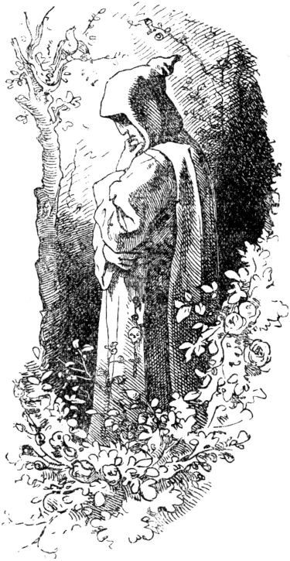Everything was wider, bigger and more beautiful, the buildings, the garden, and instead of the low old monastery church there was now a proud minster with three towers. That struck the monk as very strange, even magical. And when he came to the monastery gate and twitched the bell with trepidation, a gatekeeper, completely unknown to him, stepped up to meet him, who backed away from him in dismay. Now the monk strolled across the monastery churchyard, where there were so many, many memorial stones that he couldn't remember seeing. And when he went up to the brothers, they all avoided him, very horrified. Just the abbot, but not hisAbbot, but another, young one, stood up to him, but at the same time held out a crucifix to him and called out: “In the name of the crucified, ghosts, who are you? And what are you looking for, who fled the caves of the dead, with us, the living? "293

Then the monk shuddered and staggered like an old man staggered, and looked down to earth. See, there he had a long, silver-white beard down over his belt, from which the bunch of keys to the barred bookshelves still hung. The monks thought the man a wonderful stranger, and with shy awe they led him to the abbot's chair. There he gave the keys to the book room to a young monk, who unlocked it and brought a chronicle book in which it read that three hundred years ago the monk Urban disappeared without a trace, nobody knew whether he had escaped or had an accident. "O forest bird, was that your song?" Asked the stranger with a sigh. “I followed you barely three minutes and listened to your singing, and three centuries have passed since then! You sang me the song of eternity I couldn't believe Now I take hold of her and worship God in the dust, even a dust! ”Said it and bowed his head, and his body fell into a heap of ashes.

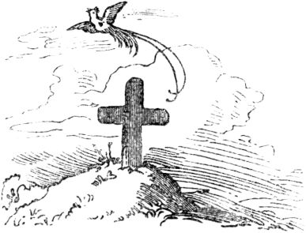

294

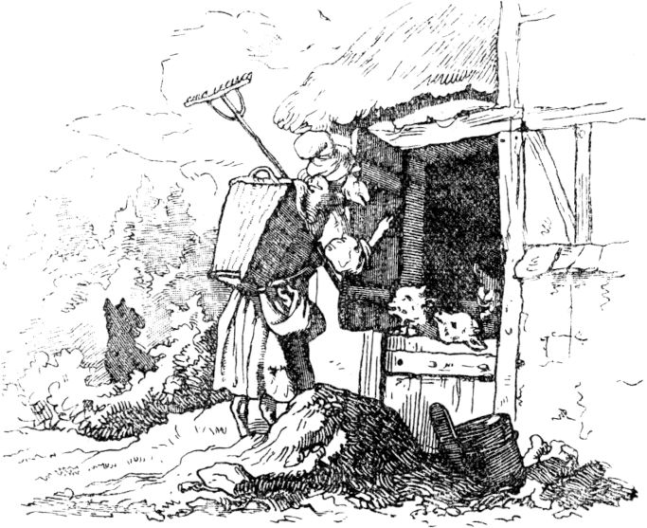

**The seven little kids.**

Once upon a time there was an old goat who had seven young kids, and when she wanted to go into the forest once, she said: “You dear kids, be careful of the wolf and don't let him in, otherwise you're all lost. ”Then she left.

In a while something rattles at the front door and calls out: “Open up, open up, dear children! Your little mother has come out of the forest! ”But the seven little goats knew straight away from their coarse voice that it wasn't their little mother, and they shouted:“ Our little mother's voice is not that rude! ”

After a while the door rattles again and 295calls out very finely and quietly: “Open up, open up, you dear children! Your little mother has come from the forest! "

But the young kids looked through the crack in the door and saw a couple of black feet and called out: “Our mother's little mother doesn't have such black feet!” And didn't open.

As the wolf heard, for it was him, he ran quickly into the mill and stuck his feet in the flour so that they turned completely white. Then he came back to the door, put his feet in the crevice, and called out very softly again: “Open up, open up you dear children! Your little mother has come from the forest! "

And when the little kids saw the white feet and heard the soft voice, they thought it was their little mother, and quickly opened the door. But no sooner did they open the door than the wolf jumped in. Oh, how frightened the poor kids were and tried to hide! One jumped under the bed, one under the table, one behind the stove, one behind a chair, one behind a large milk pot and one in the clock case. But the wolf found them all and brought them together. Afterwards he went away, lay down in the garden under a tree and began to sleep.

When the old goat came back from the forest afterwards, she found the house open and the room empty, so she immediately thought, now it's not safe, and started looking for her dear kids, but she couldn't find them Wherever she looked, and no matter how loud she shouted, there was no answer. Finally she went into the garden, where the wolf was still lying under the tree and had 296slept and snored so that all the branches trembled; and as she got closer to him, she saw that something was wriggling in his stomach. She was happy and thought that her little kids were still alive. Now she jumped quickly into the little house, fetched a pair of scissors and cut open the wolf's stomach, and her seven little kids jumped out one after the other, and they were all still alive. Then the old woman quickly fetched seven rocking stones [ [2](http://www.gutenberg.org/files/63465/63465-h/63465-h.htm#fn_2) ], put them in the wolf's stomach, and sewed it up again.

As soon as the wolf woke up, he was thirsty and went to the well to drink, but when he took a step, the rocking stones in his stomach started to beat together, and then he said:

“What is rumbling, what is pumping in my stomach?

I meant I had young kids

And now it's nothing but rocking stones! "

and when the wolf came to the well and wanted to drink, the rocking stones drew him in, and he drowned. And the old goat danced for joy around the fountain with her kids.

[2] Rocking stones or rocking stones, rounded basalt debris.

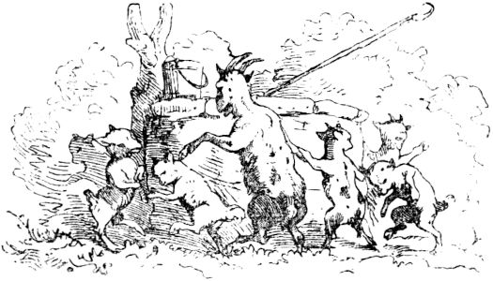

297

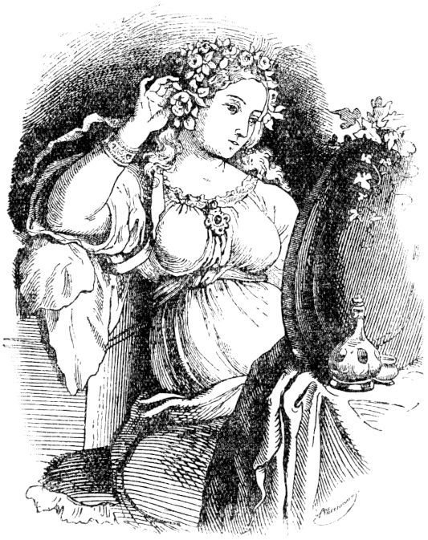

**Snow white.**

Once upon a time there was a queen who had no children and wanted one because she was so lonely. Now, one day, as she was sitting at an embroidery and looking at the frame of black ebony while it was snowing and snowflakes falling from the sky, she was in such deep thought that she pricked her fingers violently, so that three drops of blood fell on the white snow fell; and then she had to think again that she had no child. "Oh!" Sighed the Queen, "if I had a child, as red as blood, as white as snow, as black as ebony!"298

And after a while this queen had a child, a maid. It was as white as snow on his body, and his cheeks bloomed like blood-red roses, and his hair was as black as ebony. The queen was pleased, called the child Snow White, and soon afterwards she died. Since the king had now become a widower and did not want to remain a widower, he took another wife for himself, a stately woman full of high beauty, but also full of unspeakable pride, and also so vain that she voted for the most beautiful woman all over the world. She was tempted to do this by a magic mirror that always told her when she looked in and asked:

"Mirror Mirror on the wall,

Who's the fairest of them all?"

"You, Queen, are the most beautiful in the country."

And the mirror was not flattering, but told the truth like any mirror.

Little Snow White, the queen's stepdaughter, grew up and became the most beautiful princess there could be, and was even more beautiful than the beautiful queen. When Snow White was seven years old, she once again asked her faithful mirror:

"Mirror Mirror on the wall,

Who is the most beautiful in the whole country? "

but the mirror did not answer as usual, but answered:

"Madam Queen, you are the most beautiful here,

But Snow White is a thousand times more beautiful than you. "

At this the queen was terrified to death, and she felt as if a knife were turning in her bosom, and then her heart was also turned against the innocent snow-white, which could not add anything to its great beauty. And because she had no rest from hers, day or night 299envious evil hearts, so she called her hunter to her and said: “You are to lead this child, the snow-white, into the dense forest and kill it. Bring me lungs and liver to the emblem that you have carried out my command! "

And there poor snow-white had to follow the hunter into the wild forest, and in the deepest thicket he drew his weir and wanted to push through the child. The Snow White wept miserably and pleaded to let her live after all, nothing had broken, and the tears and the misery of the innocent child touched the hunter so deeply that he thought to himself: Why should I burden my conscience, and murder this beautiful innocent child? No, I would rather let it go! If the wild animals eat it, as they will probably do, the Queen may answer for it before God. And there he let Snow-White run wherever it wanted, caught a young game, stabbed it, and gutted it, and brought the wicked queen's lungs and liver. She took both and fried it in salt and lard and ate it, and was glad that she, as she thought, now the fairest woman in the whole country was alone again. Snow-white in the forest soon became frightened, as it strode all alone through the thicket, and how it felt the hard, sharp stones for the first time, how the thorns tore its dress, and completely when it saw wild animals for the first time. But the wild animals did nothing to harm him; they looked at Snow White and drove into the bushes. And the girl walked all day and went over seven mountains. But the wild animals did nothing to harm him; they looked at Snow White and drove into the bushes. And the girl walked all day and went over seven mountains. But the wild animals did nothing to harm him; they looked at Snow White and drove into the bushes. And the girl walked all day and went over seven mountains.

In the evening Snow White came to a little little house in the middle of the forest, and then they went in to rest, 300because it was very tired, was also very hungry and very thirsty. Inside in the little little house everything was too cute and dainty and very clean at the same time. There was a little table in the room, it was covered with snow-white, and on it stood and lay seven plates, each with a little vegetables and bread, seven spoons, seven pairs of knives and forks, seven cups. And there were seven little beds on the wall, all covered in pure white. Then the hungry Snow White ate from the seven little plates, just a little bit of each, and drank a drop of wine from each little cup. Then it lay down in one of the seven little beds to rest, but the little bed was too small, and she had to try another one, but none of them would fit properly, until the last the seventh, which fit, snow-white slipped into it,

In the meantime it was night, and there came the house owners, seven little miners, each with a burning pit light on the front of their belt, and they saw straight away that one had been there. The first one began to ask: “Who was sitting on my chair?” The second asked: “Who ate from my plate?” The third asked: “Who broke my bun?” The fourth: “Who has from mine Licked vegetables? ”The fifth:“ Who cut with my little knife? ”The sixth:“ Who stabbed with my little fork? ”And the seventh asked:“ Who drank from my little cup? ”As the dwarfs asked, saw they looked around for their little beds and asked: "Who was lying in our little beds?" 301"Who is in my bed?" Because there was the snow white in it. Then all the miners shone their little lamps, and saw the beautiful child with astonishment, and did not disturb it, but instead they let the seventh lie in their little beds, each for an hour until the night was around. Now that the morning was shining with its early rays into the little house of the dwarfs, Snow White woke up and was afraid of the dwarfs. But they were very good and friendly and said not to be afraid and asked what it was called? So Snow White said and told everything how things had happened to him. Then the dwarf males said: "You can stay with us in our little house, Snow-White, and you can run our household, you can cook our food, Wash our laundry and keep everything clean and tidy, and make our little beds too. ”That was fine with Snow White, and it kept the dwarfs at home. During the day they did their work in the mountains, deep under the earth, where they looked for gold and precious stones, and in the evening they came and ate and lay down in their seven beds.

Meanwhile the wicked queen had become glad in her angry heart that she was now the most beautiful again, as she thought, and tried the mirror again and asked him:

"Mirror Mirror on the wall,

Who is the most beautiful in the whole country? "

The mirror answered her:

"Mrs. Queen! You are the most beautiful here

But snow white over the seven mountains

By the seven good dwarfs

That is a thousand times more beautiful than you! "

That was again a dagger stab in the vain heart of the Queen, and she thought about it day and night, 302how she would come to the life of the Snow White, and at last it occurred to her to open herself up in Snow White disguise, 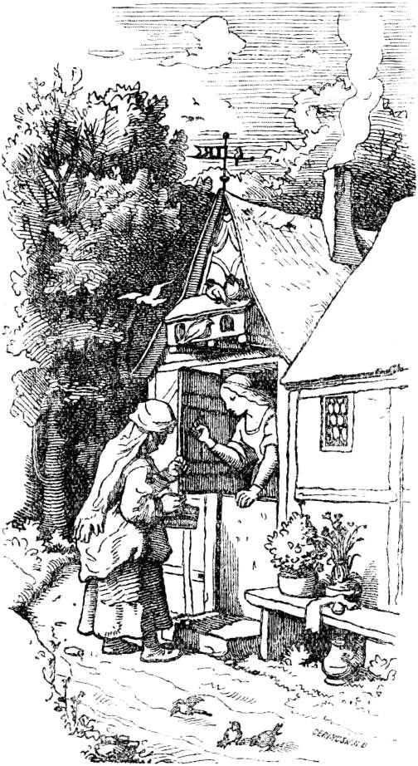and she disguised her face, and put on little clothes, also took a handful of things, and went 303over the seven mountains until she came to the little little house of the dwarfs. Then she knocked on the door and called: “Holla! Holla! Buy nice goods! ”But the dwarfs had told Snow White to watch out for strangers, especially the evil queen. So the girl looked out carefully, 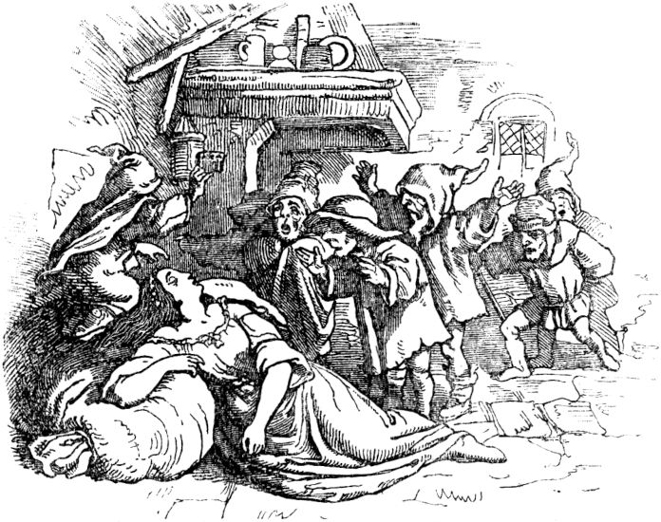then she saw the beautiful trinkets that the woman wore to the market, the beautiful necklaces and cords and all kinds of finery. Then Snow White thought nothing bad and let the shopkeeper in and bought her a neck cord, and the woman wanted to show her how this cord was put on, and tied his neck from behind so that Snow White ran out of breath and it was dead sank down. "There you have a reward for your great beauty!" Said the wicked queen, and rose from there.304

Soon afterwards the seven dwarfs came home, and there they found their lovely, dear Snow White dead and saw that it had been strangled with the string. Quickly they cut the cord in two and dripped a few drops of the gold tincture onto Snow-White's pale lips, then it began to breathe softly and gradually came to life again. When it was now able to tell, it told how the old grocer's wife was viciously constricting her neck, and the dwarfs shouted: “That was no other woman than the false queen! Take care and don't let any soul in the little house when we're not there. "

When the Queen came home from her bad walk, she went straight to her mirror and asked him:

"Mirror Mirror on the wall,

Who is the most beautiful in the whole country? "

and the mirror replied:

"Mrs. Queen! You are the most beautiful here,

But snow white over the seven mountains

By the seven good dwarfs

That is a thousand times more beautiful than you. "

Then the queen's heart swelled with anger, like a toad's belly, and she thought again day and night about Snow White's ruin. Soon she took on the wrong shape of another woman again, by disguising her face and wearing foreign clothes, made a poisoned comb, which she put on for other things, and went over the seven mountains to the little dwarf house. There she knocked on the door again, called: “Holla! Holla! Buy beautiful goods! Holla! "Schneeweißchen looked out of the window and said:" I am not allowed to let anyone in! "But the junk woman called:" What a shame about the beautiful combs! " 305which flashed all gold. Snow-white wished for a golden comb from the bottom of her heart, thought nothing bad, opened the door and let the shopkeeper in and bought the comb.

"Now I want to show you too, my most beautiful child, how the comb is pulled through the hair and how it is put in place," said the false shopkeeper, and used it to stroke the snow-white's hair; then the poison acted immediately so that the poor child fell over and was dead. "Well, now you will probably forget to get up again," said the wicked queen, and fled from the house.

Soon afterwards - and that was luck - it was evening, and then the seven dwarfs came home again, found poor Snow-White to be dead, and found the poisonous comb in his beautiful hair. They quickly pulled this out of the hair, and then it came to itself again. And the dwarfs warned again very much not to let anyone into the house.

At home the evil queen stepped back in front of her mirror and asked him:

"Mirror Mirror on the wall,

Who is the most beautiful in the whole country? "

And the mirror replied:

"Mrs. Queen! You are the most beautiful here,

But over the seven mountains

With the seven good dwarfs

Is snow white - a thousand times more beautiful than you. "

Then the queen knew, with poisonous anger, that all her wicked schemes against Snow White were fruitless, not to be left behind and cannot be grasped, and she swore a heavy curse that Snow White must die and should cost her, the Queen, her own life . And then she secretly poisoned a beautiful apple, but only 306on one side, where it was most beautiful, took a basket full of ordinary apples, disguised her face, dressed like a peasant woman, went over the seven mountains again and knocked on the dwarf's house by calling out: “Holla! Buy beautiful apples! buys! "Schneeweißchen looked out of the window and said:" Go away, woman! I am not allowed to open or buy anything! "

“Also good, dear child!” Said the wrong farmer's wife. “I'll get rid of all of my beautiful apples even without you! You have one for free! "

"No, thank you very much, I am not allowed to accept anything!" Cried Snow White. “Do you think the apple is poisoned? You see, I bite into it myself! That tastes good once! You haven't eaten an apple like this in your whole life. ”The deceptive woman bit into the side of the apple that was not poisoned, and Snow-white became lustful and reached out for the apple, and the farmer's wife handed it over and stopped . No sooner had Snow White bit the apple on the other side, where it had a beautiful red cheek, than Snow White's red cheeks turned pale, and it fell over and was dead.

"Now you are safe, thing!" Said the Queen and went away, and at home she went in front of the mirror and asked again:

"Mirror Mirror on the wall,

Who is the most beautiful in the whole country? "

and this time the mirror replied:

"You, Queen, are the most beautiful in the country alone!"

Now the wicked queen's heart was satisfied, as far as a heart full of malice and wickedness and guilty of murder can be satisfied.

But how frightened the seven good dwarfs when they were 307came home in the evening and found her little snowy white dead. In vain they searched for a cause, and in vain they tried the miraculous power of their gold tincture, Snow White was and now remained dead.

Then the sad little dwarfs put the dear child on a stretcher, and sat around it, and wept for three days, after which they wanted to bury her. But since Snow White did not yet look like dead, but still as fresh as a girl who was sleeping, so they did not want to lower it into the ground alone, but made a beautiful coffin of glass, put it in there and wrote on it: Snow White, a king's daughter - and then put the coffin on one of the seven mountains, and one of them always kept watch over the coffin. Then the animals also came out of the forest and wept over Snow White, the owl, the raven and the pigeon.

And so Snow White lay in the coffin for many years without it rotting; on the contrary, it still looked as fresh and as white as freshly fallen snow, and again had red quilts, like fresh blood roses, and the black, ebony-colored hair. Then a beautiful young king's son came to the little dwarf's house, who had lost his way in the seven mountains, and saw the glass coffin standing and read the writing on it: Snow-white, a king's daughter - and asked the dwarfs to give him the coffin with Snow-white that he wanted to buy it from them.

But the dwarfs said: “We have gold in abundance and do not need yours! And for all the gold in the world we do not give the coffin. ”-“ So give it to me! ”Pleaded the prince. “I can't be without Snow White, I want to honor it to the utmost and 308keep it holy, and it should stand in my most beautiful room; I ask you to do so! "

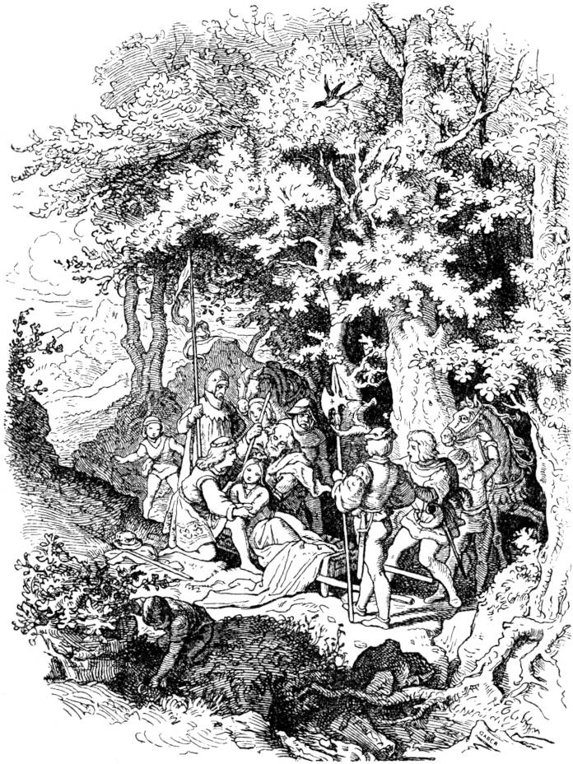

The dwarfs were moved with pity and gave him snow-white in a glass coffin. The 309he gave his servants to carefully carry him away, and he followed pensively. Then one of the servants stumbled over the root of a tree that shook the coffin and almost dropped it, and the poisonous piece of apple that Snow White still had in its mouth (because it fell over before it swallowed the bite) went through the shaking, 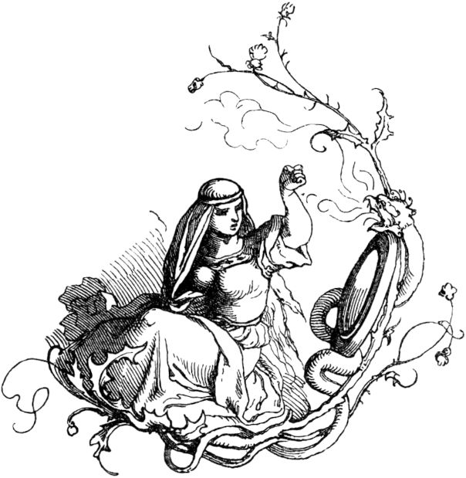out, and suddenly it was alive again.

The king's son quickly had it put down, opened the coffin and lifted it out with his arms, and told him everything, and now he loved it all the more, and took it to his wife, took it to his father's castle, and became the Wedding prepared 310with great splendor, and many distinguished guests were invited, including the wicked queen. The prettiest dressed up, stepped in front of her mirror and asked again:

"Mirror Mirror on the wall,

Who is the most beautiful in the whole country? "

the mirror replied:

"Madam Queen, you are the most beautiful here,

But the young queen is a thousand times more beautiful than you! "

Then the queen did not know what to say and start because of envy and sheer addiction, and she became very worried about her heart and did not even want to go to the wedding; but then she wanted to see the one who was more beautiful than she, and went there. And when she came into the hall, Snow White met her as the most beautiful royal bride that ever existed, and then she might sink into the ground in horror.

Snow-white, however, was not only the most beautiful, she also had a great, noble heart that did not itself avenge the crimes that the wrong woman committed against her. But a poisonous worm came and ate the heart of the wicked queen, and this worm was envy.

311

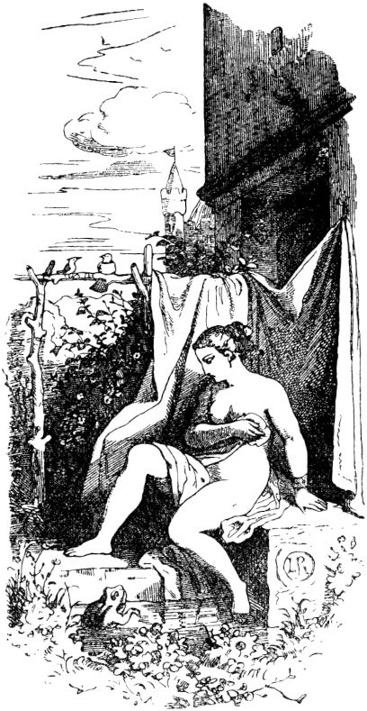

**The Sleeping Beauty.**

Once upon a time there was a king and queen who had no children, but wanted a child every day. At one time it happened that the queen was bathing and sighed when she was so alone: ​​“Oh, I would have a child!” Then a frog jumped out of the water and said: “What you wish you shall do!” And on that the 312Having a daughter for the queen was beautiful beyond all measure, and the king was delighted that his dearest wish had been fulfilled, and arranged a great feast to which he invited all his friends. Now there were also wise women living in the country who were gifted with magic and miraculous powers and enjoyed great reverence for all the people; The king invited them too, and were supposed to eat on golden plates. But then the kings did not have as many bowls and plates as they do now, and this king only had a dozen, that is twelve, and the wise women were thirteen, so he could only invite twelve, and the thirteenth remained uninvited, which she was but resented.

The wise women gifted the king's child with precious goods, not with beauty, for she already possessed it, but with kindness, cheerfulness, grace, gentleness, modesty, piety, modesty, virtue, sincerity, understanding and wealth, and the twelfth wanted just then Wise woman also expressed her wish when the thirteenth, who had not been invited, stepped into the room and angrily exclaimed: "In fifteen years, the king's daughter will stab herself in a spindle and fall dead!" With these words was the angry alrune Disappeared again and the others stood rigid with terror, for the wise women made no vain words. Fortunately, the twelfth wise woman had not yet made her wish. She couldn't change what a wise woman had once threatened, 313abolished everywhere, and instead the spinning wheels were introduced. In the meantime the beautiful king's daughter grew into a young lady who was unparalleled in beauty, gentleness, kindness, mildness, humility, decency, kindness of heart, virtue and understanding, and so it came to his fifteenth year, loved by all who knew it, yes adored. And then the princess felt like looking around the castle a bit, went through several rooms and came to a staircase that led to an old tower; She climbed it and came to a low chamber door, there was an old, rusty key on it, and curious what the very young girls are like, the princess turned the key and the door opened immediately. An ancient spider woman sat there, busily spinning with a spindle; it might not have heard or read the king's law, or long ago forgotten it. The dancing spindle, whirling up and down, made the young king's daughter very happy; she grabbed the spindle, wanted to spin too, and stabbed herself with it, because it was just the day on which the angry wise woman's prophecy was to come true. And the king's daughter fell asleep. And then the same sleep came over the king and queen and the whole palace. It may have been boring! The whole court fell asleep, from the court marshal to the kitchen boy, whom the cook was ruffling his hair by mistake and wanted to give him a slap, and cook and waiter, chambermaid and maid, child and bowler, dog and cat, yes, they Pigeons and sparrows on the roof, the peacocks and parrots and even the flies on the wall were all asleep. And the fire on the stove died down and fell asleep, and he 314The wind died down too, and everything became peeping so that you couldn't hear a little mouse crackling in the whole castle while the little mice were sleeping too. And then no one came into the enchanted slumber castle, 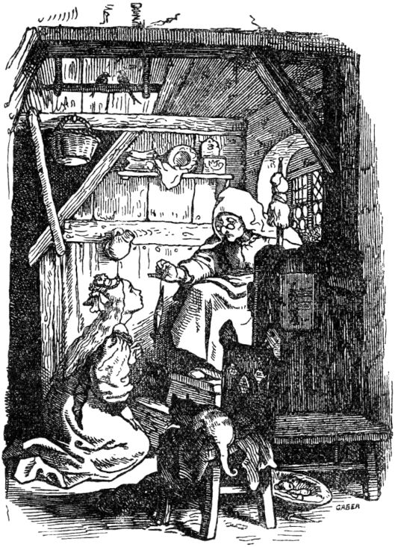around which a mighty hedge of thorns grew up, every year a few feet higher, until it had overgrown the highest tower, so that you couldn't even see the flag and the weathercock, and so close that no human being could penetrate. And then the castle was gradually completely forgotten, and only the legend went back 315There is a castle on the thorns, in which Sleeping Beauty sleeps , the enchanted princess, how long and how long no one knows. It is true that from time to time the king's sons came who wanted to penetrate through the hedge, but it was too dense and could not get hold of it, remained entangled in the thorns and perished miserably in it.

And so now a hundred years had passed, and the time was there for the Sleeping Beauty to wake up again, but nobody knew this exactly, and then a king's son came too, who heard the tale of the sleeping Sleeping Beauty from the mouth of an old man, who she certainly assured him, because his father and great-grandfather would often have told him about it and the old man had to lead the king's son to the notorious thorn hedge. And that happened just on the hundredth anniversary since the Sleeping Beauty fell into its magical sleep. And the thorn hedge was full of rose flowers, that had not been the case since time immemorial, and the king's son could walk freely through the thorn hedge, no thorn touched his robe, but immediately behind him the hedge closed again. And there he found everything intact; no wind had blown and no rain wet the century had so quietly flown over the heads of the slumbering, like a swan over a still lake full of dreaming water-lilies. All the flies and all the mice were still asleep, the hen and the rooster, the cat and the dog, the maid and the maid, the chamberlain and the chamberlain, and the king and queen too. The king's son saw all this with great astonishment, went up to the tower and came into the room where the sweet Sleeping Beauty lay, and slept so gently, surrounded by the halo of his innocence and by the 316Shine in its beauty. Then the prince bent down and kissed Sleeping Beauty, and immediately it opened its eyes. The king's son told him how it all happened and led him down to the castle. Then everything awoke, king and queen, dwarf and maid, dogs and horses, 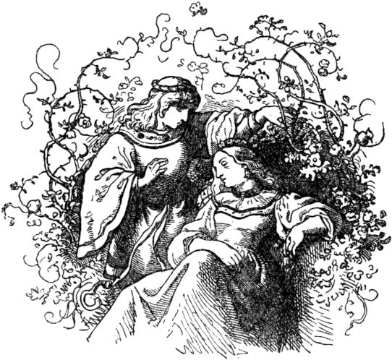Fire and water, wind and weather valve, and the cook gave the kitchen boy the slap in the face that he owed him a hundred years ago, and everything went back to normal, and a stately wedding was held, namely the Sleeping Beauty with the prince who did it redeemed from slumber, and lived happily ever after together until their end.

317

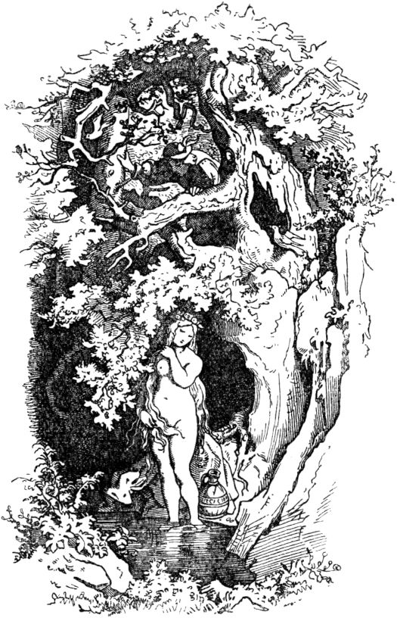

**The seven swans.**

In one country was a young knight who was rich and handsome, and had a splendid castle. At one time he was riding his dogs into the forest to hunt, when he saw a hind (doe), which was whiter than the snow, and fled from him up and away into the mountains between the wild high bushes. The knight man 318but followed her hurriedly, and at last came into a wild, dark valley, where he lost the hind from his face due to the dogs, rode back and forth and called the dogs together again. Over it he came to a river, by which he saw a beautiful maiden, she washed herself and carried a gold chain in her hand. And since he liked this maiden very well, he got off his horse gently, sneaked close to her and took the golden chain from her hand. In this chain, however, there was special power and planetary magic, and the virgin was a divining woman, and so beautiful that he forgot the hind and his dogs because of her beauty, and intended to bring the virgin home as his wife. And so he did and led her home to his castle.

Now the young knight still had a mother, for whom the cord was inconvenient, for she had previously led the regiment all by herself, and was now concerned that she would lose power and prestige at the castle. And became angry with the cord and hated her, and often admonished her son not to love them too much, and would have loved to instigate strife and discord between the two. But she couldn't manage that because her son didn't want to hear her words and was annoyed with her every time. When she saw this, she was obedient and obedient to her son and the young woman in everything, but everything came from a false heart, in which she had thought up a cruel malice against the young woman, although she was her outwardly seemed very honorable. Then came the time that the young woman came into childbed and recovered from six sons and a daughter, all of whom wore gold rings around their necks. At once the wicked old woman, the mother of the young gentleman, came and took her 319She carried seven children away while the mother slept, and put in their place seven young dogs that had been thrown that night. Now this false and unfaithful woman had a trusted servant, to whom she handed the seven children over, and obliged him by faithfulness and oaths that he should carry her into the wild forest, kill her and bury her in the earth or drown in water. As the servant had promised to do, he carried the children into the forest, laid them under a tree, and prepared to strangle them. But then a horror struck him at the murder, and he shuddered from such unfaithful deed, and let the children live, went and told the woman that he had done her command.

But the Creator of all beings, who guides all things for the best, had pity on the little children and sent them a foster father, that was an old, wise master who lived in the forest to cultivate wisdom, who took the children into his cave and nourished them with the milk of the hinds who used to come to him for seven years.

When that wicked woman had taken the children away from the mother, she led her son to the young woman, showed him the little dogs and said: "See, son, the children your wife gave birth to you, they are young dogs." to her son out of revenge for loving the young woman so much. When he saw this, he believed his mother and threw a hatred of the young woman he had loved so much before, did not want to hear a word of apology, but had her buried in the ground in the courtyard in front of the palas of his castle on her breast, and over her head he had a washbasin with water placed, and ordered his servants to wash over her head and put their hands on hers 320beautiful hair to dry. Nor should she be given any other food than dogs.

And so the poor woman had to stand in the pit in troubles and fears for seven whole years, and was not allowed to have mercy on her. Her beautiful body was consumed by it, her clothes rotten and only the skin remained over her bones.

Meanwhile the young children learned to shoot game and birds in the forest, and to feed on their flesh, 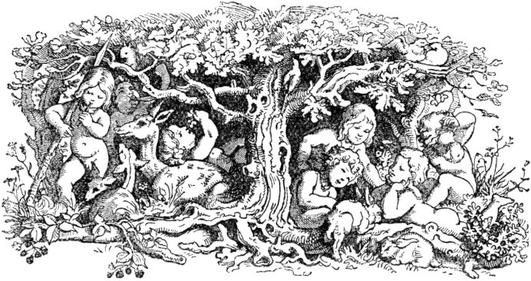and then it happened that the knight, her father, went hunting again in the forest. Then he became aware of the children who were running to and fro in the wood, and they all had little gold necklaces on their necks. And his heart was moved with affection for the children; would have liked to take one or the other, but they did not allow themselves to be caught, but disappeared into the forest. At home he told his mother and other gentlemen and friends that he had seen little children with gold chains on their necks in the forest. His mother was inwardly shocked by this, took the servant out and asked him: "Did you kill the children at that time, or did you let them live?" Then confessed 321the servant said he was unable to kill them with his own hand, but he had put them under a tree, and there they would certainly have died soon. Thereupon she ordered the servant to ride quickly into the forest, to look for the children who had by no means died, and to take their golden chains, otherwise they would both be put to shame. The servant obeyed in fear, looked for the children in the forest for three days and did not find them; Only on the fourth day did he find them; they had taken off their chains and were now turned into swans and were playing on the water. But the girl was still in human form and watched the swans play on the water. So the servant went secretly and took away the six golden chains; but the girl escaped him so that he could not reach it.

As the servant offered the old men’s chains, he sent them to a goldsmith and had him make a beaker from them. When the goldsmith wanted to cast a beaker from the chains, he found that the gold was so noble and pure that it could neither be worked with a hammer nor made flowing in fire, except for a little chain, which he broke and made one Ring of it; The others he weighed on his scales, put them aside, and gave so much other gold in return, and made a cup of it, which he gave to the woman and also the ring, who locked them both tightly in her case.

Those swans, however, who were now unable to regain their human form, were saddened and sang, in a sweet, pitiful voice, a wistful song that sounded like crying little children. At last they rose high on their plumage to see where they were turning 322want? Then they saw a large, mirror-clear lake on which they sat down. The lake, however, enclosed a high mountain, on which hung a large rock and on top of it lay a beautiful castle. 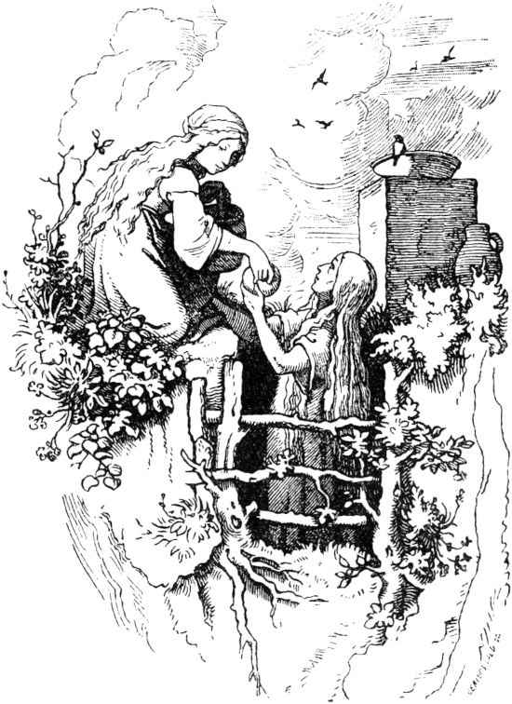So the rock was steep, and the water was so close to the mountain that there was no access to the castle except a very narrow path. And that was precisely the castle of the young knight, who was the father of those children, and the windows of the dining room of the castle faced the water, so that the master soon saw the swans 323was, and was astonished, for he had never seen such beautiful birds. So he threw bread and other food down on them, and told his servants that no one should chase them away or drive them away, but that they should throw bread down at all times, until the swans kept themselves at home there. This commandment was followed diligently, and the swans got used to it and became so tame that they always came at mealtime and received their food.

But the poor abandoned girl, her sister, had now kept her human form, but was helpless, and went begging up to her father's castle. Then they gave her the garbage from the table, and she shared it with the poor woman in the pit, for whenever she saw her she had to weep bitterly. But one did not know the other. The maid also brought some remaining crumbs down under the castle to the water, and gave them to the swans, their brothers. Whenever she approached, the swans would come flying and fluttering and cuddling, and ate their food from the maid's apron. She kissed her kindly and often took her in her arms, and then always went back to the castle towards evening, and slept all night in front of the woman who stood in the ground without her knowing that she was her mother.

All the residents of the castle saw all this with great astonishment, and that she always cried when she stood with the woman, and also that she looked very much like her. And then the knight's heart was moved, too, that he looked more closely at the girl, and saw the resemblance to his wife, and saw the golden necklace on her neck. And let the little girl step in front of her and asked her: “My dear child, tell me, where you are from 324and from where do you come from? Who are your parents and how did you tame the swans so that they eat out of your lap? "

Then the poor child sighed from the bottom of her heart and said: “Dear Lord! I never knew the parents I had. I don't know if I saw them either. But if you ask about the swans, they are my brothers who were nourished with me by the milk of the hinds in the forest. At one time it happened that my brothers took off their golden chains because they wanted to bathe, so they were turned into swans; and because the chains were stolen, they could not regain their human form and had to remain swans. "

The false unfaithful woman and the servant, her accomplice, heard this speech and were terrified and both turned pale, conscious of their guilt. The knight noticed this and thought about it while walking down from the castle. But the old woman incited the servant to kill the maid. And he took a bare sword and followed the girl when, according to his custom, she went down to the swans. Only the master saw him, came near, and when the servant was about to commit the iniquity, he knocked the sword out of his hand. Then the servant fell on his knees and confessed everything. The knight then went to his mother and threatened her to confess; then she unlocked her case and gave the son the cup that was supposed to be made by the chains. The knight immediately sent for the goldsmith and asked him seriously about the cup. Since the latter was now also concerned with the punishment, he confessed the truth that he still had the chains whole, except for 325one from which he made a ring. The knight bade him bring the chains and gave them to the maiden; She put them around the swans, each one around the neck. Then they all got their human form again, except for one - he had to remain a swan. Many books have described many strange adventures about this swan. Now the knight had the poor woman taken out of the earth in a hurry, and refreshed her with noble spices and precious spices so that she would become a beautiful woman again. He had his false mother put in the same hole in which his innocent wife had languished and suffered from that wickedness for seven long years. So it happened to her according to the prophet's saying: Whoever dug it falls into the pit.

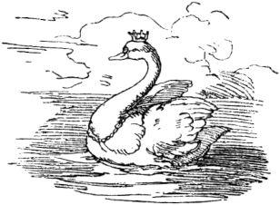

**The three dogs.**

A shepherd left his two children, a son and a daughter, nothing but three sheep and a little house, and said on his death bed: "Divide yourselves as brothers and sisters, so that quarrels and quarrels do not arise between you." When the shepherd had now died, the brother asked the sister, which one she would prefer, the sheep or the little house? And when she got the house 326chose, he said: "So I will take the sheep and go into the wide world: many have already found happiness and I am a Sunday child." He then went away with his inheritance; however, happiness did not want to meet him for a long time. Once he was sitting very morosely at a crossroads, uncertain where he wanted to turn; 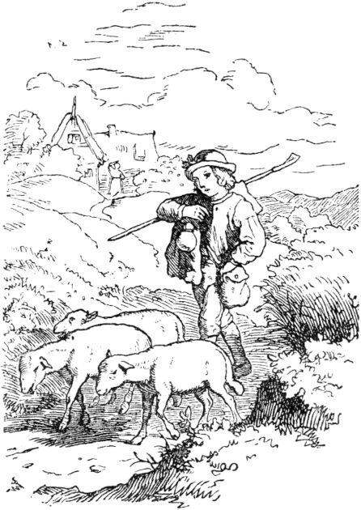Suddenly he saw a man next to him who had three black dogs, one of which was always larger than the other. “Well, young fellow,” said the man, “you have three beautiful sheep there. You know what, give me the sheep, I will give you my dogs for it. ”Despite his sadness, he had to laugh. "What should I do with your dogs?" He asked; "My sheep feed themselves, but the dogs want to be fed." - "My dogs are of a strange kind," answered the stranger; “They feed you instead of you, and they will make you happy. The smaller one is called 'bring food', the second 'tear', and the big strong one 'break steel and iron'. To test the quality of his dogs, he said: "Bring food!" And immediately ran 327the one dog left and came back with a large basket full of the most splendid foods. The shepherd did not regret the exchange; he let it go and wandered about the country for a long time.

Once he met a carriage drawn by two horses and dressed entirely in black blankets, and the coachman was also dressed in black. In the car sat a beautiful girl in a black robe, she wept bitterly. The horses trotted slowly and sadly and drooped their heads. "Coachman, what does that mean?" Asked the shepherd. The coachman replied gruffly, but the latter did not hesitate to ask until the coachman told them that there was a large dragon in the area and that he had to be promised a maiden as an annual tribute in order to protect it from its devastation Devour skin and hair. The lot decides among the fourteen-year-old virgins and this time it affected the king's daughter. The king and the whole country are deeply saddened by this, and yet the dragon must receive its sacrifice. The shepherd felt pity for the beautiful young girl and followed the carriage. This finally stopped at a high mountain. The maiden got out and walked slowly towards her terrible fate. The driver now saw that the strange man was about to follow her and warned him, but the shepherd would not let himself be turned away. When they had climbed half of the mountain, a terrible monster with a scaly body, wings and enormous claws on its feet came down from the summit; A glowing stream of sulfur blazed out of its throat, and it was about to pounce on its prey, when the shepherd shouted: "Tear up!" and the second of his dogs threw himself on the dragon, bit himself in the softness of it, and This finally stopped at a high mountain. The maiden got out and walked slowly towards her terrible fate. The driver now saw that the strange man was about to follow her and warned him, but the shepherd would not let himself be turned away. When they had climbed half of the mountain, a terrible monster with a scaly body, wings and enormous claws on its feet came down from the summit; A glowing stream of sulfur blazed out of its throat, and it was about to pounce on its prey, when the shepherd shouted: "Tear up!" and the second of his dogs threw himself on the dragon, bit himself in the softness of it, and This finally stopped at a high mountain. The maiden got out and walked slowly towards her terrible fate. The driver now saw that the strange man was about to follow her and warned him, but the shepherd would not let himself be turned away. When they had climbed half of the mountain, a terrible monster with a scaly body, wings and enormous claws on its feet came down from the summit; A glowing stream of sulfur blazed out of its throat, and it was about to pounce on its prey, when the shepherd shouted: "Tear up!" and the second of his dogs threw himself on the dragon, bit himself in the softness of it, and the shepherd, however, could not be turned away. When they had climbed half of the mountain, a terrible monster with a scaly body, wings and enormous claws on its feet came down from the summit; A glowing stream of sulfur blazed out of its throat, and it was about to pounce on its prey, when the shepherd shouted: "Tear up!" and the second of his dogs threw himself on the dragon, bit himself in the softness of it, and however, the shepherd was not turned away. When they had climbed half of the mountain, a terrible monster with a scaly body, wings and enormous claws on its feet came down from the summit; A glowing stream of sulfur blazed out of its throat, and it was about to pounce on its prey, when the shepherd shouted: "Tear up!" and the second of his dogs threw himself on the dragon, bit himself in the softness of it, and 328so bothered him that the monster finally sank down and exhaled its poisonous life, but the dog ate him up completely so that nothing was left but a few teeth, which the shepherd stuck to him. 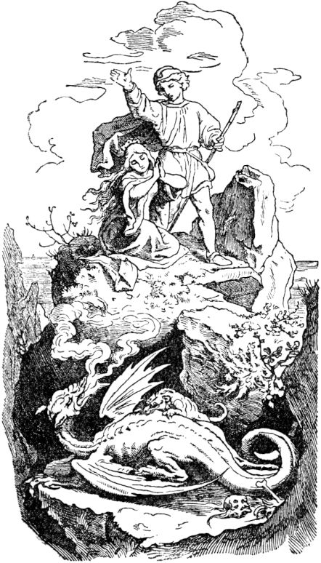The king's daughter was completely swooned with shock and joy, the shepherd brought her back to life, and now she sank at her savior's feet and pleaded with him to come to her father, who would reward him richly. The youth replied that he wanted to look around the world first, but would come back three years later. And he stuck to this decision. The maiden sat back in the carriage, and the shepherd went on another way.

But the driver had bad thoughts. As they drove over a bridge under which a great river flowed, he stopped, turned to the king's daughter and said: “Your savior is gone and desires yours 329Thanks not. It would be nice of you if you made a poor person happy. So tell your father that I killed the dragon; but if you don't want that, I'll throw you into the river here and no one will ask about you, for it is said that the dragon has devoured you. ”The maiden wailed and pleaded, but in vain; at last she had to swear to pass the coachman off as her savior and not to reveal the secret to any soul. So they drove back to the city, where everyone was beside themselves with delight; the black flags were taken from the towers and colored ones were placed on them, and the king embraced his daughter and her supposed savior with tears of joy. “You saved not only my child but the whole country from a great plague,” he said. “That is why it is cheap that I reward you. My daughter is to be your wife; but since she is still too young, the wedding should not take place for a year. ”The coachman thanked him, was splendidly dressed, made a nobleman and instructed in all the fine morals that his current status required. The king's daughter, however, was terrified and wept bitterly when she heard this, and yet did not dare break her oath. When the year was up, all she could do was meet another year's deadline. This also came to an end and she threw herself at the feet of the Father and asked for another year, thinking of the promise of her real Savior. The king could not withstand her plea and granted her the request, with the addition, however, that this was the last time he allowed her. How quickly time passed! The wedding day was now set,330

On the same it happened that a stranger came into town with three dogs. He asked about the cause of the general joy and learned that the king's daughter was just being married to the man who had slayed the terrible dragon. The stranger accused this man of a deceiver who adorns himself with strange feathers. But he was seized by the guard and thrown into a narrow prison with iron doors. As he was lying on his bundle of straw and pondering his sad fate, he suddenly thought he heard the whining of his dogs outside; then a bright thought dawned in him. "Break steel and iron!" He shouted as loudly as he could and immediately he saw the paws of his largest dog on the lattice window, through which the daylight fell sparsely into his cell. The grid broke and the dog jumped into the cell and gnawed the chains with which his master was bound; then he jumped out again and his master followed him. Now he was free, but it pained him very much that someone else should reap his reward. He was also starving and he called his dog: "Bring food!" Soon afterwards the dog came back with a napkin full of delicious food; a royal crown was embroidered on the napkin.

The king had just been sitting at the table with his entire court when the dog appeared and licked the bride's maiden's hand pleadingly. She had recognized the dog with joyful shock and tied her own napkin around it. She saw this as a sign from heaven, asked her father for a few words and trusted him the whole secret. The king sent a messenger after the dog, who soon after brought the stranger to the king's cabinet. The king led him into the hall by the hand; the former 331The driver turned pale at the sight of him and kneeled to beg for mercy. The king's daughter recognized the stranger as her savior, who was also identified by the dragon's teeth that he still carried with him. The coachman was thrown into a deep dungeon, and the shepherd took his place at the side of the king's daughter. This time she did not ask for the wedding ceremony to be postponed.

The young couple had been living happily for a long time, when the former shepherd thought of his poor sister and expressed the wish to tell her of his happiness. He also sent a wagon to fetch her, and it was not long before she was lying on her brother's chest. Then one of the dogs began to speak and said: “Our time is up now; you no longer need us. We only stayed with you long enough to see if you would not forget your sister even if you were lucky. ”Then the dogs turned into three birds and disappeared into the air.

**Swan, stick on!**

Once upon a time there were three brothers, the oldest of whom was called Jakob, the second Friedrich and the third and youngest Gottfried. This youngest was the guard of all the banter of his brothers and the usual distractor of their anger. If something crossed their path, Gottfried had to pay for it and he had to put up with all of this because he was of a weak build and could not defend himself against his stronger brothers. This made life angry for him and he thought day and night to make his fate more bearable 332do. When he was once in the forest gathering wood and weeping bitterly, an old woman came up to him; she asked him about his misery and he trusted her with all his sorrows. “Oh, my boy,” said the woman, “isn't the world big? Why don't you try your luck somewhere else? ”Gottfried took this to heart and left his father's house early one morning and set out into the big wide world in order, as the woman had said, to look for his happiness. 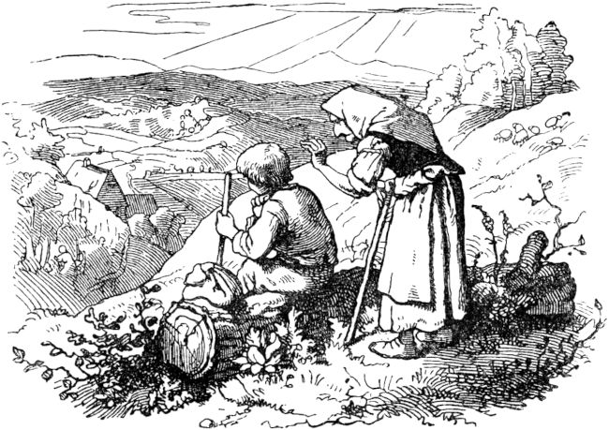But saying goodbye to the place where he was born and had at least had a happy childhood touched him, and he sat down on a hill to take another look at his native village. See, there stood the woman behind him, clapped him on the shoulder and said: “You did that well once, my boy! But what do you want to start now? ”- Gottfried was only now thinking about what to start? Until now he had believed happiness 333must fly into his mouth like a roasted dove. The woman could guess his thoughts, smiled and grinned, and said: “I want to tell you what to do. Why? because I love you, and because I believe that you will not forget me either if you sit in happiness in your lap. "Gottfried promised this with hand and mouth; the old woman continued: “Tonight, when the sun goes down, go to the big pear tree that stands there on the Way of the Cross. Under it a man will lie and sleep, but a big beautiful swan will be tied to the tree; You are careful not to wake the man up and you have to come just as the sun goes down, but you untie the swan and take him away with you. People will be in love with its beautiful feathers, and you may allow them to pluck one out. But if the swan is touched, it will scream, and if you then say: Swan, stick on! so whoever touches him will have his hand firmly glued on and not get rid of it until you tap it with this little stick, which I am hereby giving you as a present. If you have caught such a gracious migration of human birds, just lead them straight ahead. There you will come to a big city, there lives a king's daughter who has never laughed. If you make them laugh, your happiness is made; but then don't forget me either, my boy! ”Gottfried made the promise again and was right at the designated tree at sunset. The man lay there and slept, and a large beautiful swan was tied to the tree with a ribbon. Gottfried loosened the bird courageously and led it away without the man waking up. so he will scream, and if you then say: Swan, stick on! so whoever touches him will have his hand firmly glued on and not get rid of it until you tap it with this little stick, which I am hereby giving you as a present. If you have caught such a gracious migration of human birds, just lead them straight ahead. There you will come to a big city, there lives a king's daughter who has never laughed. If you make them laugh, your happiness is made; but then don't forget me either, my boy! ”Gottfried made the promise again and was right at the designated tree at sunset. The man lay there and slept, and a large beautiful swan was tied to the tree with a ribbon. Gottfried loosened the bird courageously and led it away without the man waking up. so he will scream, and if you then say: Swan, stick on! so whoever touches him will have his hand firmly glued on and not get rid of it until you tap it with this little stick, which I am hereby giving you as a present. If you have caught such a gracious migration of human birds, just lead them straight ahead. There you will come to a big city, there lives a king's daughter who has never laughed. If you make them laugh, your happiness is made; but then don't forget me either, my boy! ”Gottfried made the promise again and was right at the designated tree at sunset. The man lay there and slept, and a large beautiful swan was tied to the tree with a ribbon. Gottfried loosened the bird courageously and led it away without the man waking up. and when you then say: swan, stick on! so whoever touches him will have his hand firmly glued on and not get rid of it until you tap it with this little stick, which I am hereby giving you as a present. If you have caught such a gracious migration of human birds, just lead them straight ahead. There you will come to a big city, there lives a king's daughter who has never laughed. If you make them laugh, your happiness is made; but then don't forget me either, my boy! ”Gottfried made the promise again and was right at the designated tree at sunset. The man lay there and slept, and a large beautiful swan was tied to the tree with a ribbon. Gottfried loosened the bird courageously and led it away without the man waking up. and when you then say: swan, stick on! so whoever touches him will have his hand firmly glued on and not get rid of it until you tap it with this little stick, which I am hereby giving you as a present. If you have caught such a gracious migration of human birds, just lead them straight ahead. There you will come to a big city, there lives a king's daughter who has never laughed. If you make them laugh, your happiness is made; but then don't forget me either, my boy! ”Gottfried made the promise again and was right at the designated tree at sunset. The man lay there and slept, and a large beautiful swan was tied to the tree with a ribbon. Gottfried loosened the bird courageously and led it away without the man waking up. Glue the hand tightly and don't get rid of it until you tap it with this little stick that I am giving you as a present. If you have caught such a gracious migration of human birds, just lead them straight ahead. There you will come to a big city, there lives a king's daughter who has never laughed. If you make them laugh, your happiness is made; but then don't forget me either, my boy! ”Gottfried made the promise again and was right at the designated tree at sunset. The man lay there and slept, and a large beautiful swan was tied to the tree with a ribbon. Gottfried loosened the bird courageously and led it away without the man waking up. Glue the hand tightly and don't get rid of it until you tap it with this little stick that I am giving you as a present. If you have caught such a gracious migration of human birds, just lead them straight ahead. There you will come to a big city, there lives a king's daughter who has never laughed. If you make them laugh, your happiness is made; but then don't forget me either, my boy! ”Gottfried made the promise again and was right at the designated tree at sunset. The man lay there and slept, and a large beautiful swan was tied to the tree with a ribbon. Gottfried loosened the bird courageously and led it away without the man waking up. If you have caught such a gracious migration of human birds, just lead them straight ahead. There you will come to a big city, there lives a king's daughter who has never laughed. If you make them laugh, your happiness is made; but then don't forget me either, my boy! ”Gottfried made the promise again and was right at the designated tree at sunset. The man lay there and slept, and a large beautiful swan was tied to the tree with a ribbon. Gottfried loosened the bird courageously and led it away without the man waking up. If you have caught such a gracious migration of human birds, just lead them straight ahead. There you will come to a big city, there lives a king's daughter who has never laughed. If you make them laugh, your happiness is made; but then don't forget me either, my boy! ”Gottfried made the promise again and was right at the designated tree at sunset. The man lay there and slept, and a large beautiful swan was tied to the tree with a ribbon. Gottfried loosened the bird courageously and led it away without the man waking up. my boy! ”Gottfried made the promise again and was right at the designated tree at sunset. The man lay there and slept, and a large beautiful swan was tied to the tree with a ribbon. Gottfried loosened the bird courageously and led it away without the man waking up. my boy! ”Gottfried made the promise again and was right at the designated tree at sunset. The man lay there and slept, and a large beautiful swan was tied to the tree with a ribbon. Gottfried loosened the bird courageously and led it away without the man waking.

Now it happened that Gottfried with his swan 334passed a construction site where some men in striped trousers were kneading clay; they admired the beautiful feathers of the bird and a cheeky boy who was covered over and over with clay said aloud: "Oh, if only I had such a feather." 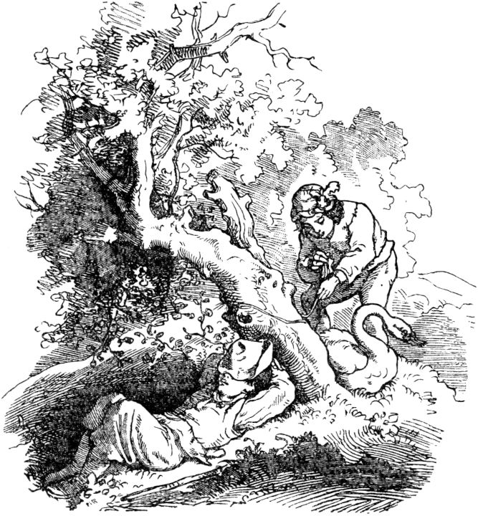“Take one off!” Said Gottfried in a friendly manner; the boy grabbed the bird's tail, the swan screamed; “Swan, stick on!” Said Gottfried, and the boy couldn't get away again, he could do whatever he wanted. The others laughed the more the boy screamed, until a maid came running up from the nearby brook, the one with a high apron 335Had washed her skirt there. She felt sorry for the boy and held out her hand to loosen him. The swan screamed; “Swan, stick on!” Said Gottfried, and the maid was also caught. When Gottfried had walked a distance with his prey, he met a chimney sweep who laughed at the strange team and asked the maid what she was doing there? "Oh, dearest Hans," answered the maid miserably, 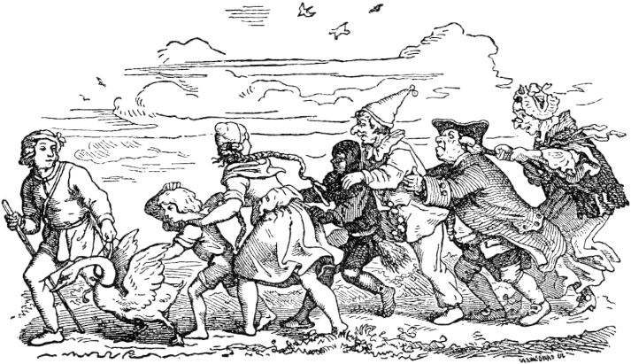"Give me your hand and get rid of the demonized boy." - "If that's all!" Laughed the chimney sweep and shook hands with the maid; the bird screamed; “Swan, stick on!” Said Gottfried, and the black person was also bewitched. They came to a village where a church fair was just taking place; a tightrope dance company gave performances there and the Bajazzo was just doing his foolish things. His mouth and nose opened wide when he saw the strange shamrock that clung to the swan's tail. "Have you become a fool, black one?" He laughed. - “There is nothing there 336to laugh! ”answered the chimney sweep. “The woman holds me so tight that my hand is nailed on. Get rid of me, Bajazzo; I'll do you some other love service. ”The Bajazzo took the black man's outstretched hand, the bird screamed; “Swan, stick on!” Said Gottfried, and the Bajazzo was fourth in the group. Now in the front row of the spectators stood the stately stout bailiff of the village, who made a very serious face and he was extremely angry about the dazzling work that could not be done with the right things. His zeal went so far that he took the bajazzo by the bare hand and wanted to tear him loose to hand him over to the bailiff; then the bird screamed and “Swan, stick on!” said Gottfried, and the bailiff shared the fate of the predecessor. The bailiff, a long, withered spindle, was appalled at the misfortune of her husband and tore at his free arm with all his might; the bird screamed; "Swan, stick on!" Said Gottfried, and the poor woman bailiff had to follow despite her shouting. From then on, nobody wanted to expand society.

Gottfried already saw the towers of the capital in front of him; a beautiful equipage came towards him, in which a beautiful young but serious lady was sitting. When she saw the colorful train, however, she burst out laughing and her servants laughed too. "The king's daughter laughed!" Everyone shouted with joy. She got out, looked at the matter even more closely, and laughed more and more at the capers made by the confined. The car had to turn around and slowly drove back to town next to Gottfried. When the king heard the news that his daughter had laughed, he was delighted and took Gottfried himself, 337his swan and its strange entourage in sight, and he had to laugh himself that the tears stood in his eyes. "You foolish fellow," he said to Gottfried, "do you know what I promised to make my daughter laugh?" - "No," said Gottfried. - "So I will tell you," answered the king. “A thousand gold guilders or a fine good. Choose between the two. ”Gottfried decided on the estate. Then he touched the boy, the maid, the chimney sweep, the bajazzo, the bailiff and the bailiff with his chopsticks, and they all felt free and ran away as if hell were burning after them, which caused new inextinguishable laughter. Then the king's daughter was moved to stroke the beautiful swan and admire its plumage. The bird screamed; “Swan, stick on! “Said Gottfried, and so he won the king's daughter. But the swan rose into the air and disappeared into the blue horizon. Gottfried now received a duchy as a gift; but he also remembered the old woman who was to blame for his happiness, and called her to be the stewardess of his and his chosen bride in his stately palace.

338

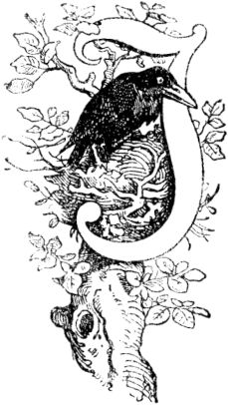

**The little mouse Sambar, or the faithful friendship of animals.**

In a vast forest there was much game, and there was a big tree with many branches, on which a raven had its nest. Then at one time he saw the bird operator coming and stretching a twine under the tree, was frightened and thought about it and thought: Is this pasture man pulling his hunting gear because of you or because of other animals? We want to see that! In doing so, the bird-caterer scattered seeds on the ground, straightened his thread and stood in wait. Soon afterwards a pigeon came with a whole flock of other pigeons, of which she was the leader, and since they saw the seed and did not pay attention to the thread, they fell on it and the net collapsed and covered them all. The bird was delighted, and the pigeons fluttered restlessly to and fro. The dove, who was the leader, said to the other doves: "Don't rely on anyone on your own and don't have anybody better than the others, but let us all swing up at the same time, maybe that we take the yarn up with us, so each one takes care of herself and the others with her." Rate followed the pigeons, flew up at the same time and lifted the yarn into the air. The bird operator had to watch and run to see where his net would fall down to the ground again; but the raven thought to himself: You also want to follow and see what will become of this miracle? flew up at the same time and lifted the yarn into the air. The bird operator had to watch and run to see where his net would fall down to the ground again; but the raven thought to himself: You also want to follow and see what will become of this miracle? flew up at the same time and lifted the yarn into the air. The bird operator had to watch and run to see where his net would fall down to the ground again; but the raven thought to himself: You also want to follow and see what will become of this miracle?339

When the wise handler of the pigeons saw that the hunter was chasing after their flight, she said to her companions: “See, the hayman is following us; If we persist in the direction over the road, we stay in his face and will not escape him, but if we fly over mountains and valleys, he cannot keep an eye on us and has to refrain from pursuing him because he will despair of it to find us again. Not far from here is a ravine, there lives a mouse, my friend, I know that when we come to her, she gnaws the net and redeems us. "

The pigeons followed the advice of their handler and came out of the bird's face. The raven, however, flew slowly after them to see what would become of this story and how the pigeons would get rid of the net, and whether he would not learn to use their life-saving means at his own risk.

Meanwhile the pigeons reached the ravine where the little mouse lived, settled down and saw that the mouse had a hundred holes and entrances and exits to its subterranean dwelling, in order to be able to hide at many ends in the event of imminent danger. The mouse was Sambar, and the wise pigeon now called the friend: - "Sambar, come out!" As the little mouse inside calling and cried the dove: "It's me, the dove, your girlfriend," Who are you? " ! ”And there came the little mouse, looked carefully out of one of the holes and asked:“ O dear companion, who knitted you like that? ”Then the dove said:“ O dear friend! Do you not know that no one lives unless God sends a hideous doom? And the most deceitful cheaters is the time! She sprinkled sweet wheat grains on me and hid it 340the sore net in my eyes, so that I and my friends fell into it. Nobody takes care of the destiny that comes from above, yes, the moon and sun also suffer from eclipse, and from the sea of ​​unfounded depths man lures the fish as he pulls the bird from the air down into its false snares. "

When the dove spoke this with much eloquence, the mouse began to gnaw the net, 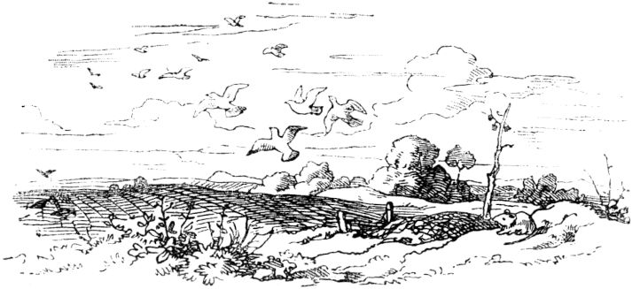namely at the end where her playmate, the pigeon, was lying, but she said: "Start with the others, my sisters, and when you have done them all , then kill me too." But the mouse did not follow her, if she asked repeatedly, and when she asked the mouse again about it, the mouse asked: "What do you tell me this so often as if you did not also wish to be free?" To which the pigeon replied: "Leave my request to you not displeased; these my sisters have trusted me as their guide; They followed me willingly and full of trust and through my carelessness they got under the net, so it is fair that I think of their redemption rather than mine, especially since it is only through their common 341Help succeeded in getting me up too, along with Vogler's yarn. You also want to tire with the others, but if you know me, your dearest friend, still on the net, you will not leave me. "

Thereupon the little mouse said: “O dear, good dove, dove heart; This attitude does you much honor and must strengthen the love between you and your companions. ”And it gnawed the net everywhere, and the pigeons flew freely and happily on their way, but the mouse slipped back into its little hole.

The raven, who had perched on a tree nearby, had seen and listened to all of this, and then spoke to himself: “Who knows,” he said, “whether I might not get into the same situation and danger as this one Pigeons? Then it is really wonderful to have noble friends who help us out of an emergency. With this mouse, friendship would always be good for me!

And then he flew from his tree and jumped to the ravine and called: “Sambar, come out!” And inside the little mouse called: “Who are you?” Then he said: “I am the raven and have seen what you love Friend, the dove, has met, and how God has done her through your loyalty, that's why I come to look for your friendship too. "Then Sambar, the clever little mouse, spoke without it coming out:" There cannot be friendship between you and me; a wise man strives only to attain what is possible, and is considered unwise who wants to attain the impossible. Someone would lead ships over land and carts over sea. How could there be company between us, since I am your feeder and you the eater? "Then the raven said:" Little mouse, understand me, and reflect on my speech. What did me 342I'll eat you up, your death! Your life should be helpful to me, and your friendship should be as constant as ambergris, which smells lovely, whether one wears it veiled. "Then the mouse said:" Know, raven, the hatred of desire is the greatest hatred. Lion and elephant hate each other because of their strength, that is a noble and equal hatred of courage and strife; but the inveterate hatred of the strong for the weak is an ignoble and unequal hatred; so the hawk hates the partridge, the cat the rat, the dog the hare, and you - me. Heat water by the fire so that it burns you like the fire, it will therefore not be a fire, also never a friend of fire, but it will, when poured into the fire, still dampen it. The wise say: He who clings to his enemy is like someone who takes a poisonous snake in his hand; he doesn't know when she's going to bite him. The wise one never trusts his enemy, but keeps away from him, otherwise what happened to him once happened to the man with the snake. "

The raven asked: "How did that happen?" And then the mouse told him the following fairy tale:

**The man and the snake.**

Once upon a time there was a man in whose house there lived a snake, which was kept well by this man's wife and was fed daily. She had her apartment very close to the stove, where it was always nice and warm, in a hole in the wall. The man and the woman imagined, according to the prevailing superstition, 343that it brings luck if there is a snake in the house. Now it happened on a Sunday that the head of the house ached, so he lay in his bed early and told the woman and the servants to go to church. Then they all went out, and it was now very quiet in the house, and now the snake slipped quietly out of its hole and looked around very much. The man, whose chamber was open, saw this and was quietly amazed that the snake 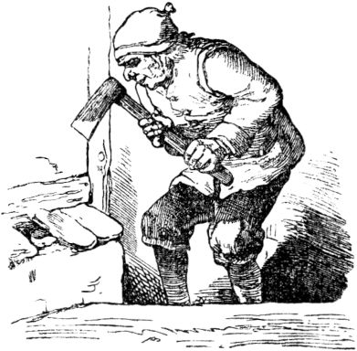against their usual habit, looked around so much. She crawled through every corner and came into the room and peeped in, but saw no one because the master of the house had hidden himself. And now she crawled on the stove, where a pot with the soup was standing by the fire, hung her head over it and spat her poison into the pot, then she hid again in her cave. The master of the house immediately got up, took the pot and dug it into the earth with the food and poison. When the time came for people to want to eat, where the snake usually came out, the man stood in front of the hole with an ax, willing, as soon as it slipped out, to cut its head off. But the snake very carefully stuck its head just a little bit out of the hole, and when the man struck, it drew back with lightning speed and showed, that she had a bad conscience. After a few days the woman talked to her husband 344he should make peace with the snake, it would probably not do so bad again; The landlord was good-willed and called a neighbor who was supposed to witness the peace alliance with the snake and to draw up a contract with her that one thing should be safe from the other. Thereupon they called the snake and made the proposal; but the snake said: “No! Our society can no longer exist in faithfulness, because when you think of what I have put into your pot, and when I think of how you hit my head with a sharp ax, then none of us would like that trust others. That is why we do not belong together; give me safe escort, that's all I ask of you, and let me go my road, the farther from you, the better, and you will stay calm in your house. ”And so it happened.

The raven, when he heard this story from the mouth of the little mouse Sambar, took the floor again and said: “I understand the lesson that your fairy tale contains, only consider your nature and my sincerity, be less strict and refuse not your cooperative. There is a difference between noble and ignoble; the gold goblet lasts longer than the glass one, and if the glass goblet breaks it is gone, but if the gold goblet suffers, its value is not yet lost. The friendship of the bad and ignoble minds is no friendship at all, but you have a noble mind, I have recognized that, and so my heart longs for your friendship and needs it, and I will not leave the entrance to your apartment, and don't eat or drink until you've given my request! "

Then the clever little mouse Sambar said: “I'll take 345now to your company, because I've never left a cheap request unanswered. But you may well consider that I am not rushing to you, and that I am safe from you in my apartment, but I desire to be useful to all who want my help, so do not boast: Haha, I have a careless one and found an unreasonable mouse! - so that you don't feel like the rooster with the fox. "

"How was that?" Asked the raven, and then the little mouse told a parable:

**The rooster and the fox.**

On a cold winter night a hungry fox crawled out of its den and went after the catch. Then he heard a rooster crawling on and on in a farmyard; it was sitting on a cherry tree and had been crowing all night. Now the fox stroked towards the tree and asked: "Mr. Rooster, what are you singing on this cold and dark night?" The rooster said: "I herald the day, the coming of which my nature teaches me to recognize." Thereupon the fox replied: "Oh rooster, you have something divine in you, that you know things to come in the future!" And immediately the fox began to dance. Now the rooster asked: “Mr. Fox, why are you dancing?” To him the fox answered: “If you sing, O wise master, it is cheap for me to dance, for it is proper to rejoice with the happy. O rooster, you noble prince of all birds, you are not only gifted to fly in the air, no, nature also lent you high prophetic gifts! O how she preferred you to all other animals! How happy 346if I were, you would grant me your favor! How gladly I kiss your venerated head imbued with wisdom! Oh how enviable, if I could then tell my friends: I was the lucky one to whom a prophet inclined his head to kiss! ”The silly rooster believed the flattering word of the malicious fox, flew from the tree and held his head out to him to kiss. 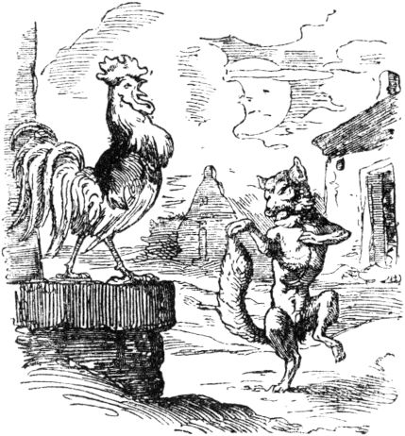He was bitten off with a snapper, and laughing the fox said: "I have found the prophet without any reason."

When the little mouse had finished this fable, it went on to say to the raven: “I did not tell you this because I believe that I am the rooster and you the fox, I am the food and you are the eater, rather I want to believe that your words were not spoken with a forked serpent's tongue. ”And thereupon the mouse went into the opening of its door-hole. The raven asked: “Why are you standing under the door? What makes you so hesitant to go out to me? Are you still afraid of me? "To which the little mouse replied:" I have put my faith and trust in you, for I like you and not fear of your dishonesty prevents me from coming out. But you have many companions of your kind, but perhaps not of your mind, and their friendship is not with me, 347like your. If someone sees me, I must fear that he will devour me. ”On the other hand, the raven said:“ What is most important of loyal association is that one should be a loyal friend to one's companion and an enemy of one's enemy; Be certain, O friend Sambar, that I have no friend who is not as loyal to you as I am. I too have power and strength enough to protect and shield you. ”Now at last the little mouse Sambar went out his little hole and conspired with the raven to an unbreakable alliance of friendship, 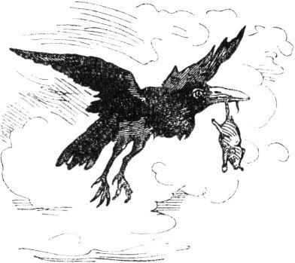and when that was done they lived together and next to each other in a peaceful and friendly manner, and every day told beautiful fairy tales to one another.

At last, however, the raven said to the mouse: “Listen, my dear friend Sambar, your apartment is loud and too close to the path; I'll see if somebody comes along who shoots or harms you or me, and it is also difficult for me to find my food here. But I know a fun and more useful stay, there is water and meadows, fruit and fodder, and there in the water also lives an old friend of mine, even a loyal comrade; I wish you would move to that place with me. "

“I would like to do that for your sake,” said the mouse, “because I am shy here myself and am not really sure, that's why you can also see the many entrances and exits to my apartment. Just believe, dear friend, me 348we have met all sorts of dangers, which I will tell you about when we get to our new stay. "

Then both said goodbye to their old place of residence, and the raven took the mouse by the little tail in its beak and flew with it to the place he meant. Then an animal peeked with its head out of the water, it was frightened by the mouse, because it did not recognize how the raven let it out of its beak, and quickly dived under. The raven flew up into a tree and shouted: “Korax, Korax!” Then the animal came out of the water, that was his friend, a turtle, who was happy to see the raven again and asked him what made him stay outside for a long time ? Then the raven told her the story of the pigeon and the mouse, and introduced his friends to each other, and the tortoise, astonished at the mouse's high sense of reason, crept over to her, shook hands with her, and was very happy to see her acquaintance do.

349

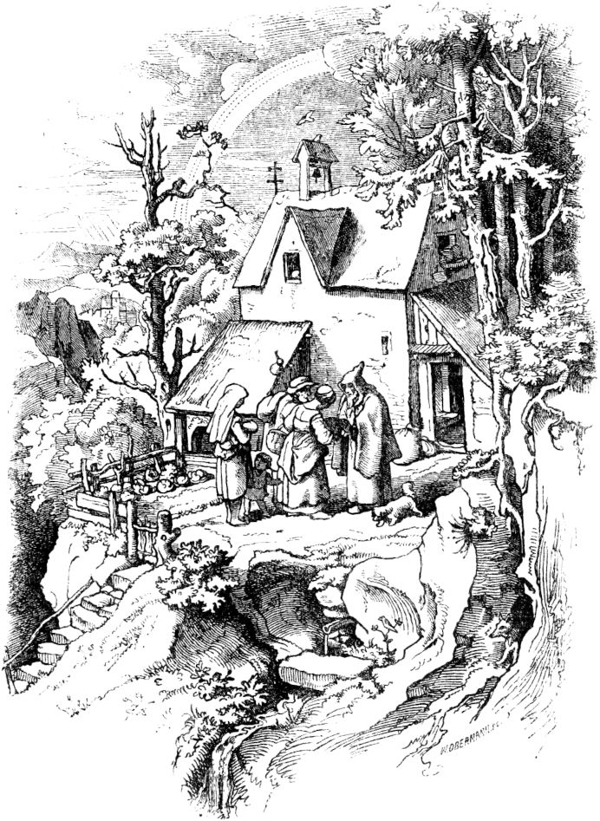

**The life story of the mouse Sambar.**

“I was born in the house of a pious hermitage; there were many of our siblings, and besides my dear deceased parents, their siblings lived 350Cousins ​​and aunts and their children all in this house. We never lacked food of all kinds, because the benevolent people in the neighborhood brought the hermit bread, flour, cheese, eggs, butter, fruit and vegetables every day, much more than he needed to pray for them . I don't know whether he prayed for them and whether that helped them a little. Now the hermit did not treat me and my relatives to everything, and therefore hung a basket in the middle of his kitchen, where we could not do it. But since as a young mouse I distinguished myself advantageously through courage, paired with cunning and caution, I still jumped from the nearby wall into the basket, ate as much as I liked, and threw the rest down to my relatives, those on that one Celebrated a real feast day. When the hermit came in and saw what had happened, he made arrangements to hang the basket even higher. Then a Wallbrother visited him, he entertained him as much as he could, and when they had eaten and drunk together, the hermit put the leftovers in the basket and hung it in the new place, and thought to see whether the little mice got in there too would like to. In the meantime the guest began to talk and tell of his journeys by land and sea, and of the adventures he had lived and passed, but he noticed that the host only listened to him with half an ear and always listened to the basket and stayed half turned to look. Then the catfish became indignant and said: 'I tell you the most beautiful adventures and you don't pay attention to them and don't seem to feel like doing it.' - 'Not at all,' replied the hermit, 'I really like to hear your speeches, but I have to watch out whether the mice get back into the food basket because this one 351Vermin eats everything away from me so that there is hardly anything left for me, and there is one special who jumps into the basket for everyone else. ' He meant me, little Sambar. Thereupon the Wallbruder said: 'In your speech you make me think of the fable of a woman who said to her friend: This woman does not give the swept wheat for the unstretched without a reason.' - ,How so? How was it?' asked the hermit, and the Waller said: 'Let me tell you. Once on my wandering I stayed with an honorable man, whom I heard at night when I slept next door, 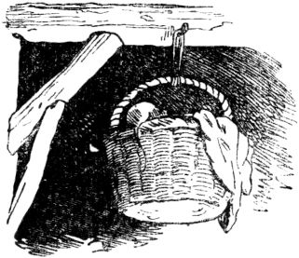speak to his wife: 'Wife, tomorrow I want to invite a number of friends over as guests.' To this the woman replied: 'You are not able to have guests and do business every day; so you waste what we have, and in the end there is nothing left in the house and yard. ' Then the man said: 'Housewife, don't be displeased with what my will is, especially in matters like this! I tell you who is always sparse, and only ever takes in and scrapes together, but never wants to spend again, and who is not really happy with what he has, comes to an end like the wolf. '

'How was the end of the wolf?' asked the woman, and her husband said: 'Once upon a time, they say, a hunter, who was going into the forest with his shooting equipment, arrow and crossbow, met a roebuck, he shot it and charged himself with it, him to carry home. But thereupon he met a bear, which hurried towards him, and the hunter, to fend off him, 352hurriedly cocked the crossbow, put the bow of the arrow on it, but he could not bend it because the roebuck prevented him, and quickly put down the crossbow, drew out his pasture knife, and began the fight with the bear, and he ran the knife through his body the moment the bear grabbed him and squeezed him dead. When the bear felt the severe wound, he roared and tore it open in anger, so that he soon bled to death. In the evening a wolf went along the way and found a dead roebuck, a dead bear and a dead hunter. He was heartily happy about this and said in his heart: Everything that I find here should all be minestay, I can live on it for a long time. My brothers shouldn't get any of it. The saying goes that supplies are master. Today I want to save and not touch the fact that the treasure lasts a long time, although I am very hungry. But there lies a crossbow, whose tendon I could gnaw off. And then the wolf went to work with the cocked crossbow, it snapped off, and the beam or bow arrow placed on it ran straight through his heart! - See, woman, 'continued the man to whom I was listening, said the Wallbrother to the hermitage about which the little mouse Sambar told her friends, the raven and the turtle, -' see, woman, there you have an example that it is not always good to collect and not to let loyal friends enjoy what you have collected. ' Then the woman said: 'You may be right.' When the morning came she got up, took the husked wheat, washed it, spread it out to dry it, and made her child look after it, and then she went on to do the rest of her business. But the child did as children do, played and ignored the wheat, and there 353the sow came, ate away, and polluted the rest of the wheat that she did not eat. When the woman came after afterwards and saw this, she was disgusted with the rest of the wheat, took it and went to the market, and offered it for sale in equal measure for the unhandled. Then I heard a neighbor of the woman who had seen what had happened say mockingly to a third person: 'Look how the woman gives wheat that is so cheaply hulled to the one that has not been hulled! Everything has its cause. ' It is the same with the mouse, of which you say it will jump into the basket for the other mice all together, and that must have its cause. Give me a pick and I will dig the mouse hole and find the cause. ' - I heard this speech, ”continued Sambar,“ in the little hole of one of my playmates; but in my cave there were a thousand gold golds hidden, Without my knowing the Einsiedel who put them in, I played with them every day and thus had my amusement. The catfish dug and soon found the gold, took it and said: 'See, the power of gold has given the mouse such strength to leap so gleefully into the high basket. It will no longer be able to do it. ' I heard these words with distress, and unfortunately I soon found them true. When morning came the other mice all came to me so that I could feed them again as usual, and they were hungrier than ever; But I was not able to jump into the basket, as I usually did, because my strength had drained from me, and immediately I saw myself being treated very dismally by the mice, my closest friends and relatives; yes, they worried that in the end they would have to give me something and feed me,354

Then I said these words to myself, sad in my mind: Good friends in need, go twenty-five to one lot ; but if it is to be a tough stand, five go into oneQuintlet. He who has no possessions has no brothers either; whoever has no brothers has no relationship; whoever has no relationship has no friendship, and whoever has no friendship is forgotten. Poverty is a hardship; Poverty makes life sick. No wound burns so violently as poverty. The rich man receives much praise, but when the rich man becomes poor, he receives double and threefold rebuke; if he was mild and hospitable, he was a wasteful; if he was noble and liberal, his name is now proud and contentious; if it is quiet and closed, it is called profound; if he is talkative, he is called a babbler. Death is less hard than poverty. The poor man is more helped when he sticks his hand into the open jaws of a poisonous snake than when he seeks help from a curmudgeon.

I also saw that Waller and Einsiedel shared the gold gold they had found in equal halves and happily parted from one another; and the hermit put his money under the pillow, on which he slept. But I thought I would acquire some of it to replace my lost strength, but the hermit woke up to my faint noise and gave me a blow that I did not know where my head was and how I got into my hole. Still, I had no rest from my greed for gold, and made a second attempt; then the hermit hit me so hard again that I bled and escaped deadly wounded into my cave. Then I had had enough, and only thought with horror of gold and money, and said four sayings to myself 355in front of my pain and sadness: No reason is better than that to consider one's own things well and not strive for others. Nobody is noble without good manners. There is no better wealth than frugality. He is wise who does not strive for what is inaccessible to him. So I resolved to persevere in poverty and a noble mind, left the Einsiedel's house and wandered into the wilderness. There I set up a homely creature and got to know the peaceful dove, 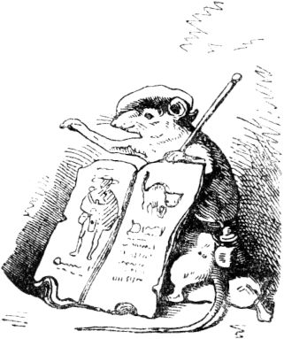who sought her help from me, so you too, friend Rabe, joined me, who told me a lot about his friendship with you, turtle Korax, so that I gladly wanted to get to know you, because it is in the world There is nothing better than the company of loyal friends and no greater sadness than being lonely and friendless. "

With that the clever little mouse Sambar ended his life story, and the turtle took the floor and spoke very mildly and kindly: “I say thank you very much for your so instructive story; you have learned a lot and your treasure has become wisdom that is more than gold. Now forget your suffering and your loss here with us and think that the noble mind is honored, even if there is a lack of earthly possessions. The lion, whether he sleeps or wakes, remains feared, and his strength goes with him wherever he goes. But the wise man likes to change his stay so that he can get to know strangers 356Country style, and he does not choose gold as a companion, no - reason. "

When the raven heard these words, he was heartily delighted at the agreement of his friends, and spoke kind words to them; while a deer came running, and when the faithful animals heard him, they fled, the turtle into the water, the mouse into a little hole, the raven up a tree. And when the stag came to the water, the raven rose into the air to see whether a hunter might be chasing the stag, but since he saw no one, he called his friends, and they came out again. The turtle saw the deer standing by the water with his neck stretched out, as if he was afraid to drink, and called to him: “Noble sir, if you are thirsty, drink; you have no one to fear here! ”Then the deer bowed its head and greeted the turtle, and approached it, and she asked where it came from? He answered: "I have been in the wild forest for a long time, when I saw the snakes wandering from one end to the other, and I was afraid that hunters would want to encircle the forest and have moved here." The turtle said: "I still came here never a hunter, so do not be afraid. And if you want to live here, you can be of our company; There is good pasture here all around. ”The stag was happy to hear that, and stayed there too, and the animals chose a place under the branches of a shady tree, where they all came together and told each other about the course of the world and also beautiful fairy tales. “A hunter has never come here, so do not be afraid. And if you want to live here, you can be of our company; There is good pasture here all around. ”The stag was happy to hear that, and stayed there too, and the animals chose a place under the branches of a shady tree, where they all came together and told each other about the course of the world and also beautiful fairy tales. “A hunter has never come here, so do not be afraid. And if you want to live here, you can be of our company; There is good pasture here all around. ”The stag was happy to hear that, and stayed there too, and the animals chose a place under the branches of a shady tree, where they all came together and told each other about the course of the world and also beautiful fairy tales.

So one day the loyal animals came together, the raven, the mouse and the turtle, but the deer stayed away and was missing. So they worried about him, whether he'd come across anything from a hunter 357and the raven was sent to look after him and bring news. Then after a while he saw him in the forest, not too far from their stay, trapped in a net, came back and announced this to his dear companions. As soon as the mouse heard this, she asked the raven to carry her to the stag and there she said to him: “Brother, who has overpowered you then? You are praised as one of the most intelligent animals! "Thereupon the stag sighed and said:" O dear sister! Mind does not shield against the judgment that comes from above. The runner's speed and strength does not tear the net that is called doom. "

As these two were still talking, the turtle came along; it had crawled as fast as it could; then the stag turned to her and said: “O dear sister, why are you coming to us? And what use does your presence bring us? The mouse alone can kill me, and when the hunter approaches, I escape easily, the raven flies away and the mouse slips away. But for you, nature created slowly, not at a quick pace, not even if you were to flee, you are threatened with shameful imprisonment. "To this the turtle replied:" A loyal friend who also has reason will not consider himself worth living when he is around his friends came. And if he is not granted to help , let him comfortbut according to his strength. A loyal friend draws the heart out of his bosom and offers it to his loyal friend. "When the turtle was still talking, while the mouse had eagerly gnawed the net, the animals heard the hunter approaching, then the stag escaped, the raven escaped, the mouse slipped away. The hunter found his net gnawed, was frightened, looked around and found 358none but the turtle. He took it so that the raven and mouse saw it with regret, and tied it tightly in a rag from the net. The mouse called to the raven: “Oh woe, woe! When happiness comes to one, he waits for the next one, and when a misfortune comes, a second one overtakes him immediately. If I did not suffer enough from the loss of my gold, I am now dispensed with the sister I have loved, she, who my heart has grown to love above all. Woe to me, woe to my body, which runs from one network of misery to the other and which is given nothing but repugnance. "

Then the raven and the stag said to the mouse: “O wise friend, don't complain so much, because complaining is not what is good for the friend and your and our grief does not free her from ties. Make up lists of how we can free them! "

The clever little mouse Sambar thought for a while, then said: “I've got it. You, deer, quickly win the hunter's road, and fall near it, as if half dead, and you, raven, stand on him as if you were eating from him. If the hunter sees that, he will put what he is carrying out of his hands, then you, friend Hirsch, drag yourself slowly a little deeper into the forest so that he can chase you, while I'll gnaw the net and make our dear sister free."

This advice was swiftly carried out. The deer and the raven hurried ahead of the hunter on a detour, and acted like a mouse. The hunter was greedy to reach the stag and threw away everything he was carrying, the stag crawled into the thicket, the raven flew after, and the hunter ran after, and the mouse gnawed the turtle's net and went with it home, there they already found the raven and the deer, which quickly dem 359Hunters had come out of sight. When he returned to the place where he had thrown his things, which he had to look for a good length as well, he found the net gnawed and could not be surprised enough. "That must have been done by the evil devil and not a good spirit!" He cursed, and thought that evil spirits and wizards must occupy this area, which the hunters aped in animal forms, went home fearfully and never hunted in this forest again. And there the friendly animals lived together in peace, harmony and happiness, and from time to time the pigeon also came into this beautiful solitude and visited the clever mouse Sambar, her dear friend, and brought news from the world and all sorts of beautiful stories, everyone enjoyed it.

**Trembling rabbit.**

Once upon a time there was a poor day laborer who had two children, a son named Abraham and a daughter named Christine. Both children were still very young when their father died, and good people had to take care of them, otherwise they would have perished because they were so poor. The girl became a splendidly blossoming beauty that was unparalleled far and wide. Abraham became a vigorous youth and, through the mediation of a benefactor, came to serve as a servant to a rich count. Before he parted with his sister, however, he had a good friend paint her portrait and took it with him, for he loved her very much. The count was very satisfied with Abraham, but often noticed that he was pulling a female portrait from his bosom 360and kissed; he was astonished that Abraham was quiet and decent and hardly came out of the house; so he asked him if the portrait represented his lover, and looked at it more closely when Abraham said it was his sister. "If your sister is so beautiful," said the count, "then she would be worth being a nobleman 's wife!" - "She is even more beautiful!" Replied Abraham. 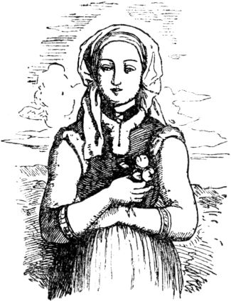The count was delighted and secretly sent his nurse to the place where Christinchen was to fetch her to his castle.

The wet nurse drove to the house of Christine's foster parents in a four-horse carriage, greeted her from her brother and told her to take her to the palace of the count. Christine longed very much to see her brother again and was ready to follow; but she had a puppy that she had once rescued from the water, called the Shiver Rabbit, and was very fond of her. The puppy jumped into the car with Christine. However, the nurse had come up with a bad plan. As they drove up the steep bank of a great river, she drew Christinchen's attention to the goldfish that were playing in the blue waves, and since Christinchen looked unconcerned out of the carriage door, she plunged them into the river while the car drove on. The nurse had a cousin who was already an old maid; 361she secretly in the car. She wore a thick veil, and the nurse instructed her to tell the count that she had made a vow not to lift her veil within six months.

The veiled lady was brought before the count, who implored her to pull back the veil, but she steadfastly refused, and the count became all the more eager. He trusted the honesty of his Abraham, who had portrayed his sister to him even more beautifully than the portrait was. He therefore offered to make her his wife. The priest was called and the ceremony took place. After this solemnity the lady no longer refused to lift the veil, but how terrified the count was when he saw a faded face instead of a fresh and youthful one! He became extremely angry and had Abraham thrown in prison, despite his assurances that this lady was not his sister; he left the deceitful portrait in the chimney.

One day the servant who slept in the count's anteroom had a strange appearance. A white figure stood before his bed and rattled chains; and spoke in a low, wailing tone: "Shivering rabbit, shivering rabbit!" Then the little dog that had hitherto been tolerated in the castle crawled out from under the bed where it was sleeping, and replied: "My dearest little Christian!" - "Where's mine." Brother Abraham? ”Asked the figure further. "He is caught very hard and is in chains and gangs!" Replied the puppy. “Where is my picture?” - “It's hanging in the smoke.” - “Where is the old chambermaid?” - “She is in the Count's arms.” - “That God have mercy! Now if I come twice more and if I am not redeemed, then I am lost for this life. ”The figure then melted like a mist. 362The servant thought he had dreamed and said nothing to his master about the apparition. But the following night the same scene was performed in front of his bed, but the figure rattled its chains more than the previous time and said that it would now come again. This time the servant was certain of his cause; he discovered the process to his master; The latter became pensive and decided to overhear the apparition. 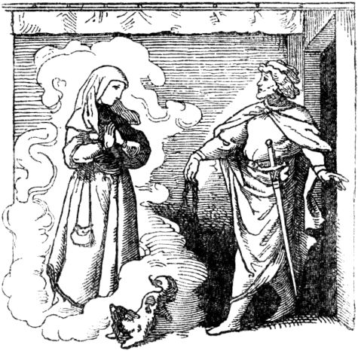At about the twelfth hour he stood behind the ajar door of the bedroom and listened. At last he saw the white figure suddenly appear in the dark of the anteroom, heard it rattle its chains and speak: "Shiver rabbit, shiver rabbit!" "He is caught very hard and is in chains and gangs." - "Where is my picture?" - "It's hanging in the smoke." - "Where is the old chambermaid?" - "She is in the count's arms." "That's it 363Have mercy! ”Then the count opened the door quickly, reached for the apparition and held a heavy chain in his hand, which at that moment stripped away from the figure. The ghostly figure had turned into a lovely image of a woman that smiled at him and that resembled that image, but surpassed it by far in beauty. The count was delighted and asked to unravel the mystery. Now Christine told how the old nurse had maliciously thrown her into the water, but the mermaids had caught her with their green veils and led her to their underground palace. She was supposed to be one of theirs, but refused and the mermaids finally allowed her to appear in the count's room for three nights. If their chains were not loosened for these three times,

The count was as pleased as astonished by this report. Abraham was released from custody and raised to the favor of the count, but the wicked nurse was thrown into the same dungeon and her cousin whipped out of the castle; Christine's picture was taken out of the chimney and the count wore it on his heart, but Christine herself became his wife. Zitterinchen licked the mistress's hand in a flattering manner, but when she promised him caressingly that it would be good days with her, she turned into a beautiful princess, who told her fate to the astonished little rabbit. She had been cursed by an evil magician and had been redeemed herself through Christine's redemption.364

**Cinderella.**

A man and a woman had two daughters, and there was also a stepdaughter there, the man's first dear child, very pious and good, but not welcomed by her stepmother and stepsisters, so it was treated badly. It had to live in the kitchen all day, do all the kitchen work, get up early, 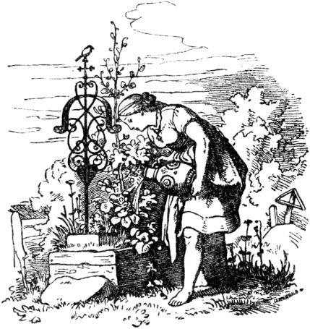cook, wash and scrub, and at night it had to sleep in the attic. Sometimes it preferred to crawl into the ashes by the kitchen stove and warm itself, and since it couldn't look clean from it, the mother and sisters also called it Cinderella, out of mockery and malice.

Once the father had gone to mass and asked the girls what he should bring them; One had wanted beautiful clothes, the other had wanted pearls and precious stones, but Cinderella was only a green hazel rice. The father had also fulfilled these wishes. The sisters cleaned and adorned themselves, but Cinderella planted the rice on her mother's grave, and watered it with her tears every day. Then the rice grew very quickly and became a beautiful little tree, and when Cinderella cried on her mother's grave, 365a little bird always came flying, she looked at it pityingly.

Then it came to pass that the king made a festival and invited all the virgins of the land to it, for his son was to choose a bride from among them. And then the sisters adorned themselves very charmingly, and Cschenbrödel had to comb their hair and plait beautiful braids, and it never occurred to anyone that she would like to go to the dance. When she finally dared to ask permission, she was horribly laughed at for thinking of wanting to go to the dance, since she had no nice clothes, and not even shoes. The wicked stepmother quickly took a bowl full of lentils, threw them into the ashes and said: “Well, well, Cinderella, do something for yourself, read the lentils first; then you should go, but you have to be ready in two hours. "

The poor child went into the garden and called the little bird on her hazelnut tree and also the pigeons that they should all read, the good ones in the potty, the bad ones in the croup, and soon it was swarming with pigeons and other birds, and it didn't last long, so the bowl full of lentils was read completely. But when the good girl happily brought the lentils, the stepmother was annoyed, and now threw two bowls full of lentils into the ashes, and she was supposed to read it in two hours. Cinderella cried, but called the birds again, and soon this work was done too. Nevertheless, her word was not kept, but she was laughed at, because she has no clothes and no shoes, and as she is, she could never be seen again, 366dance, and then those proud went away, leaving Cinderella deeply saddened. She went to her little tree and wept bitterly, when the bird came flying and called:

"My dear child, tell me

I will give you what you wish for! "

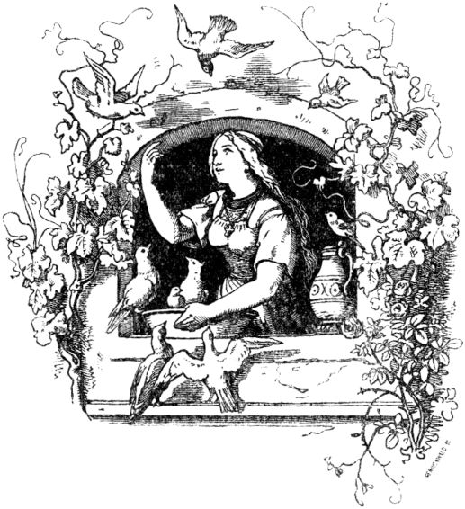

Then Cschenbrödel called out, touching the little tree:

“O dear little tree, shake yourself!

O dear little tree, shake yourself!

Throw nice clothes over me! "

Then a beautiful dress and precious stockings and shoes flew down, Cschenbrödel quickly put them on and went to the ball, and the girl was so beautiful, oh, so beautiful that no one knew her, not even her mother and sisters, and the prince danced 367only with him, and with no other virgin, and when he went home that evening he wanted to follow him, but it escaped from him, quickly took off his dress and shoes on the grave, under the tree, and lay down in his ashes. Clothes and shoes disappeared instantly.

So it went twice more, Cschenbrödel always came to the dance unrecognized and always in beautiful clothes, the king always danced only with him, and he always followed, and the third time it roughly lost one little golden shoe; The king's son picked him up, admired his delicacy and spoke it aloud, also let the heralds announce that only the maiden, on whose foot the little shoe would fit, should be his wife, and rode from house to house to make the test .

The two sisters tried on the little shoe in vain; it was as if her feet were getting a lot bigger, then the king's son asked if there weren't three daughters there? and the man said: "Yes, Mr. Prince! another little cinderella! ”and the mother immediately added:“ who cannot be seen. ”But the king's son wanted to see her anyway; Cinderella washed herself fine and clean and entered, also in her ash-gray smock outshining the sisters with her beauty. And as it put on the golden shoe, so it fit splendidly, like a glove. And the king's son recognized her again immediately and called out: “This is my lovely dancer, my dear bride!” Took her, led her to the castle and ordered a stately wedding feast to be arranged.

When going to church, Cschenbrödel wore a very golden dress and a golden crown on her head; her sisters walked to her right and left with envy. Then the bird came down from the hazel tree and pecked everyone in the eye so that it would go blind. As now the 368Bride left church, the little bird came again, and each of them picked out the other eye again, and so they were struck blind for their lives for their envy and wickedness.

**The boys with the golden stars.**

Once upon a time there was a young count who, as beautiful as he was, did not yet know love and had therefore not yet given space to his mother and friends' ideas of getting married. But he found pleasure in sneaking around the village at night and overhearing the young boys and girls what they were doing, singing and saying in their spinning-rooms. Now once he heard a conversation of which he himself was the subject. "Oh, if our good count took a wife," said one of the girls, "if I would, I would cook him the most delicious dishes." Children wait and care for children very well. ”-“ But I, ”said the third,“ wanted to bring him two boys if he took me to his wife, they should wear little golden stars on their breasts. ”

The next day he had the three girls called and they had to tell him again everything they had said yesterday about him if he took a wife. The last one refused for a long time because she was ashamed; but when she finally acknowledged her bold wish, the count took her friendly hand and said: “You shall be my wife if you bear me two boys, as you said; but if not, I want you with me 369Chase disgrace out of my castle. ”The girl agreed, for she was of joyful courage and had hidden love for the count in her heart. The wedding was celebrated accordingly, although the old countess looked very angry about it. When a few moons had passed and the young countess felt good hope, it happened that the count had to go to distant lands, and he asked his mother, who pretended to be kind to her, to write to him as soon as his wife was born would have.

The hard times approached and the young woman recovered from two lovely boys, they wore little golden stars on their breasts, but she was so exhausted that she passed out for a long time; When she woke up and asked about the children, she was told that she had given birth to two misshapen cats that had been drowned. She complained a lot about it, more than about the misfortune that followed. She was shamefully expelled from the house, like a beggar, and no one had pity on her except a servant; he secretly trusted her that she had given birth to two beautiful boys with little golden stars on their breasts; they were given to him in a basket with the order to throw them into the water, since they were cats; but he had opened the basket, and since the innocent little worms took hold of him, he had given them to an auntie for education.

The boys grew up and became more and more beautiful, the poor woman thought of her husband again, if he saw the boy he would do well everything that his wicked mother owed her. Then she dreamed that she should 370go under a large linden tree on the Way of the Cross, there she would find a heap of linen knots, with which she should fill her pockets, but no longer take them and then go to Portugal , where her husband was entangled in the love webs of a sorceress or fairy. 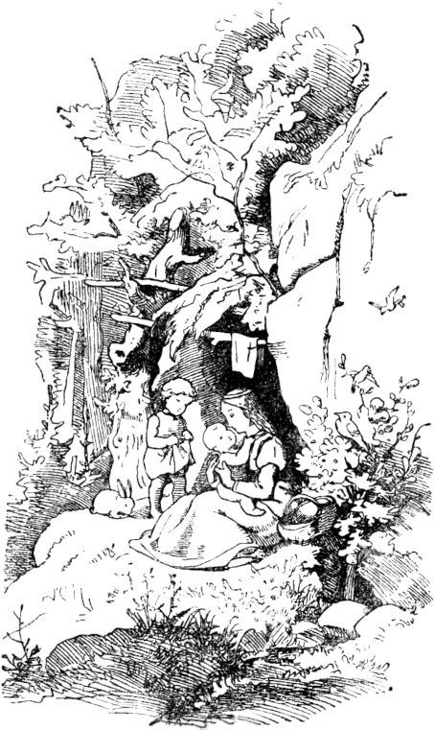The woman went to the tree, found the linen knots, and filled her pockets with them. In a forest she was attacked by robbers and completely plundered, so that she did not keep a penny; she had to help herself by begging, her feet were torn with blood and there was no end to her way. Then another dream consoled her in her misery and promised her ultimate success. Once she begged at the gate of a beautiful castle; the noblewoman saw her boys and was utterly surprised by their beauty. She asked the poor woman for one of her boys and promised to grant her every request. It was hard for the poor to miss one of their children, but it was for them 371finally agreed and asked for the golden spinning-wheel that the noblewoman had just been standing in front of her. She was amazed at the desire, but gave up the wheel, and one of the two boys stayed with her. The poor woman had gone on and on and finally had to part with her second boy, for whom she received a little golden white wine. She kept these two treasures very carefully and continued her arduous journey.

After endless toil, she finally arrived in Portugal and came to the castle where her husband lived. The servants told her that her master was married, but no one had yet seen his wife's face, since she was only in the castle at night and during the day no one knew where she had come. When the sun had now set, she crept into the palace garden, sat down under the countess's window and turned her spinning-wheel so that it shone like a star through the night. The sorceress, who was the count's wife, saw this and went to the woman and asked her about the strange toy. The woman offered it to her as a gift if she would grant her a request in return, namely to ask to be allowed to stay with her husband for one night. The woman was very surprised, but agreed; but secretly she gave the count a sleeping potion so that he did not wake up all night and saw the desperate woman at his side approaching the morning when the sorceress fetched her. The next evening, however, she sat again in front of the castle and turned her little golden white wine; the sorceress came back and had to grant her the same request. This time she had done it by mistake and not mixed her husband's sleeping potion strong enough; so before morning came he woke up, amazed This time she had done it by mistake and not mixed her husband's sleeping potion strong enough; so before morning came he woke up, amazed This time she had done it by mistake and not mixed her husband's sleeping potion strong enough; so before morning came he woke up, amazed 372to find herself, the emaciated, stunted woman next to her, who now poured out her whole heart in front of him. Then the count was seized by a nameless longing for his children and promised her to recognize them again as his wife. Then he pretended to be asleep when the fairy came and led the woman away. But he told the fairy that he had had a strange dream. A man had mistakenly rejected his wife and freed another; The first, however, sought him out with the sacrifice of her body and her beauty. What should the husband do now when she found him? "Then he must divorce the second and return to the faithful one!" Said the fairy. - "You have spoken your judgment," answered the count and told her everything that had happened. Then the fairy parted from him painfully. The count, however, returned home with his faithful wife after he had released his boy. The angry mother was not allowed to come before his face again; his wife, on the other hand, he held dear and dear; He rewarded the compassionate servant richly. The boys with the little golden stars grew to their parents' joy and later became valiant war heroes who fought and won many battles.

**The juniper tree.**

It was a long time ago - probably two thousand years - there was once a rich man who had a beautiful, pious wife, and they both loved each other very much; but they had no children, but they wanted them very much, and the woman often prayed for them day and night, but they got none and got none. In front of their house 373was a courtyard with a juniper tree in it; One day in winter the woman stood under it peeling an apple, and when she peeled the apple, she cut her finger and the blood flowed into the snow. "Oh," said the woman and sighed really hard, looked at the blood in front of her and was deeply sad: "I would have had a child as red as blood and as white as snow." 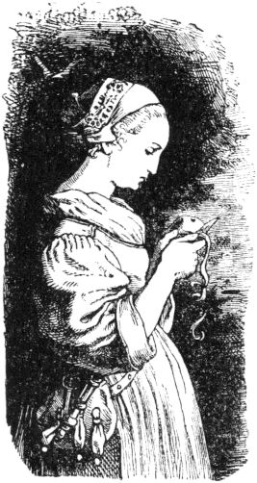And when she said that, she felt happy again, it seemed to her that it should come true. So she went back into the house, and when a month was over, the snow had passed, and two months, it was green, and three months, the flowers came out of the ground, and four months, all the trees were crowded together in the wood and the green branches had all grown into one another. There the birds sang so that all the wood resounded, and the blossoms fell from the trees. Then the fifth month was over, and the woman was standing under the juniper tree again, her heart leapt for joy and she fell on her knees and could not stop. And when the sixth month was over, the fruits became thick and strong, and she became very still, and in the seventh month, she reached for the berries and ate her fill. then she became sad and sick. The eighth month went and she called her husband and wept and said, "If I die, bury me under the juniper tree." There was 374she was very confident and happy until the ninth month was over; then she had a child, as white as snow and as red as blood, and when she saw it she was so happy that she died.

Then her husband buried her under the juniper tree, and he began to cry a lot. For a while, and that subsided, and since he had cried a little, he became more cheerful again and for a while he took another wife. He had a daughter with the second wife, but the child of the first wife was a little boy; it was as red as blood and as white as snow. When the woman looked at her daughter, she loved her very much, but when she looked at the little boy, it always went through her heart and it seemed to her that he was standing in her way everywhere, and she then always thought, how she was going to spend all that fortune on her daughter. But that was what the evil one had given her. She was now very angry with the little boy, pushed him around from one corner to the other, puffed him here and poked him there, so that the poor child was always afraid. When it came from school, it didn't have a place to sit quietly.

Once the woman had gone into the room when the little daughter came up too and said: "Mother, give me an apple." "Yes, my child," said the woman, and gave her a beautiful apple from the box; but the box had a large, heavy lid with a large, sharp iron lock. “Mother,” said the little daughter, “shouldn't my brother have one too?” That annoyed the woman, but she didn't let her notice and said: “Yes, when he comes home from school.” And when she saw him through the window , it was just as if the evil one came upon her. Quickly took it 375took the apple away from her daughter and said: “You shouldn't have one sooner than your brother.” Then she threw the apple into the box and closed it. When the little boy stepped into the door, she said to him in a very friendly manner: "My son, do you want an apple?" And looked at him very angrily. “Mother,” said the little boy, “what are you looking at me so greedy! yes, give me an apple. ”“ Come with me, ”she said, and opened the lid. 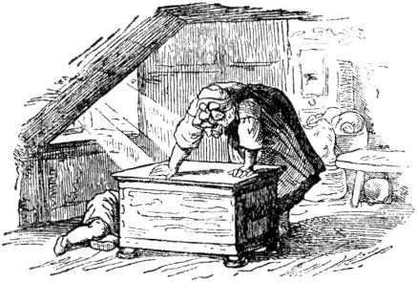"Get out an apple." And when the little boy bends down - the bad guy advises her - bratsch! she slammed the lid so that the little boy's head flew off and fell under the red apples. Then it overflowed her and she thought in great fear: “How can I get that away from me!” So ​​she went down into the room and took a white cloth from the bottom drawer of the chest of drawers; now she put his head on his body and tied the scarf around so that nothing could be seen, then she sat him on a chair in front of the door and put the apple in his hand.

Soon afterwards Marlenchen came to her mother's kitchen; she stood by the fire and kept stirring in a pot. “Mother,” said Marlenchen, “brother is sitting in front of the door and looks all white; he has an apple in his hand; I asked him to give me the apple, but he didn't answer and that made me feel dreadful. ”“ Go there again, ”said the mother, 376"And if he doesn't want to answer again, give him a punch behind the ears." Then Marlenchen went up and said: "Brother, give me the apple." the head fell down; at this she was shocked and began to cry very much; she ran to mother and said: "Oh mother, I cut off my brother's head," and cried and cried and did not want to be satisfied. “Marlenchen,” said the mother, “what have you done! 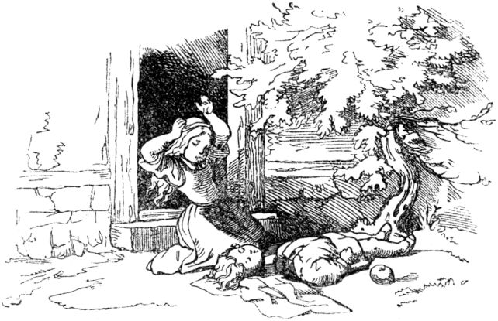But just be quiet so that nobody notices, that can't be changed after all; we want to cook it in vinegar. ”So the mother took the little boy, chopped him into pieces, put them in a saucepan and cooked him in vinegar. But Marlenchen stood by and wept and wept, and the tears all fell into the pot so that they did not need any salt.

Then the father came home, sat down at the table and said: "Where is my son?" Then the mother carried a large, large bowl with black sour sauce, and Marlenchen cried and could not hold herself at all. There 377said the father again: “Where is my son?” “Oh,” said the mother, “he went overland to the Großohm, he wants to stay there for a while.” “What is he doing there? He didn't even say Adjö to me. ”“ He wanted to go and asked me if he could stay six weeks; he's in good hands there. ”“ Oh, ”said the man,“ I'm really sad, and it's not right, he should have told me Adjö. ”With that he began to eat and said:“ Marlenchen, what are you crying Brother will probably come back. ”“ Oh, woman, ”he said then,“ what do I like the food, give me more! ”And the more he ate, the more he wanted, and he always said:“ Give me more "You shouldn't have any of it, that's as if it were all mine." And he ate, and ate, and he threw all the bones under the table until everything was gone. But Marlenchen went to her chest of drawers and took her best silk cloth from the bottom drawer; took all the bones out from under the table, tied them in the silk cloth and carried them to the door, weeping their bloody tears. There she laid it under the juniper tree in the green grass, and when she had laid it there, suddenly it was so easy for her and she no longer cried. Then the juniper tree began to move, and the branches kept moving apart and then back together, as if someone were really happy and pretended to be with their hands. With that a mist went through the tree, and a fire burned through the mist, and out of the fire a beautiful bird flew, it sang so splendidly and flew high in the air, and when it was gone the juniper tree was like it had been before but the cloth with the bones was gone. But Marlenchen was very happy, as if her brother were still alive. 378Then she went into the house again, very cheerfully, sat down at the table and ate.

But the bird flew away, sat down on a goldsmith's house and began to sing:

My mother who slaughtered me

My father who ate me

My sister, the Marlenichen,

Search all my areas

Bind them in a silk cloth,

Put it under the juniper tree.

Kiwit, Kiwit,

What a beautiful bird I am.

The goldsmith was sitting in his workshop and was making a gold chain when he heard the bird sitting on his roof and singing, and that seemed too beautiful to him. So he got up, and as he walked down the hall, he lost a slipper. He walked right into the middle of the street, however, and had only one slipper and one sock on. He had his apron in front of him, and in one hand the gold chain and in the other hand the pliers; the sun shone so brightly on the street. So he stood so that he could see the bird well. “Bird,” he said, “how beautiful you can sing! Sing the piece to me again. ”“ No, ”said the bird,“ I don't sing twice for nothing. Give me the gold chain and I will sing it again. ”“ There, ”said the goldsmith,“ you have the gold chain, now sing it to me again. ”Then came the bird,

My mother who slaughtered me

My father who ate me

My sister, the Marlenichen,

Search all my areas

Bind them in a silk cloth,

379

Put it under the juniper tree.

Kiwit, Kiwit,

What a beautiful bird I am.

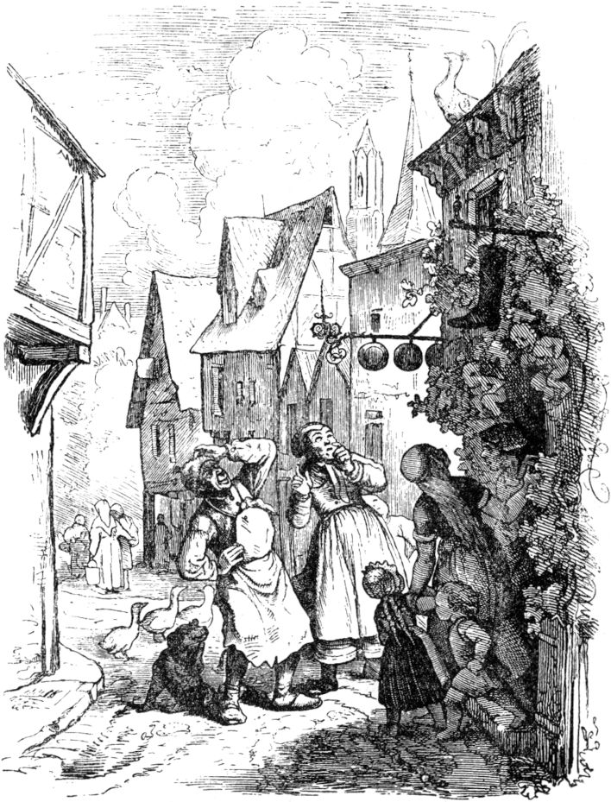

Then the bird flew away and sat on the roof of a shoemaker and sang:380

My mother who slaughtered me

My father who ate me

My sister, the Marlenichen,

Search all my areas

Bind them in a silk cloth,

Put it under the juniper tree.

Kiwit, Kiwit,

What a beautiful bird I am.

When the shoemaker heard this, he ran to his door in shirt sleeves, looked at his roof, and had to hold his hand over his eyes so that the sun wouldn't dazzle him. "Bird," he said, "what good things can you sing!" Then he called into his door: "Woman, come out, there is a bird that can sing beautifully." Then he called his daughter, his Children and journeymen, the apprentices and the maidservant, and they all came into the street and looked at the bird and how beautiful it was; he had such beautiful red and green feathers, and it was like gold around his neck, and his eyes blinked like stars in his head. “Bird,” said the shoemaker, “now sing the piece to me again.” “No,” said the bird, “I don't sing twice for free, you have to give me something.” “Woman,” said the man, “go in the shop, on the top shelf, There are a pair of red shoes, bring them out. ”So the woman went and got the shoes. "There, bird," said the man, "now sing the piece to me again." Then the bird came, took his shoes with his left paw, flew back onto the roof and sang:

My mother who slaughtered me

My father who ate me

My sister, the Marlenichen,

Search all my areas

Bind them in a silk cloth,

Put it under the juniper tree.

381

Kiwit, Kiwit,

What a beautiful bird I am.

When he finished, he flew away. He had the chain in his right paw and his shoes in his left paw, and he flew far away to a mill, and the mill went clap clap, clap clap, clap clap. Twenty miners sat in the mill, they hewed a stone and chopped hick hack, hick hack, hick hack, and the mill went clap clap, clap clap, clip clap. Then the bird sat down on a linden tree in front of the mill and sang:

My mother who slaughtered me

then a squire stopped.

My father who ate me

then two more stopped and listened.

My sister, the Marlenichen,

then four stopped again

Search all my areas

now only thirteen skidded,

Bind them in a silk cloth,

now only seven

Put it under

now only five

the juniper tree.

Just one more

Kiwit, Kiwit,

What a beautiful bird I am.

Then the last stopped and had heard the last. “Bird,” he said, “what are you singing beautifully! Let me hear that too, sing that again. ”“ No, ”said the bird,“ I don't sing twice for nothing; give me the millstone and I'll sing it again. ”“ Yes, ”said 382he, "if it belonged to me alone, you should have it." Then the others said: "If he sings again, he should have it." Then the bird came down, and all twenty squires took hold of it and lifted it with lifting trees open the stone. Then the bird put its neck through the hole and put it on as if it were a collar, flew up to the tree again and sang:

My mother who slaughtered me

My father who ate me

My sister, the Marlenichen,

Search all my areas

Bind them in a silk cloth,

Put it under the juniper tree.

Kiwit, Kiwit,

What a beautiful bird I am.

When he had finished singing, he opened his wings and had the chain in his right paw, his shoes in the left, and the millstone around his neck, and flew away with it to his father's house. In the living room the father, mother and Marlenchen were sitting at table, and father said: “Oh, how I feel so easy and comfortable.” “Oh no,” said the mother, “I'm as afraid as if one were There would be a heavy thunderstorm. "But Marlenchen sat and cried and cried, then the bird came flying and when he sat down on the roof, the father said:" My heart is so happy, and the sun is shining so beautiful outside, I feel like it just as if I should see an old friend again. ”“ Oh no, ”said the woman,“ I'm so scared, my teeth are chattering, I feel as if I have a fire in my veins. ”But Marlenchen sat in the corner and cried and had a handkerchief over his eyes, and wept the handkerchief all wet. Then the bird sat down on the juniper tree and sang:

My mother who slaughtered me

383

Then the mother covered her ears and screwed up her eyes because she did not want to see or hear; but it roared in her ears like the strongest storm, and her eyes burned and twitched like lightning.

My father who ate me

"Oh, mother," said the man, "that is a beautiful bird, it sings so wonderfully, the sun shines so warm, and it smells like may flowers."

My sister, the Marlenichen,

Then Marlenchen put her head on her knees and kept crying, but the man said: “I'm going out, I have to see the bird nearby.” “Oh, don't go,” said the woman, “I felt as if trembling the whole house and it would be on fire. ”But the man went out and looked at the bird.

Search all my areas

Bind them in a silk cloth,

Put it under the juniper tree.

Kiwit, Kiwit,

What a beautiful bird I am.

At the same time the bird dropped the golden chain, and it fell around the man's neck, just so that it fitted him nicely. So he went in and said, “Look, what a good bird that is; he gave me this beautiful necklace and it looks so splendid. ”But the woman became so frightened that she fell down, and her cap fell from her head. Then the bird sang again:

My mother who slaughtered me

"Oh, that I would be a thousand fathoms underground so I wouldn't have to hear that."

My father who ate me

Then the woman fell down for dead.

My sister, the Marlenichen,

384

"Oh," said Marlenchen, "I want to go out too and see if the bird gives me something." And then she went out.

Search all my areas

Bind them in a silk cloth,

Then he threw off her shoes.

Put it under the juniper tree.

Kiwit, Kiwit,

What a beautiful bird I am.

Then she became very happy and cheerful; she put on the new red shoes, danced and jumped in. 'Oh,' she said, 'I was so sad when I went out, and now I'm funny; that’s a lovely bird; gave me a pair of shoes. "" No, "said the woman and jumped up, her hair standing on end like flames of fire," I feel as if the world is going to end! I want to go out too, maybe it will be easier for me too. ”And when she came out the door, brat! the bird threw the millstone on her head so that she was completely crushed. When the father and Marlenchen heard this, they went out and saw steam, flames and fire on the spot, and when that had gone out, the little brother stood there, taking father and Marlenchen by the hand. All three were now quite happy and went into the house,

385

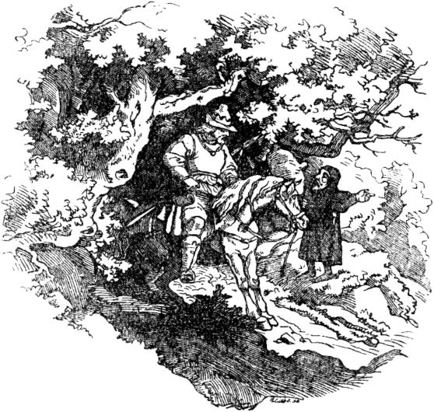

**The white wolf.**

A king rode hunting in a great forest, in which he got lost, and had to wander many a day and some night, always did not find the right path and suffered hunger and thirst. At last he met a little black man who asked the king for the right way. “I want to lead and escort you,” said the little man, “but you must also give me something in return, you must give me what comes first from your house.” The king was happy and said on the way: “You are quite good, males; Truly and if my best dog ran towards me, I would still like to give it to you as a reward. ”But the little man replied:“ I don't like your best dog, I like something else. ”As they now arrived at the castle so saw the king's youngest 386Daughter rode her father through the window and jumped cheerfully towards him. But since she hugged him, he said: "Oh, I would like my best dog to have come to meet me!" The king's daughter was very shocked at this speech, and cried and cried: "How that, my father ? Do you prefer your dog to me, and should he give you a happier welcome? ”But the king comforted her and said:“ O dear daughter, it wasn't meant like that! ”And told her everything. But she remained very steadfast and said: "It is better this way than that my dear father perished in the wild forest," and the little man said: "After eight days I will fetch you."

And right after eight days, a white wolf came into the royal palace, and the king's daughter had to sit on his back, and hey, it went through thick and thin, up and down, and the king's daughter couldn't stand riding the wolf and asked: “Is it still a long way?” - “Be silent! Far, far is it still to the glass mountain - if you don't keep silent, I'll throw you down! ”Now it went on again until the poor king's daughter hesitated again and complained and asked whether it was still far? And then the wolf said the same threatening words to her, and kept running away, on and on, until she dared to ask the question a third time, when he immediately threw her off his back and ran away.

Now the poor princess was all alone in the dark forest, and went and went and thought: At last I'll come to see people someday. And finally she came to a hut, there was a little fire burning and there was an old forest mother who had a potty by the fire. And then the king's daughter asked: “Mother, you have 387Didn't see the white wolf? ”-“ No, you have to ask the wind, it asks everywhere, but stay here a little longer and eat with me. I'll cook a chicken soup here. ”The princess did, and when they had eaten the old woman said:“ Take the chicken bones with you, you will be able to use them well. ”Then the old woman showed her the right way to the wind.

When the king's daughter got to the wind, she found him sitting by the fire cooking himself some chicken soup, but when she asked about the white wolf, he replied: "Dear child, I didn't see him, I didn't go once today, and wanted to have a nice rest once. Ask the sun, it rises and sets every day, but first do it like me, rest and eat with me, afterwards you can take all the chicken bones with you, you will probably be able to use them well. "

When this was done, the little one went to the sun, and it was like the wind again, the sun was just cooking a chicken soup for itself, so it went very quickly, had not seen the white wolf, and invited the princess to lunch. "You have to ask the moon, because the white wolf probably only runs at night, and then the moon sees everything." When the king's daughter had eaten with the sun and picked up the bones, she went on and asked the moon. He too cooked chicken soup and said: “It's fatal, I didn't appear last time, or I rose too late, I don't know anything about the white wolf.” Then the girl cried and cried: “Oh heaven, who should I ask now ? ”“ Well, just be patient, my child! ”Said the moon. - "In front 388Eating won't be a dance, sit down and eat the chicken soup with me first and take the bones with you, you will need them. I know something new; the black man in the glass mountain - that is celebrating the wedding today, the man in the moon is also invited. "-" Oh, the glass mountain, the glass mountain! That's where I wanted to go, that's where the white wolf was supposed to carry me! ”Cried the king's daughter. 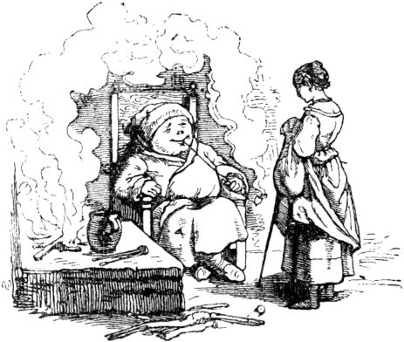“Well, I can shine up there and show you the way,” said the moon, “otherwise you could easily be wrong, because I, for example, consist entirely of nothing but glass mountains. Always take your little bones with you. ”The princess did, but in the hurry she forgot a little bone.

Soon she was standing by the glass mountain, but it was very smooth and slippery, there was no way to get up, but the king's daughter took all the chicken bones from the old forest mother, from the wind, from the sun and from the moon, and made one out of them The ladder was getting very long, but alas, in the end a single rung was still missing, another link. Then the princess cut off the top joint from her little finger, and so it did well, and she could now quickly climb to the top of the glass mountain. At the top there was a large opening, and there was a beautiful staircase leading down to it 389everything full of splendor and splendor, and there was a hall full of wedding guests and many musicians and richly decorated tables. And there sat the black man and at his side sat a lady who was his bride, but the black man seemed sad. And it hurt so much for the king's daughter, too, that she was late, and that the little black man was so sad, and thought to himself: I want to sing a song about the white wolf, maybe then he'll know me - because he hadn't even looked at her yet, and consequently hadn't recognized her either. And there was a harp on the wall, which the princess played well, she took it and sang:

"I don't like your best dog,

Something else is dear to me!

The youngest princess. "

"The white wolf that ran away

She doesn't know where he was;

The youngest princess. "

The little black man listened up, but the princess continued to play and sing:

"She went after the wolf,

Cut off her phalanx,

The youngest princess. "

"Now it is there - you don't know it,

This song sings you sadly

The youngest princess. "

Then the little black man jumped up from his seat and was suddenly a very handsome young prince, and hurried up to her and hugged her in his arms.

Everything had been magic. The prince was enchanted into the little old man and into the white wolf and into the glass mountain, until a princess, in order to get to him, took a member of hers 390Little finger would be tasted, but if that did not happen up to a certain time, he would have to remain another free and black man all his life. Now the spell was released, the other bride disappeared, the disenchanted prince married the king's daughter, then traveled with her to her father, who was heartily pleased to see her again, and they all lived happily together to the end. If this has not happened, it is more or less likely that they are still alive today.

**Brother Saver and Brother Vertuer.**

Once upon a time there was a farmer who had two sons, and he let them learn handicrafts, “because,” he said, “handicraft has a golden soil”. One son became a shoemaker, the other a tailor, and when their apprenticeship was over they went on a journey. They were both a couple of funny brothers, but the shoemaker wasted all of his money in smoking tobacco, snuff and brandy, but the tailor did not smoke, sniff or snort. Occasionally he advised his brother to be economical with the money, but the shoemaker laughed at him and said: “What should I save for? you are saving! Saver must have a trust, - says the proverb. "

So the good fellows wandered together for a whole year. The tailor kept a special purse, in which every time his brother spent money on useless things, he put the same amount from the communal treasury, which was never rich, into one 391Not pfennig, and so he did all year round and enjoyed the way the little pouch's belly grew stronger and stronger.

Now they exchanged words once again, again about saving and trusting; the tailor boasted of the treasure he had saved, where the shoemaker said: "It will be a real beggar what you have saved." Over them they came to a bridge that had beautiful, broad and smooth stones on its wall, and there he wanted Schneider convince his brother 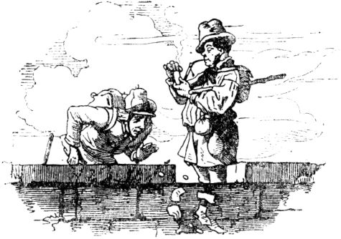that saving is a good thing, because the saying goes: Save in time, you have in need, and: Young blood, save your goods! It hurts in old age. They took off their satchels, and the tailor took out his little pouch and counted the beautiful silver groschen and sixes, which had turned reddish from being carried for so long, on a stone bridge; it was a pretty penny, and he was royally pleased about it. The shoemaker saw it quite indifferently, stuffed himself a pipe and was just starting a fire when suddenly a gust of wind came along so violent that the little tailor would have been blown into the river if the bridge had no border 392would have, but the money, the wind blew everything down into the water. The tailor stood rigid with terror, but the shoemaker put the burning sponge on the pipe and asked with the calmest face in the world: "Well, Brother Saver, how much do you have now?" "As much as Duhuhuhuhu! As much as Duhuhuhuhu! "-

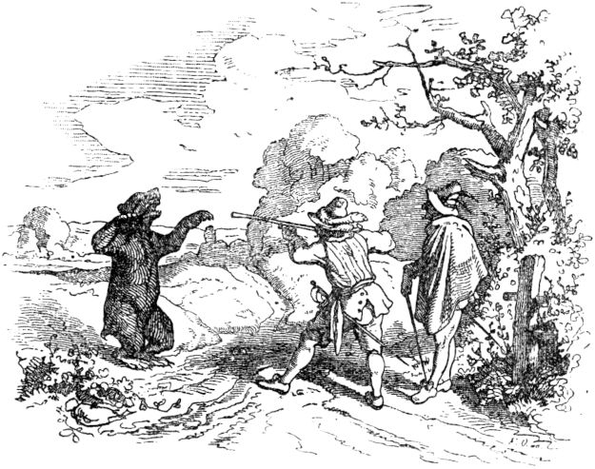

**Rupert the bearskin.**

Once upon a time there was a fellow of sturdy build who looked defiantly into the world and had the courage to connect with the rest of the world, so he went among the soldiers and fought bravely and bravely with the enemy until peace was made and the soldiers said goodbye that they could go where they came from, 393or wherever else they wanted to go. Then Rupert thought: I want to go to my brothers - because he no longer had parents - and wanted to stay with them until the war came again. But the brothers said: “We just missed someone who is waiting for the war - oh, wait! We don't want to know anything about war or warriors, we want to have peace and quiet ! If you made your way in war, make your way in peace too; at the door is yoursso that you know! ”- Then the soldier Rupert did not give his brothers a single good word, took his shooting stick and went out into the world again - and came into a large forest and said to himself: It is shameful, a brave fellow and To send a warrior away into the middle of a peace with which one of us knows nothing about the world of God. I must have a war! If only someone came with whom I could tie up, and if it were the devil himself! - and as Rupert thought, he loaded his rifle and put a powerful shot into it with a double charge and also two bullets. Then a tall man came through the forest to Rupert, wearing a black slouch hat with a red rooster feather on it, a crooked hawk nose, a foxfire-red beard, and a green hunter's coat and asked: "Where are you going? Gesell? ”-“ What do you have to ask about it? ”- Rupert asked roughly back, because he wanted to tie in with the first best, or with the first worst. - "Hoho! Just not so perky! ”- called the green man with the slouch hat and the red rooster feather. "If you are missing something, I can help!" - "I just miss the best thing, the money!" Replied Rupert. - “Should money have plenty if you had courage!” - “Courage? Sappernunditjö! Lord, who tells Him that I have no courage? I one if you had courage! ”-“ Courage? Sappernunditjö! Lord, who tells Him that I have no courage? I one if you had courage! ”-“ Courage? Sappernunditjö! Lord, who tells Him that I have no courage? I one 394Soldier, and no courage? Courage like the devil! ”-“ Look around you! ”- said the green man - and then Rupert looked around, there stood a bear behind him, almost as big as a rhinoceros, and opened its throat and roared, and came up walking towards Rupert - but he took his rifle, pointed and said: “Do you want a pinch of snuff? There you have a pinch! ”- and shot the bear double the charge into his nose, a bullet into each hole that penetrated into the brain - and then the bear made a mighty leap and a loud roar, fell over and was gone . - “Look, look, you have courage, as I can see!” - said the green man in the slouch hat with the red rooster feather “and you should have money from me as much as you want, but on one condition!”

"I'd like to hear that!" Said Rupert, who had long since noticed who he was dealing with, because the shoemaker had apparently taken a strange measurement for one boot, just as if he were making a boot for a horse. - "Should it be about bliss - thank you very much!" - continued Rupert.

“Stupid fellow!” Replied the forest hunter, “what do I get from your bliss? You can keep it to yourself, I don't care about it. No, that is my condition that for the next seven years you do not wash , comb , shave your beard, cut your nails, sleep in any bed and pray the Our Father, which is not your trade in any case. In exchange I will give you a coat and a coat, which you will only have to wear for these seven years. If you die within this time, you are mine; if you stay alive, I have no part in you, but you still have money and can use it 395start what you want, and I'll brush you clean again, and should be with my tongue. "

"So - and you call it all a condition?" Asked Rupert. "I think there are almost a dozen of them, but that's about it, I want to try it, trying is more than studying!" - "Topp!" Said the devil and took off the green skirt and pulled the dead bear very quickly the fur and went on: “Here is your skirt, here is your coat and your bedspread. All you have to do is reach into your coat pocket and you'll find money, and the bear skin, you cover yourself with it, you bear skin ; that is the most beautiful lazy person that one can only wish for with a pocket full of money and therefore not necessary to do anything! ”-

When Rupert had put on the green coat, he reached into his pocket above all to see whether it was true about the money, for he did not trust the devil because he is called a father of lies. But since the bag turned out to be a never-empty Fortunatus bag, Rupert put his bearskin on and walked away from the devil without saying goodbye, because the devil had meanwhile disappeared.

Rupert now lived into the day, let God be a good man and the devil a good man too, let his beard grow stately so that he could appear in any German or Polish Reichstag, because the power is in your hair, that already teaches the history of Samson, and made it so that in his second year he looked like a Schubut and Waldschratt, especially since his fingernails were extraordinarily aristocratic and elegant, even beyond the Chinese standard. People avoided him when they saw or smelled him from a distance, because although he did not smoke tobacco, he smelled much worse than a hoopoe from a distance, 396who is wrongly decried as a stinker, because the hoopoe itself does not stink at all, only its uncleanliness and what it deals with give it such a bad reputation.

But now the bearskin always gave the poor a lot of money so that they should pray that it would last the seven years, and the poor gladly took the money and promised to pray very diligently. I don't know whether they did it, and the innkeepers were happy to take him in, too, because he let a lot rise, and it is generally clear that if someone only has money and lets it rise, he can be the worst bearskin without hesitation. it always finds support and approval and recognition, but money is part of it once and for all.

Now the bear skinning had been going on for the fourth year, and the bearskin was fed up with it, because he no longer liked himself, let alone others; on his face he was dragging a very busy jungle of hair moss, his fingers had grown pitchforks, and he wasn’t having much fun either, despite all the money. In the inns he was always given the rearmost and highest rooms, three, four, five flights of stairs up and always close to the retreats. Once he was sitting in his little room in a very annoyed way, pondering his fate, and longing for his time to be around when he wanted to put on a new person and take off the pig's beard and the gallows nails on his fingers, when he heard someone groan and groan next door croak in mercy for stone. Immediately he went over to help the neighbor, for the bearskin had by nature a mild and good heart. There sat a wailing and wailing old man who, when the bearskin came, thought it was the bad one, and wanted to fetch him because he was 397Bearskin looked much more like the devil than any other creature of God, but he was finally appeased and moved to complain of his need. This need was exactly the same as that of the bearskin, namely the well-known need for money. The good old man had three daughters and a lot of debts, and was supposed to lead a very drawn-in life because he could not pay the landlord who had moved him out. The bearskin laughed at it; he had a good laugh, of course, like everyone who has a goldborn in his pocket. He paid the old man's debts by pennies and pennies, and the latter invited him to go with him and see his daughters, who were not a little beautiful, and one of whom was to marry him out of gratitude. That was fine with the bearskin, for he had a lot of time to spare, and he often spent a long time on his bearskin, and went out on conquests, as a brave soldier should always do, only it was a pity that he was not nice and cute was allowed to do, no whiskers and goatees, waxed black, and no coiffed curls and slender flanks and smooth nails and no Cologne water and no first-class Havana cigar. He was not allowed to do any of this, but had to stay completely bearskin and go and run storm as he lived and lived, was, stood, went and smelled. The two eldest daughters of the rescued man were horrified by the monster that wore the wig with different braids over its face instead of on the back of its head, that clapped hands like the griffin, and that had already been wearing its underwear for four years, from which it had become completely Isabel was, and smelled like an empty old vinegar barrel in the vaulted cellar, nothing less than appetizing. Only the youngest daughter, and at the same time the most beautiful, held out by not running away. He was not allowed to do any of this, but had to stay completely bearskin and go and run storm as he lived and lived, was, stood, went and smelled. The two eldest daughters of the rescued man were horrified by the monster that wore the wig with different braids over its face instead of on the back of its head, that clapped hands like the griffin, and that had already been wearing its underwear for four years, from which it had become completely Isabel was, and smelled like an empty old vinegar barrel in the vaulted cellar, nothing less than appetizing. Only the youngest daughter, and at the same time the most beautiful, held out by not running away. He was not allowed to do any of this, but had to stay completely bearskin and go and run storm as he lived and lived, was, stood, went and smelled. The two eldest daughters of the rescued man were horrified by the monster that wore the wig with different braids over its face instead of on the back of its head, that clapped hands like the griffin, and that had already been wearing its underwear for four years, from which it had become completely Isabel was, and smelled like an empty old vinegar barrel in the vaulted cellar, nothing less than appetizing. Only the youngest daughter, and at the same time the most beautiful, held out by not running away. The two eldest daughters of the rescued man were horrified by the monster that wore the wig with different braids over its face instead of on the back of its head, that clapped hands like the griffin, and that had already been wearing its underwear for four years, from which it had become completely Isabel was, and smelled like an empty old vinegar barrel in the vaulted cellar, nothing less than appetizing. Only the youngest daughter, and at the same time the most beautiful, held out by not running away. The two eldest daughters of the rescued man were horrified by the monster that wore the wig with different braids over its face instead of on the back of its head, that clapped hands like the griffin, and that had already been wearing its underwear for four years, from which it had become completely Isabel was, and smelled like an empty old vinegar barrel in the vaulted cellar, nothing less than appetizing. Only the youngest daughter, and at the same time the most beautiful, held out by not running away. 398She kept an eye on the fact that this bearskin had saved her father and thereby saved herself from disgrace and disgrace; she possessed the fine virtue of gratitude that so many do not have. Now that the bearskin perceived that this beautiful child did not flinch from its ugly and frightening figure, yes, that it wanted to fulfill its father's word with him - so he offered her a beautiful ring, but only halfway - as a symbol that he himself betrothed to her, and asked her to pray diligently for him that he would have another three years, 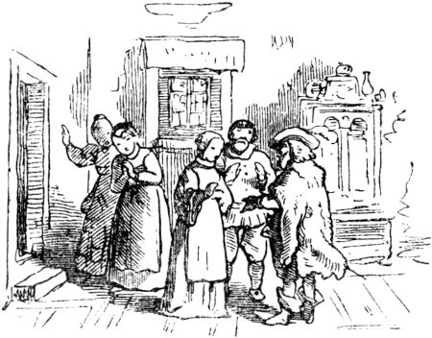and possibly also something about staying alive, and said goodbye for three years in order to debark during this time and to come back as a well-tasted master after its expiration. Not everyone can do this feat either; Many a tolerably good and tame boy leaves home and comes back like a forest devil as the greatest bearskin there is. The youngest, most beautiful and most beautiful boy, who was engaged to the bearskin, dressed in black and had much to endure from her sisters because of her shaggy bridegroom. These mocked, now one, now the other: "Be careful, when you give him your hand, that he doesn't bite it off, because he loved you!" - "Take care, my sweet child, that he doesn't bite you." don't lick up, bears love honey! ”-“ Do 399all will to him, otherwise he will growl, your future shaggy bear! ”-“ Oh, what a funny wedding it will be when the bear dance starts! ”- But the young bride was silent about everything and let her older sisters scoff joke as much as they wanted, meanwhile her fiancé continued his life, but without doing too much of the good and bad, lived happily through the last of the seven years, and on the last day he went back to the place where he had seven years ago the devil had appeared. This reappeared correctly, but with some disgruntlement, because he noticed 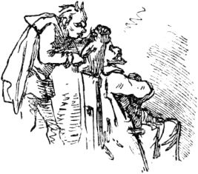the fact that the bearskin had long since gotten tired of bearskins and wanted to break up with him wanted to make the deal wise and exchange the skirts again, but the bearskin said: "It's not that quick, first you lick me and clean me like you do promised, so that I can look like a pretty person again, and not a Waldschratt or you, you unclean spirit! ”Then the devil had to renovate the bearskin nicely, comb his hair with his fingers and with his tongue, which scratched like a grater , lick his skin clean, cut his nails too, and have to wash him and make him look good again. That was angry with him, and it was a difficult piece of work, because you saw in the world what a major effort it costs with one-year-old bear skins, let alone if oneremained in bear skinning for seven years. Then the devil got a kick to the valet from the former bearskin, now Mr. Rupert, and the latter dressed very well 400nice, and traveled by extra mail and steam to the place of residence of his fiancée, but no one knew him there. He behaved like a rich suitor and announced that he wanted to marry one of the three beautiful women, one of whom was already his fiancée. This one paid no attention to him at all, but her sisters, they would have liked him too much, and cleaned themselves up like peacocks and quarreled which one should take him. But Rupert asked his bride for a cup of wine, drank, and asked her to let him know; as she did so, she saw half of her engagement ring in the cup, and was completely amazed and delighted. But he embraced her and kissed her; then her sisters came dressed up and terribly dressed up, and their faces turned green and yellow out of envy and anger for their sister's happiness - and ran away. One rushed into the draw well full of resentment and anger, the other hung herself on the floor full of poison and bile, and the devil was immediately at hand, caught both souls and said: "I must have a soul - and now i have two. I wish you luck with your wedding! ”- With that he left, and Rupert married his lovable youngest child after the mourning and has never been a bearskin again.

**The fairy tale of the knight Bluebeard.**

Once upon a time there was a mighty knight who had a lot of money and property and lived wonderfully and happily in his castle. He had a blue beard, of which he was only called Knight Bluebeard, although his real name was actually different, but his real name has been lost. 401This knight had married more than once, but one had heard that all his wives had died in quick succession without actually knowing their illness. Now Knight Bluebeard went free again, and there was a noble lady in his neighborhood who had two beautiful daughters and some chivalrous sons, and these siblings loved one another very tenderly. When Knight Bluebeard wanted to marry one of these daughters, neither of them had any real desire, for they were afraid of the Knight's blue beard and did not like to part. But the knight invited his mother, daughters and brothers all of them to his great, beautiful castle as guests, and provided them with so much pleasant pastime and so much pleasure through hunts, dinners, and dances. Games and other celebrations so that at last the youngest of the sisters took heart and decided to become Knight Bluebeard's wife. Soon afterwards the wedding was celebrated with great splendor.

After a while the knight Bluebeard said to his young wife: “I have to travel and give you the care of the whole castle, house and yard, with everything that goes with it. Here are also the keys to all rooms and chambers, which you can enter at any time. But this little golden key closes the rearmost cabinet at the end of the large row of rooms. In this, my dear, I must forbid you to go, as dear to you my love and your life is. If you were to open this cabinet, the most terrible punishment of curiosity awaited you. I would then have to separate your head from your torso with my own hand! ”- The woman did not want to accept the little golden key in response to this speech, but she had to do this to make it safe 402and so she parted with her husband with the promise that it would never occur to her to unlock that cabinet and go into it.

When the knight was gone, the young woman received a visit from her sister and her brothers, who liked to go hunting; and now the splendors in the many, many rooms of the castle were examined with pleasure every day, and so the sisters finally came to the cabinet. Although she was very curious herself, the woman did not want to open the door, but the sister laughed at her suspicion and said that Knight Bluebeard was only stubbornly keeping the most precious and valuable of his treasures hidden in it. And so the key was put into the lock with some hesitation, and then the door flew open with a thud, and in the sparingly lighted room it was revealed - a terrible sight! - the bloody heads of all former women of Knights Bluebeard, which just as little as the present one had been able to withstand the urge of curiosity, and all of which the wicked man had beheaded with his own hand. Shaken by death, the women and their sister now fell back; The woman had lost her key in shock, and when she picked it up there were stains of blood on it that could not be rubbed off, and it was just as impossible to close the door again, for the lock was bewitched, and horns heralded the arrival of mountaineers before the Castle gates. The woman breathed a sigh of relief and believed that it was her brothers she was waiting for after the hunt, but it was Knight Bluebeard himself, who had nothing more to do than to ask for his wife, and when she came up to him, pale, trembling and dismayed so he asked for the key; she wanted to get the key and and all of which the wicked man had beheaded with his own hand. Shaken by death, the women and their sister now fell back; The woman had lost her key in shock, and when she picked it up there were stains of blood on it that could not be rubbed off, and it was just as impossible to close the door again, for the lock was bewitched, and horns heralded the arrival of mountaineers before the Castle gates. The woman breathed a sigh of relief and believed that it was her brothers she was waiting for after the hunt, but it was Knight Bluebeard himself, who had nothing more to do than to ask for his wife, and when she came up to him, pale, trembling and dismayed so he asked for the key; she wanted to get the key and and all of which the wicked man had beheaded with his own hand. Shaken by death, the women and their sister now fell back; The woman had lost her key in shock, and when she picked it up there were stains of blood on it that could not be rubbed off, and it was just as impossible to close the door again, for the lock was bewitched, and horns heralded the arrival of mountaineers before the Castle gates. The woman breathed a sigh of relief and believed that it was her brothers she was waiting for after the hunt, but it was Knight Bluebeard himself, who had nothing more to do than to ask for his wife, and when she came up to him, pale, trembling and dismayed so he asked for the key; she wanted to get the key and now the women and her sister fell back; The woman had lost her key in shock, and when she picked it up there were stains of blood on it that could not be rubbed off, and it was just as impossible to close the door again, for the lock was bewitched, and horns heralded the arrival of mountaineers before the Castle gates. The woman breathed a sigh of relief and believed that it was her brothers she was waiting for after the hunt, but it was Knight Bluebeard himself, who had nothing more to do than to ask for his wife, and when she came up to him, pale, trembling and dismayed so he asked for the key; she wanted to get the key and now the women and her sister fell back; The woman had lost her key in shock, and when she picked it up there were stains of blood on it that could not be rubbed off, and it was just as impossible to close the door again, for the lock was bewitched, and horns heralded the arrival of mountaineers before the Castle gates. The woman breathed a sigh of relief and believed that it was her brothers she was waiting for after the hunt, but it was Knight Bluebeard himself, who had nothing more to do than to ask for his wife, and when she came up to him, pale, trembling and dismayed so he asked for the key; she wanted to get the key and to close the door again, for the castle was enchanted, and horns announced the arrival of mounted men at the gate of the castle. The woman breathed a sigh of relief and believed that it was her brothers she was waiting for after the hunt, but it was Knight Bluebeard himself, who had nothing more to do than to ask for his wife, and when she came up to him, pale, trembling and dismayed so he asked for the key; she wanted to get the key and to close the door again, for the castle was enchanted, and horns announced the arrival of mounted men at the gate of the castle. The woman breathed a sigh of relief and believed that it was her brothers she was waiting for after the hunt, but it was Knight Bluebeard himself, who had nothing more to do than to ask for his wife, and when she came up to him, pale, trembling and dismayed so he asked for the key; she wanted to get the key and so he asked for the key; she wanted to get the key and so he asked for the key; she wanted to get the key and 403he followed her closely, and when he saw the stains on the key, all his gestures changed and he cried: "Woman, you must now die from my hands! I left all violence to you! Everything was yours! Your life was rich and beautiful! And so little was your love for me, you bad maid, that you ignored my only insignificant request, my serious command? 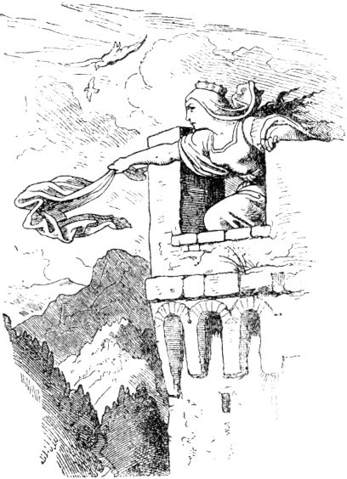Prepare yourself for death! It's over with you! "

Horrified and terrified, the woman hurried to her sister and asked her to quickly climb the tower and look for her brothers and, as soon as she saw them, give them an emergency signal, while she threw herself on the ground and to God begged for her life. And in between she called: “Sister! Don't you see anyone yet? ”-“ Nobody! ”Sounded the desolate answer. - "Woman! come down! "shouted Knight Bluebeard," your deadline is up! "

"Sister! don't you see anyone? ”shouted the trembling woman. "A cloud of dust - but oh, they are sheep!" Answered the sister. - "Woman! come down or I'll get you! ”shouted Knight Bluebeard.

"Mercy! I'll be right there! Sister! see 404you nobody? "-" Two knights come on horseback, they saw my sign, they ride like the wind. "

"Woman! Now I'll get you! ”Bluebeard's voice thundered, and then he came up the stairs. But the woman gained courage, threw the door of her room in the lock and held it tight, and she and her sister screamed for help as loudly as they both could. In the meantime the brothers hurried over like lightning, stormed up the stairs and just came to see Knight Bluebeard bursting the door and penetrating the room with drawn sword. A brief skirmish and Knight Bluebeard was dead on the ground. The woman was released, but for a long time could not get over the consequences of her curiosity.

**Golden chicken.**

Once upon a time there was an old man who lived in a cottage in the forest who, in addition to several children, also owned a golden cockerel, that is the smallest among the European birds and belongs to the sex of the wrens. The old man was very fond of this dearest bird, and the children were no less fond of it, and when the old man died he said to the children: "Don't sell the golden cockerel, because that's a lucky bird." But like the old man Having died, hardship and want returned to the children's house. Now, every week, the Golden Cockerel laid an egg the size of a pea and the color of a pea yellow. Father had always carried these eggs away and returned with money and food. Now that the provisions had run out, the eldest son decided to take the eggs that had been laid and offer them for sale. Where he got the golden chicken eggs 405but offered, he was laughed at, and finally a man whom the poor starving boy was taking pityed him gave him a few pfennigs for it. When these were consumed and the hunger was stronger than before, the boy set off again, this time with just one egg, and he was happier. He found the man to whom his father had always sold the eggs and who knew their worth, for they were made of pure gold. But when the man noticed that the boy did not know anything about the secret, he said: “What should I do with the egg? Sell ​​me the bird, I want to pay you very well. ”And also went straight to the forest house. The other children wept and complained when their eldest brother sold the golden cockerel to the man, who put a few blank coins on the table for it. The bird fluttered restlessly in the cage,

And when the bird was gone, the happiness in the little forest house was completely over; the children could not get the same and had to go begging, and they came far apart.

It was about this time that the king of the country died, and after the period of mourning his beautiful young widow made it known that she would extend her hand and share the throne with him who, blindfolded, would stab down the hanging crown with a lance . At that time the golden chicken kept singing: “Whoever eats me becomes king! He who eats me becomes king! ”That pleased the man who had bought it, and although he now had to forego the golden eggs when he ate it, he killed it, had it plucked 406and label it with colored silk to recognize it when fried, and gave the cook strict orders to take care of it. He had invited many friends to a festive meal so that if he ate the bird and suddenly became king he would be honored immediately.

While all sorts of preparations were being made for the feast, the young person who had sold the golden chicken came as a poor, idle beggar in front of the house and asked the cook for alms or a piece of bread, and she said: “You should have it something, but also has to do something! " He fetched water, split wood for the stove, turned the spatula and watched the birds roasting in the pan, including the golden chicken. Almost immediately he hit the pan with a piece of wood, and then the golden chicken fell out into the glowing coals.

"Damn the little bird!" Thought the young man, although he was very frightened, and put it in his mouth and ate it, although he burned himself badly. But he didn't know that it was his former golden cockerel. When the cook came into the kitchen, she counted the birds, saw that one thing was missing, and chased the new unfaithful kitchen boy away with scolding and scolding, but quickly drew another little bird and presented the dish to her master. The latter ate the little bird he had drawn and is still sitting today, waiting until he becomes king, and is annoyed that he has beaten his friends.

The chased away sadly crept through the streets and begged in front of a miller's door. He just needed a donkey driver and gave the poor fellow that job; he was allowed to sleep with the donkeys in the stable. 407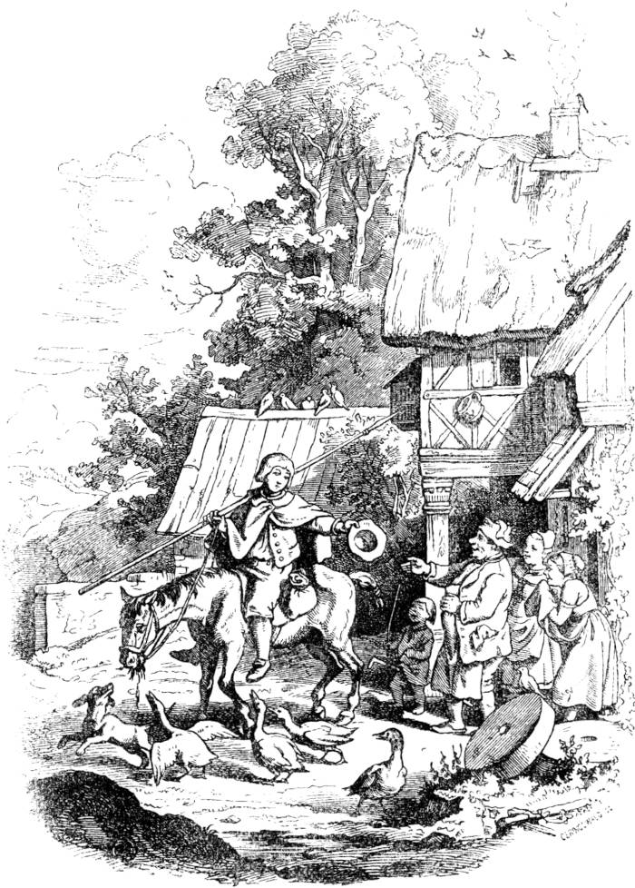And behold, the next morning, when the miller was strewing other straw and clearing away the old one, found golden eggs in the straw, on which his donkey driver was sleeping 408would have. He liked that and he thought: You'll have to keep this fellow for a long time, he's a goldfinch, while the previous one was a bastard.

Now the day of the crown piercing came, and the donkey driver said that if everyone was allowed to pierce and try his luck, he would also dare to, asked the miller for a spear and a horse. The miller laughed at the top of his neck, but he thought it was a great joke, gave him an old lame and spindly mare and an old spear and sent him to stab him for the royal crown.

Everyone laughed as the strange knight of the sad figure came trotting along, and the queen looked indignant that such a poor fellow pressed himself to the crown-piercing, for which so many distinguished knights and lords had gathered; but since she had once completely given permission to pierce the crown, she was now not allowed to do the same exclusively.

The fighting game began with one count and one knight after the other stabbing for the crown blindfolded and none of them obtained it; and it ended with the donkey driver being so happy to hit the crown and stab it down. The queen didn’t like that, but she had to become the donkey driver’s wife because she had once sworn to do so, and so the same became king, and that miller, his master, found no more gold eggs in the straw of his stable, only such as they lay the donkey.

Since the queen did not love her husband because of his poor origin, she thought day and night to get rid of him. So she took her next refuge in a powerful old sorceress, and she gave her a herb that had the strength, the human form 409to transform into an animal one. The wicked queen mixed this herb with the food for her husband and master, and, behold, when the king had enjoyed the food, he began to change and became a real donkey, which had previously been a very beautiful young person. For this reason he was chased out of the court with disgrace and shame, and now someone else was elected king, whose choice was wisely not left to luck and blind chance again, 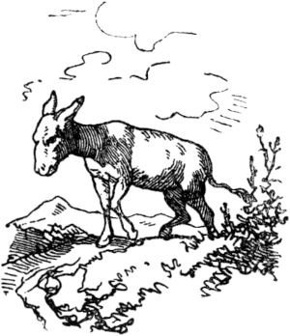because they were afraid of seeing another donkey climb to the top.

The poor old donkey driver, now a donkey himself, had to feel all the hardship of his new class. He had made his way to the mill, where he had once happily driven donkeys and slept on straw. The miller, when he saw him coming, was unable to distinguish him from the other donkeys, although there was something human in his eyes. And there he was put in the mill with the other donkeys, had to carry sacks of grain and flour year in and year out, and was no better or worse off than the rest of the donkeys.

Now that poor donkey, when he was still a human, had a sister who had come from him and begged, and she had asked for bread in a monastery, and they had her as a strong young thing Maid service accepted. She was loyal and hardworking, finally became a nun herself, and was trusted in the office of 410Porter. This monastery was now grinding in the very same mill in which the certain donkey was, and when he came to the monastery gate for the first time with his sacks, he recognized his sister in the porter, because he still had human thoughts and human memories . Then he stood up and showed his joy, and a certain sympathy for this donkey awoke in the bosom of the porter too; that was the voice of nature. Now the porter was knowledgeable of all herbs and grew the best and strongest in the monastery garden herself. So she went, picked a magic herb that had the power to transform the animal shape, if it was given by magic, into human again, and gave it to the donkey to eat. Then he became human again as before, and thanked his good sister with many kisses and tears. But for seven years he had borne sacks and clubs enough and did not ask again to go to the people. Near the monastery, where he found his good, pious sister, he built a hut out of tree branches and became a pious hermitage and forest brother. There he lived on roots and herbs, and took pleasure in the lovely song of the forest birds and fed and tended them, with the exception of the golden cockerels, which he disliked, and cursed them because one thing had only brought him bad luck, and caught them her and killed her where there was only one thing he could get hold of. wherever he found his good, pious sister, he built a hut out of tree branches and became a pious hermitage and forest brother. There he lived on roots and herbs, and took pleasure in the lovely song of the forest birds and fed and tended them, with the exception of the golden cockerels, which he disliked, and cursed them because one thing had only brought him bad luck, and caught them her and killed her where there was only one thing he could get hold of. wherever he found his good, pious sister, he built a hut out of tree branches and became a pious hermitage and forest brother. There he lived on roots and herbs, and took pleasure in the lovely song of the forest birds and fed and tended them, with the exception of the golden cockerels, which he disliked, and cursed them because one thing had only brought him bad luck, and caught them her and killed her where there was only one thing he could get hold of.

411

**The three stupid devils.**

Once in hell there was a great miracle that only men and no women came to hell and they would have loved to have women in it. Then a very young devil threw himself up and said: “What does it matter, I'll bring one here!” The other devils are happy, but they don't quite believe what that one says. The devil leaves at once, and the others wish him great luck. So he comes to earth and meets a young prostitute; to this he says: “Hey, maiden! doesn't she feel like getting married? ”-“ Why not, ”she said. "I think the wedding can be tomorrow." - "Fine with me," said the devil. So how it was tomorrow, he goes to the pastor and has the prostitute given to him as his wife. But before the kissing moon is over, the young woman demands money, clothes and that which is beautiful, and the devil can hardly earn his bread, often has to save over his mouth and leave it to his wife and as a result he becomes skinny and lean and is no longer as good of cheer as before. The woman had expected more from this beau - lots of money and nice clothes. So she starts and gets cold to her devil. He gives good words; - he hums. - But she quarrels badly and threatens him with blows. The devil smiles and he thinks: I will still be able to force you. But he quarrels - But she quarrels badly and threatens him with blows. The devil smiles and he thinks: I will still be able to force you. But he quarrels - But she quarrels badly and threatens him with blows. The devil smiles and he thinks: I will still be able to force you. But he quarrelsone word, she quarrels, and that goes on and on every day. What happens? The devil is lastly hit hard. Then the devil thinks: ei, what are you going to worry about with the woman? go home pretty, and - then he went home. When he goes to hell and doesn't bring a woman with him, the devils laugh at him hard 412from and everywhere they call: “Stupid devil! stupid devil! ”But he replies:“ I don't want any again and if I got the whole hell for free. Be glad I didn't bring it with me, it would have made hell all the more hot for all of us! ”Then another slightly older devil speaks:“ Now I want to go , I want to get one here! ”He's leaving too, comes up a pea field, there he meets an old maid. Then he thinks: wait, this is not such a tasty youngster, you want to take it. 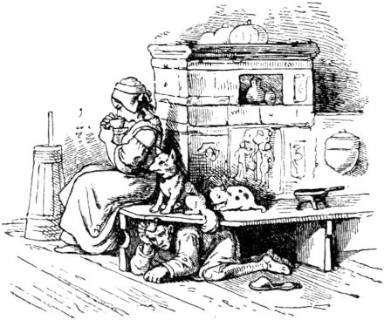So he says to her: “Hey there, maiden! doesn't she feel like getting married? ”-“ Oh yes! if He has money and bread for me? ”-“ Oh yes! ”says the devil. When the two of them had married, the woman noticed that the devil had lied, for he was a poor, anemic devil and had nothing and could not do anything. That came home to him because he had run into a miser who saved the salt on the potatoes and on Sundays put a button in the bell bag instead of the Heller. It gives the devil enough to do and little to bite, but he could have scolding as much as he wanted, and pranks were not rare either. And when his stomach grumbles with hunger and his tongue hangs out for a long time, she doesn't have mercy on him. If the devil wants to eat something, he has to go and stuff potatoes. 413big sack full, so he gets hit, too, and that happens every day. Finally the poor devil is getting tired and says to himself: “Oh what, are you supposed to toil with the woman? I'm going away, that's a very bad animal! ”He goes and comes back to hell. Here he is immediately asked where he has his wife? - "Yes woman! Has something! 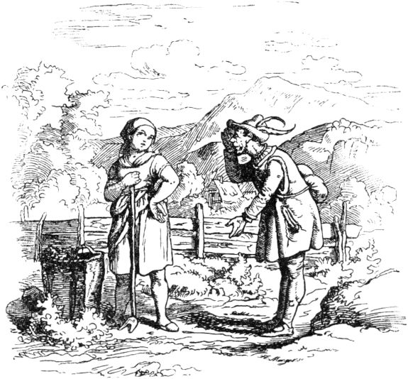I don't want any! I want to remember those I had up there in my life! You take them with you to hell too! I'm glad that I got rid of them. ”- It was now said everywhere:“ Stupid devil! stupid devil! "

But now a very old devil speaks: “Now I want to go ; I will paint it for the women! ”- The old devil leaves and comes to earth; there he walks through a young birch forest and sees a woman from a distance. That was a widow who was still whole 414looked handsome. He looks at her and she looks at him, and with polite speeches and polite arguments they come to an agreement and the pastor nails and rivets them together as tightly as the heart desires. But after the wedding, the devil saw that you don't have to buy cats in a poke and that widows don't go free on the road. She already knew the hype, since the sacred marital status was not new to her; Narrow food and well water was the least thing, there was an open shop for everyone, and the man just had to watch, and if it got too bad for him, as no devil can take such watching, she hung him on the wall and went with her loved ones to beers. When she came back, she took him down and he was supposed to learn Mausen that you can save the cat. But then it gets too bad for the devil

As he is now in the berries, he meets a charcoal burner, complained to him of his need and asked for something to eat. Then the charcoal burner said: “Yes, dear old man, I have seven children of my own and often not a bite of bread.” - “You charcoal burner, black fellow, give me advice on how to tame the angry woman. I ask you for everything in the world, help me! "-

The charcoal burner replied:

A bad woman, a bitter penance,

And woe to him who must have one.

The devil thinks: oh, if that sounds like that, you'd better go home again. If only I had stayed home from the start! - He seeks revenge against women and says: “Hey, brother! you are also poor, I want to make you rich, but you have to follow me 415Koehler says: "Oh yes, I would like to be rich and I want to do what you want." Then the devil says: "Listen, Brother Koehler, I know a king who has three princesses, I want one drive and you should be the doctor. When I have gone to the princess, the king will call for a doctor who can drive out bangs. Then you go to this king and say: 'Lord King, I want to help the princess, but I have to be completely alone with her in the same room, of course with all honors.' When you are let in with the princess, you say to me: Thunder and devil, go out! - open a window and I get out of there. But you can only do that twice, if you do it three times, I'll break your neck! ”- The Koehler asked: "Even if I show you a beautiful, good woman?" To which the devil replied: "We want to see." But he thought, I can promise him that, so there is no need. We devils know women. - One evening the charcoal burner came out of the forest and his wife said to him: “You, man, the rich king wrote that his princess is dying of death, yes, very sick; whoever helps her shall get half the kingdom from him, or as much gold as the doctor and the king are both difficult. If only you, dude! you knew a good home remedy and could help the princess to get out of our poverty one day! ”- Then the charcoal burner said to his wife:“ I want to do a test once, maybe I'll be happy ”and left. When he came to the king, he asked: "Dude, Do you dare to make my princess well? ”-“ Oh yes, Mr. King! ”answered the charcoal burner. “I have to get some species out of the pharmacy first 416and I have to fetch it myself and then I have to be all alone with the princess. "Then the king said:" Dude! As you ask, it should be done. If you heal my princess, you'll get half of my kingdom or as much gold as you and me are heavy. ”- The charcoal burner now did as the devil had commanded him, and the beautiful princess was healed on the spot. The king gave the charcoal burner the choice: gold or land, - and the charcoal burner took the gold.

Before long the other princess was possessed by the devil. The king lets the charcoal burner come back and says to him: “Dude, you have made my first sick daughter well, help this one too!” - The charcoal burner said: “I will try, Mr. King!” And see, he helped the second Princess again, too, and the king gave the charcoal burner the same amount of gold.

The charcoal burner was now very rich, but still grieved because he was not allowed to drive out the devil again, who had resolved to plague the women and certainly not let it go. The first two times it was agreed, the third time he had to leave the devil in the princess, otherwise the devil would break his neck; and if he could not drive out the devil a third time, he had to dare to let the king kill him; he wondered whether the third time he might not succeed in leading the devil.

Now the third princess also fell ill because the devil had got into her. Again the king had the old charcoal burner come and said to him: "You, old man, if you don't help my princess, I'll let you hang up!" To which the charcoal burner replied: "My most gracious lord 417King! I want to do a rehearsal, but for that it is necessary that all the good, beautiful girls in the whole city gather tomorrow morning in white clothes, with red sashes and in locks of hair, also all your clergymen, stand in front of the castle and sing the maidens Clergy I am led up the mountain next to the princess. But there must by no means be any of the common prostitutes or of the old maids who still lust for free, or the widows who want to move their marriage seat; and you must strictly order your priests to do so. When we are then at the highest level, then I will make a test. ”The king quickly made every effort to ensure that this condition would be fulfilled. The next morning the big meeting was in front of the castle. The train was moving uphill

"Thunder and devil, go out!"

The devil went out, but called to the charcoal burner: “Rogue, you keep your word! Wait, now I'll break your neck! ”But the charcoal burner took responsibility and said:“ Stop! Our pact has a caveat; you mustn't harm me if I show you a beautiful good woman. Just look around, look at these. ”Then the devil looked around and looked at one after the other and recognized that he had no power over them. And then he was ashamed to stay on earth and was also afraid of his dragon, and so he made a patter and a stench and left as he had come.

And then the devil went home to hell again, and how he came, all his comrades asked him whether he was not bringing a wife with him? And as he said: he will bring 418none with, because it was said again: "Stupid devil, stupid devil!" and there was a lot of fun and spectacle and the laughter of the devil, that it cracked and crackled and the whole hell shook and burst like an old wall. And there are still no women in hell, except for the devil's old grandmother - because women are so good.

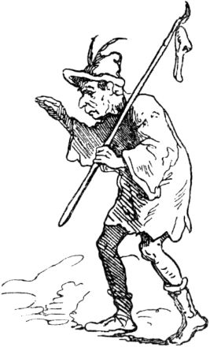

**The thankful animals.**

Once a pilgrim traveled overland, who came on his way through the forest to a wolf pit and noticed that there was something living in it. And as he looked down, he saw in it a man who was a goldsmith, and with him was a monkey, a snake, and a grass snake; all three of them had suddenly fallen into the pit. Then the pilgrim thought to himself: Show mercy to the poor and help man from his enemies. So he threw a rope into it 419Grube and held one end tightly in his hand, willing to pull the goldsmith up, but the monkey quickly jumped to it, climbed up and jumped out of the pit. The second time the catfish threw down the rope, and the adder curled up on it. And for the third time the snake caught hold of the rope and came to light. These three animals thanked the catfish for his kindness and said to him: 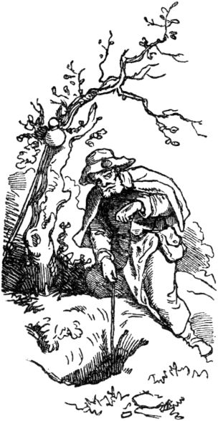“What you have done us good, we will try to repay you again, and when your path brings you near us, you can count on us that we will be of service to you as much as we can; but be faithfully warned of the people down there, because nothing that lives there is as ungrateful as he is. We have experienced this and tell you that you know how to behave. "

With that the three animals parted from the pilgrim, but the pilgrim remembered his duty, that it is befitting of man to help man, and again threw the rope into the pit and pulled the goldsmith out. He thanked him in many words for the grace and mercy that the pilgrim had done to him, and asked to visit him in the royal residence where he lived, and left him.

On his way on, the catfish came near the residence and the place where the monkey, the adder and the snake lived. They were happy, and so did he 420The monkey brought the catfish, who was very tired, fruit and sweet figs; the adder showed him a cool, pleasant grotto where he could rest and rest, and lay down in front of it and watched his sleep, for no one dared go where the big one Snake lay. The snake, however, slipped into the royal castle and stole some gold jewels there, which she gave to Waller to admire, but did not tell him where she had got them from. When he left the animals, he went to the royal city and looked for the goldsmith; He showed him the jewels and offered them to him to buy. The goldsmith saw that they were the king's property, remained silent, went to the king and indicated that he had caught the thief of these treasures in his house. For this he received a handsome reward, and the king sent his captors, who caught the catfish, beat him, took him through the streets and out to the gallows to hang him. On the way the old man remembered the warning of the animals and sighed loudly: "Oh, if I had followed your advice, you loyal animals, this tribulation would not have been granted to me!"

Now the snake had just found its apartment on the road that led to the high court, and heard the plaintive speech of the innocent man, for whose misfortune it was partly to blame, and was sad and thought about how it would help him. Now when the king's son, a young boy, was also led on the way to watch the thief's punishment, she crawled over and bit his leg, so that it soon swelled up. Then all the people stopped in alarm, and they hurriedly sent for doctors and astrologers to help where possible. The doctors brought in Theriac, a medicine that was praised for snakebite, but it did not help. But the astrologers 421read in the stars that the catfish led to death was innocent, and the king boy himself shouted in a clear voice: "Bring the pilgrim here to lay his hand on my wound and my swelling, and I'll be whole!"

Then the pilgrim was brought before the king, who asked about his fate, and the pilgrim faithfully told the king everything about the good, thankful animals and the shameful ingratitude of the goldsmith whom he rescued from death. And then he raised his hands and eyes to heaven and pleaded: "O almighty God, as true as it is that I am innocent of the theft, so true will my hand heal this person!" - And from that moment on the king's son was healed . When the king saw this, his heart was glad and joyful, and he honored the pilgrim with precious gifts, left him all the jewels for the sake of which the pilgrim had been terrified, and had the goldsmith hang on the spot, as a punishment for his large and black one Ingratitude.

**The four clever fellows.**

Once upon a time there were four fellow travelers who wandered together and met quite by chance on the way. One of them was a king's son, the second a nobleman, the third a merchant, the fourth a manual worker. All four of them had run out of cash, as the rich and poor sometimes travel, and they had nothing but the clothes they wore on their bodies; their sacks were empty. How they now become a great royal residence 422approaching and feeling mighty hunger, they raised the question of where would they get money and food from? And then said the king's son: “We may advise as we wish, then it goes only the way that God has arranged, and whoever clings to God with true hope will not be abandoned.” Then said the merchant: “Be careful paired with reason is more than anything! "And the nobleman: 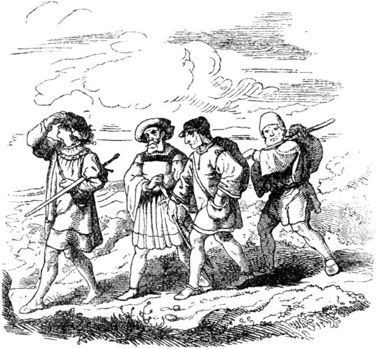"A strong, well-formed youth is worth even more." Then the traveling companion, who was a manual worker, remarked: "According to my poor understanding, I believe that carefulness with practice is the best."

As the four traveling companions had come near that city towards evening during such conversations, they rested in front of the gate, and then the three others said to the fourth, the traveling companion: “You praise every care that you go there take care 423that we will all have our meals tonight! ”-“ I will do that, ”replied the worker,“ if everyone afterwards wants to do according to his teaching, that it is good for us all. ”The companions promised him that, and so went the one went into town and wondered what a man must do to earn enough that four men could eat themselves for a day? Then they told him that nothing was more profitable than carrying wood, because wood was expensive, the forest was wide and the townspeople were comfortable. So the man hurried into the forest, tied himself a heavy load of wood, carried it into the city, received two silver pennies in return, for which he could dispose of food and drink for himself and his companions, and wrote on it with chalk with great joy Gate of the inn where they stayed:

The next morning the three journeymen said to the fourth, the nobleman: “Now look and see that you areprovide us with food today, and use your beauty and youthful strength, and whatever else you know, to help. ”He walked towards the city and thought to himself: You can't and don't like work, and you don't know what to do next. Yet it would be a shame for you to return to your companions with an empty hand. And in gloomy thoughts he stood at the pillar of a house, willing to part with sorrow from his traveling companions. A young, beautiful, and rich widow passed by, saw the noble's youthful figure, and wished to find out where he was from? She sent her servant, had him invited as guests, found out about his circumstances and made friends with him, so that when he parted with her she gave him a hundred 424Gold pennies venerated. Then he returned to the comrades in the small inn in front of the gate with a rich bite to eat, and wrote to the gate: With a fresh youth one day someone won one hundred gold pennies.

Now on the third day the three of them said to the merchant: "Today you are moving there and, with your caution, which is paired with reason, win us a good day and a welcome meal." Then the merchant went away and through the city, which on Seas lay down to the harbor; just then a merchant lay at anchor in the harbor, and the merchants greeted the patron of the ship, asked about his goods, and wanted to trade with him, but he was asking too much of them all and they could not come to an agreement with him. So they said to one another: “We don't want to offer him anything else now; in a short period of time he regrets his high demand, and even if his goods are worth so much, there is none other than us who has a desire to buy them. ”And then those merchants walked away from the patron. But the poor merchant who was the son of a rich merchant, went to the patron, discovered himself to him, told him his father's name and bought the whole shipload from him for fifty thousand guilders. Soon the merchants returned once more, and because they needed the goods, they paid the buyer five thousand guilders in profit and paid the price for the goods. So the young merchant went cheerfully to his journeymen and wrote at the gate where the companions' writing was already there: One day a man won five thousand guilders through caution and reason. And now held a splendid meal of joy with his companions. Soon the merchants returned once more, and because they needed the goods, they paid the buyer five thousand guilders in profit and paid the price for the goods. So the young merchant went cheerfully to his journeymen and wrote at the gate where the companions' writing was already there: One day a man won five thousand guilders through caution and reason. And now held a splendid meal of joy with his companions. Soon the merchants returned once more, and because they needed the goods, they paid the buyer five thousand guilders in profit and paid the price for the goods. So the young merchant went cheerfully to his journeymen and wrote at the gate where the companions' writing was already there: One day a man won five thousand guilders through caution and reason. And now held a splendid meal of joy with his companions.

The following morning the three spoke to him 425The king's son, whose origin they did not know: “Society, it is up to you that you go and provide us with food and drink. See what God brings you and your faithful hope and may it be plentiful! "

Then the king's son set off for the city and thought: What should you do and begin? You have not learned a job, you have no youthful beauty, you have no rich merchant for your father and you are not clever and not careful. You only have your trust in God, and God will help you. Then the king's son sat down on a stone by the road and sank into deeply gloomy thoughts.

But the king died again in this royal city, and on that day his corpse was brought out of the city to a nearby monastery and all the people followed the procession. The king's son, however, sat so absorbed in thinking about the disgusting fate which he had experienced that he cared nothing about what was going on outside of him, and so he failed to get up when the procession with the royal bier passed by. Then a mighty man stepped up, who was angry at this impropriety, gave the king's son a blow on the cheek and said, pushing him from the stone on which he was sitting: “You cursed villain! Do you not have mourning in your heart for the death of the king whom all weep? Away with you! "

The king's son let the procession pass in silence, and when it returned he was sitting on the stone again, sad and thoughtful. Then that mighty man approached him angrily again and snapped at him with a harsh speech: "Didn't I tell you earlier that you shouldn't be found here anymore?" And he waved to him 426Minions and had him taken to a dungeon. There he sat, but with full hope to God that he would redeem him. And when the people then met to elect a new king because the previous one had died without an heir, the mighty man said that he had a man in prison who seemed to be a traitor, and that he should be publicly interrogated and justice should be judged over him . So the prisoner was put above all the people and asked how and why he had come to this country? And he said, “Know that I am the son of a king” (and gave his father's name) “and when my father died, the kingdom fell to me; but my younger brother had more followers, so he drove me from the throne, and because I had to worry that he would kill me, I escaped from my inheritance and came to this country. "

Among the people who heard this there were many men who had known the king's father and had also walked in that kingdom. They testified that that king was a just and pious man, and that his older son was also pious and capable, and some shouted: “Vivat! Long live the king! ”And then the others shouted:“ Vivat! Long live the king! ”And chose the king's son to be their lord. Then he was lifted up and led in triumph through the city, according to the country's custom and custom, and also around the city, and then he came with the crowd to the nearby inn, where he lived with his traveling companions, and at the gate the three Sayings of his companions' thoughts stood and looked at them and ordered them to write: Diligent care, strong youth, cautious reason and what meets people good and bad,427

Everyone was amazed at the new king's sense of purpose, pleased with their choice and recognized that God had sent this ruler to them. When the king was brought into the throne room and sat on the kingship chair, he sent for his traveling companions and gathered around him all the nobles of the kingdom, all the wise men and all the people, as far as the room could hold, and said: “Praised be God, the King of kings, and thanks to his holy name! My dear companions did not believe that God directs our steps, but now they have to recognize this in me, because neither the strength of the body, combined with active care, nor the youthfulness and well-being, nor trading wit and wisdom has brought me to the throne. I never hoped from the day my brother drove me out of the kingdom to partake of such honor and dignity again; I came here poor and in a pilgrim's dress, but it was God's hand that guided me, it was God who exalted me, on whom my heart hung with true hope! "

At this speech a man rose from the people and said: “Now we first hear how worthy you, O King, are of this kingdom, since God has given you so much wisdom and reason. We will be well advised with you, as a wise king, for his loyalty did not lead you to that society without a cause. Praise and thanks be to him! ”- The people happily agreed, and the king took up the floor again and said:“ When I was expelled, I served a nobleman for a while without being recognized, but I was moved to leave the service. and when I received my wages I had only two pfennigs left after what I had to pay for my clothes. I thought in 428to my mind: You want to sacrifice one penny to God and use one for your necessities. Then I met a bird dealer who was carrying a pair of lovebirds to market, and I thought: There is no better man can serve God than when he redeems a creature from death, and then I haggled over the two pigeons, and the bird does not give me either wanted to give a penny 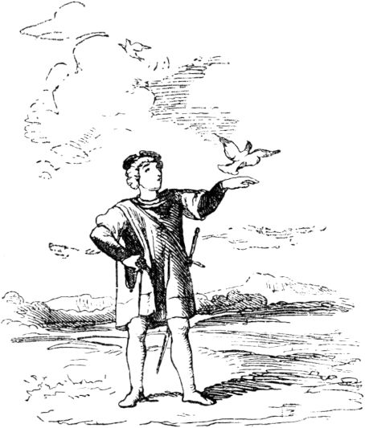So I thought to myself: If you leave one of them trapped, they are separated from each other, and that is their worst service. So I gave my two pennies to the two pigeons, carried them into a wide field and let them fly. Then they flew onto the branch of a wild pear tree, under which I was standing, and when I was about to leave again, I heard the one dove say to her friend: 'This man has redeemed us from death and destroyed our lives all of his property as much as he had bought We owe him thanks and retaliation. ' And then the doves called to me and said: 'You have shown us great mercy, and it is our duty that we repay you again. Under this tree's roots lies a great treasure, dig up and you will find it. ' I dug 429And found the treasure and kept it, praised God and asked him to take the good doves under his protection and to keep them from all evil, but then I said to them: 'If only your reason and wisdom is so great, and there you can even fly, how did it come about that you ended up in the custody of the man from whose hands I bought you! ' The two lovebirds replied: 'O you wise questioner! Do you not know that the flight of the birds, the speed of the deer, the strength of the bulls can do nothing against doom or the divine ordinance! No creature can protect itself against this, and just as little as a creature of our kind, just as little can man on earth escape divine destiny. '"

When the king had explained to the nobles and the people how he had come to a peaceful trust in God, he was praised anew, and he ordered his traveling companions to stay close by. He made the nobleman a lord at the court, the merchant he made over the income of the empire and the manual worker he made the supervisor of the trades, and so their happiness was based on understanding, reason, prudence and trust in God.

430

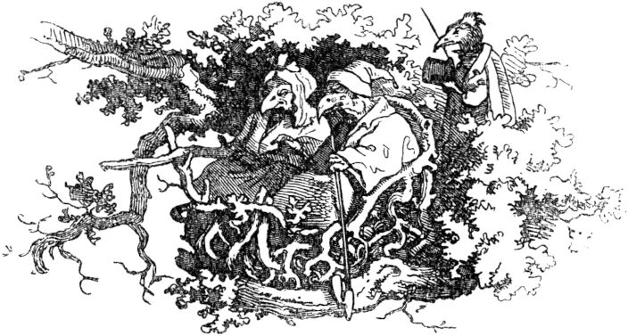

**Vogel Holgott and Vogel Mosam.**

Funny brooks poured into a lake and it was full of fish and was situated in a lonely area, where neither people nor herons and other fish-eating birds came from the sea. This lake was discovered by an elderly bird called Holgott, of the osprey race, and he liked the pleasant location, the peaceful silence around the lake and the abundance of food. Then he thought to himself: “You want to move here with your wife and all yours, because here we find enough of everything we need, here nobody is repugnant to me and my children like this area when we are dead as having a beautiful inheritance. ”Now Vogel Holgott had a wife who was sitting at home in the nest on her eggs, which were close to being hatched, and this female had a dear friend, also a bird called Mosam. This friend was so dear to her that she did not like food or drink when he was not around her 431was, and without him she had no pleasure or amusement.

When her husband now discovered his advice and decision to move to that beautiful area, but harshly forbade her to tell Mosam, her friend, she was extremely sorry, and she pondered discoveries and plans for this her husband's plan secretly could be stuck without his noticing. And then she said to her husband: “Look, my dear Holgott, our young will soon hatch, and I was told a medicine to use for the young when they creep out so that their plumage grows strong and firm : this medicine also protects you from bad accidents for life. Now I would like to fetch this medicine, if you allow me and it would please you! "

“What kind of arcanum is that?” Asked Vogel Holgott, and the woman replied: “That is a fish in a lake that flows around an island that nobody knows but me and the one who tells me. That is why I advise and ask you to sit on the eggs in my place and brood, while I will fetch the fish or two, and we will then take them with us to the new stay that you have chosen for us. "

To this the man replied: “It is not fitting for the sensible to try everything that the first best doctor advises him; for some advise us to do things that are impossible to attain. What good is the lion's sled for the sick, or poison for the vipers? Should someone therefore stand up to the lion and visit the vipers in their den and dare to risk death themselves, on the advice of a doctor? Let go, O woman, of your foolish plan and let us move to that place while our boys stay here; find there 432you fish of all kinds, perhaps also those salutary ones, and nobody knows them then, except us. Anyone looking for their medicinal herbs in a dangerous place, would like to see what happened to the old monkey. ”-“ How did it fare? ”Asked the female bird, and the bird told Holgott:

**From two monkeys.**

“An old monkey lived in a fertile place where trees and fruits, water and pastures were in abundance. Since he was just always in good life, 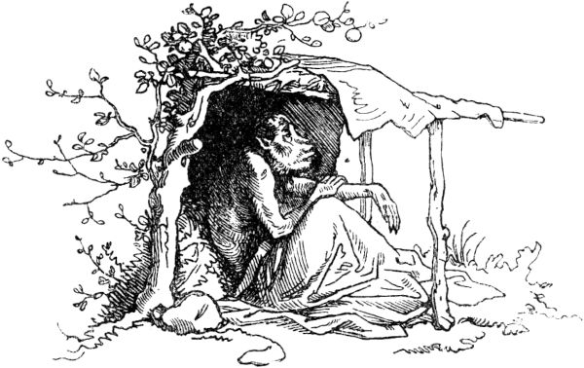so at his age he got the diamond and was very troubled by it, became thin and weak so that he could no longer get his food. Another monkey came up to him and asked him in astonishment: 'How come I have to see you so sick and emaciated?' - 'Oh!' sighed the old monkey, 'I know no other cause than God's will, from which no one can escape 433able. ' Then said the other: 'I knew a friend who had the same disease, and nothing helped him but the head of a black adder. When he ate it, he recovered, you should do that too! ' - The old monkey replied: 'Who gives me such an adder's head, since I am so weak that I can hardly get any fruit from the tree?' The latter replied: 'Two days ago I saw a man standing in a rock in front of a cave, who was lying in wait for the black adder that lay in the cave and wanted to pull its tongue out because he needed one; I want to take you there. When the man has killed the adder, you take the head and eat it. ' - The old monkey said: 'I am sick and sick, if I become healthy and strong, I will gladly reward you for your service.' Then that monkey led the old one into the rock cave, in which he knew a dragon lived. There were large kicks in front of the cave, like those of a person, the old monkey thought the man who killed the adder had left behind, crawled in and looked for the head. Then the dragon jumped out and strangled him and devoured him. The boy, however, was pleased that he had lured and cheated on his companion and was now in sole possession of the beautiful fruit trees. "

When Vogel Holgott had told his female this, he added: “I say this for the sake of the teaching that lies therein: No sensible person should dare his life on foolish and deceitful advice.” But the female said: “I have Understood you very well, but here it's a completely different case, because the fish that I mean can be fetched without danger and will be very useful to our boys. "

When Vogel Holgott saw that sensible persuasion did not work with his wife, he gave in: “You can 434if you don't let it go, get the fish; But make sure that you do not trust anybody either the one or the other secret, for thus the wise teach: Every reason is praiseworthy practice, but the greatest reason proves the greatest reason who buries his secret, so that no one is able to find it. "Then the female flew away and on the spot to his dear friend Mosam and told him everything his husband had in mind and that he wanted to move to a fun place where nothing was to be feared from animals or from humans. And said: "If you would like to find something, oh friend, that you too could come there, but with the knowledge and will of my husband, because if something good should happen to me, I will have no joy without you." To which the bird replied Mosam: "Why should I be forced to only to stay there with your husband's permission? Who gives him such power over me and others? Who forbids me to move there too? At this hour I want to fly over there and build my nest there, since it is such a sufficient place. And if your husband comes and wants to drive me away, I will probably know how to defend him and tell him that neither he nor his ancestors were settled there and that he is no more right about that area than I and others. "Then replied the female: “You are not wrong, but I would like your presence there on the assumption that there is always peace and harmony among us. If you go there against my husband's will, we will face suspicion and defamation, and our friendship will turn into mourning. My advice is this: you go to my husband, 435found that very beautiful area and decided to move there, he will reply that he had already discovered this place before and was determined to move there; then you say: O friend Holgott, then you are the first and that place more worthy than I, but I ask you, let me live with you, so I will be a loyal friend and companion to you there. "

Vogel Mosam heeded this advice and hurried to Vogel Holgott, while the female flew to the first best pond and caught two fish and carried them home as if they were the healing miracle fish, and Vogel Holgott replied to the proposal that he would please Mosam's company . The female, however, pretended not to like her husband's indulgence towards her boyfriend, so that he would not notice her betrayal, and said: “We have chosen that place for ourselves and I'll see to it that Vogel Mosam will go with us, like that his many friends also follow, and in the end we have to give way to their majority. ”Her husband replied:“ You are right; but I trust Mosam and hope that with his assistance we will fight off the intruders, so maybe it is a good thing that this friend lives with us. Nobody trusts too much in their own strength and power. We are indeed among the strongest among the birds, but help is for the weak, to overcome the strong, just as cats overcame the wolf. "

"How was that?" Asked Holgott's wife, and he told her:

436

**About the wolf and the mouse dogs.**

“There was a flock of wolves on the seashore, one of them was particularly bloodthirsty, who wanted to gain a special reputation among his journeymen at one time and went to hunt in a mountain range where there were many and various animals. But these mountains were fenced off, and the animals were safe from other animals and lived together in harmony; among them was a flock of mouse dogs or cats that had a king. Now the wolf had come cunningly through the enclosure, hid himself and every day caught a cat and ate it. The cats were very sorry for this, and they gathered under their king for advice; and there were three wise, discerning tomcats in particular, whom the king called to his council and asked the first to vote against the harmful wolf. The first tomcat said: 'I have no advice against this great monster but to command us in God's grace, for how can we resist the wolf?' The king asked the second tomcat and he said: 'I advise that we leave this place together and look for another, quieter place, as we have to stay here in great distress and in danger of life and limb.' The third tomcat, however, responded to the king's questioning: 'My advice is to stay here and not emigrate for the sake of the wolf. I also have some advice on how to overcome it. ' - 'Tell him,' commanded the king, and the cat went on to say: 'We must take care, when the wolf has acquired new prey and where it is carrying and consuming it, then you must, O king, me and our strongest approach him as if we wanted to eat what he leaves, so he will than to command us in God's grace, for how would we resist the wolf? ' The king asked the second tomcat and he said: 'I advise that we leave this place together and look for another, quieter place, as we have to stay here in great distress and in danger of life and limb.' The third tomcat, however, responded to the king's questioning: 'My advice is to stay here and not emigrate for the sake of the wolf. I also have some advice on how to overcome it. ' - 'Tell him,' commanded the king, and the cat went on to say: 'We must take care, when the wolf has acquired new prey and where it is carrying and consuming it, then you must, O king, me and our strongest approach him as if we wanted to eat what he leaves, so he will than to command us in God's grace, for how would we resist the wolf? ' The king asked the second tomcat and he said: 'I advise that we leave this place together and look for another, quieter place, as we have to stay here in great distress and in danger of life and limb.' The third tomcat, however, responded to the king's questioning: 'My advice is to stay here and not emigrate for the sake of the wolf. I also have some advice on how to overcome it. ' - 'Tell him,' commanded the king, and the cat went on to say: 'We must take care, when the wolf has acquired new prey and where it is carrying and consuming it, then you must, O king, me and our strongest approach him as if we wanted to eat what he leaves, so he will for how would we like to resist the wolf? ' The king asked the second tomcat and he said: 'I advise that we leave this place together and look for another, quieter place, as we have to stay here in great distress and in danger of life and limb.' The third tomcat, however, responded to the king's questioning: 'My advice is to stay here and not emigrate for the sake of the wolf. I also have some advice on how to overcome it. ' - 'Tell him,' commanded the king, and the cat went on to say: 'We must take care, when the wolf has acquired new prey and where it is carrying and consuming it, then you must, O king, me and our strongest approach him as if we wanted to eat what he leaves, so he will for how would we like to resist the wolf? ' The king asked the second tomcat and he said: 'I advise that we leave this place together and look for another, quieter place, as we have to stay here in great distress and in danger of life and limb.' The third tomcat, however, responded to the king's questioning: 'My advice is to stay here and not emigrate for the sake of the wolf. I also have some advice on how to overcome it. ' - 'Tell him,' commanded the king, and the cat went on to say: 'We must take care, when the wolf has acquired new prey and where it is carrying and consuming it, then you must, O king, me and our strongest approach him as if we wanted to eat what he leaves, so he will that we jointly leave this place and look for another quieter place, since we have to stay here in great tribulation, life and limb. ' The third tomcat, however, responded to the king's questioning: 'My advice is to stay here and not emigrate for the sake of the wolf. I also have some advice on how to overcome it. ' - 'Tell him,' commanded the king, and the cat went on to say: 'We must take care, when the wolf has acquired new prey and where it is carrying and consuming it, then you must, O king, me and our strongest approach him as if we wanted to eat what he leaves, so he will that we jointly leave this place and look for another quieter place, since we have to stay here in great tribulation, life and limb. ' The third tomcat, however, responded to the king's questioning: 'My advice is to stay here and not emigrate for the sake of the wolf. I also have some advice on how to overcome it. ' - 'Tell him,' commanded the king, and the cat went on to say: 'We must take care, when the wolf has acquired new prey and where it is carrying and consuming it, then you must, O king, me and our strongest approach him as if we wanted to eat what he leaves, so he will to stay here and not emigrate for the sake of the wolf. I also have some advice on how to overcome it. ' - 'Tell him,' commanded the king, and the cat went on to say: 'We must take care, when the wolf has acquired new prey and where it is carrying and consuming it, then you must, O king, me and our strongest approach him as if we wanted to eat what he leaves, so he will to stay here and not emigrate for the sake of the wolf. I also have some advice on how to overcome it. ' - 'Tell him,' commanded the king, and the cat went on to say: 'We must take care, when the wolf has acquired new prey and where it is carrying and consuming it, then you must, O king, me and our strongest approach him as if we wanted to eat what he leaves, so he will 437consider them to be quite safe and not to fear anything from us. Then I want to jump on him and scratch his eyes out, and then everyone else has to attack him so that he can no longer defend himself against us, and we must not be wrong that one or the other of us is losing our life or Sustains wounds; for through this we redeem ourselves and our children from the enemy, and a wise man does not part from his father's inheritance cowardly and fearfully; no, he defends it with danger to life and limb. ' The king endorsed this advice. Then it happened that the wolf had caught a good catch, which he dragged onto a rock, and there the cats carried out the deed advised by the brave wise tomcat; and the wolf had to end its life shamefully under their claws and countless bites. "

"This example," continued Vogel Holgott, "I tell you, dear woman, so that you will understand that true friendship is helpful, and that is why I am happy to take Vogel Mosam with me to my friend and companion." When this heard the female, she rejoiced she inside, that her attack ended so unsuspiciously and according to her heart's desire. And there the three birds rose to that merry place; left the hatched young behind in the old nest, built nests there and lived there peacefully and amiably with plenty of food for a while. And the bird Holgott, who grew old and weak, and his wife had the bird Mosam much more in their hearts than he would them, as will be shown shortly.

A drought, hot time came, when everything withered, and the lake dried up, and the fish died; then Vogel Mosam said to himself: “It is a beautiful thing to be faithful companionship, and it is praiseworthy when friends 438stick together. But everyone is next to himself. Who is useless to himself, how can the other be useful? Anyone who does not foresee future damage and avoid it will not escape it when it is there. Now I foresee how the company of these birds will do me harm and harm, since the food is diminishing from day to day; and in the end they'll chase me away. But I like it here, and I could live here alone without that company; then it would be a good thing if I got ahead of them and got rid of them, and that of the man first, because the woman trusts me completely, and I then force her much more easily. She can even help kill the man. "

With such nasty and shameful thoughts, the bird Mosam flew to the female and approached her very sad and depressed. She asked him: “Why do I see you so sad, my friend?” And he replied: “I mourn the difficult times and see the ghost of hunger striding terribly. And mostly because of you my heart mourns. There is only one thing I know that would benefit you, if my advice does not seem unwise to you. ”-“ Which one is that? ”Asked the female, and Mosam said:“ Ties of friendship are worth more than bonds of consanguinity, because these are often more harmful than poison. A proverb says: whoever lacks a brother has one enemy less, and whoever has no relatives has no envious people. I want to suggest something to you that will be useful to you, dear friend, although it will be hard for you to accomplish it, 439and do not think that you will advise me badly. But it would be easy for me to suffer death for your sake; therefore speak so! Because whoever does not give his life for a loyal friend is very foolish, because a friend is always more useful than a brother or like children. "Now Mosam spoke with deceit:" My advice is that you seek to get rid of your old weak husband and to get rid of whom you must so laboriously take care of; then happiness and salvation will ripen for you, and me with you! And do not ask about the cause of this advice until you have taken it, because if I had no good reason for it, believe me, I would not advise you to do so. I'll create a better and younger man for you who will always love and protect you. And if you do not follow my advice, you will be like that mouse who despised good advice. "

Then the female bird asked: "How was it with that mouse?" And Mosam said:

**The cat and the mouse.**

“Once upon a time there was a man who was harmed by the mice in his pantry, and he adopted a cat so that it would drive away the mice and devour them. Now there was one of the mice that was quite large, and it was stronger than the others, and when she perceived what had happened, she looked for an opportunity to speak to the cat from a safe place, and said to it: 'I know that your Lord has ordered you to drive out and kill me and my friends. Now I am happy to make your acquaintance and 440I want to commend myself to your favor and keep good peace with you. ' Said the cat: 'I am delighted to meet you, and it will be extremely valuable to me if you will honor me with your friendship. Your company would also be the most desirable to me, but I can't promise you anything that I can't keep you. See, most honored mouse, my lord has made me the keeper of his house, so that you and your kin may no longer harm him; If I spared you, it would say: that is a bad cat! So either avoid harming my master or avoid the house 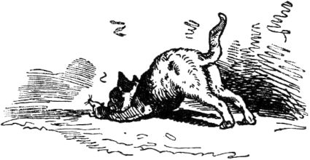and look for another place to stay that is comfortable for you, besides do not blame me if you are damaged. The mouse said: 'I have asked you politely, and so I only ask you forgive me my freedom and give me your friendship.' - 'Yes,' said the cat, 'you are dear to me and dear, but how can I combine my friendship with you with my duty in the face of the damage your companions do to my master? If I let you live, he'll kill me, that's cheap. Therefore, I grant you three days in which time you can move around to another apartment. ' - The mouse replied: 'It is very difficult and reluctant to part with this apartment; I'll be careful not to get too close to you and stay here as long as I like it. ' True to its word, the cat spared the mouse for three days, 441no longer at all as if there were a cat in the house; When the three days were over and the mouse ran out of its little hole again quite unconcerned, the cat lay in the corner of the pantry and lurked, jumped at and caught and ate the mouse skin and hair. "

“That is a parable,” continued Vogel Mosam, “by which you can see that it is not fitting for those who understand to despise the advice of loyal friends. And the proverb says that the advice of friends is often the same bitter medicine that is healing and banishes infirmity. "

The female bird pondered for a long time and hesitated as to what to do and how to accomplish it, so that no illusion of evil should fall upon her either. Then the false friend advised her to take a fish through which the fishermen put a sharp fishing rod to lure large fish, and which the man put under the other fish he was eating, so he would strangle it. The woman did that, and because the bird Holgott was old and no longer caught fish himself, and his wife sometimes made him suffer from hunger, he greedily swallowed the fish with the fishhook and choked on it, and as it happened, so he cursed those who so shamefully doomed him to death. When this was done, the bird Mosam lived a short time with the unfaithful woman, but because the food became increasingly scarce, he began to get very tired of it. and pounced on them, killing them. Her sons, who came to visit their dear parents, just flew by and fell on the bird Mosam when their mother was already dying, who knew everything to them and passed away. Then they pecked out the eyes of the bird Mosam with their pointed beaks and left it to starve miserably, thus avenging the double iniquity which it had committed against their parents.

442

**The shudder.**

Once upon a time there were two brothers, one of whom, the eldest, hadn't fallen on his head, but was rather employable and clever beyond measure; but the younger one had, as they say, a board in front of his head. That worried his father very much, but not him, because he lived completely carefree and innocent in the world like stupid people live, and he might well have the little saying in his head without knowing it: Don't learn too much, you chicken otherwise you have to do too much. If the father wanted to have done something, he had to tell the elder, Matthes, because the other, the little boy, did everything wrong, broke the oil jug and the brandy bottle or stayed away for an eternity. Matthes, on the other hand, did everything well, he only had one mistake, he was of a fearful nature, it scared him too much. When he passed the churchyard in the evening, He shuddered, and when he saw a little mouse scurrying, he shuddered, and when he heard a ghost story tell, he got goose bumps from the vain shudder like a grater, and complained: "Oh, oh, oh, I even get scared very. ”But his brother, the stupid little boy, often laughed at him and said:“ Huh, huh, how can it make you shudder? I would like to be able to do art, I have never been scared of it all my life - I really want to learn how to scare! "

“You look like someone who wants to learn something!” Scolded his father at Hansen. "It would be about time, of course, you will be a big, strong lout - but learn with the creeps, you Hans Dampf, there is nothing, that is no art, with it you do not earn a grain of salt for your bread. And do you know how to make the creeps 443learns? What is the bet that you are too stupid for that too? "

While the father and brother were still laughing at the stupid little boy, the neighbor sexton and schoolmaster came over to visit and heard the little boy being laughed at and was told that the boy wanted to learn how to shudder. "He can learn that splendidly from me!" Said the sexton. "My school building is the allerelendeste nest of a home throughout places me the creeps's all day, that to me over theHead collapses and once kills the hopeful ranks together. Hand me the little boy, I have to teach some stupid beards sciences, surely I will also be able to teach them how to shudder! ”The father was satisfied with the suggestion, and the boy followed the sexton over to the old shaky schoolhouse. But it didn't shudder to him at all, it didn't matter to him that the house was threatened with collapse, just as it didn't matter to Schulzen and the honorable community.

Now the sexton thought about another little piece that should definitely make the little boy shudder. He told him to ring the evening bell, but secretly slipped up into the bell house before him, and when Hansen had gone up to the stairs and grasped the rope to the evening bell, he heard a muffled groaning sound from the stairs. As he looked around, there stood a great white veiled figure, rigid and immobile. "Who are you? What do you want? ”Asked Hanschen without giving him the slightest scare. No Answer. "I ask you who you are?" Shouted Hanschen in a stronger voice. No Answer. “Don't you have a mouth, snowman? Again: What do you want? ”None 444Answer. - My little boy, not lazy, jumps at the figure with one jump, like the puppet in a puppet show on the devil and runs her, who did not know such heartiness, pardauz, over the heap that she rolls a long way down the stairs, and what stairs! Stairs of the only kind that can only be found on old village church towers, trodden, rotted, 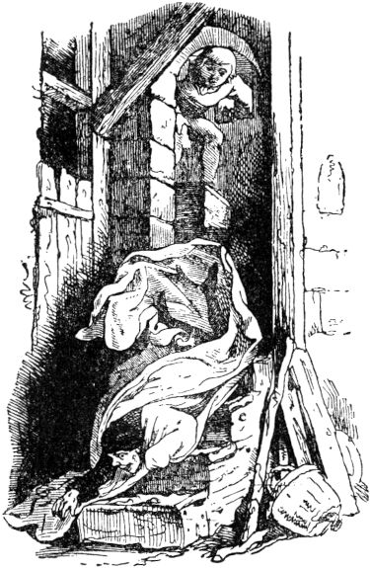narrow, full of centuries-old dust. Below lay the ghost, groaning and croaking, but Hansen rang the bell for evening prayers and even waved the bell ringer as if nothing had happened; then he cheerfully climbed down the stairs and went out of the tower, the door of which he closed behind him. The sexton had no idea where her husband was. “Where is he?” She asked Hanschen. "Who?" Asked Hansen. "He!" Said the sexton. “He's over to the tower in front of you.” - “So!” Said Hänschen: “ he iswas that? There was a white Labutzel on the stairs who didn't want to give me an answer, so I pushed him down the stairs, he's still over there and croaks. ”-“ Gallows rope! ”Shouted the sexton, tore out the key from Hanschen hand and jumped up on the tower, there her husband lay in his sheet and had broken a leg.445

Now Hansen was not doing well at all; the sexton sued his father, and he went wild and shouted: “The boy is a good-for-nothing, he should get out of my sight! Away, march! Here is money - go, let yourself be hung wherever you want - you will never come before my eyes. Insult and disgrace and harm are from you, you no good! "

“Go with God, little boy!” Scoffed Matthes; "Make sure you learn how to shudder, the shudder should be fashionable now, and people out in the world are terrified of all kinds of things, you will get your share of the shudder too!"

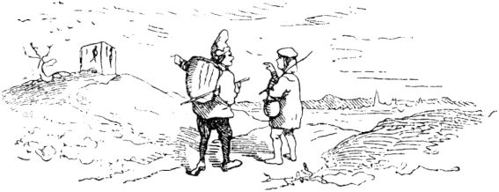

Hänschen went, he had money, and if someone has money, he doesn't even need to shudder. On the way he often said to himself: “If only I was shuddering, if only I was just shuddering!” This was heard by a man who came behind Hanschen and said to him: “Look over there - there is the tripod, there is a beautiful one Company off - just seven of them, as they say: a gallows full. There, take your night camp among the seven, there you will learn the creeps. "

“If that were true,” said Hänschen, “I want to give you all my money tomorrow morning. You can come to me and get it, or you can stay with me right away! "

“That I would be a fool and under the light gallows 446stay with you! ”replied that one. “No, my good friend, it is much easier to learn to shudder when one is alone than when he is two. Good night - Good-bye tomorrow in the morning! ”- Hanschen sat down under the gallows and, because it was cold, lit a fire that seemed pretty bright up to the hanged men, and the sharp night wind moved their trembling bodies to and fro, back and forth.

"Oh, you very poor devils!" Shouted Hanschen. “You are freezing that you snap and rattle. Wait, I want to bring you down, you should warm yourselves by my fire. ”And Hansen was not lazy, found a gallows ladder, climbed up, untied the hanged men and set them by his fire, which he now made stronger and bigger. But those looked pathetic, green, yellow and pitiful, lightning blue, abominable, as the saying goes, and did not move or move; the fire ate around it and began to char the rags and rags that hung around the dead corpses. “Well?” Said Hänschen, “you are burning your clothes! That's right with you: same rags, same rags! Wait - I want to help you be so careless! ”Took them one by one and hung them up again, wrapped himself in his cloak, stretched by his fire and fell asleep. This is how the man he went with yesterday and who came today to get the money found him. But since he saw Hansen sleeping so peacefully, he had little hope that he would have learned to shudder overnight, and when Hansen woke up and told him what he had been doing, the man turned to go and said: " I didn't earn your money this time, you will never learn how to shudder. "447

As Hanschen went on and on his way, he said to himself: “It's always a shame that I can't learn how to shudder, must be too stupid. Eh, eh - if only I could shudder. "

This was heard by a carter who was walking along the same path, and he said to Hanschen: “Well, can't you shudder? Only stop there in the pub on the way, if you have money, the landlord makes skin-shuddering drinks, I got overrun every time I had to stop at his house. "" We want to see that! " thanked the carter and walked towards the same tavern.

"Do what?" Asked the landlord. "Would like to learn how to shudder," answered Hänschen. "The people on the road say it would be easy to learn from you, you made such gruesome calculations and kept such gruesome chalk!" - Wait, yummy! thought the landlord, I would like to teach you something so that you get the horror, and to Hansen he said: "My dear traveling companion, you have been reported untruthfully; In my house you can by no means learn how to shudder, and I don't serve my guests as some jester told you and lied to you. If you are in the mood for the creeps, go up there to the old cursed castle up there and see that you get the king's daughter to be the wife of her father who promised him who freed the castle from its poltergeists; there is something to be scared about and get rich. "

"I will do as you advise me," said Hanschen, and the landlord spoke again: "It is not enough for you to go upstairs. First you have to ask the king's permission and you have to stay up there for three nights 448stay. If you get away with your life, the princess is your wife. "

"And if I can't get away with my life, what then?" Asked Hänschen - and the landlord laughed in his face and said: "I can see you're a clever man, you would certainly have invented the powder if it hadn't been invented yet." ! "

And Hänschen hurried to the king, asked for permission and received it, the king also said: "My son, you can take three things with you, but nothing alive." Now, even in his youth, Hanschen was always too fond of fire turned on, sat at the schnitzel bench and sometimes at the lathe, and knew how to deal with such things. That is why he wanted nothing more to take with him to the castle than a good lighter, a schnitzel bench and a lathe, "so that I don't freeze," he said: "and I can pass the time." and he took up his seat in a pretty room with a large fireplace in the old castle. When night fell, Hansen lit a bright fire that warmed and shone very nicely. Suddenly two coal-black cats came they had eyes as if from green fire and shouted: “Miau, meow, we are freezing!” “Well, if you are cold, just keep yourselves warm; there is a fire here! ”said Hänschen. The cats did that too, then they said: “The time is going to be too long for us, we want to play three cards, three-leaf or Pochens.” “Pochens for me,” said Hanschen, “if you brought cards with you.” The cats really did a game of cards, and showed it to Hanschen, and then Hanschen saw that they had terrible claws on their black paws and said: "With all due respect, your wife has mother 449You haven't cut your nails for a long time, feel ashamed, come on, I want to clean them for you! ”and grabbed the cats and stuck their paws in the lathe. Then they bit at him, and so he took his carving knife and cut off their heads, and threw cats' heads and bodies out of the window into the castle moat. When he came back to the fire, a large dog was sitting there baring its teeth and having a fiery tongue hanging out its arms length from its neck. Hanschen didn't like this again, 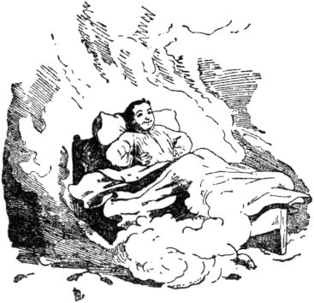He took his carving knife again and struck the dog straight between the teeth in the throat, then the tongue fell down and the upper head said goodbye to its lower part. Now Hanschen thought he was quiet and wanted to enjoy it too; There was a bed in the corner, so he lay down in it and covered himself up. But he had not yet fallen asleep when the bed began to move like a steam car and drove around the whole castle, up and down stairs, through halls and rooms - but Hansen said: "Look, now I can feel how it's doing, when the great gentlemen drive. You just keep driving. ”- Finally the bed might be tired from driving, it rolled back into Hansen's room, where the fire was still burning, there it stood still, and Hansen fell asleep and slept like a dead man.

The next morning the king stood by his bed and said: "Well, that would mean a sound sleep if I had it!" No king sleeps that well. Happy 450me that the boy is still alive and snoring. Heda! Hänschen! ”-“ Good morning, Mr. King! Already so early? ”Asked Hänschen. “I wish I rested,” said the King. "Thank you, too!" Said Hänschen. "You can have breakfast and lunch downstairs at the innkeeper's bill, but you'll be up here again in the evening, do you like?" Said the king and asked. "Well, of course," said Hanschen; "It has to be three nights."

How Hanschen got to the landlord was very surprised and asked: “Well? Still alive? - But you will have learned how to shudder last night? ”-“ Don't touch it! ”Replied Hanschen. Then the landlord himself began to shudder over and over in front of Hanschen. Hänschen took the King's account and did not worry about them, and when it was evening he was back up in the haunted castle and lit his fire. Suddenly there was a crackling up in the chimney, as if everything were breaking into a thousand rubble, and a guy came down, but he was only halfway. "Well," said Hänschen: "What is that supposed to be? There is still a half-decision missing, one and a half men are still no company. ”Hanschen had hardly said that, bautz! came the other half, in the middle of the fire. Hänschen took the two halves, threw it out of the fireplace into the room, and put his fire back in order. When he got there and looked around, the two halves had become a single guy, but not a handsome one, he was sitting on Hansen's chair.

"Place there!" Shouted Hansen, "here I sit, march, or I'll cut you in half with the paring knife."

Suddenly there was a rumble in the chimney again, dead legs 451and skulls pattered down, and a few more men of the most hideous appearance. "Good evening, gentlemen!" Said Hanschen; “They're whole men, I'll put up with that. Do they belong in the Schön family? Oh, what a shame that there isn't a mirror in the room. How can I actually serve you? ”- The men looked at Hanschen with terrible looks, one of them took the dead legs, there were just nine, and set them up as cones, the others took the skulls and rolled them to the cones.

“I like to play skittles for my life!” Said Hanschen, “won't you allow me to play too? Do you play board game or partens? For the portion money? How?"

"Do you have any money?" Asked the men grimly.

" *Oui!*"Said Hanschen, and went into his pocket and jingled.

"Well, push on!" Shouted one of the men, handing him a skull.

“With all due respect, that is a square ball. Give me a lathe, I want to turn it nice and round so that we can hit all nine well. ”Said and sat down, and turned the skulls round. Then the game started, Hanschen pushed well, but the men pushed even better, Hanschen lost something, and the game started again, Hanschen pushed and shouted joyfully: “All nine!” - “No, twelve!” The men shouted along with it dull sound, and disappeared with bones and skulls, and the old clock on the castle tower struck twelve. "Well, what!" Shouted Hansen. “Is that also a manner? First they lure me in my little money, and now I do a good job, get out of the dust. ”Then he lay down again in the bed, which remained very quiet today, and slept until the light of day.452

“Today he will probably not be alive any more,” said the king as he approached Hänschen's room, “I don't hear him snoring like yesterday, I will probably be over with him.” But Hansen encouraged himself very quickly and said: “ I wish you have rested, Your Majesty! ”-“ Likewise, thank you! ”Answered the King. "How was it that night?" - "Pretty nice, thank you for your kind inquiry, Mr. King!" Replied Hanschen. "There was a kind of chimney sweep there, they came down to the chimney and we bowled with death legs." The king's skin shuddered and he said: "But that's really scary!" . "That - just!" Replied the king. "Now luck, for the third night!"

“It's really fatal that I never learn how to shudder!” Said Hanschen to himself when the third night came. Suddenly there was a great rumor, six men stepped into the room, they were carrying a death drawer on the stretcher, put it in front of Hanschen and disappeared. Hänschen thought: “Who can lie in there?” And opened the coffin. There was one in there that was stiff and freezing. - "Oh, he's freezing, he's stiff from the frost," said Hanschen, "I have to warm him!" Lifted the dead man out of the coffin and carried him to his fire, but he stayed cold. "He has to go to bed, he'll get warmed up" - and took him and put him in bed, and himself too. After a while the dead man became warm and woke up, and spread out and said: “Who told you to disturb me in my rest? Now you should die! "-" Is that in a hurry? "Asked Hansen, grabbed it quickly, threw it into the drawer of the dead, the lid on it, and screwed it on quickly. The six men came straight away 453again, they picked up the coffin and carried it away.

Soon afterwards a horrible giant stepped in, with a great long beard, who shouted: “Worm! Now you have to die! You have to go with me! ”-“ I'm not going with you! ”Said Hanschen. “I'm not worried about it; I still have work to do, as you can see! ”and sat down at the lathe, and kicked the wheel, and turned the spindle, and held the chisel to the wood. The giant bent over the wheel and wanted to grab Hanschen. All of a sudden he screamed loudly: “Ouch! Ow! My beard, my beard! ”It was the end of the beard between the gut stringwho helped swing the wheel, came and had wound up tight from the fast turning and now pulled his whole head after her, and Hansen stepped on it freshly and said: "Guy, be careful, now I'm going to turn your big nose off, and turn your eyes out of your fat head and turn a cone ball, as true as my name is Hanschen! ”Then the giant gave the best words, Hanschen should let him go, he also wanted to show him the three boxes of gold that one was the king, the second was destined for the poor, the third he would give to him. "Well," said Hänschen, "give the thing here, but until I have it, you stay taut in the buck and carry the lathe on your shoulders."

It was very uncomfortable to carry, the bench on the shoulders, and the beard intertwined in the wheel that pulled. The giant went ahead into another room and showed Hans the boxes full of gold. Then it struck twelve, and then he disappeared, and the lathe stood without a support. Hanschen felt as if the boxes were also making an appearance to disappear when he shouted: "Stop, stop!" And took hold of them and held them tightly and pulled them 454over to his room, where he went to sleep, again without the creeps.

The next morning the king came and asked: "Well, it was definitely a scary night for you?"

"Why then, Herr König?" Asked Hansen. “I was given a box full of gold, also one for you and one for the poor. Do you have to get scary when you get gold as a gift? "

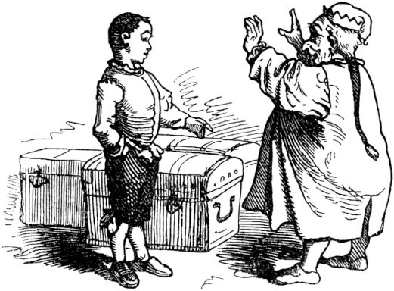

“You have achieved great things!” Said the king. “Through your fearlessness you freed the castle from the poltergeists and forced the enchanted treasure into the light. You shall also have your wages and marry my daughter! "

"Obliged, Herr König!" Said Hänschen, "but it is a pity that I am supposed to get married and I am still so stupid that I have not yet learned to shudder."

"Oh, my dear son and son-in-law!" Replied the king. “You just marry, everything will work out there. Quite a few people couldn't do that either and got married, and then they got extremely creepy and couldn't get rid of the goose bumps. "455

"I am pleased with the same hope, Herr König!" Exclaimed Hansen happily.

Soon it was a wonderful wedding, Hansen was very happy, very rich and had a beautiful wife, but he said: "I don't know how long it will be until I learn to be scared."

"Now wait, little boy! You should still shudder, "said the young queen, Hansen's wife, had a bucket of water with small gudgeons and ellipses brought over, and when Hans was asleep she took the blanket from him and poured the bucket full of water and little fish over it Hanschen here. "Brrrr!" He started, snapping from the cold. “I dreamed that I fell into the fish pond. - Brrrr! It scares me, it scares me! Got goose bumps like a grater! Do you see, dear woman? Finally now - now I can shudder, now I can shudder. "-

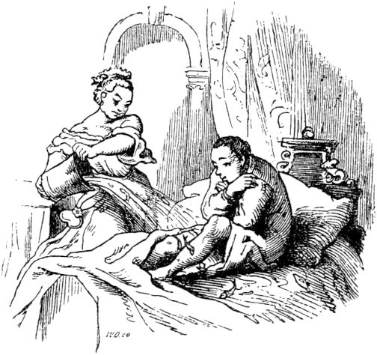

457

**Alphabetical index of fairy tales.**

**(The digits mean the page number.)**

* Monkeys, of two [432](http://www.gutenberg.org/files/63465/63465-h/63465-h.htm#chap_432)
* Cinderella [364](http://www.gutenberg.org/files/63465/63465-h/63465-h.htm#chap_364)
* Bade, The King in [192](http://www.gutenberg.org/files/63465/63465-h/63465-h.htm#chap_192)
* Bearskin, Rupert the [392nd](http://www.gutenberg.org/files/63465/63465-h/63465-h.htm#chap_392)
* Bluebeard, The Fairy Tale of the Knight [400](http://www.gutenberg.org/files/63465/63465-h/63465-h.htm#chap_400)
* Bride, The beautiful young [167](http://www.gutenberg.org/files/63465/63465-h/63465-h.htm#chap_167)
* Brother Saver and Brother Vertuer [390](http://www.gutenberg.org/files/63465/63465-h/63465-h.htm#chap_390)
* Sleeping Beauty [311](http://www.gutenberg.org/files/63465/63465-h/63465-h.htm#chap_311)
* The Shudder [442](http://www.gutenberg.org/files/63465/63465-h/63465-h.htm#chap_442)
* The Kitten and the Knitting Needles [218](http://www.gutenberg.org/files/63465/63465-h/63465-h.htm#chap_218)
* The fairy tale of the man in the moon [191](http://www.gutenberg.org/files/63465/63465-h/63465-h.htm#chap_191)
* The fairy tale of the knight Bluebeard [400](http://www.gutenberg.org/files/63465/63465-h/63465-h.htm#chap_400)
* The fairy tale of the land of milk and honey [279](http://www.gutenberg.org/files/63465/63465-h/63465-h.htm#chap_279)
* The fairy tale of the seven Swabians [15](http://www.gutenberg.org/files/63465/63465-h/63465-h.htm#chap_15)
* The Little Mouse Sambar, or the Faithful Friendship of Animals [338](http://www.gutenberg.org/files/63465/63465-h/63465-h.htm#chap_338)
* The Nut Branch [114](http://www.gutenberg.org/files/63465/63465-h/63465-h.htm#chap_114)
* The Partridge [96](http://www.gutenberg.org/files/63465/63465-h/63465-h.htm#chap_96)
* Little Red Riding Hood [90](http://www.gutenberg.org/files/63465/63465-h/63465-h.htm#chap_90)
* Tears [165](http://www.gutenberg.org/files/63465/63465-h/63465-h.htm#chap_165)
* Däumling, Der kleine [199](http://www.gutenberg.org/files/63465/63465-h/63465-h.htm#chap_199)
* The Old Wizard and His Children [119](http://www.gutenberg.org/files/63465/63465-h/63465-h.htm#chap_119)
* The Courageous Flute Player [181](http://www.gutenberg.org/files/63465/63465-h/63465-h.htm#chap_181)
* The golden roebuck [109](http://www.gutenberg.org/files/63465/63465-h/63465-h.htm#chap_109)
* The Rooster and the Fox [345](http://www.gutenberg.org/files/63465/63465-h/63465-h.htm#chap_345)
* The rabbit and the fox [176](http://www.gutenberg.org/files/63465/63465-h/63465-h.htm#chap_176)
* The Rabbit Keeper [186](http://www.gutenberg.org/files/63465/63465-h/63465-h.htm#chap_186)
* Little Tom Thumb [199](http://www.gutenberg.org/files/63465/63465-h/63465-h.htm#chap_199)
* The King in Bath [192](http://www.gutenberg.org/files/63465/63465-h/63465-h.htm#chap_192)
* The Heartless Man [128](http://www.gutenberg.org/files/63465/63465-h/63465-h.htm#chap_128)
* The Man and the Snake [342](http://www.gutenberg.org/files/63465/63465-h/63465-h.htm#chap_342)
* The Monk and the Little Bird [291](http://www.gutenberg.org/files/63465/63465-h/63465-h.htm#chap_291)
* The miller and the mermaid [247](http://www.gutenberg.org/files/63465/63465-h/63465-h.htm#chap_247)
* The Judge and the Devil [146](http://www.gutenberg.org/files/63465/63465-h/63465-h.htm#chap_146)
* The blacksmith from Jüterbogk [64](http://www.gutenberg.org/files/63465/63465-h/63465-h.htm#chap_64)
* The devil is on the loose or the fairy tale how the devil invented brandy [57](http://www.gutenberg.org/files/63465/63465-h/63465-h.htm#chap_57)
* The Juniper [Tree 372](http://www.gutenberg.org/files/63465/63465-h/63465-h.htm#chap_372)
* The white wolf [385](http://www.gutenberg.org/files/63465/63465-h/63465-h.htm#chap_385)
* The race between the rabbit and the hedgehog [219](http://www.gutenberg.org/files/63465/63465-h/63465-h.htm#chap_219)
* The Magic Contest [206](http://www.gutenberg.org/files/63465/63465-h/63465-h.htm#chap_206)
* The Dog's Distress [274](http://www.gutenberg.org/files/63465/63465-h/63465-h.htm#chap_274)
* The Little Shepherd's Dream [267](http://www.gutenberg.org/files/63465/63465-h/63465-h.htm#chap_267)
* King's Munster [264](http://www.gutenberg.org/files/63465/63465-h/63465-h.htm#chap_264)
* The two spherical millers [142](http://www.gutenberg.org/files/63465/63465-h/63465-h.htm#chap_142)
* The Grateful Animals [418](http://www.gutenberg.org/files/63465/63465-h/63465-h.htm#chap_418)
* The Three Stupid Devils [411](http://www.gutenberg.org/files/63465/63465-h/63465-h.htm#chap_411)
* The three feathers [157](http://www.gutenberg.org/files/63465/63465-h/63465-h.htm#chap_157)
* The three gifts [226](http://www.gutenberg.org/files/63465/63465-h/63465-h.htm#chap_226)
* The three wedding guests [174](http://www.gutenberg.org/files/63465/63465-h/63465-h.htm#chap_174)
* The three dogs [325](http://www.gutenberg.org/files/63465/63465-h/63465-h.htm#chap_325)
* The three musicians [238](http://www.gutenberg.org/files/63465/63465-h/63465-h.htm#chap_238)
* Goldmaria and Pechmaria [99](http://www.gutenberg.org/files/63465/63465-h/63465-h.htm#chap_99)
* The witch and the royal children [285](http://www.gutenberg.org/files/63465/63465-h/63465-h.htm#chap_285)
* The Cat and the Mouse [439](http://www.gutenberg.org/files/63465/63465-h/63465-h.htm#chap_439)
* The boys with the golden stars [368](http://www.gutenberg.org/files/63465/63465-h/63465-h.htm#chap_368)
* The ears of corn [170](http://www.gutenberg.org/files/63465/63465-h/63465-h.htm#chap_170)
* The life story of the mouse Sambar [349](http://www.gutenberg.org/files/63465/63465-h/63465-h.htm#chap_349)
* The Beautiful Young Bride [167](http://www.gutenberg.org/files/63465/63465-h/63465-h.htm#chap_167)
* The Seven Goats [294](http://www.gutenberg.org/files/63465/63465-h/63465-h.htm#chap_294)
* The Seven Ravens [159](http://www.gutenberg.org/files/63465/63465-h/63465-h.htm#chap_159)
* The Seven Swans [317](http://www.gutenberg.org/files/63465/63465-h/63465-h.htm#chap_317)
* The enchanted princess [51](http://www.gutenberg.org/files/63465/63465-h/63465-h.htm#chap_51)
* The Four Clever Fellows [421](http://www.gutenberg.org/files/63465/63465-h/63465-h.htm#chap_421)
* The specimens of the master thief [39](http://www.gutenberg.org/files/63465/63465-h/63465-h.htm#chap_39)
* Sleeping Beauty, The [311](http://www.gutenberg.org/files/63465/63465-h/63465-h.htm#chap_311)
* Vinegar jug, man and woman in the [212](http://www.gutenberg.org/files/63465/63465-h/63465-h.htm#chap_212)
* Feathers, The Three [157](http://www.gutenberg.org/files/63465/63465-h/63465-h.htm#chap_157)
* Flute Player, The Courageous [181](http://www.gutenberg.org/files/63465/63465-h/63465-h.htm#chap_181)
* Gifts, The Three [226](http://www.gutenberg.org/files/63465/63465-h/63465-h.htm#chap_226)
* Little Goats, The Seven [294](http://www.gutenberg.org/files/63465/63465-h/63465-h.htm#chap_294)
* Journeyman, The Four Wise [421](http://www.gutenberg.org/files/63465/63465-h/63465-h.htm#chap_421)
* Grim reaper [123](http://www.gutenberg.org/files/63465/63465-h/63465-h.htm#chap_123)
* Golden [253](http://www.gutenberg.org/files/63465/63465-h/63465-h.htm#chap_253)
* Golden Chicken [404](http://www.gutenberg.org/files/63465/63465-h/63465-h.htm#chap_404)
* Goldmaria, Die, und die Pechmaria [99](http://www.gutenberg.org/files/63465/63465-h/63465-h.htm#chap_99)
* God Everywhere [178](http://www.gutenberg.org/files/63465/63465-h/63465-h.htm#chap_178)
* Scary, The [442](http://www.gutenberg.org/files/63465/63465-h/63465-h.htm#chap_442)
* Hahn, Der, and the Fox [345](http://www.gutenberg.org/files/63465/63465-h/63465-h.htm#chap_345)
* Hans in fortune [150](http://www.gutenberg.org/files/63465/63465-h/63465-h.htm#chap_150)
* Hansel and Gretel [81](http://www.gutenberg.org/files/63465/63465-h/63465-h.htm#chap_81)
* Hare, Der, and the Fox [176](http://www.gutenberg.org/files/63465/63465-h/63465-h.htm#chap_176)
* Hasenhüter, The [186](http://www.gutenberg.org/files/63465/63465-h/63465-h.htm#chap_186)
* Heart, the man without [128](http://www.gutenberg.org/files/63465/63465-h/63465-h.htm#chap_128)
* Witch, Die, and the King's Children [285](http://www.gutenberg.org/files/63465/63465-h/63465-h.htm#chap_285)
* Millet thief [104](http://www.gutenberg.org/files/63465/63465-h/63465-h.htm#chap_104)
* Shepherds, The Little One, Happiness Dream [267](http://www.gutenberg.org/files/63465/63465-h/63465-h.htm#chap_267)
* Wedding guests, the three [174](http://www.gutenberg.org/files/63465/63465-h/63465-h.htm#chap_174)
* Holgott, Vogel, and Vogel Mosam [430](http://www.gutenberg.org/files/63465/63465-h/63465-h.htm#chap_430)
* Dogs, The Three [325](http://www.gutenberg.org/files/63465/63465-h/63465-h.htm#chap_325)
* Dog, Des, Distress [274](http://www.gutenberg.org/files/63465/63465-h/63465-h.htm#chap_274)
* Kitten, Das, and the Knitting Needles [218](http://www.gutenberg.org/files/63465/63465-h/63465-h.htm#chap_218)
* Cat, Die, and Mouse [439](http://www.gutenberg.org/files/63465/63465-h/63465-h.htm#chap_439)
* Boys with the little golden stars [368](http://www.gutenberg.org/files/63465/63465-h/63465-h.htm#chap_368)
* Ears of Corn, The [170](http://www.gutenberg.org/files/63465/63465-h/63465-h.htm#chap_170)
* Life Story, The, the Mouse Sambar [349](http://www.gutenberg.org/files/63465/63465-h/63465-h.htm#chap_349)
* Man who, without heart [128](http://www.gutenberg.org/files/63465/63465-h/63465-h.htm#chap_128)
* Man, The, and the Snake [342](http://www.gutenberg.org/files/63465/63465-h/63465-h.htm#chap_342)
* Man in the moon, the fairy tale from [191](http://www.gutenberg.org/files/63465/63465-h/63465-h.htm#chap_191)
* Man and woman in a vinegar jug [212](http://www.gutenberg.org/files/63465/63465-h/63465-h.htm#chap_212)
* Fairy tale, Das, vom Ritter Bluebeard [400](http://www.gutenberg.org/files/63465/63465-h/63465-h.htm#chap_400)
* Märchen, Das, vom Schlaraffenland [279](http://www.gutenberg.org/files/63465/63465-h/63465-h.htm#chap_279)
* Fairy tale, Das, von der Seven Schwaben [15](http://www.gutenberg.org/files/63465/63465-h/63465-h.htm#chap_15)
* Little Mice Sambar, Das, or the Faithful Friendship of Animals [338](http://www.gutenberg.org/files/63465/63465-h/63465-h.htm#chap_338)
* Master thief, the specimens of the [39](http://www.gutenberg.org/files/63465/63465-h/63465-h.htm#chap_39)
* Monk, The, and the Bird [291](http://www.gutenberg.org/files/63465/63465-h/63465-h.htm#chap_291)
* Müller, Der, and the Mermaid [247](http://www.gutenberg.org/files/63465/63465-h/63465-h.htm#chap_247)
* Müller, The two spherical [142](http://www.gutenberg.org/files/63465/63465-h/63465-h.htm#chap_142)
* Munster, The King [264](http://www.gutenberg.org/files/63465/63465-h/63465-h.htm#chap_264)
* Musicians, The Three [238](http://www.gutenberg.org/files/63465/63465-h/63465-h.htm#chap_238)
* Mermaid, the miller and the [247](http://www.gutenberg.org/files/63465/63465-h/63465-h.htm#chap_247)
* Nut branch, The [114](http://www.gutenberg.org/files/63465/63465-h/63465-h.htm#chap_114)
* Oda and the Serpent [224](http://www.gutenberg.org/files/63465/63465-h/63465-h.htm#chap_224)
* Princess, The Enchanted [51](http://www.gutenberg.org/files/63465/63465-h/63465-h.htm#chap_51)
* Specimen, Die, of the master thief [39](http://www.gutenberg.org/files/63465/63465-h/63465-h.htm#chap_39)
* Ravens, The Seven [159](http://www.gutenberg.org/files/63465/63465-h/63465-h.htm#chap_159)
* Partridge, The [96](http://www.gutenberg.org/files/63465/63465-h/63465-h.htm#chap_96)
* Roebuck, the golden [109](http://www.gutenberg.org/files/63465/63465-h/63465-h.htm#chap_109)
* Judge, The, and the Devil [146](http://www.gutenberg.org/files/63465/63465-h/63465-h.htm#chap_146)
* Little Red Riding Hood, The [90](http://www.gutenberg.org/files/63465/63465-h/63465-h.htm#chap_90)
* Rupert the Bearskin [392](http://www.gutenberg.org/files/63465/63465-h/63465-h.htm#chap_392)
* Snake, Oda and the [224](http://www.gutenberg.org/files/63465/63465-h/63465-h.htm#chap_224)
* Land of plenty, the fairy tale from [279](http://www.gutenberg.org/files/63465/63465-h/63465-h.htm#chap_279)
* Schmied, Der, von Jüterbogk [64](http://www.gutenberg.org/files/63465/63465-h/63465-h.htm#chap_64)
* Snow white [297](http://www.gutenberg.org/files/63465/63465-h/63465-h.htm#chap_297)
* Little Tailor, From the brave [5](http://www.gutenberg.org/files/63465/63465-h/63465-h.htm#chap_5)
* Swabia, Vom, who ate the liver [34](http://www.gutenberg.org/files/63465/63465-h/63465-h.htm#chap_34)
* Swan, stick on! [331](http://www.gutenberg.org/files/63465/63465-h/63465-h.htm#chap_331)
* Swans, The Seven [317](http://www.gutenberg.org/files/63465/63465-h/63465-h.htm#chap_317)
* Seven Ravens, The [159](http://www.gutenberg.org/files/63465/63465-h/63465-h.htm#chap_159)
* Seven Swabians, the fairy tale of the [15](http://www.gutenberg.org/files/63465/63465-h/63465-h.htm#chap_15)
* Seven Swans, The [317](http://www.gutenberg.org/files/63465/63465-h/63465-h.htm#chap_317)
* Siebenschön [259](http://www.gutenberg.org/files/63465/63465-h/63465-h.htm#chap_259)
* Saver, Brother, and Brother Vertuer [390](http://www.gutenberg.org/files/63465/63465-h/63465-h.htm#chap_390)
* Star and bathtub [137](http://www.gutenberg.org/files/63465/63465-h/63465-h.htm#chap_137)
* Brave little tailor, from [5](http://www.gutenberg.org/files/63465/63465-h/63465-h.htm#chap_5)
* The devil is going on [57](http://www.gutenberg.org/files/63465/63465-h/63465-h.htm#chap_57)
* Devil, the judge and the [146](http://www.gutenberg.org/files/63465/63465-h/63465-h.htm#chap_146)
* Devil, The Three Stupid [411](http://www.gutenberg.org/files/63465/63465-h/63465-h.htm#chap_411)
* Hell, how he invented brandy [57](http://www.gutenberg.org/files/63465/63465-h/63465-h.htm#chap_57)
* Animals, The Grateful [418](http://www.gutenberg.org/files/63465/63465-h/63465-h.htm#chap_418)
* Little table, set yourself up, donkey, stretch yourself, stick out of the sack [229](http://www.gutenberg.org/files/63465/63465-h/63465-h.htm#chap_229)
* Death, godfather [123](http://www.gutenberg.org/files/63465/63465-h/63465-h.htm#chap_123)
* Enchanted Princess, The [51st](http://www.gutenberg.org/files/63465/63465-h/63465-h.htm#chap_51)
* Vogel Holgott and Vogel Mosam [430](http://www.gutenberg.org/files/63465/63465-h/63465-h.htm#chap_430)
* From the chickens and chickens [171](http://www.gutenberg.org/files/63465/63465-h/63465-h.htm#chap_171)
* From the Swabian who ate the liver [34](http://www.gutenberg.org/files/63465/63465-h/63465-h.htm#chap_34)
* From the brave little tailor [5](http://www.gutenberg.org/files/63465/63465-h/63465-h.htm#chap_5)
* Anger roast [69](http://www.gutenberg.org/files/63465/63465-h/63465-h.htm#chap_69)
* Of the Wolf and the Mouse Dogs [436](http://www.gutenberg.org/files/63465/63465-h/63465-h.htm#chap_436)
* From two monkeys [432](http://www.gutenberg.org/files/63465/63465-h/63465-h.htm#chap_432)
* Juniper Tree, The [372](http://www.gutenberg.org/files/63465/63465-h/63465-h.htm#chap_372)
* Race, The, Between the Rabbit and the Hedgehog [219](http://www.gutenberg.org/files/63465/63465-h/63465-h.htm#chap_219)
* Wolf, The White [385](http://www.gutenberg.org/files/63465/63465-h/63465-h.htm#chap_385)
* Wolf, Von dem, and the Maushunde [436](http://www.gutenberg.org/files/63465/63465-h/63465-h.htm#chap_436)
* Wizard, the old man, and his children [119](http://www.gutenberg.org/files/63465/63465-h/63465-h.htm#chap_119)
* Magic competition, the [206](http://www.gutenberg.org/files/63465/63465-h/63465-h.htm#chap_206)
* Shiver [359](http://www.gutenberg.org/files/63465/63465-h/63465-h.htm#chap_359)
* Zornbraten, from [69](http://www.gutenberg.org/files/63465/63465-h/63465-h.htm#chap_69)

462

**Content.**

|  |  |
| --- | --- |
|  | **page** |
| From the brave little tailor | [5](http://www.gutenberg.org/files/63465/63465-h/63465-h.htm#chap_5) |
| The fairy tale of the seven Swabians | [15th](http://www.gutenberg.org/files/63465/63465-h/63465-h.htm#chap_15) |
| From the Swabian who ate the liver | [34](http://www.gutenberg.org/files/63465/63465-h/63465-h.htm#chap_34) |
| The master thief's specimens | [39](http://www.gutenberg.org/files/63465/63465-h/63465-h.htm#chap_39) |
| The bewitched princess | [51](http://www.gutenberg.org/files/63465/63465-h/63465-h.htm#chap_51) |
| The devil is loose or the fairy tale how the devil invented brandy | [57](http://www.gutenberg.org/files/63465/63465-h/63465-h.htm#chap_57) |
| The blacksmith from Jüterbogk | [64](http://www.gutenberg.org/files/63465/63465-h/63465-h.htm#chap_64) |
| From roast anger | [69](http://www.gutenberg.org/files/63465/63465-h/63465-h.htm#chap_69) |
| Hansel and Gretel | [81](http://www.gutenberg.org/files/63465/63465-h/63465-h.htm#chap_81) |
| Little Red Riding Hood | [90](http://www.gutenberg.org/files/63465/63465-h/63465-h.htm#chap_90) |
| The partridge | [96](http://www.gutenberg.org/files/63465/63465-h/63465-h.htm#chap_96) |
| The Goldmaria and the Pechmaria | [99](http://www.gutenberg.org/files/63465/63465-h/63465-h.htm#chap_99) |
| Millet thief | [104](http://www.gutenberg.org/files/63465/63465-h/63465-h.htm#chap_104) |
| The golden roebuck | [109](http://www.gutenberg.org/files/63465/63465-h/63465-h.htm#chap_109) |
| The nut branch | [114](http://www.gutenberg.org/files/63465/63465-h/63465-h.htm#chap_114) |
| The old wizard and his children | [119](http://www.gutenberg.org/files/63465/63465-h/63465-h.htm#chap_119) |
| The Grim Reaper | [123](http://www.gutenberg.org/files/63465/63465-h/63465-h.htm#chap_123) |
| The man without a heart | [128](http://www.gutenberg.org/files/63465/63465-h/63465-h.htm#chap_128) |
| Star and bathtub | [137](http://www.gutenberg.org/files/63465/63465-h/63465-h.htm#chap_137) |
| The two round millers | [142](http://www.gutenberg.org/files/63465/63465-h/63465-h.htm#chap_142) |
| The judge and the devil | [146](http://www.gutenberg.org/files/63465/63465-h/63465-h.htm#chap_146) |
| Happy Hans | [150](http://www.gutenberg.org/files/63465/63465-h/63465-h.htm#chap_150) |
| The three feathers | [157](http://www.gutenberg.org/files/63465/63465-h/63465-h.htm#chap_157) |
| The seven Ravens | [159](http://www.gutenberg.org/files/63465/63465-h/63465-h.htm#chap_159) |
| The teardrop jug | [165](http://www.gutenberg.org/files/63465/63465-h/63465-h.htm#chap_165) |
| The beautiful young bride | [167](http://www.gutenberg.org/files/63465/63465-h/63465-h.htm#chap_167) |
| The ears of corn | [170](http://www.gutenberg.org/files/63465/63465-h/63465-h.htm#chap_170) |
| From the chickens and chickens | [171](http://www.gutenberg.org/files/63465/63465-h/63465-h.htm#chap_171) |
| The three wedding guests | [174](http://www.gutenberg.org/files/63465/63465-h/63465-h.htm#chap_174) |
| The hare and the fox | [176](http://www.gutenberg.org/files/63465/63465-h/63465-h.htm#chap_176) |
| God everywhere | [178](http://www.gutenberg.org/files/63465/63465-h/63465-h.htm#chap_178) |
| The courageous flute player | [181](http://www.gutenberg.org/files/63465/63465-h/63465-h.htm#chap_181) |
| The hare keeper | [186](http://www.gutenberg.org/files/63465/63465-h/63465-h.htm#chap_186) |
| The fairy tale of the man in the moon | [191](http://www.gutenberg.org/files/63465/63465-h/63465-h.htm#chap_191) |
| The king in the bath | [192](http://www.gutenberg.org/files/63465/63465-h/63465-h.htm#chap_192) |
| Little Thumbnail | [199](http://www.gutenberg.org/files/63465/63465-h/63465-h.htm#chap_199) |
| The magic contest | [206](http://www.gutenberg.org/files/63465/63465-h/63465-h.htm#chap_206) |
| Man and woman in a vinegar jug | [212](http://www.gutenberg.org/files/63465/63465-h/63465-h.htm#chap_212) |
| The kitten and the knitting needles | [218](http://www.gutenberg.org/files/63465/63465-h/63465-h.htm#chap_218) |
| The race between the hare and the hedgehog | [219](http://www.gutenberg.org/files/63465/63465-h/63465-h.htm#chap_219) |
| Oda and the snake | [224](http://www.gutenberg.org/files/63465/63465-h/63465-h.htm#chap_224) |
| The three gifts | [226](http://www.gutenberg.org/files/63465/63465-h/63465-h.htm#chap_226) |
| Set the table, donkey stretch out, stick out of the sack | [229](http://www.gutenberg.org/files/63465/63465-h/63465-h.htm#chap_229) |
| The three musicians | [238](http://www.gutenberg.org/files/63465/63465-h/63465-h.htm#chap_238) |
| The miller and the mermaid | [247](http://www.gutenberg.org/files/63465/63465-h/63465-h.htm#chap_247) |
| Golden | [253](http://www.gutenberg.org/files/63465/63465-h/63465-h.htm#chap_253) |
| Seven beautiful | [259](http://www.gutenberg.org/files/63465/63465-h/63465-h.htm#chap_259) |
| The king's cathedral | [264](http://www.gutenberg.org/files/63465/63465-h/63465-h.htm#chap_264) |
| The little shepherd's dream of happiness | [267](http://www.gutenberg.org/files/63465/63465-h/63465-h.htm#chap_267) |
| The dog's distress | [274](http://www.gutenberg.org/files/63465/63465-h/63465-h.htm#chap_274) |
| The fairy tale of the land of milk and honey | [279](http://www.gutenberg.org/files/63465/63465-h/63465-h.htm#chap_279) |
| The witch and the royal children | [285](http://www.gutenberg.org/files/63465/63465-h/63465-h.htm#chap_285) |
| The monk and the bird | [291](http://www.gutenberg.org/files/63465/63465-h/63465-h.htm#chap_291) |
| The seven little kids | [294](http://www.gutenberg.org/files/63465/63465-h/63465-h.htm#chap_294) |
| Snow white | [297](http://www.gutenberg.org/files/63465/63465-h/63465-h.htm#chap_297) |
| The Sleeping Beauty | [311](http://www.gutenberg.org/files/63465/63465-h/63465-h.htm#chap_311) |
| The seven swans | [317](http://www.gutenberg.org/files/63465/63465-h/63465-h.htm#chap_317) |
| The three dogs | [325](http://www.gutenberg.org/files/63465/63465-h/63465-h.htm#chap_325) |
| Swan, stick on! | [331](http://www.gutenberg.org/files/63465/63465-h/63465-h.htm#chap_331) |
| The little mouse Sambar, or the faithful friendship of animals | [338](http://www.gutenberg.org/files/63465/63465-h/63465-h.htm#chap_338) |
| The man and the snake | [342](http://www.gutenberg.org/files/63465/63465-h/63465-h.htm#chap_342) |
| The rooster and the fox | [345](http://www.gutenberg.org/files/63465/63465-h/63465-h.htm#chap_345) |
| The life story of the mouse Sambar | [349](http://www.gutenberg.org/files/63465/63465-h/63465-h.htm#chap_349) |
| Trembling rabbit | [359](http://www.gutenberg.org/files/63465/63465-h/63465-h.htm#chap_359) |
| Cinderella | [364](http://www.gutenberg.org/files/63465/63465-h/63465-h.htm#chap_364) |
| The boys with the golden stars | [368](http://www.gutenberg.org/files/63465/63465-h/63465-h.htm#chap_368) |
| The juniper tree | [372](http://www.gutenberg.org/files/63465/63465-h/63465-h.htm#chap_372) |
| The white wolf | [385](http://www.gutenberg.org/files/63465/63465-h/63465-h.htm#chap_385) |
| Brother Saver and Brother Vertuer | [390](http://www.gutenberg.org/files/63465/63465-h/63465-h.htm#chap_390) |
| Rupert the bearskin | [392](http://www.gutenberg.org/files/63465/63465-h/63465-h.htm#chap_392) |
| The fairy tale of the knight Bluebeard | [400](http://www.gutenberg.org/files/63465/63465-h/63465-h.htm#chap_400) |
| Golden chicken | [404](http://www.gutenberg.org/files/63465/63465-h/63465-h.htm#chap_404) |
| The three stupid devils | [411](http://www.gutenberg.org/files/63465/63465-h/63465-h.htm#chap_411) |
| The thankful animals | [418](http://www.gutenberg.org/files/63465/63465-h/63465-h.htm#chap_418) |
| The four clever fellows | [421](http://www.gutenberg.org/files/63465/63465-h/63465-h.htm#chap_421) |
| Vogel Holgott and Vogel Mosam | [430](http://www.gutenberg.org/files/63465/63465-h/63465-h.htm#chap_430) |
| From two monkeys | [432](http://www.gutenberg.org/files/63465/63465-h/63465-h.htm#chap_432) |
| About the wolf and the mouse dogs | [436](http://www.gutenberg.org/files/63465/63465-h/63465-h.htm#chap_436) |
| The cat and the mouse | [439](http://www.gutenberg.org/files/63465/63465-h/63465-h.htm#chap_439) |
| The shudder | [442](http://www.gutenberg.org/files/63465/63465-h/63465-h.htm#chap_442) |
| Alphabetical index of fairy tales | [457](http://www.gutenberg.org/files/63465/63465-h/63465-h.htm#chap_457) |

Printed and bound by Hesse & Becker in Leipzig. 4,424

**Notes on the transcription**

Der Originaltext ist zum größten Teil in Fraktur gesetzt. Textstellen in Antiqua sind in Kursivschrift gesetzt (keine Kursivschrift im Original).

Offensichtliche Druckfehler wurden korrigiert.

Die folgenden Fehler wurden wie hier aufgeführt korrigiert (vorher/nachher):

* ... ein großer Gedaken durch das ...
* ... ein großer [Gedanke](http://www.gutenberg.org/files/63465/63465-h/63465-h.htm#corr_1) durch das ...
* ... ihm folgte der Blitzschwab ...
* ... ihm [folgten](http://www.gutenberg.org/files/63465/63465-h/63465-h.htm#corr_2) der Blitzschwab ...
* ... in seinem Schloß um einiger wenigen Strolche ...
* ... in seinem Schloß um einiger [weniger](http://www.gutenberg.org/files/63465/63465-h/63465-h.htm#corr_3) Strolche ...
* ... Daß di der Drach net beisse kahn! ...
* ... Daß di der Drach net [beiße](http://www.gutenberg.org/files/63465/63465-h/63465-h.htm#corr_4) kahn! ...
* ... heiße ihm uns ein Lämmlein zu geben ...
* ... heiße [ihn](http://www.gutenberg.org/files/63465/63465-h/63465-h.htm#corr_5) uns ein Lämmlein zu geben ...
* ... auf einmal kamen scharze Ameisen ...
* ... auf einmal kamen [schwarze](http://www.gutenberg.org/files/63465/63465-h/63465-h.htm#corr_6) Ameisen ...
* ... in der Menschen Händen bist ...
* ... in der Menschen [Hände](http://www.gutenberg.org/files/63465/63465-h/63465-h.htm#corr_7) bist ...
* ... den Herrn Insegrimm im Bette ...
* ... den Herrn [Isegrim](http://www.gutenberg.org/files/63465/63465-h/63465-h.htm#corr_8) im Bette ...
* ... die Alte war nigends zu erblicken ...
* ... die Alte war [nirgends](http://www.gutenberg.org/files/63465/63465-h/63465-h.htm#corr_9) zu erblicken ...
* ... denn du hast mich damals nicht mit wahren ...
* ... denn du hast [mir](http://www.gutenberg.org/files/63465/63465-h/63465-h.htm#corr_10) damals nicht mit wahren ...
* ... Des Abends ging sie vors erste beste Haus ...
* ... Des Abends [gingen](http://www.gutenberg.org/files/63465/63465-h/63465-h.htm#corr_11) sie vors erste beste Haus ...
* ... Die drei Hochzeitgäste. ...
* ... Die drei [Hochzeitsgäste](http://www.gutenberg.org/files/63465/63465-h/63465-h.htm#corr_12). ...
* ... ohne eine Wort zu sagen ...
* ... ohne [ein](http://www.gutenberg.org/files/63465/63465-h/63465-h.htm#corr_13) Wort zu sagen ...
* ... er das Dach eines kleines Häuschens ...
* ... er das Dach eines [kleinen](http://www.gutenberg.org/files/63465/63465-h/63465-h.htm#corr_14) Häuschens ...
* ... und da kam ihm seine böse Lust wieder an ...
* ... und da kam [ihn](http://www.gutenberg.org/files/63465/63465-h/63465-h.htm#corr_15) seine böse Lust wieder an ...
* ... und Menschenfresser tappte blind umher ...
* ... und [der Menschenfresser](http://www.gutenberg.org/files/63465/63465-h/63465-h.htm#corr_16) tappte blind umher ...
* ... durch den, denn sie immer ...
* ... durch den, [den](http://www.gutenberg.org/files/63465/63465-h/63465-h.htm#corr_17) sie immer ...
* ... Backwerk wurde ebenso schnell ...
* ... Backwerk [wurden](http://www.gutenberg.org/files/63465/63465-h/63465-h.htm#corr_18) ebenso schnell ...
* ... hatte er Macht, alle Sterbliche zu überwältigen ...
* ... hatte er Macht, alle [Sterblichen](http://www.gutenberg.org/files/63465/63465-h/63465-h.htm#corr_19) zu überwältigen ...
* ... und eilte gutes Mutes nach seiner ...
* ... und eilte [guten](http://www.gutenberg.org/files/63465/63465-h/63465-h.htm#corr_20) Mutes nach seiner ...
* ... Da kam wieder eine rauchende ...
* ... Da kam wieder eine [rauschende](http://www.gutenberg.org/files/63465/63465-h/63465-h.htm#corr_21) ...
* ... sie recht fruchbar gelegen ...
* ... sie recht [fruchtbar](http://www.gutenberg.org/files/63465/63465-h/63465-h.htm#corr_22) gelegen ...
* ... seines Vater wiederzufinden ...
* ... seines [Vaters](http://www.gutenberg.org/files/63465/63465-h/63465-h.htm#corr_23) wiederzufinden ...
* ... wo ihr eingesprochen seid und ...
* ... wo ihr [eingebrochen](http://www.gutenberg.org/files/63465/63465-h/63465-h.htm#corr_24) seid und ...
* ... Dem aber, welchen das allgemeine Stimmrecht ...
* ... [Der](http://www.gutenberg.org/files/63465/63465-h/63465-h.htm#corr_25) aber, welchen das allgemeine Stimmrecht ...
* ... Das rief das Mäuslein ...
* ... [Da](http://www.gutenberg.org/files/63465/63465-h/63465-h.htm#corr_26) rief das Mäuslein ...
* ... sie alle erledigst hast ...
* ... sie alle [erledigt](http://www.gutenberg.org/files/63465/63465-h/63465-h.htm#corr_27) hast ...
* ... hineinkommen möchte? Indes ...
* ... hineinkommen möchte[.](http://www.gutenberg.org/files/63465/63465-h/63465-h.htm#corr_28) Indes ...
* ... aber nahm war, daß ...
* ... aber nahm [wahr](http://www.gutenberg.org/files/63465/63465-h/63465-h.htm#corr_29), daß ...
* ... Hirsch sich zur ihr und sprach: ...
* ... Hirsch sich [zu](http://www.gutenberg.org/files/63465/63465-h/63465-h.htm#corr_30) ihr und sprach: ...
* ... dich nicht wäscht, ...
* ... dich nicht [wäschst](http://www.gutenberg.org/files/63465/63465-h/63465-h.htm#corr_31), ...
* ... ausgenommen den Teufel seine alte Großmutter ...
* ... ausgenommen [dem](http://www.gutenberg.org/files/63465/63465-h/63465-h.htm#corr_32) Teufel seine alte Großmutter ...
* ... Wir sind im Dank ...
* ... Wir sind [ihm](http://www.gutenberg.org/files/63465/63465-h/63465-h.htm#corr_33) Dank ...
* ... über den Kopf zusammenfällt und einmal ...
* ... über [dem](http://www.gutenberg.org/files/63465/63465-h/63465-h.htm#corr_34) Kopf zusammenfällt und einmal ...
* ... daß das Haus den Einsturz drohte ...
* ... daß [dem Haus der](http://www.gutenberg.org/files/63465/63465-h/63465-h.htm#corr_35) Einsturz drohte ...
* ... als er auf Hänschen Zimmer zuging ...
* ... als er auf [Hänschens](http://www.gutenberg.org/files/63465/63465-h/63465-h.htm#corr_36) Zimmer zuging ...
* ... die Darmseite, die das Rad umschwingen ...
* ... die [Darmsaite](http://www.gutenberg.org/files/63465/63465-h/63465-h.htm#corr_37), die das Rad umschwingen ...

End of Project Gutenberg's Ludwig Bechsteins Märchenbuch, by Ludwig Bechstein

*** END OF THIS PROJECT GUTENBERG EBOOK LUDWIG BECHSTEINS MÄRCHENBUCH ***

***** This file should be named 63465-h.htm or 63465-h.zip *****

This and all associated files of various formats will be found in:

http://www.gutenberg.org/6/3/4/6/63465/

Produced by Ray Papworth and the Online Distributed

Proofreading Team at https://www.pgdp.net

Updated editions will replace the previous one--the old editions

will be renamed.

Creating the works from public domain print editions means that no

one owns a United States copyright in these works, so the Foundation

(and you!) can copy and distribute it in the United States without

permission and without paying copyright royalties. Special rules,

set forth in the General Terms of Use part of this license, apply to

copying and distributing Project Gutenberg-tm electronic works to

protect the PROJECT GUTENBERG-tm concept and trademark. Project

Gutenberg is a registered trademark, and may not be used if you

charge for the eBooks, unless you receive specific permission. If you

do not charge anything for copies of this eBook, complying with the

rules is very easy. You may use this eBook for nearly any purpose

such as creation of derivative works, reports, performances and

research. They may be modified and printed and given away--you may do

practically ANYTHING with public domain eBooks. Redistribution is

subject to the trademark license, especially commercial

redistribution.

*** START: FULL LICENSE ***

THE FULL PROJECT GUTENBERG LICENSE

PLEASE READ THIS BEFORE YOU DISTRIBUTE OR USE THIS WORK

To protect the Project Gutenberg-tm mission of promoting the free

distribution of electronic works, by using or distributing this work

(or any other work associated in any way with the phrase "Project

Gutenberg"), you agree to comply with all the terms of the Full Project

Gutenberg-tm License (available with this file or online at

http://gutenberg.org/license).

Section 1. General Terms of Use and Redistributing Project Gutenberg-tm

electronic works

1.A. By reading or using any part of this Project Gutenberg-tm

electronic work, you indicate that you have read, understand, agree to

and accept all the terms of this license and intellectual property

(trademark/copyright) agreement. If you do not agree to abide by all

the terms of this agreement, you must cease using and return or destroy

all copies of Project Gutenberg-tm electronic works in your possession.

If you paid a fee for obtaining a copy of or access to a Project

Gutenberg-tm electronic work and you do not agree to be bound by the

terms of this agreement, you may obtain a refund from the person or

entity to whom you paid the fee as set forth in paragraph 1.E.8.

1.B. "Project Gutenberg" is a registered trademark. It may only be

used on or associated in any way with an electronic work by people who

agree to be bound by the terms of this agreement. There are a few

things that you can do with most Project Gutenberg-tm electronic works

even without complying with the full terms of this agreement. See

paragraph 1.C below. There are a lot of things you can do with Project

Gutenberg-tm electronic works if you follow the terms of this agreement

and help preserve free future access to Project Gutenberg-tm electronic

works. See paragraph 1.E below.

1.C. The Project Gutenberg Literary Archive Foundation ("the Foundation"

or PGLAF), owns a compilation copyright in the collection of Project

Gutenberg-tm electronic works. Nearly all the individual works in the

collection are in the public domain in the United States. If an

individual work is in the public domain in the United States and you are

located in the United States, we do not claim a right to prevent you from

copying, distributing, performing, displaying or creating derivative

works based on the work as long as all references to Project Gutenberg

are removed. Of course, we hope that you will support the Project

Gutenberg-tm mission of promoting free access to electronic works by

freely sharing Project Gutenberg-tm works in compliance with the terms of

this agreement for keeping the Project Gutenberg-tm name associated with

the work. You can easily comply with the terms of this agreement by

keeping this work in the same format with its attached full Project

Gutenberg-tm License when you share it without charge with others.

1.D. The copyright laws of the place where you are located also govern

what you can do with this work. Copyright laws in most countries are in

a constant state of change. If you are outside the United States, check

the laws of your country in addition to the terms of this agreement

before downloading, copying, displaying, performing, distributing or

creating derivative works based on this work or any other Project

Gutenberg-tm work. The Foundation makes no representations concerning

the copyright status of any work in any country outside the United

States.

1.E. Unless you have removed all references to Project Gutenberg:

1.E.1. The following sentence, with active links to, or other immediate

access to, the full Project Gutenberg-tm License must appear prominently

whenever any copy of a Project Gutenberg-tm work (any work on which the

phrase "Project Gutenberg" appears, or with which the phrase "Project

Gutenberg" is associated) is accessed, displayed, performed, viewed,

copied or distributed:

This eBook is for the use of anyone anywhere at no cost and with

almost no restrictions whatsoever. You may copy it, give it away or

re-use it under the terms of the Project Gutenberg License included

with this eBook or online at www.gutenberg.org/license

1.E.2. If an individual Project Gutenberg-tm electronic work is derived

from the public domain (does not contain a notice indicating that it is

posted with permission of the copyright holder), the work can be copied

and distributed to anyone in the United States without paying any fees

or charges. If you are redistributing or providing access to a work

with the phrase "Project Gutenberg" associated with or appearing on the

work, you must comply either with the requirements of paragraphs 1.E.1

through 1.E.7 or obtain permission for the use of the work and the

Project Gutenberg-tm trademark as set forth in paragraphs 1.E.8 or

1.E.9.

1.E.3. If an individual Project Gutenberg-tm electronic work is posted

with the permission of the copyright holder, your use and distribution

must comply with both paragraphs 1.E.1 through 1.E.7 and any additional

terms imposed by the copyright holder. Additional terms will be linked

to the Project Gutenberg-tm License for all works posted with the

permission of the copyright holder found at the beginning of this work.

1.E.4. Do not unlink or detach or remove the full Project Gutenberg-tm

License terms from this work, or any files containing a part of this

work or any other work associated with Project Gutenberg-tm.

1.E.5. Do not copy, display, perform, distribute or redistribute this

electronic work, or any part of this electronic work, without

prominently displaying the sentence set forth in paragraph 1.E.1 with

active links or immediate access to the full terms of the Project

Gutenberg-tm License.

1.E.6. You may convert to and distribute this work in any binary,

compressed, marked up, nonproprietary or proprietary form, including any

word processing or hypertext form. However, if you provide access to or

distribute copies of a Project Gutenberg-tm work in a format other than

"Plain Vanilla ASCII" or other format used in the official version

posted on the official Project Gutenberg-tm web site (www.gutenberg.org),

you must, at no additional cost, fee or expense to the user, provide a

copy, a means of exporting a copy, or a means of obtaining a copy upon

request, of the work in its original "Plain Vanilla ASCII" or other

form. Any alternate format must include the full Project Gutenberg-tm

License as specified in paragraph 1.E.1.

1.E.7. Do not charge a fee for access to, viewing, displaying,

performing, copying or distributing any Project Gutenberg-tm works

unless you comply with paragraph 1.E.8 or 1.E.9.

1.E.8. You may charge a reasonable fee for copies of or providing

access to or distributing Project Gutenberg-tm electronic works provided

that

- You pay a royalty fee of 20% of the gross profits you derive from

the use of Project Gutenberg-tm works calculated using the method

you already use to calculate your applicable taxes. The fee is

owed to the owner of the Project Gutenberg-tm trademark, but he

has agreed to donate royalties under this paragraph to the

Project Gutenberg Literary Archive Foundation. Royalty payments

must be paid within 60 days following each date on which you

prepare (or are legally required to prepare) your periodic tax

returns. Royalty payments should be clearly marked as such and

sent to the Project Gutenberg Literary Archive Foundation at the

address specified in Section 4, "Information about donations to

the Project Gutenberg Literary Archive Foundation."

- You provide a full refund of any money paid by a user who notifies

you in writing (or by e-mail) within 30 days of receipt that s/he

does not agree to the terms of the full Project Gutenberg-tm

License. You must require such a user to return or

destroy all copies of the works possessed in a physical medium

and discontinue all use of and all access to other copies of

Project Gutenberg-tm works.

- You provide, in accordance with paragraph 1.F.3, a full refund of any

money paid for a work or a replacement copy, if a defect in the

electronic work is discovered and reported to you within 90 days

of receipt of the work.

- You comply with all other terms of this agreement for free

distribution of Project Gutenberg-tm works.

1.E.9. If you wish to charge a fee or distribute a Project Gutenberg-tm

electronic work or group of works on different terms than are set

forth in this agreement, you must obtain permission in writing from

both the Project Gutenberg Literary Archive Foundation and Michael

Hart, the owner of the Project Gutenberg-tm trademark. Contact the

Foundation as set forth in Section 3 below.

1.F.

1.F.1. Project Gutenberg volunteers and employees expend considerable

effort to identify, do copyright research on, transcribe and proofread

public domain works in creating the Project Gutenberg-tm

collection. Despite these efforts, Project Gutenberg-tm electronic

works, and the medium on which they may be stored, may contain

"Defects," such as, but not limited to, incomplete, inaccurate or

corrupt data, transcription errors, a copyright or other intellectual

property infringement, a defective or damaged disk or other medium, a

computer virus, or computer codes that damage or cannot be read by

your equipment.

1.F.2. LIMITED WARRANTY, DISCLAIMER OF DAMAGES - Except for the "Right

of Replacement or Refund" described in paragraph 1.F.3, the Project

Gutenberg Literary Archive Foundation, the owner of the Project

Gutenberg-tm trademark, and any other party distributing a Project

Gutenberg-tm electronic work under this agreement, disclaim all

liability to you for damages, costs and expenses, including legal

fees. YOU AGREE THAT YOU HAVE NO REMEDIES FOR NEGLIGENCE, STRICT

LIABILITY, BREACH OF WARRANTY OR BREACH OF CONTRACT EXCEPT THOSE

PROVIDED IN PARAGRAPH 1.F.3. YOU AGREE THAT THE FOUNDATION, THE

TRADEMARK OWNER, AND ANY DISTRIBUTOR UNDER THIS AGREEMENT WILL NOT BE

LIABLE TO YOU FOR ACTUAL, DIRECT, INDIRECT, CONSEQUENTIAL, PUNITIVE OR

INCIDENTAL DAMAGES EVEN IF YOU GIVE NOTICE OF THE POSSIBILITY OF SUCH

DAMAGE.

1.F.3. LIMITED RIGHT OF REPLACEMENT OR REFUND - If you discover a

defect in this electronic work within 90 days of receiving it, you can

receive a refund of the money (if any) you paid for it by sending a

written explanation to the person you received the work from. If you

received the work on a physical medium, you must return the medium with

your written explanation. The person or entity that provided you with

the defective work may elect to provide a replacement copy in lieu of a

refund. If you received the work electronically, the person or entity

providing it to you may choose to give you a second opportunity to

receive the work electronically in lieu of a refund. If the second copy

is also defective, you may demand a refund in writing without further

opportunities to fix the problem.

1.F.4. Except for the limited right of replacement or refund set forth

in paragraph 1.F.3, this work is provided to you 'AS-IS' WITH NO OTHER

WARRANTIES OF ANY KIND, EXPRESS OR IMPLIED, INCLUDING BUT NOT LIMITED TO

WARRANTIES OF MERCHANTABILITY OR FITNESS FOR ANY PURPOSE.

1.F.5. Some states do not allow disclaimers of certain implied

warranties or the exclusion or limitation of certain types of damages.

If any disclaimer or limitation set forth in this agreement violates the

law of the state applicable to this agreement, the agreement shall be

interpreted to make the maximum disclaimer or limitation permitted by

the applicable state law. The invalidity or unenforceability of any

provision of this agreement shall not void the remaining provisions.

1.F.6. INDEMNITY - You agree to indemnify and hold the Foundation, the

trademark owner, any agent or employee of the Foundation, anyone

providing copies of Project Gutenberg-tm electronic works in accordance

with this agreement, and any volunteers associated with the production,

promotion and distribution of Project Gutenberg-tm electronic works,

harmless from all liability, costs and expenses, including legal fees,

that arise directly or indirectly from any of the following which you do

or cause to occur: (a) distribution of this or any Project Gutenberg-tm

work, (b) alteration, modification, or additions or deletions to any

Project Gutenberg-tm work, and (c) any Defect you cause.

Section 2. Information about the Mission of Project Gutenberg-tm

Project Gutenberg-tm is synonymous with the free distribution of

electronic works in formats readable by the widest variety of computers

including obsolete, old, middle-aged and new computers. It exists

because of the efforts of hundreds of volunteers and donations from

people in all walks of life.

Volunteers and financial support to provide volunteers with the

assistance they need, are critical to reaching Project Gutenberg-tm's

goals and ensuring that the Project Gutenberg-tm collection will

remain freely available for generations to come. In 2001, the Project

Gutenberg Literary Archive Foundation was created to provide a secure

and permanent future for Project Gutenberg-tm and future generations.

To learn more about the Project Gutenberg Literary Archive Foundation

and how your efforts and donations can help, see Sections 3 and 4

and the Foundation web page at http://www.pglaf.org.

Section 3. Information about the Project Gutenberg Literary Archive

Foundation

The Project Gutenberg Literary Archive Foundation is a non profit

501(c)(3) educational corporation organized under the laws of the

state of Mississippi and granted tax exempt status by the Internal

Revenue Service. The Foundation's EIN or federal tax identification

number is 64-6221541. Its 501(c)(3) letter is posted at

http://pglaf.org/fundraising. Contributions to the Project Gutenberg

Literary Archive Foundation are tax deductible to the full extent

permitted by U.S. federal laws and your state's laws.

The Foundation's principal office is located at 4557 Melan Dr. S.

Fairbanks, AK, 99712., but its volunteers and employees are scattered

throughout numerous locations. Its business office is located at

809 North 1500 West, Salt Lake City, UT 84116, (801) 596-1887, email

business@pglaf.org. Email contact links and up to date contact

information can be found at the Foundation's web site and official

page at http://pglaf.org

For additional contact information:

Dr. Gregory B. Newby

Chief Executive and Director

gbnewby@pglaf.org

Section 4. Information about Donations to the Project Gutenberg

Literary Archive Foundation

Project Gutenberg-tm depends upon and cannot survive without wide

spread public support and donations to carry out its mission of

increasing the number of public domain and licensed works that can be

freely distributed in machine readable form accessible by the widest

array of equipment including outdated equipment. Many small donations

($1 to $5,000) are particularly important to maintaining tax exempt

status with the IRS.

The Foundation is committed to complying with the laws regulating

charities and charitable donations in all 50 states of the United

States. Compliance requirements are not uniform and it takes a

considerable effort, much paperwork and many fees to meet and keep up

with these requirements. We do not solicit donations in locations

where we have not received written confirmation of compliance. To

SEND DONATIONS or determine the status of compliance for any

particular state visit http://pglaf.org

While we cannot and do not solicit contributions from states where we

have not met the solicitation requirements, we know of no prohibition

against accepting unsolicited donations from donors in such states who

approach us with offers to donate.

International donations are gratefully accepted, but we cannot make

any statements concerning tax treatment of donations received from

outside the United States. U.S. laws alone swamp our small staff.

Please check the Project Gutenberg Web pages for current donation

methods and addresses. Donations are accepted in a number of other

ways including checks, online payments and credit card donations.

To donate, please visit: http://pglaf.org/donate

Section 5. General Information About Project Gutenberg-tm electronic

works.

Professor Michael S. Hart is the originator of the Project Gutenberg-tm

concept of a library of electronic works that could be freely shared

with anyone. For thirty years, he produced and distributed Project

Gutenberg-tm eBooks with only a loose network of volunteer support.

Project Gutenberg-tm eBooks are often created from several printed

editions, all of which are confirmed as Public Domain in the U.S.

unless a copyright notice is included. Thus, we do not necessarily

keep eBooks in compliance with any particular paper edition.

Most people start at our Web site which has the main PG search facility:

http://www.gutenberg.org

This Web site includes information about Project Gutenberg-tm,

including how to make donations to the Project Gutenberg Literary

Archive Foundation, how to help produce our new eBooks, and how to

subscribe to our email newsletter to hear about new eBooks.